**MICROPROCESSOR-BASED SYSTEMS DESIGN**

**UCS617**

**Lab Assignment-2 (8086)**

**Submitted to:**

**Dr Shivani Sharma**

**Submitted By:**

Dixant Kumar 102103017

Jagdish Agarwal 102103266

Pulkit Arora 102103267

Jeetesh Rajpal 102103268

Janardhan Singh Jadon 102103269



**BE Third Year, COE**

**Group No: 3COE10**

**Computer Science and Engineering Department**

**TIET, Patiala**

**INDEX**

|  |  |  |
| --- | --- | --- |
| **Sr. No.** | **Title** | **Page** |
| **1.** | Write an assembly language program to add two 16-bit numbers in 8086. | **1** |
| **2.** | Write an assembly language program to subtract two 16-bit numbers in 8086. | **2** |
| **3.** | Write an assembly language program to multiply two 16-bit numbers in 8086. | **3** |
| **4.** | Write an assembly language program to divide two 16-bit numbers in 8086. | **5** |
| **5.** | Write an assembly language program to demonstrate AAA, AAS, AAM, AAD, DAA and DAS in 8086. | **6** |
| **6.** | Write an assembly language program to find out the count of positive numbers and negative numbers from a series of signed numbers in 8086. | **13** |
| **7.** | Write an assembly language program to find out the largest number from a given unordered array of 8-bit numbers, stored in the locations starting from a known address in 8086. | **15** |
| **8.** | Write an assembly language program to find out the largest number from a given unordered array of 16-bit numbers, stored in the locations starting from a known address in 8086. | **17** |
| **9.** | Write an assembly language program to print Fibonacci series in 8086. | **19** |
| **10.** | Write an assembly language program to perform the division 15/6 using the ASCII codes. Store the ASCII codes of the result in register DX. | **21** |

**Program 1**

**Aim: Write an assembly language program to add two 16-bit numbers in 8086.**

**Sol:**

MOV AX,1234H

MOV BX,1236H

ADD AX,BX

HLT

**Output:**

Fig 1.1

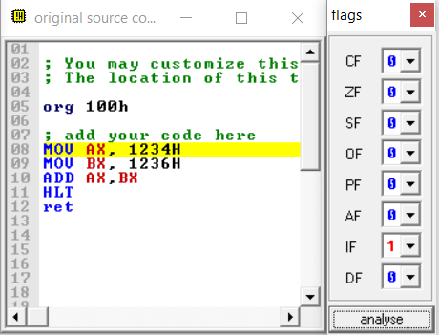

Fig 1.2

**Program 2**

**Aim: Write an assembly language program to subtract two 16-bit numbers in 8086.**

**Sol:**

MOV AX, 1234H

MOV BX, 1236H

SUB AX, BX

HLT

**Output:**

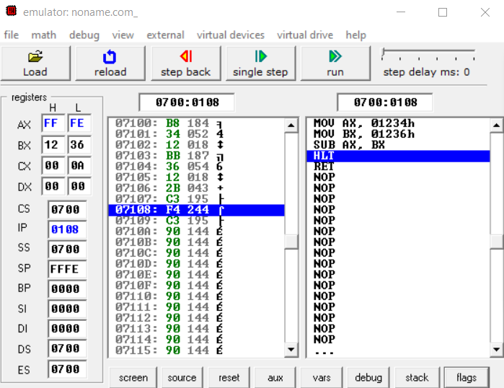

Fig 2.1

Fig 2.2

**Program 3**

**Aim: Write an assembly language program to multiply two 16-bit numbers in 8086.**

**Sol:**

MOV AX, [0301H]

MOV BX, [0303H]

MUL BX

HLT

**Input:**

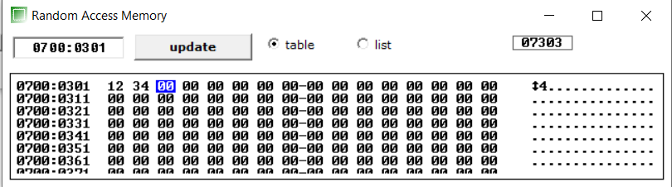

Fig 3.1

Fig 3.2

**Output:**

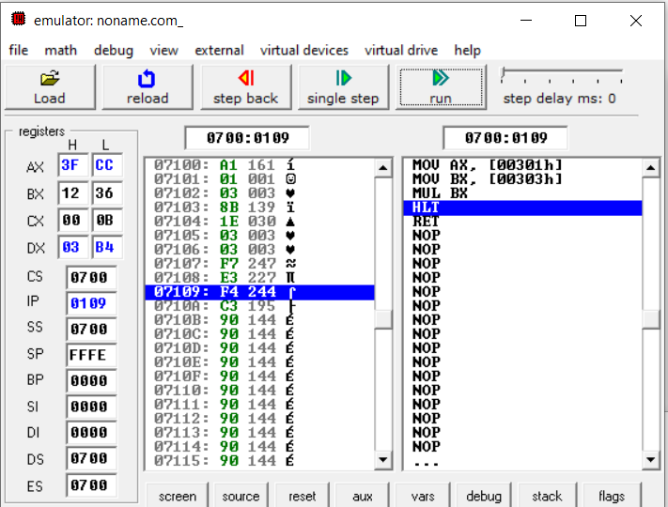

Fig 3.3

Fig 3.4

**Program 4**

**Aim: Write an assembly language program to divide two 16-bit numbers in 8086.**

**Sol:**

MOV AX,5600H

MOV BX,2500H

DIV BX

HLT

**Output:**

Fig 4.1

Fig 4.2

# **Program 5**

**Aim: Write an assembly language program to demonstrate AAA, AAS, AAM, AAD, DAA and DAS in 8086**

# **Sol:**

|  |  |
| --- | --- |
| **AAA** | **AAS** |
| MOV AX,0032H | MOV AL,0033H |
| MOV BX,0033H | SUB AX,0039H |
| ADD AX,BX | AAS |
| AAA | OR AL,0030H |
| HLT | HLT |

|  |  |
| --- | --- |
| **AAM** | **AAD** |
| MOV AL,03H | MOV AX,0033H |
| MOV BL,09H | MOV BX,0032H |
| MUL BL | AAD |
| AAM | DIV BX |
| OR AX,3030H | HLT |
| HLT |  |

|  |  |
| --- | --- |
| **DAA** | **DAS** |
| MOV AL,71H  ADD AL,43H  DAA  HLT | MOV AL,71H  SUB AL,43H  DAS  HLT |

**AAA:**

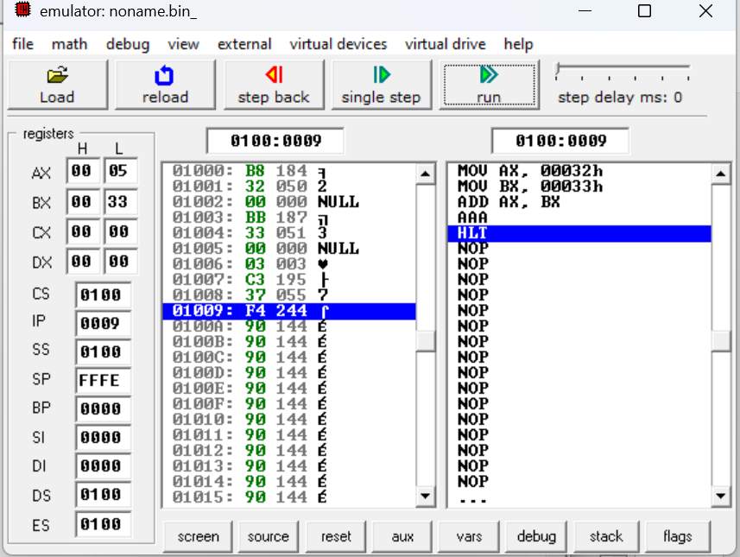

Fig 5.1

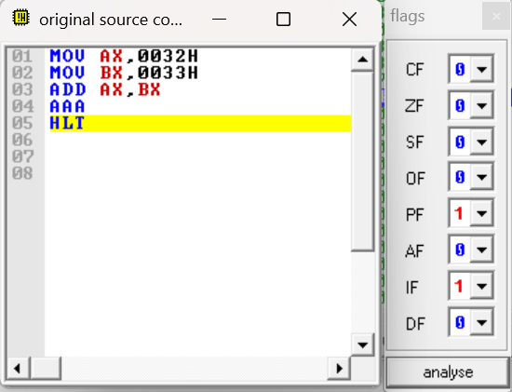

Fig 5.2

**AAS:**

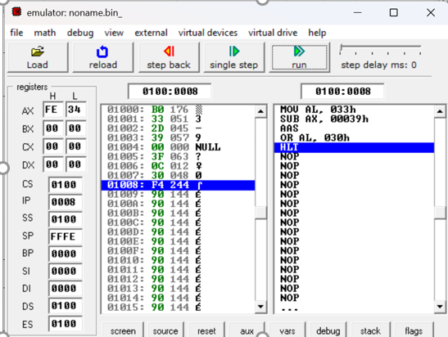

Fig 5.3

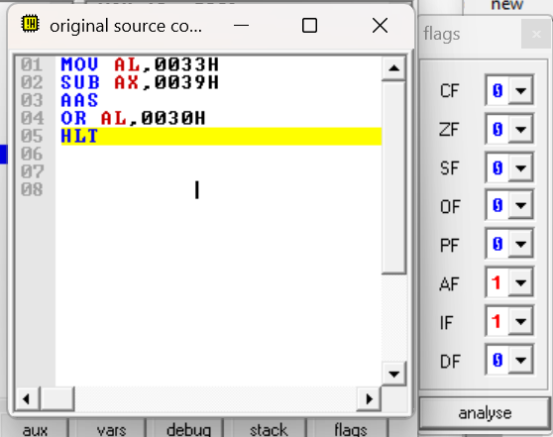

Fig 5.4

**AAM:**

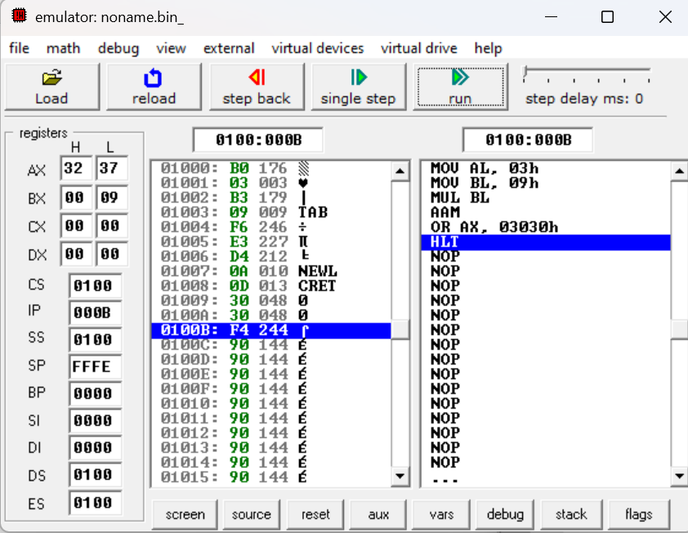

Fig 5.5

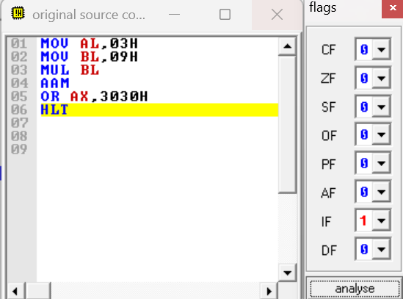

Fig 5.6

**AAD:**

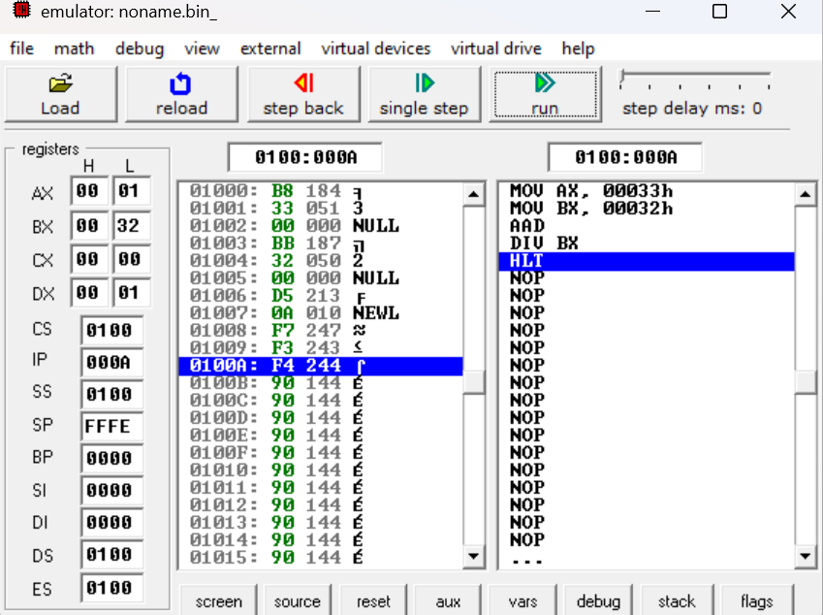

Fig 5.7

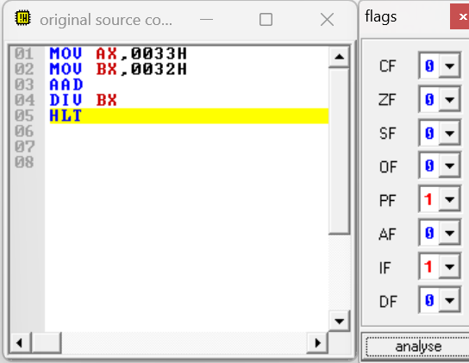

Fig 5.8

**DAA:**

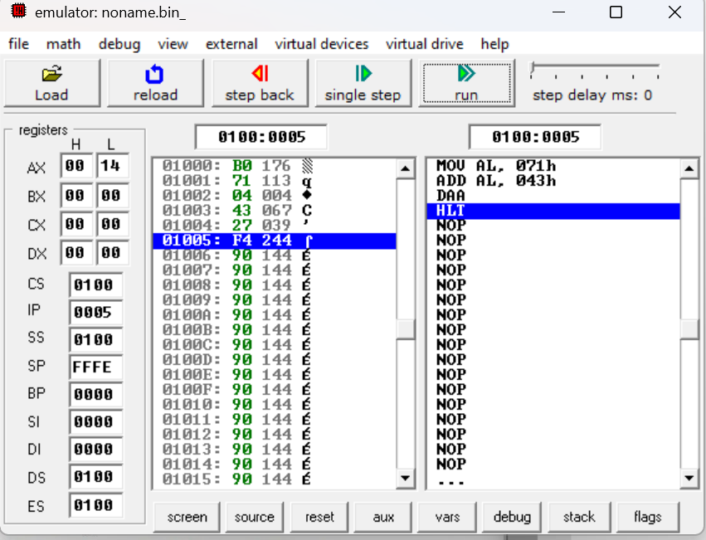

Fig 5.9

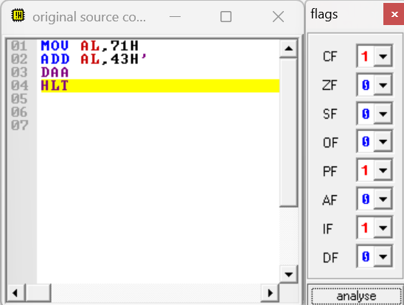

Fig 5.10

**DAS:**

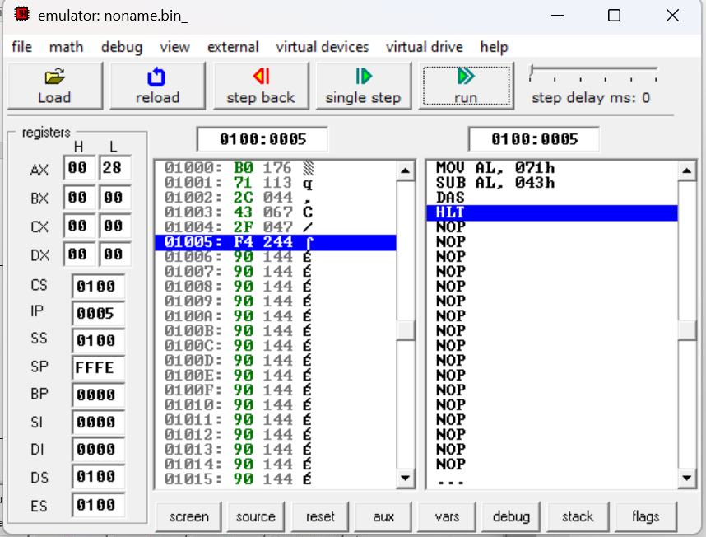

Fig 5.11

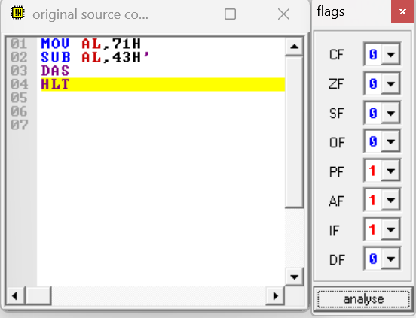

Fig 5.12

**Program 6**

**Aim: Write an assembly language program to find out the count of positive numbers and negative numbers from a series of signed numbers in 8086.**

**Sol:**

MOV CL,0AH

MOV BL,00H

MOV DL,00H

LEA SI, [1000H]

L1: MOV AL, [SI]

SHL AL, 01

JNC L2

INC DL

JMP L3

L2: INC BL

L3: INC SI

DEC CL

JNZ L1

MOV [100AH], BL

MOV [100BH], DL

HLT

**Input:**

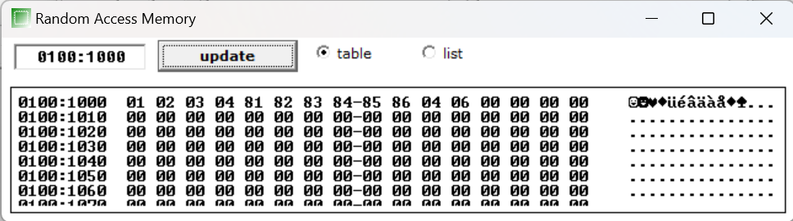

Fig 6.1

**Output**:

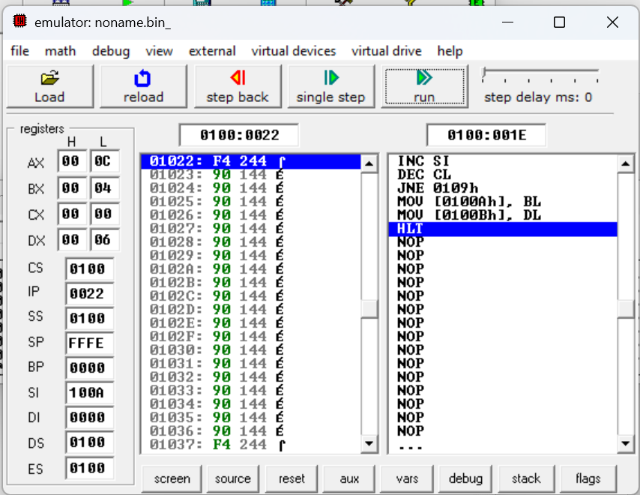

Fig 6.2

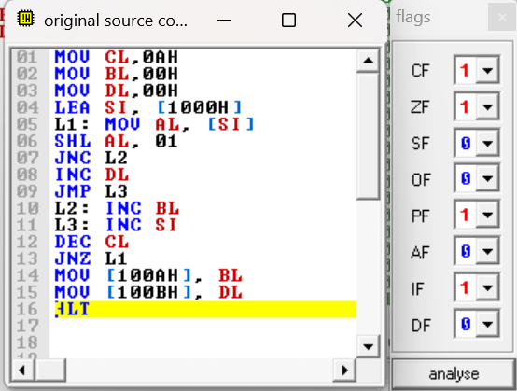

Fig 6.3

**Program 7**

**Aim: Write an assembly language program to convert to find out the largest number from a given unordered array of 8-bit numbers, stored in the locations starting from a known address in 8086.**

**Sol:**

MOV CL, 0AH

LEA SI, [1000H]

MOV AL, [SI]

L1: INC SI

MOV BL, [SI]

CMP AL, BL

JC L2

JMP L3

L2: MOV AL, BL

L3: DEC CL

JNZ L1

MOV [100AH], AL

HLT

**Input:**

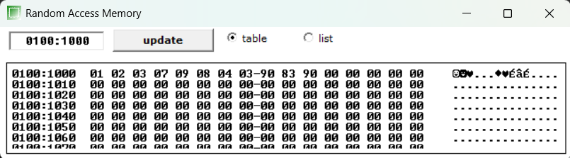

Fig 7.1

**Output:**

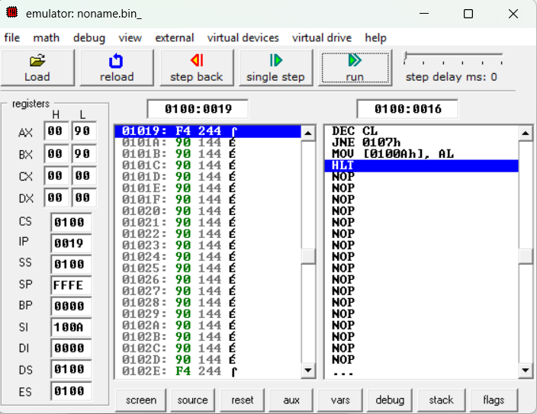

Fig 7.2

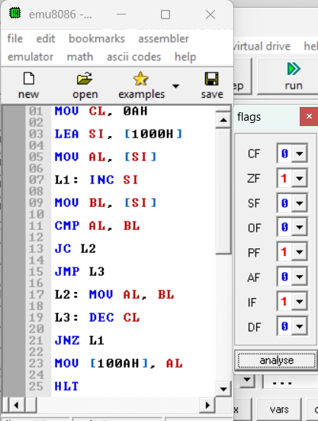

Fig 7.3

**Program 8**

**Aim: Write an assembly language program to find out the largest number from a given unordered array of 16-bit numbers, stored in the locations starting from a known address in 8086.**

**Sol:**

MOV BX, 1000H

MOV C L, [BX]

INC BX

MOV AX, [BX]

DEC CL

Back: INC BX

INC BX

CMP AX, [BX]

JNC Next

MOV AX, [BX]

Next: DEC CL

JNZ Back

MOV [1020H], AX

HLT

**Input:**

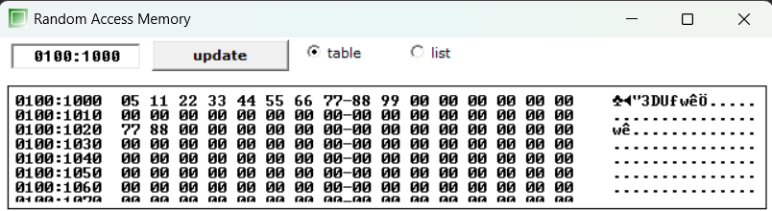Fig 8.1

**Output:**

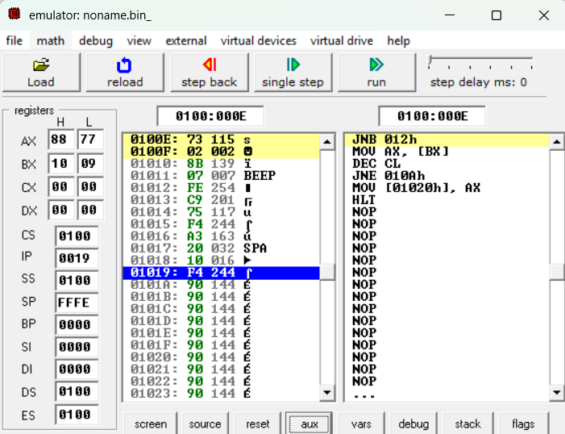

Fig 8.2

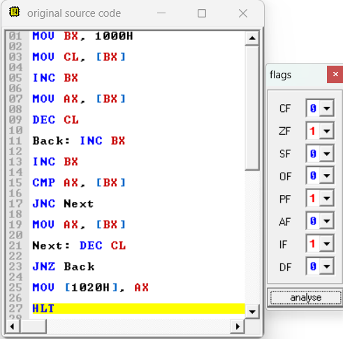

Fig 8.3

**Program 9**

**Aim: Write an assembly language program to print Fibonacci series in 8086.**

**Sol:**

MOV AL,00H

MOV SI,500H

MOV [SI], AL

ADD SI,01H

ADD AL,01H

MOV [SI], AL

MOV CX, [0000H]

SUB CX,0002H

L1:MOV AL, [SI-1]   
ADD AL, [SI]

ADD SI,01H

MOV [SI], AL

LOOP L1

HLT

**Input**:

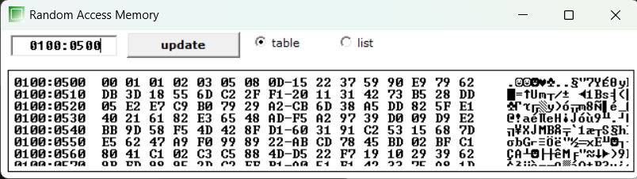

Fig 9.1

**Output:**

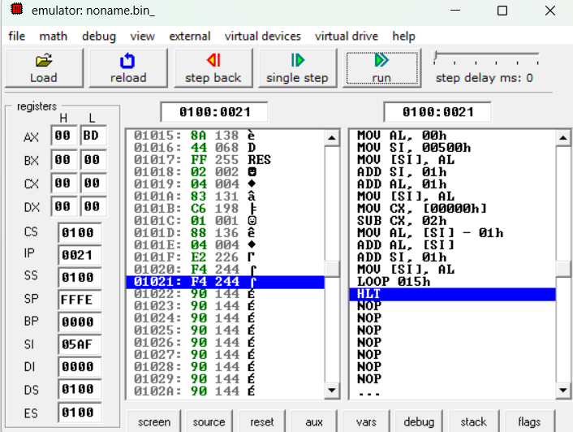

Fig 9.2

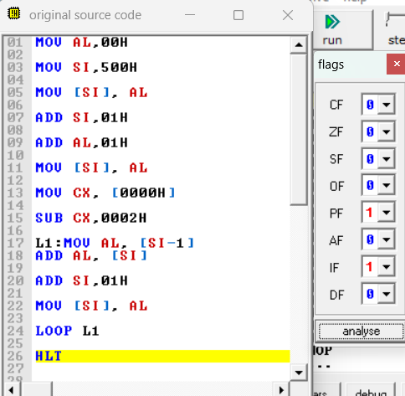

Fig 9.3

**Program 10**

**Aim: Write an assembly language program to perform the division 15/6 using the ASCII codes. Store the ASCII codes of the result in register DX.**

**Sol:**

MOV AX, ‟15‟

MOV BX, “6‟

SUB AX, 3030H

SUB BH, 30H

AAD

DIV BH

ADD AX, 3030H

MOV [SI], AX

HLT

**Output:**

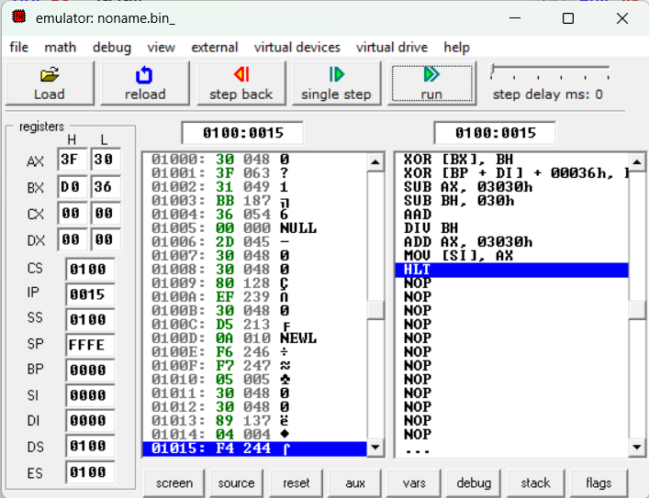

Fig 10.1

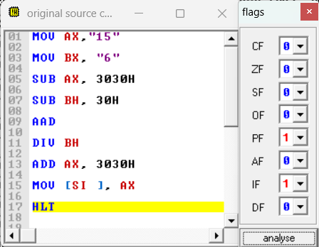

Fig 10.2