**ELC ACTIVITY**

Name- Pulkit Arora

Roll no.- 102103267

Group- C010

App Name- QR Code Generator

Description-

This apps Converts Data to a image known as QR image. A QR code is a type of barcode that can be read easily by a digital device and which stores information as a series of pixels in a square-shaped grid.

QR codes are frequently used to track information about products in a supply chain and – because many smartphones have built-in QR readers – they are often used in marketing and advertising campaigns.

Uses Of QR Code

1. Direct customers to a landing page/website

### Dial your business number

### 3.Send a message

### 4.Download apps

### 5.View business location

### 6.Shopping and E-commerce

**How To use QR Code Generator**

**STEP 1 –** Type the required Data in the encircled coloum.

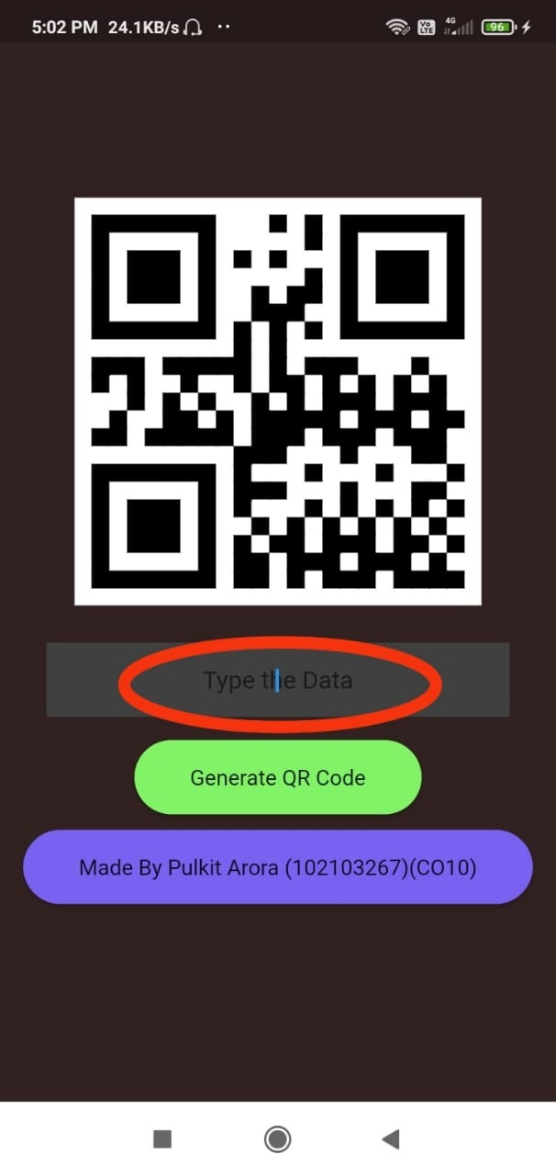

**STEP 2-** For Example you Typed “google.com”.

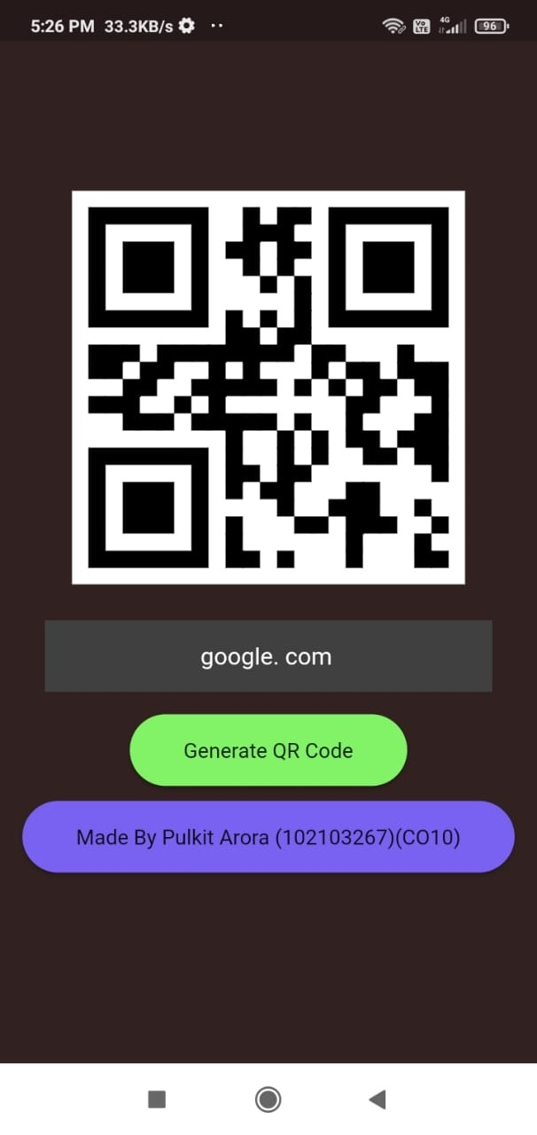

**STEP 3-**  Click on “Generate QR Code” Button.

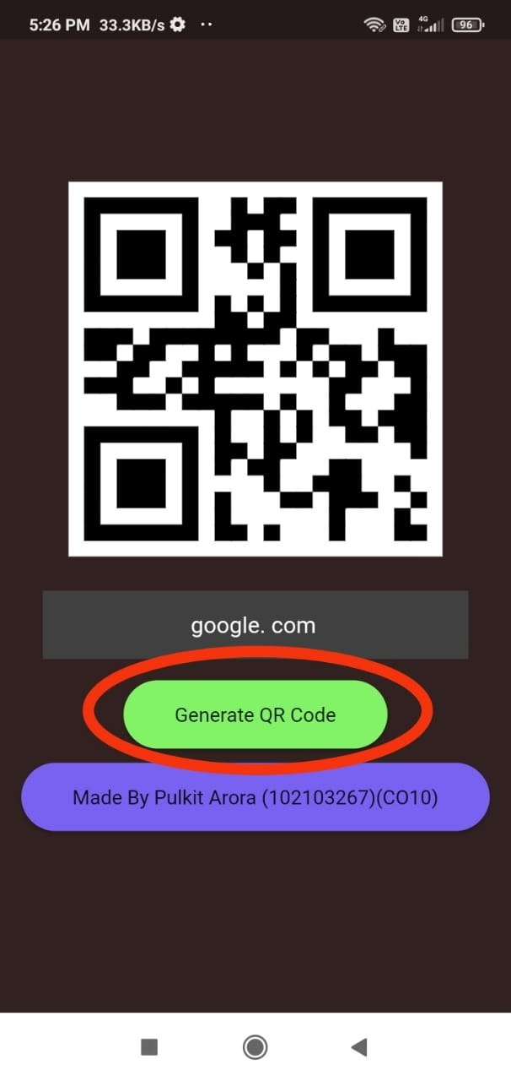

**STEP 4-** The Required QR Code is ready. Now you can share it with anyone, by taking its screenshot.