Proposition: Theorem 2 is false.

Consider the timed automaton,

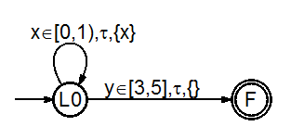

Consider the run.