analyz this spark ai project end to end inluclding flow which calls DarwinRandomEmployeeGenerator
Ran an agent, ran 6 commands, searched code, read 12 files, used a tool
SparkAI project — quick map
Repo: SparkAI.sln (root: C:\Darwin\IntegrationTesting\Tools\SparkAI)
Piece | Job
SparkAI.AppHost | .NET Aspire — spin up all pieces local dev, wire OTLP
SparkAI.Server | ASP.NET Core API, main brain. LlmController entry, SignalR hubs, DI
SparkAI.Rag | Node/TS RAG microservice, port 3001
SparkAI.Client | Angular UI, port 4300
SparkAI.Server.Tests | MSTest unit tests
Talk paths: Client → Server/Rag over HTTP. Server → Rag over HTTP, Server → Mongo, Server → LLM (chat completions), Server → Darwin ControlCentre API (via Darwin.IntegrationTesting.TestToolKit managers).
DarwinRandomEmployeeGenerator — flow trace
Not inside SparkAI folder itself — sibling repo C:\Darwin\IntegrationTesting\Tools\DarwinRandomEmployeeGenerator, pulled in via project refs (SparkAI.Server.csproj:72-73).
Trigger: POST /api/len-ai/{userId} → LlmController.cs:227
Chain:
- TestCasesGenService.ProcessLlmRequestAsync → if EmployeeData empty in req → ResolveCompatibleEmployeesAsync (fallback gen, no feature flag — pure "no data uploaded" condition)
- → BenefitCompatibleEmployeesGeneratorService.GetEmployees — build EmployeeFormModel (org/env/scheme/country/payroll/age range/count), resolve env conn
- → randomEmployeeGenerator.EmployeeGenerator(options, employeeFormModel) — DI'd IRandomEmployeeGenerator, impl RandomEmployeeGenerator.cs:80-235 (ClassLibrary):
  - Get scheme token from Darwin CC
  - LoadSchemeTemplateAsync — pull scheme template/config
  - EmployeeGeneratorHelper.PopulateFields — actual random gen: random strings/numbers/booleans/regex-constrained fields/dates within age bounds (helper file EmployeeGeneratorHelper.cs, shared Random instance line 10)
  - Since caller sets IsBenefitCompatibleRequired = true → BenefitComplianceProcessorService.AlignEmployeeDataWithBenefitRules (LLM-backed) tweaks values to hit target compliant %
  - Writes Excel + zips → returns zipFilePath
- Back in BenefitCompatibleEmployeesGeneratorService: extract zip, read Excel via SpreadsheetGear → List<Dictionary<string,object>> employees
- TestCasesGenService sets requestBody.EmployeeData = compatibleEmployees → feeds LLM eligibility prompt pipeline + benefit-starting-position orchestrator → final test-case Excel/zip returned to caller.
Config: DI reg in ApplicationServiceExtensions.cs:130-134. appsettings.json:112 has RandomEmployeeGeneratorExe path — dead/unused, legacy console-exe reference, no code path calls it. Separate EmployeeGeneratorLenAI LLM endpoint (gpt-41-mini) just for this flow.
Note: age eligibility extraction throws if benefit model lacks min/max, while DefaultValues (16/100) config exists but isn't used as fallback there — possible inconsistency, unconfirmed as active bug.
now u have complete idea about spark ai flow /mcpmarket-me:frame-flowchart-sticky generate deatailed flow of sprak ai project working that can make users understand what going on in spark ai
Read mcp-visualize-read_me-1786961498052.txt, used 2 tools
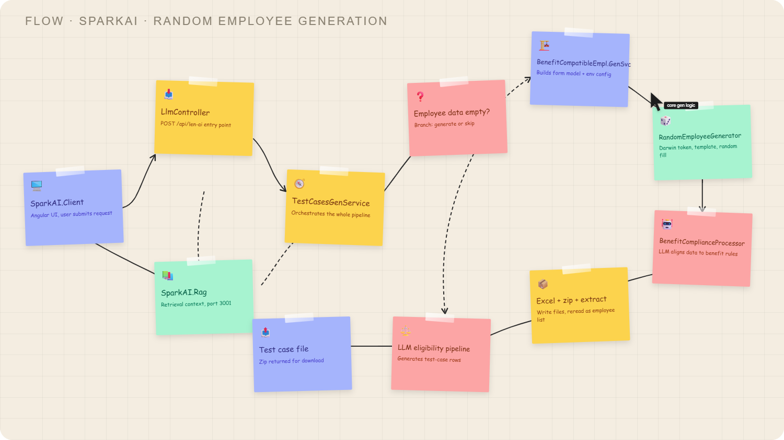
Whiteboard flow ready. Path traced: client hits LlmController → TestCasesGenService (RAG feeds context in parallel) → checks if employee data empty → if so, BenefitCompatibleEmployeesGeneratorService → RandomEmployeeGenerator (Darwin token + template + random fill) → BenefitComplianceProcessor (LLM aligns to benefit rules) → excel/zip written and re-read as employee list → merges back into LLM eligibility pipeline → final test-case zip returned to client.
no disgram generated is too lame please check it and make it look like extract flow which going on in background
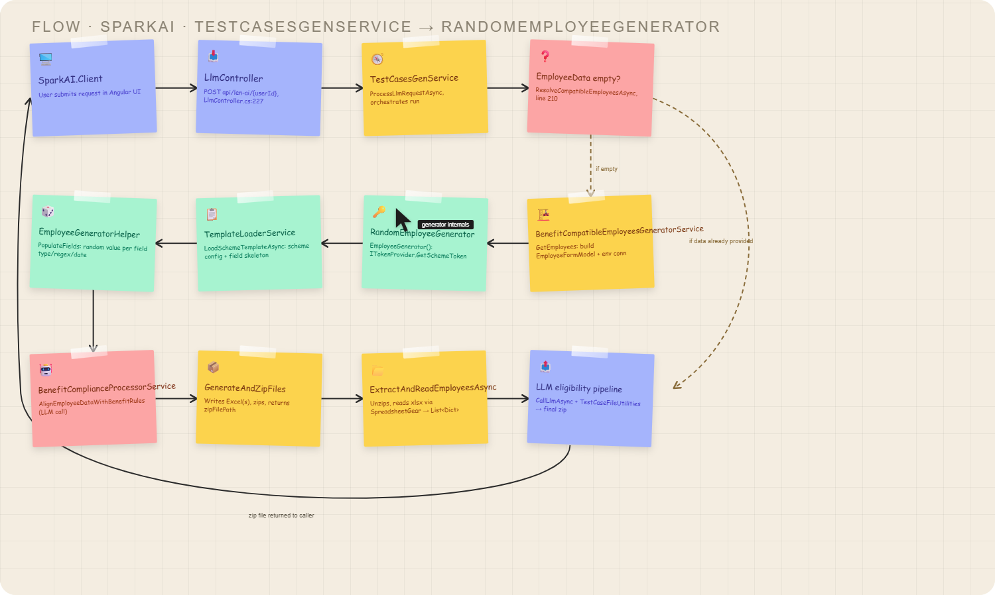
Redone with the actual class/method names from the code, snake-routed so no crossing lines, and both branches (empty → generate, already-has-data → skip) drawn explicitly with labels. Full chain: LlmController → TestCasesGenService → decision → BenefitCompatibleEmployeesGeneratorService → RandomEmployeeGenerator (token) → TemplateLoaderService → EmployeeGeneratorHelper.PopulateFields → BenefitComplianceProcessorService (LLM align) → zip write → unzip/read → merge into LLM eligibility pipeline → back to client. Let me know if any node needs to go deeper or if you want the RAG/AppHost pieces folded in too.
instaed of class names or files names can't gerate flow like we used to do for flow disgram , understand functianlity what's going on and then genrate meaningful flow

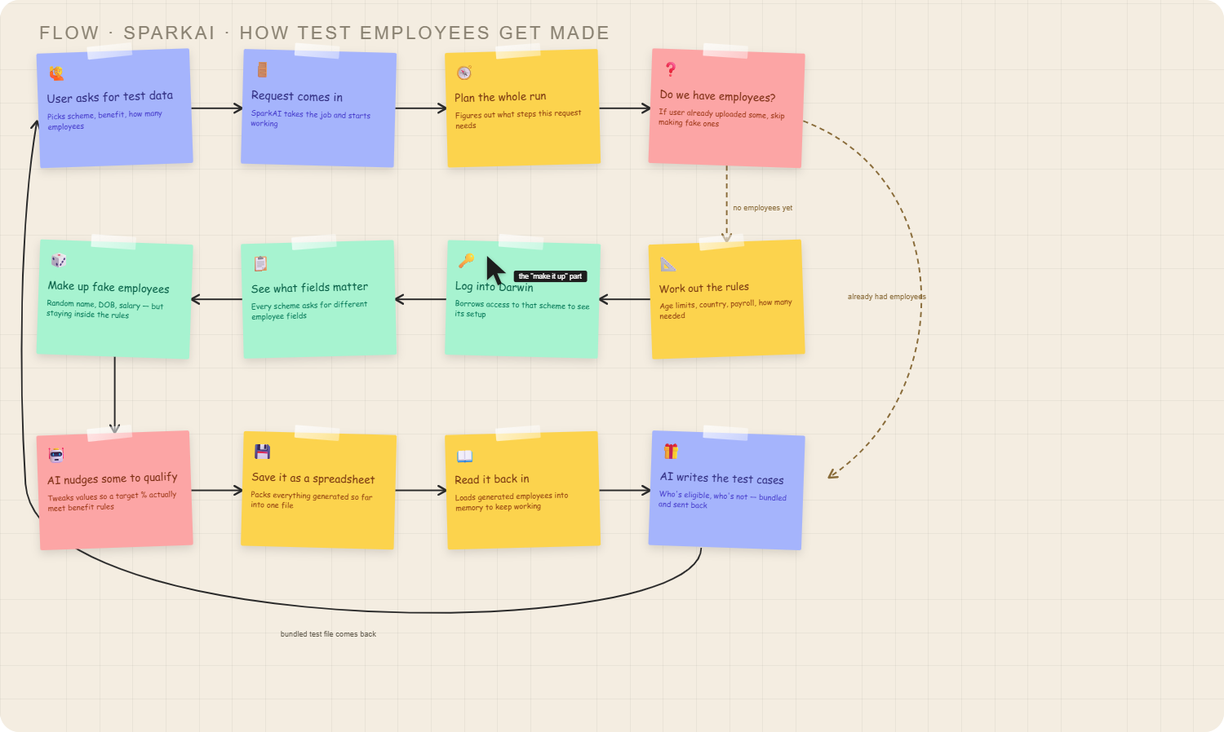
Rebuilt with plain functional story, no class/file names: user asks for test data → request comes in → plan the run → check if employees already exist → (if not) work out rules → log into Darwin → see required fields → make up fake employees → AI nudges some to qualify → save as spreadsheet → read it back → AI writes eligibility test cases → bundled file returned.
reanalyze things and make more accurate version of flow including agents internal working like for employee genrator we using review n critic and same for test genration we using genrator and revierwer
Need re-check code for agent loops (generator/reviewer/critic) before redrawing.
Searched code, read 3 files
Widget from visualizeshow_widget
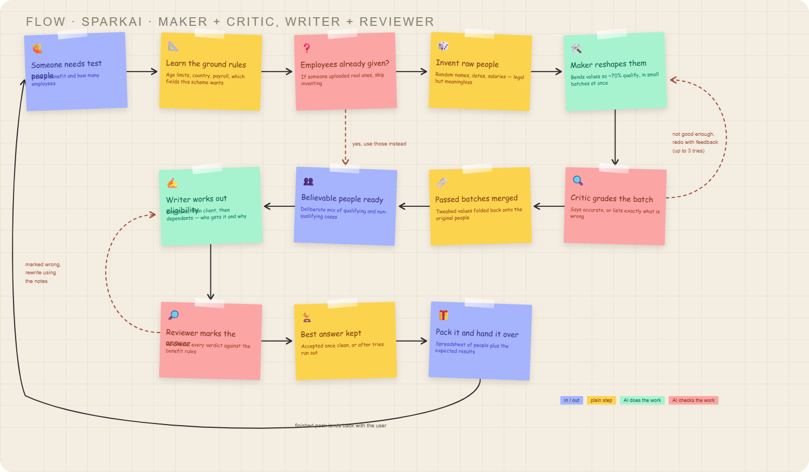

Re-read the code first — both agent loops confirmed, and they are not the same shape:
Loop 1 — employee data (maker + critic). Employees split into batches of 5, batches run in parallel. Each batch: maker LLM reshapes values so a target share (~70%) qualify → critic LLM grades it accurate or returns a feedback + issues list → if not accurate, the critic's feedback is injected into the next attempt's prompt as a refinement section, max 3 attempts. On the last attempt it proceeds anyway rather than failing. Batch is also rejected if the row count doesn't match.
Loop 2 — eligibility test cases (writer + reviewer). Same evaluator-optimizer shape, different knobs: can be switched off entirely (EnableValidator), max 2 retries, reviewer feedback plus issues get fed back into the rewrite. Runs per stage — employee eligibility, then client eligibility, then dependants — and retries are counted into the audit record.
Both critics fail open: if the LLM is unreachable or the response won't parse, they return "accurate" and the pipeline continues rather than blocking.
i am not able to download the file why?
have u observe from this step Pack it and hand it over we call spark console app which runs test cases and returns the test cases result and then we package result, so include that step also
Let me check code — earlier I read the exe path as unused. Verifying.
Searched code
Correct — I missed it. Reading the service.
Read SparkConsoleExecutionService.cs, searched code
Good catch — I missed it. Confirmed in code: after the test sheet is written, SparkConsoleExecutionService copies it into a per-environment/per-user folder and shells out to SparkPipeline.exe synchronously (with a timeout), which runs the tests for real and returns an exit code plus TotalTests / PassedTests / FailedTests / IgnoredTests. Only then does the packaging step run. Also spotted a real age-filter pass before the AI work. Both now in the diagram.
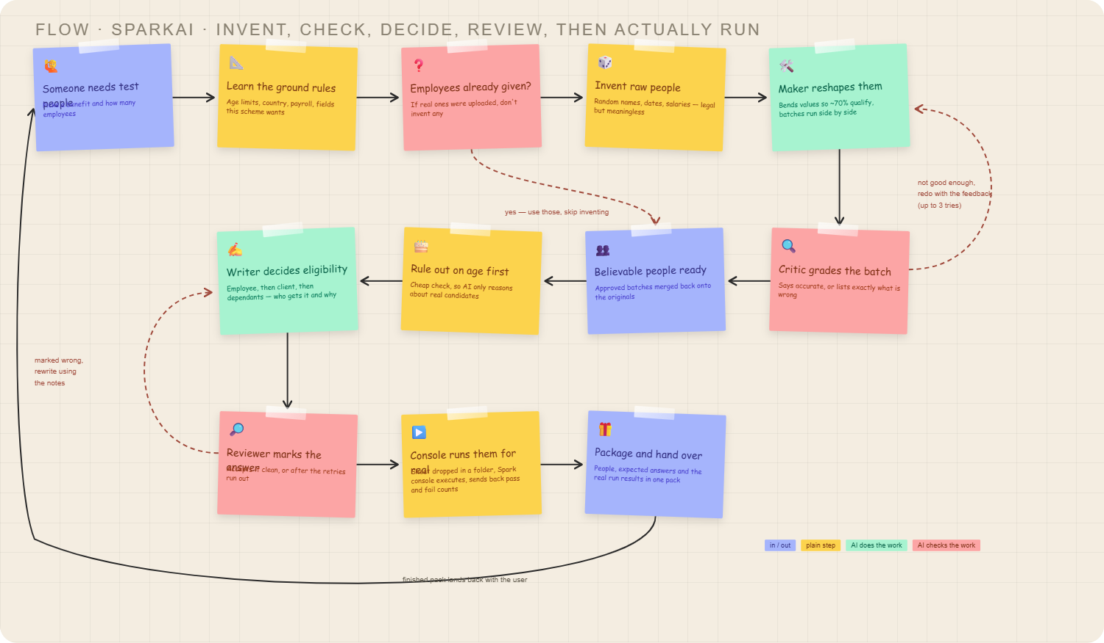

Two corrections to what I told you earlier:
Console run — I got this wrong before. I'd said the only exe path in config was dead legacy. That was true of RandomEmployeeGeneratorExe, but I stopped there and missed a second, live one: SparkConsoleSettings.SparkConsoleExeLocation → SparkPipeline.exe. It runs synchronously, times out if it hangs, and its exit code plus test counts get tagged onto the trace and folded into the response. It also guards against path traversal on the environment and user names, and wipes the user's folder before each run.
Age filter. There's a plain deterministic age pass before any AI reasoning, feeding its result into the eligibility stage as prior context — cheap filter first, expensive model second. Added as its own node.
few edits, replace Someone needs test people with User need to test benefit configuration, replace Learn the ground rules Age limits, country, payroll, fields this scheme wants with step benefit doc to json model (analyze it) check claude.md for wiki, repace Invent raw people with Genrate New Employees, Believable people ready with Believable Employees records ready, remove this marked wrong, rewrite using the notes
Read CLAUDE.md, searched code
Checked CLAUDE.md → pointed to the wiki-gen/output/ pages. That step is document-to-JSON: uploaded benefit doc goes through the RAG server for section extraction, an LLM converts it to a canonical JSON benefit model, the JSON is repaired/validated, hashed, and cached in Mongo so an unchanged doc reuses the existing model. Written into the node.
Widget from visualizeshow_widget
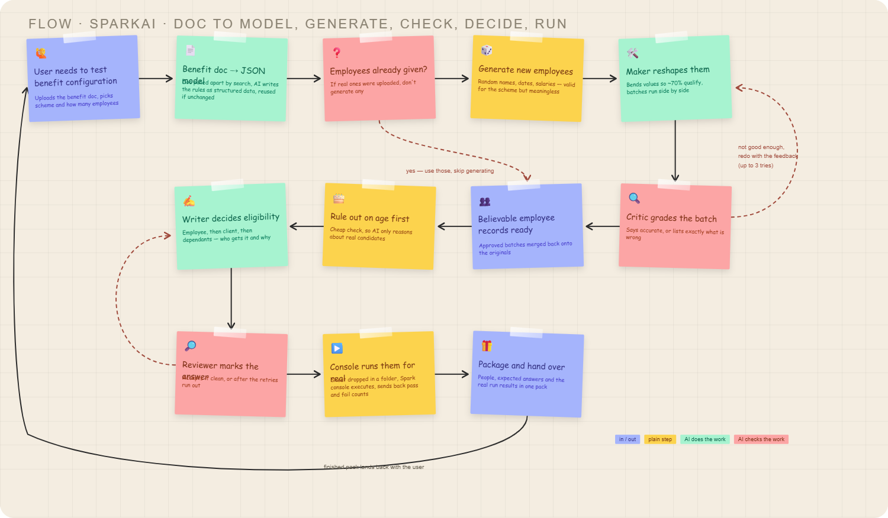
All five edits applied.
html
sparkai-flow.html
10.1kB
All five edits in, widget and file both updated.
One knock-on worth flagging: node 2 changed colour from plain step to AI step, since doc→JSON is a real LLM call, not a config read. The age-limit detail that used to live in that node is already carried by the "rule out on age first" node, so nothing was lost.
The reviewer→writer loop arrow is still drawn, just unlabelled now — say the word if you'd rather drop the arrow too.
make this text more meaningful as it doen't make sense : Doc pulled apart by search, AI writes the rules as structured data, reused if unchanged
Editedsparkai-flow.html+1-1
Widget from visualizeshow_widget
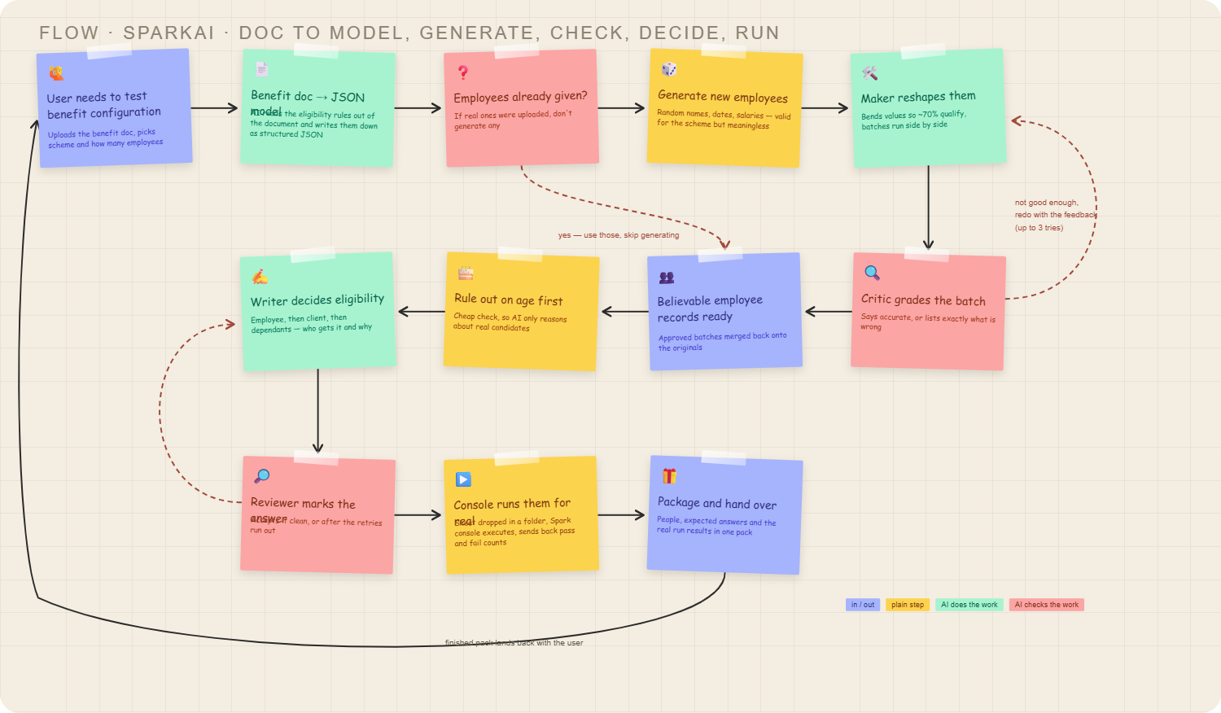
Study AI Security Project materials end to end
Kicked off a full research pass on the AI Security Project folder — covering the diagrams, Excalidraw files, GitHub link, and the code itself — running in the background. I'll report back once it's done.
Ran 3 commands, read 18 files, used a tool
Background task completedAgent "Study AI Security Project materials end to end" finished· took 6m 57s
AI Security Project — end-to-end summary
What it is: an autonomous research-agent app (topic in → structured report out) that has AI-security tooling built into it as core infrastructure, not a security tool as the end product itself.
Request flow:
- API key check + rate limit (10 req/60s via Redis) + Bedrock Guardrail input scan
- Job queued in Redis Streams, picked up by a background worker
- Smart lookup cascade to avoid recomputation: Redis semantic cache (cosine ≥0.85) → pgvector exact long-term-memory match (≥0.88) → pgvector related-LTM (0.5–0.88, feeds context) → full pipeline on total miss
- 4-agent LangGraph pipeline: Search → Summarize → Write → Critic, with a retry loop back to Search if the critic fails fact-checking
- All LLM calls go through a TensorZero gateway (GPT-4o primary, Groq llama-3.1-8b-instant fallback)
- Bedrock Guardrail output scan blocks anything harmful
- Result cached, stored as a vector in Postgres, scored by 4 LLM-as-judge evals (relevance/completeness/hallucination/quality), everything traced in LangSmith
- Client polls for the result (text/JSON/PDF)
Security-specific layers:
- Defense: API key + rate limiting + dual Bedrock Guardrails (input and output), explicit deny topics for weapons/illegal activity/self-harm, PII blocking
- Offense/testing: a separate PyRIT-based red-team dashboard (port 8001) that attacks the app with jailbreak, prompt-injection, crescendo, and skeleton-key techniques — runs on demand and automatically every week via EventBridge
- Observability: LangSmith traces plus automatic safety/quality scoring per job, so regressions are visible
Code: Python/FastAPI (app/main.py entry point, agents.py LangGraph pipeline, guardrails.py, memory.py, cache.py), a standalone PyRIT dashboard, a TensorZero gateway config, and full Terraform for AWS (VPC, ECS Fargate, ALB, RDS+pgvector, ElastiCache, Bedrock Guardrail resource, Secrets Manager, ECR, EventBridge). GitHub Actions handles CI/CD.
Diagrams vs code: the architecture diagram (both the .mmd/PNG and the Excalidraw redraw) matches the actual implementation closely — same thresholds, same ordering, same components.
One thing worth flagging: the Excalidraw file also has a second, unrelated set of notes mixed into the same canvas — a course outline about Kubernetes security scanning (kube-bench vs Trivy, CIS Benchmark). That's not part of this project; looks like stray content that got merged in by accident.
ok now i want to implement same architechture for my spark ai app. you dont have code anything just do the revamp of sparl ai app as per this application, introduce agents where reqyured, and give me updated spark ai architechture. let me know if u have any questions
Before I lock in the architecture, a few real decisions that change the design:
continue
Before I design it, four decisions that materially change the shape:
Where does the revamped SparkAI run?
Azure
Which layers from the reference do you actually want in SparkAI?
Guardrails (input + output), Semantic cache + vector long-term memory, LLM-as-judge eval + tracing, Red-team harness (PyRIT-style)
How far do you want the agent redesign to go?
Full graph rewrite
What should I hand you?
Whiteboard diagram + written architecture
Design locked. Two canvases — one for the platform/security layers, one for the agent graph. A single canvas at this component count renders too small to read in chat.
Widget from visualizeshow_widget
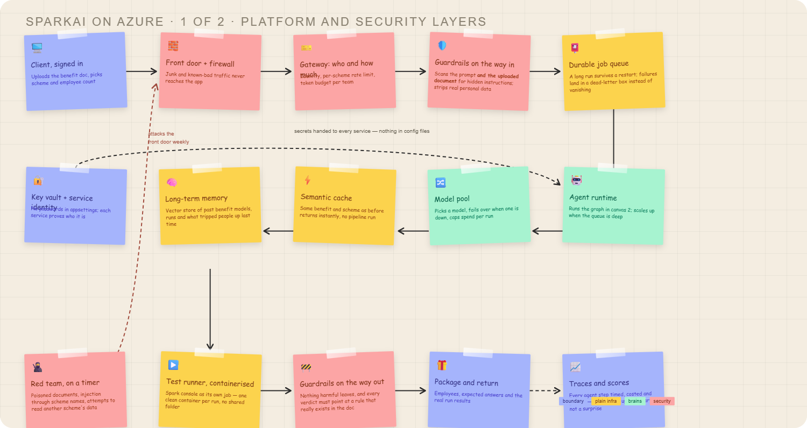
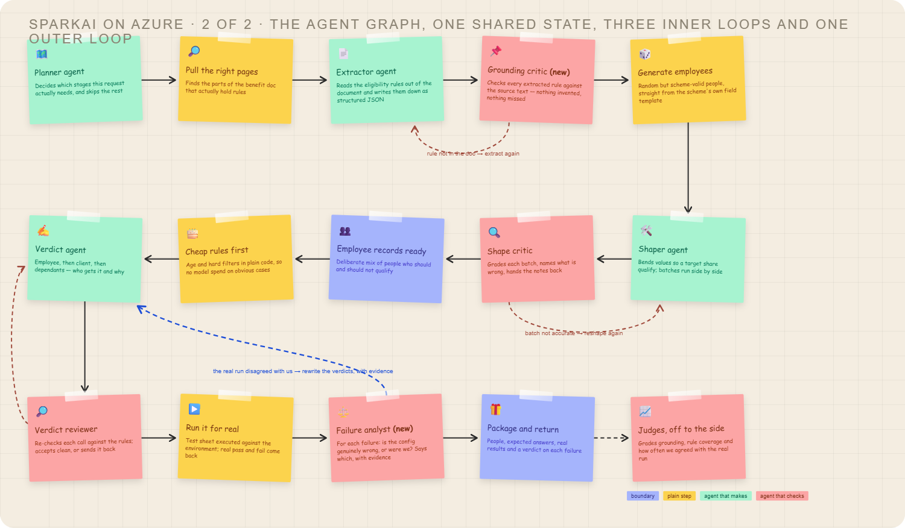

Yes — tools are the missing half. Here's the inventory, then the flow with your Health Insurance model.
Tool inventory
Tool | What it does | Bound to
darwin.get_scheme_token | Auth against the environment | generator, executor
darwin.get_scheme_template | Field skeleton the scheme expects | generator
darwin.get_profile_fields | Field types, regex, allowed values | generator, shaper
doc.load / doc.split / doc.embed | Benefit document → structured chunks | retrieval
vector.search | Retrieve clauses; also LTM lookup | retrieval, extractor, verdict
quote.verify | Does this verbatim quote exist in that chunk? | grounding critic
rules.evaluate | Evaluate a benefit model against one employee, deterministically | verdict, shaper, shape critic, failure analyst
people.generate | Random but schema-valid employee rows | generator
workbook.write / workbook.read | Test sheet in and out | sheet builder, executor
testrunner.execute | Run the sheet against the environment | executor
guardrail.scan | Input and output safety | graph entry/exit
The tool that changes the design
rules.evaluate deserves the bold. Look at what your model actually contains:
EmployeeType == "Regular" AND FullTimeEquivalent >= 0.5
NOT (EmployeeType IN ["Intern/Co-Op (Trainee)", "Temporary", "Apprentice (Trainee)"])
NOT (ExpatOut == TRUE)
That is boolean logic over typed fields. There is no judgement in it. An LLM evaluating this is slower, costlier, and less reliable than fifteen lines of Python — and it can't be unit-tested.
So the split becomes:
- LLM does: extract the model from prose, interpret genuinely ambiguous operators, choose interesting test data, explain failures.
- Code does: all eligibility arithmetic.
The verdict agent's job shrinks to calling the evaluator and reasoning only about what the evaluator couldn't resolve. That's what makes this enterprise-grade rather than a demo.
Flow walkthrough — Health Insurance, 10 employees, 70% target
1. Planner
Reads the model, derives the plan:
plan = Plan(
stages=["retrieve","extract","ground","generate","shape","critique",
"prefilter","verdict","review","sheet","execute","analyse"],
dependants_in_scope=True, # DependantEligibility is non-empty
starting_position=False, # BenefitSelection == "AutoAllocated", nothing to choose
employee_age_gate=False, # MinAge 0 / MaxAge 99 — excludes nobody
)
Two stages skipped before any model call, both derived from the model itself.
2–3. Retrieval → Extractor
The extractor emits your JSON, but every branch carries evidence:
{
"rule_id": "dep-child-fte-quebec",
"kind": "dependant",
"expression": "category=Children AND age<=25 AND FullTimeEducation=true AND Province=Quebec",
"quote": "In Quebec, coverage for children in full-time education continues to age 25.",
"chunk_id": "c17",
"confidence": 0.91
}
4. Grounding critic
Two passes. Mechanical first — quote.verify confirms each quote literally exists in its chunk. Then one model call on what survived, asking whether the quote actually means the expression.
On your model it would flag:
- dep-child-disabled (MaxAge 99). Disabled-child extensions are frequently implied by a general clause rather than stated with an age. If no quote supports "99", it's an invented bound.
- Coverage gap check. The model has no waiting period, no effective-date rule. If the document mentions one, the critic reports a missing rule — which no critic in the current system can do, because they only check internal consistency.
Fails → back to extractor with the specific gaps, max 2 retries.
5. Employee generator
Pulls the field template from Darwin, generates 10 rows:
id | EmployeeType | FTE | ExpatOut | Country01 | DOB | dependants
E-001 | Regular | 1.0 | FALSE | — | 1985-03-11 | spouse 41, child 22 (FT ed., Ontario)
E-002 | Regular | 0.6 | FALSE | — | 1990-07-02 | child 22 (not in education)
Random but schema-valid. Nothing yet aimed at the benefit.
6. Shaper
Target is 7 pass / 3 fail. The agent's real contribution is failure diversity — three failures for three different reasons beats three interns:
- E-008 → EmployeeType = "Temporary" (deny list)
- E-009 → FullTimeEquivalent = 0.4 (fails the allow condition)
- E-010 → ExpatOut = TRUE (deny)
It runs rules.evaluate after each edit to confirm it achieved the intent it was aiming for, rather than assuming.
7. Shape critic
Checks the count, the ratio, and that no row fails for two reasons at once — a Temporary employee with FTE 0.4 tests one thing while looking like it tests two.
8. Prefilter
Employee age gate is 0–99, so this is a no-op for employees — already known from the plan. For dependants it does the real work, and this is where your model gets interesting. Child aged 22:
Situation | Band that applies | Result
Full-time education, Ontario | MaxAge 24 + FullTimeEducation | eligible
Not in education | MaxAge 20 | not eligible
Full-time education, Quebec | MaxAge 25 + FullTimeEducation + Quebec | eligible
Open question I can't resolve from the JSON: Children appear in four overlapping bands. When several match, is it most-favourable-wins, first-match-wins, or all-must-pass? The four bands are only unambiguous if the semantics are defined somewhere. Whatever the answer, it needs to live in rules.evaluate as an explicit, tested policy — not be inferred by a model each run.
9. Verdict agent
Calls rules.evaluate per employee, then reasons only about leftovers:
{
"employee": "E-003",
"eligible": false,
"decided_by": "rules.evaluate",
"matched": ["deny.EmployeeType IN [...]"],
"confidence": 1.0
}
And the one the evaluator can't settle:
{
"employee": "E-005",
"eligible": null,
"decided_by": "agent",
"blocked_on": "Operator IS_POPULATED_AND_REACHES_DATE on Country01 is not defined",
"confidence": 0.35
}
That operator is genuinely opaque — populated and reaches a date, but which date, and reaches it when? Rather than guessing, the agent marks it unresolved and it surfaces as an issue. Silent guessing on an operator nobody understands is exactly how these systems produce confident nonsense.
10. Reviewer
Verifies each verdict cites a rule that exists in the model, and that the dependant band selection matches the declared policy.
12–13. Sheet → execute
10 tests run. Result: 8 passed, 2 failed.
14. Failure analyst
Failure A — E-006, child aged 25 in Quebec, full-time education. We predicted eligible; Darwin says not covered.
{
"employee": "E-006",
"we_said": "eligible",
"system_said": "not eligible",
"verdict": "our_expectation_wrong",
"reason": "Quebec band reads MaxAge 25 as inclusive. Darwin appears to treat it as exclusive.",
"evidence": ["rule dep-child-fte-quebec", "run log line 44"],
"confidence": 0.72
}
Failure B — E-002, FTE 0.6, Regular, no deny match. We predicted eligible; Darwin says not.
{
"verdict": "config_genuinely_wrong",
"reason": "No rule in the model excludes this employee. The scheme configuration does not match the document.",
"confidence": 0.88
}
This is the payoff. Failure B is a real defect in the benefit configuration — the thing the tool exists to find. Failure A is our own boundary error, and it routes back through the outer loop to the verdict agent with the run log as evidence. Today both look identical: a red cell in a spreadsheet that a human has to triage.

Two things I'd want your answer on before going further: the dependant band-overlap semantics, and what IS_POPULATED_AND_REACHES_DATE actually means. Both are load-bearing for the evaluator.
Want me to carry on with the remaining agents in this format — shaper, reviewer, judges — or write up rules.evaluate properly, since it's now the centre of the design?
i think u not getting what i want, i am not much known to langgrpah framework how it works, lets go by each agent one by one in deep how flow will work, skip anything about dpenedents, starting position.
Fair — let me fix the framework gap first, then we go one agent per message.
How LangGraph actually works
Five concepts. That's the whole thing.
1. State is a dict that every node shares. You declare its shape once. Nodes don't pass arguments to each other — they read keys and write keys.
2. A node is just a function. Takes the state, returns only the keys it changed. LangGraph merges that back in.
def my_node(state: SparkState) -> dict:
return {"benefit_model": something} # only this key gets updated
3. Edges say what runs next. Fixed edge = always go there. Conditional edge = a function looks at the state and returns the name of the next node.
4. A loop is just an edge pointing backwards. There's no special construct. You point node B back at node A, and you guard it with a counter in the state, or it runs forever.
5. Compile, then invoke. The graph becomes a normal callable.
A complete toy graph, so it's concrete:
from langgraph.graph import StateGraph, START, END
from typing import TypedDict

class State(TypedDict):
text: str
ok: bool
tries: int

def write(state: State) -> dict:
return {"text": generate(state), "tries": state["tries"] + 1}

def check(state: State) -> dict:
return {"ok": is_good(state["text"])}

def route(state: State) -> str: # returns a node name
if state["ok"]:
return "done"
if state["tries"] >= 3: # the guard
return "done"
return "retry"

g = StateGraph(State)
g.add_node("write", write)
g.add_node("check", check)
g.add_edge(START, "write")
g.add_edge("write", "check")
g.add_conditional_edges("check", route, {"retry": "write", "done": END})
app = g.compile()

app.invoke({"text": "", "ok": False, "tries": 0})
That write → check → route back to write shape is the entire pattern behind every critic loop in our design. Extractor/grounding-critic, shaper/shape-critic, verdict/reviewer — all three are that same eight lines with different functions plugged in.
One more thing that matters for enterprise use: a checkpointer. Pass one at compile time and the state is persisted after every node, so a run that dies at step 9 resumes at step 9 instead of restarting. That's how a 20-minute pipeline survives a deploy.
app = g.compile(checkpointer=PostgresSaver(conn))

Agent 1 — Planner
Job: decide which stages this run needs, before spending anything.
Reads: the request fields, plus the benefit model if one is already cached.
Writes: plan.
Tools: cache.lookup, vector.search (long-term memory). No document tools — it runs before extraction.
Why it's only half an agent. Nearly every decision here is a lookup, not a judgement:
Question | How it's answered
Have we run this exact benefit + scheme before? | hash lookup
Did the user attach their own employees? | len(employees_raw) > 0
Does this benefit need a selection step? | BenefitSelection == "AutoAllocated" → no
Does the age gate exclude anyone? | MinAge 0, MaxAge 99 → no
None of that needs a model. The LLM earns its place in exactly one spot: when someone types a free-text request instead of filling the form.
def planner(state: SparkState) -> dict:
if hit := cache.lookup(run_hash(state)):
return {"plan": Plan(stages=["package"]), "cached": hit}

plan = Plan(
stages=["retrieve", "extract", "ground", "generate",
"shape", "critique", "verdict", "review",
"sheet", "execute", "analyse"],
employee_age_gate=False,
)

if state.get("employees_raw"):
plan.drop("generate", "shape", "critique")

if text := state.get("free_text_request"):
proposed = intent_chain.invoke({"request": text}) # small model
plan = clamp_to_allowed(plan, proposed) # code has final say

return {"plan": plan}
clamp_to_allowed is the important line. The model may only narrow the plan — drop stages, set the employee count. It can never add a stage or reach a tool. If a poisoned benefit document ever reaches the planner, the worst it can do is skip work, not invoke something.
With your Health Insurance model, the planner produces a plan that skips nothing on the main path, sets employee_age_gate=False (0–99 excludes nobody), and notes BenefitSelection = AutoAllocated so no selection stage is needed. Two decisions made, zero tokens spent.
Wiring:
g.add_edge(START, "planner")
g.add_conditional_edges("planner", plan_router, {
"cached": "package",
"generate": "retrieve",
"byo": "retrieve", # user brought employees, still need the model
})
Failure mode: if the intent chain fails or returns junk, fall through to the deterministic plan. The planner should never be able to block a run.

That's agent 1. Next is retrieval (short — it's a tool chain, not an agent), then the extractor, which is where the first real model work happens. Say go and I'll take the next one.

