Chapter 1 - Introduction

Smoking in India has been known since at least 2000 BC when cannabis was smoked and is first mentioned in the *Atharvaveda*, which dates back a few hundred years BC. Fumigation and fire offerings are prescribed in the Ayurveda for medical purposes and have been practiced for at least 3,000 years while smoking, *dhumapana*(literally "drinking smoke"), has been practiced for at least 2,000 years. Tobacco was introduced to India in the 17th century. It later merged with existing practices of smoking (mostly of cannabis).There are approximately 120 million smokers in India. According to the World Health Organization (WHO), India is home to 12% of the world’s smokers. Approximately 900,000 people die every year in India due to smoking as of 2009. As of 2015, the number of men smoking tobacco in rose to 108 million, an increase of 36%, between 1998 and 2015 [1].

About 6 million people die of tobacco use globally every year and India accounts for 1/6th of the total deaths. Tobacco use has assumed epidemic proportions and kills more people than tuberculosis, accidents, homicides, suicide, AIDS and malaria combined. Deputy Director, RST Regional Cancer Hospital, Dr. B K Sharma, says that this figure is estimated to grow to more than 8 million a year by 2030.An Indian Council of Medical Research (ICMR) report says that use of tobacco accounts for about 30% of all cancers in men and women in India. Cancer of mouth is most common among men followed by lung cancer. Tobacco related cancer accounts for 42% of the male deaths and 18.3% of female cancer deaths [2].

With this increasing consumption of smoking and tobacco the diseases associated with these are also on an increase. So steps are required to control these product’s consumption. Our app keeps record of the people consuming such products. It stores all their details like their name, age, address, age when they start consuming, per day consumption, salary, type of products they consume etc. Then the data is analyzed graphically depending on patient’s starting age, gender, literacy etc. Also a report with a personalized message is generated for the user. The message is generated depending on the details provided by the user like salary, profession, per day consumption etc.

Chapter 2 - Related Work

As the smoking and chewing habits are increasing day by day so the applications that motivates to quit smoking and chewing are need of an hour. Even though there are multiple applications available but still they all lack in some aspect or another

The existing applications require higher android versions or hardware but our application works on the basic android versions and on simple smart phones, with no special features or hardware required. Also these existing applications are very time consuming and uses processes that are not efficient, leading to poor performances and excessive use of resources, thus making the system slow. Most important all these existing apps focuses on letting the user quit but uses the words smoking and chewing or related content again and again, which reminds the user of this habit so instead of making him/her quit, to some extent it forces the user to smoke or chew again. We have given a special attention on this aspect and had minimized the use of such content to almost negligible.

Our application also focuses on doctors or experts who help their patients to quit. They can store there large volumes of data on our application and can view various trends in our analytics section. These trends than can be used to take valuable steps against smoking and chewing.

Moreover the existing applications did not provide any special features which can help the user to divert his/her time when the craving is at its peak. We have also kept this aspect in our mind while developing this application and have offered features that are really helpful like playing music if the user is fond of music or offering an interesting game to play, or playing movies etc. Also our app focuses on pictorial presentations for motivating like taking photo of image and then applying wrinkles on face making them conscious of their physical appearance.

Moreover our application generates a personal message for each user that targets the certain immediate effects of such habits like if an individual is a student so the message would contain, how smoking and chewing will effect his/her carrier, professional life etc. These messages strike the user the most and strongly motivates him/her to quit these habits.

Chapter 3 - System Analysis and Design

System Analysis is a process of collecting and interpreting facts, identifying the problems, and decomposition of a system into its components. System Design is a process of planning a new business system or replacing an existing system by defining its components or modules to satisfy the specific requirements.

Organization:

Organization implies structure and order. It is the arrangement of components that helps to achieve predetermined objectives. Our application is simply structured into various simple modules like new entry, printing, analytics, viewing etc.

### Interaction

It is defined by the manner in which the components operate with each other. The modules in our application are less coupled leading to only necessary inter modular interaction. Like whenever a new patient record is entered a notification is sent to the admin which is necessary to avoid irrelevant or inaccurate data.

### Interdependence

Interdependence means how the components of a system depend on one another. For proper functioning, the components in application are coordinated and linked together according to a specified plan. The output of one subsystem is the required by other subsystem as input and this has been properly implemented.

### Integration

Integration is concerned with how a system components are connected together. It means that the parts of the system work together within the system even if each part performs a unique function. The modules in this application are highly integrated leading to an effective functioning of the application.

### Central Objective

The objective of system must be central. It may be real or stated. It is not uncommon for an organization to state an objective and operate to achieve another. The main motive of our application is to store huge bulk of data efficiently and to motivate the user to quit the smoking or chewing. In context of our project, the existing quitting applications had many shortcomings. All these existing apps focuses on letting the user quit but uses the words smoking and chewing or related content again and again, which reminds the user of this habit again and again so instead of making him/her quit to some extent it force the user to smoke or chew again.

3.1 : Software Requirement Specifications

System Requirement for running on Computer using emulator

Processor : Intel I3 or above with clock speed 3.0 GHz or more

Ram Size: 3 GB or more

Hard disk capacity : 50GB

Software Requirements for running on computer

IDE – Android Studio 2.0 or above

Emulator – Screen Size atleast 1080*720

Hardware Requirements for running on mobile

Ram Size: 512 MB

Free Hard disk Space: 100MB

Software Requirements for running on mobile

Os: Android

SDK Version: 19 or above

Database Used

Firebase Real Time Database

FireBase Storage

For Charts

MP Android Charts

For Loading Data

Internet Connection-512kbps and above

3.2 Use Case Diagrams

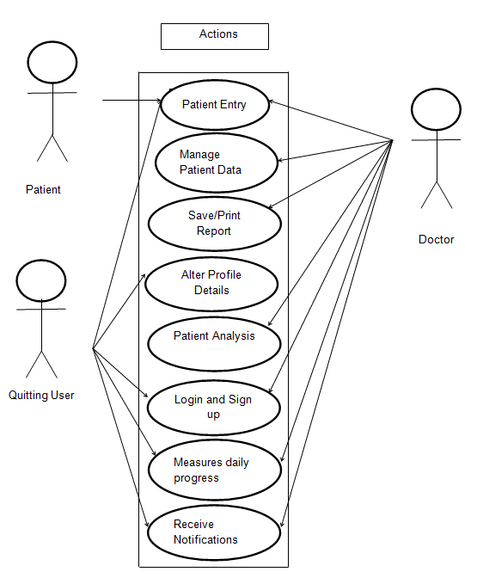

3.3 Activity Diagram

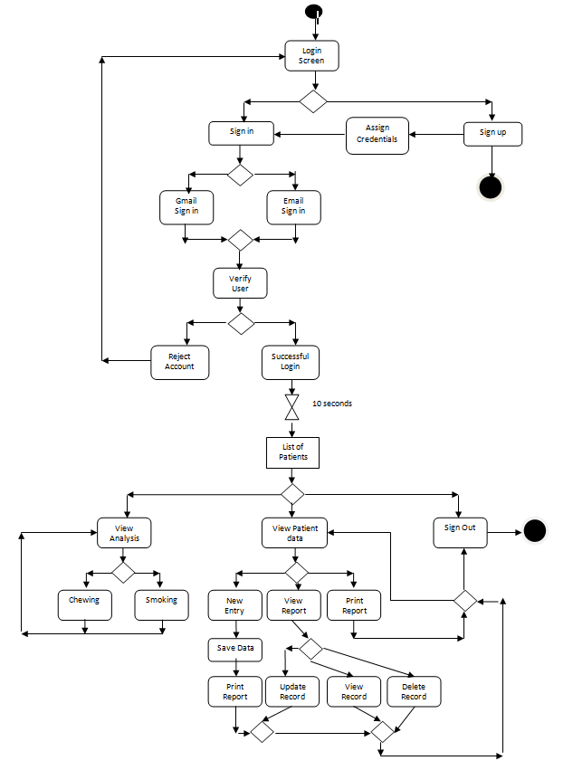

Chapter 4 - Proposed Work

First Phase

Our project focuses on a very general society issue that is tobacco intake and it harms and motivate people to quit this habit hence the name Quit It .Our app is divided into two phases where the first phase is for doctors who have lots of patients who come to their clinic regarding this problem and want to be free from such habits. Maintaining such enormous data and its analysis for doctors is a major task so our app helps such doctors to collect patient data which reduces queue and also helps doctors to maintain patient data and can talk to them personally .The patient can also fill the form from home as our app can be distributed to everyone and he can directly contact a doctor or visit him without having to enter his details on a paper in the clinic which saves time. Also meeting can be arranged with the doctor through our app. Our app also helps the doctors to view the patients list and also conduct study and analysis on the data. The study can be conducted through interactive charts which are formed based on the data from the database. The doctor can also search the list of patients according to the name. He can delete update or create patients data. The doctor can see details of all patients that have visited their clinic but the patient can only view his details. The details of the patient can be sent to him through mail or other features depending on the doctor and our app also generates a personalized message for the patient which can be edited by the doctor and can be sent to the patient via mail, whatsapp or message(inclusive of normal message cost). Our app also allows the doctor to generate a report just by a click of a button which is downloaded in pdf format and can be printed or mailed to the user depending upon the doctor or patients preference.

Second Phase

The second phase of our app focuses on patients who want to quit smoking and based on their data helps them to quit smoking. This quit smoking is a broad term and contains various forms and features. Like presenting daily missions to the user and motivating them to complete them by giving them some rewards. Also providing them data to read or some games which can distract their mind on the basis of their interest during their craving time. An alert could be sent to the users mobile at the time of craving which will help them to resist their craving. Also we can provide them with regular incidents and videos of how tobacco affects their life. We can notify them about their health status progress since they have joined the app. The money they have saved and also of their increased life expectancy. We can also make a small community where users of our app can discuss with each others their daily problems and difficulties faced and get motivated. Our app can take pictures of the user and notify them of the wrinkles and other problems that they can get if they continue their habit. Our app needs to be extended in Hindi so that it can be used in rural areas where this problem is too much. The app has lots of scope for future purposes all of which cannot be discussed.

Implementation

Ours is Android based project and uses firebase as the database which is free storage up to 15 GB and is a free product by Google. The app starts with a login page where you can login or signup as a patient or as a doctor. Based upon the user credentials you will see the details of all the patients if you are a doctor. The patients along with their image if any will be fetched from firebase as soon as the doctor sign in. We have made use of firebase database reference to access the objects from firebase real-time database and firebase storage reference to fetch images from firebase storage and link them to each patient. The image is provided by patient at time of filling his details which he can provide from gallery or take a selfie .Once he provide the image we will process the image to detect his face and remove the unnecessary background so that we can process it further .A folder is created where image is stored and the path of image is linked to patients other data. The user can search the patients based on the names. We also have a side drawer for navigation like analysis on various aspects such as age, gender, state etc. MP-Charts have been used for chart-making. The doctor can also print the report .Our app generates a report which is nothing but a canvas drawing which is seen in pdf format. The message in the report is in points form for readability. The doctor can send a message generated through our app and edit the message accordingly the send button passes an implicit intent to other apps and prompts the user to choose one. The message is generated through a if-else ladder. All the data is handled in an entry activity and data to other activities is send as a parcel. Also crud operations are handled using firebase objects and user sign in is handled by firebase-auth. The data entered by the user is packed in an object of entry type and sent to firebase database. Firebase also allows us to sync the data at real time so if it changes somewhere the changes will be reflected at each part.

Chapter 5 - Implementation/Results

Features With Screenshots

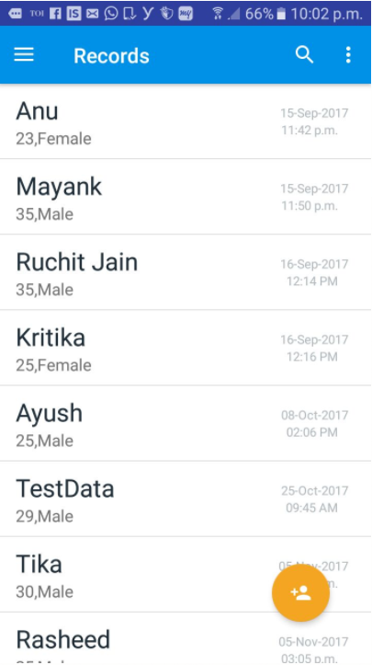

Fig 5.1 List Of Patients

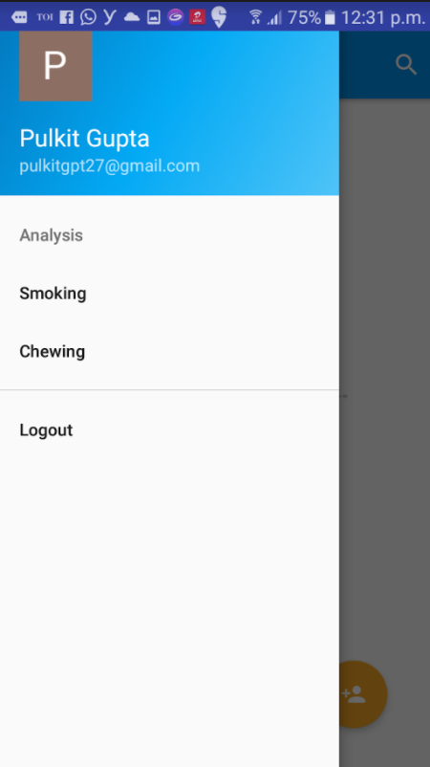

Fig 5.2 Navigation through drawer

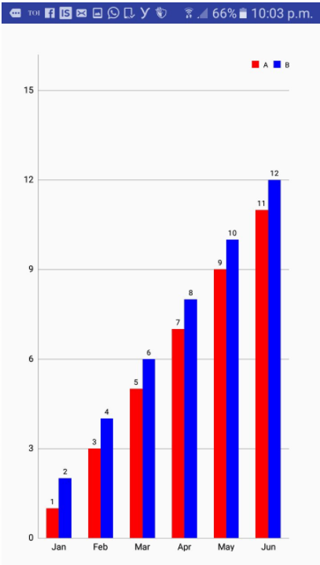

Fig 5.3 Monthly Analysis

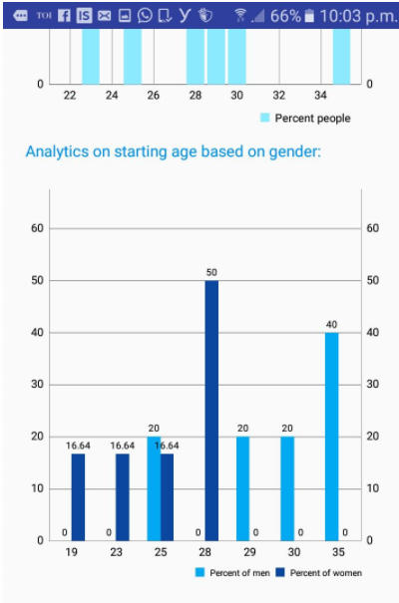

Fig 5.4 Gender Analysis

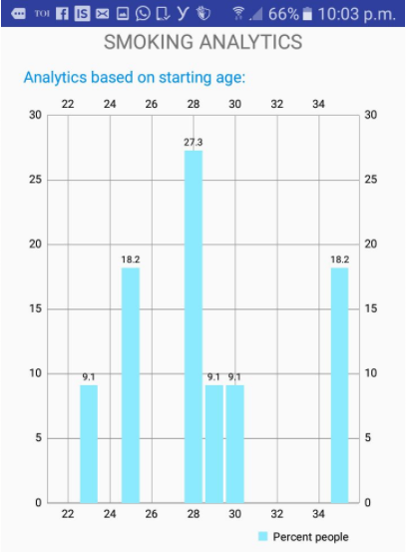

Fig5.5 Analysis On Starting Age

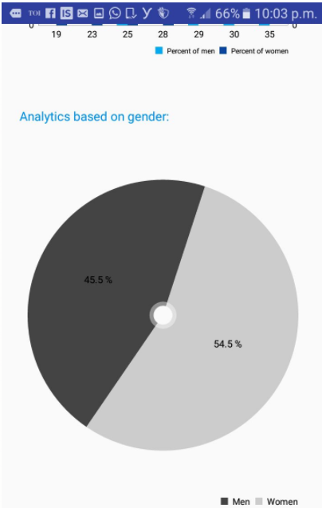

Fig 5.6 Pie Chart For Gender Anlaysis

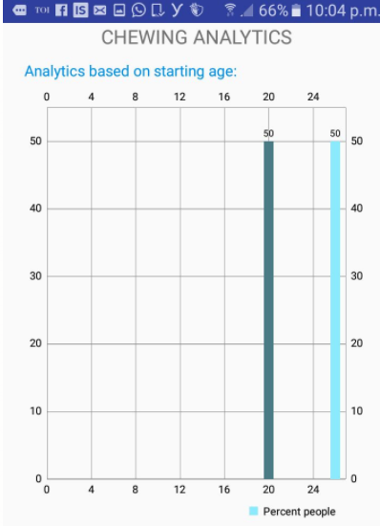

Fig 5.7 Bar chart for starting age in chewing analysis

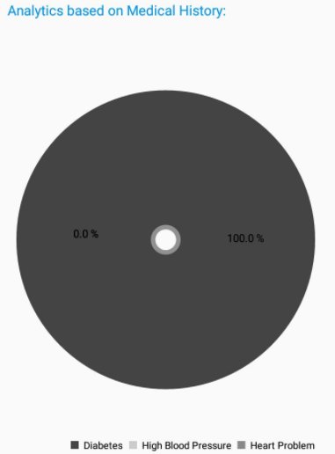

Fig 5.8 Pie Chart For Medical History

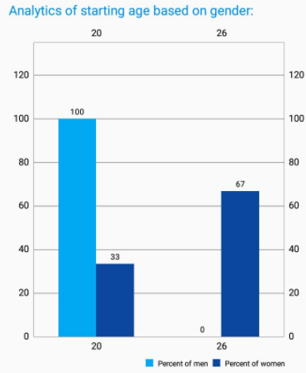

Fig 5.9 Bar chart for Starting age for chewing analysis

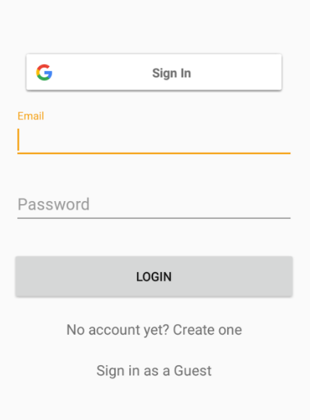

Fig 5.10 Login Page

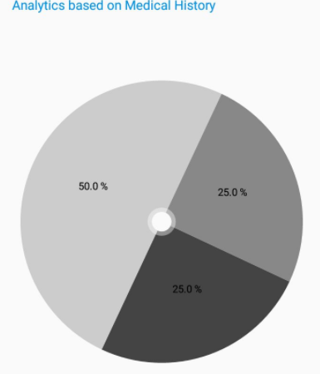

Fig 5.11 Medical History for Chewing analysis

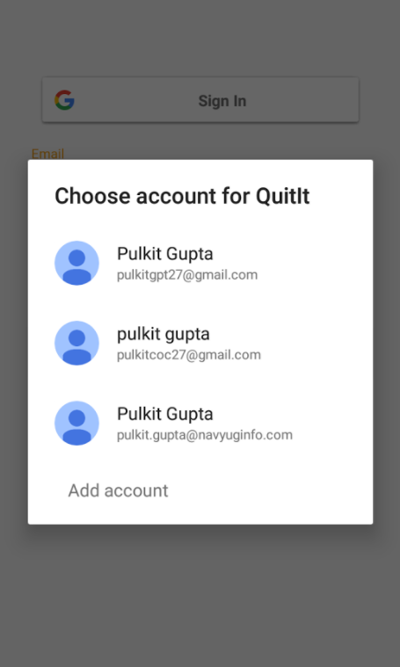

Fig 5.12 Google Sign In

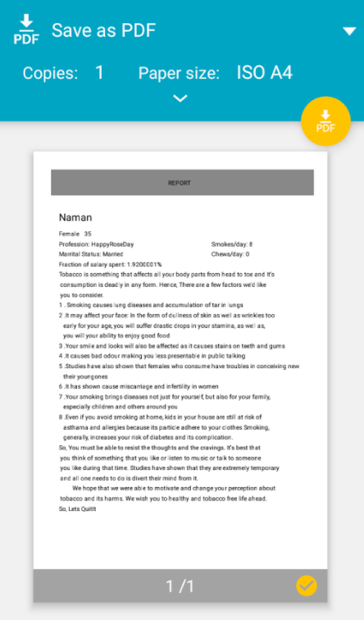

Fig 5.13 Report Generated As Pdf

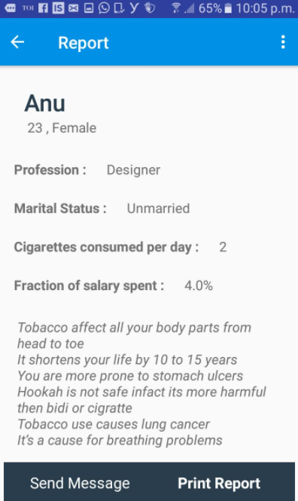

Fig 5.14 Details Of A Patient

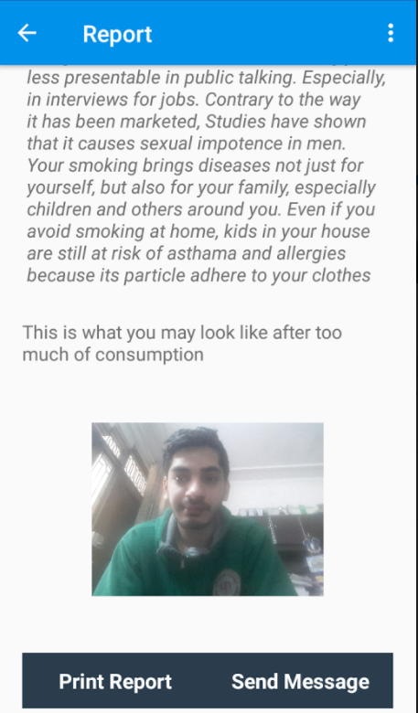

Fig 5.15 Simple Sign In Page

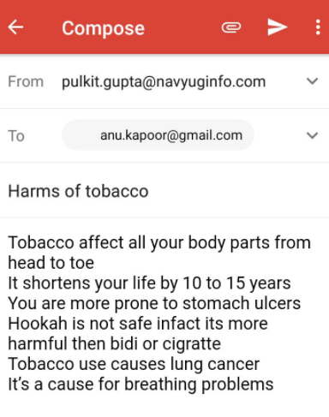

Fig 5.16 Sending Mail To Patient

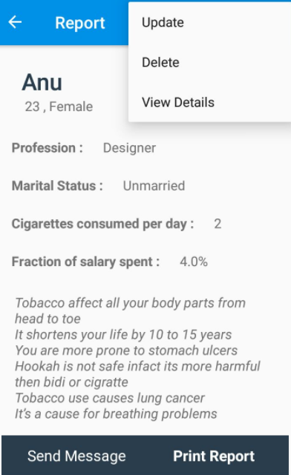

Fig 5.17 Crud Operation on Patient

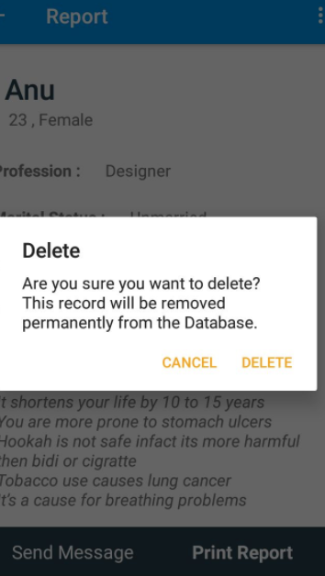

Fig 5.18 Delete Operation For Patient

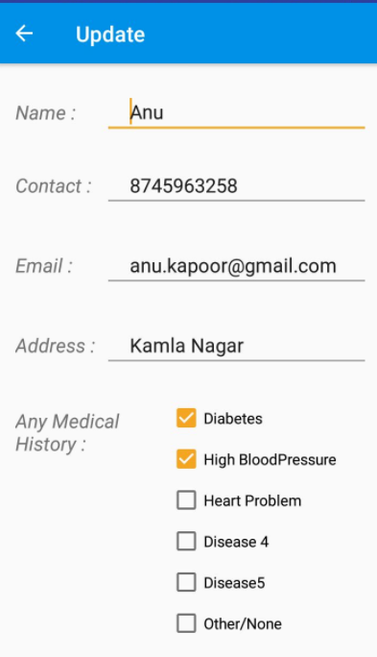

Fig 5.19 Update For A Patient

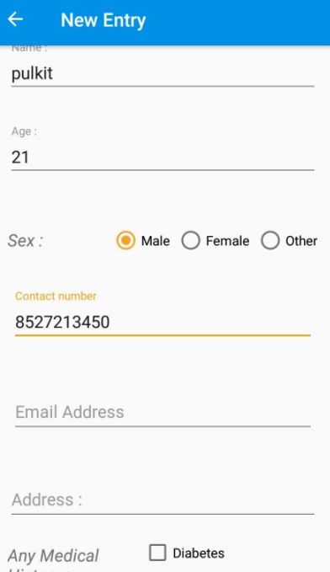

Fig 5.20 New Entry

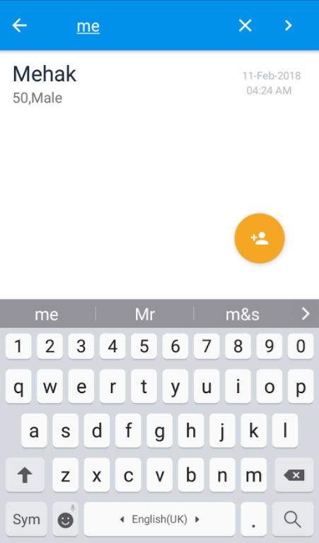

Fig 5.21 Search Operation

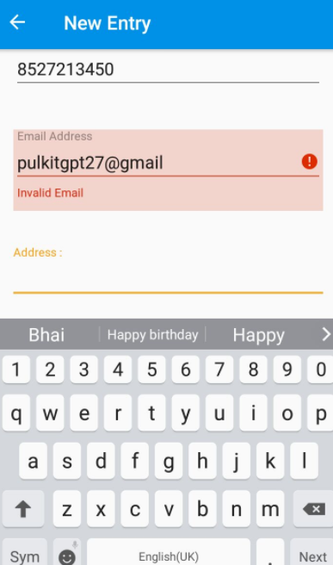

Fig 5.22 Validations On Entry

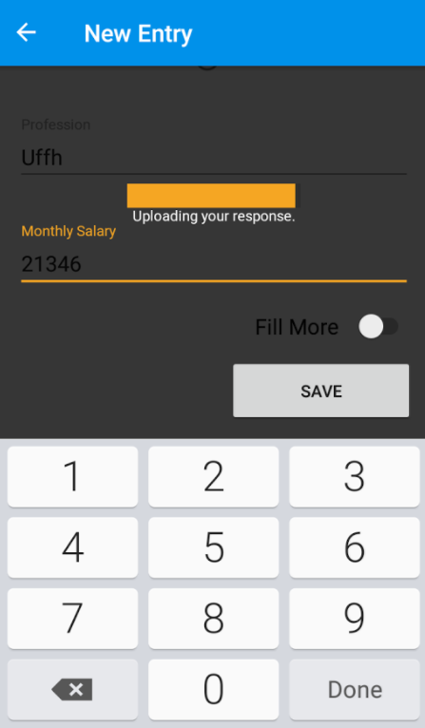

Fig 5.23 Saving Your Data to Database

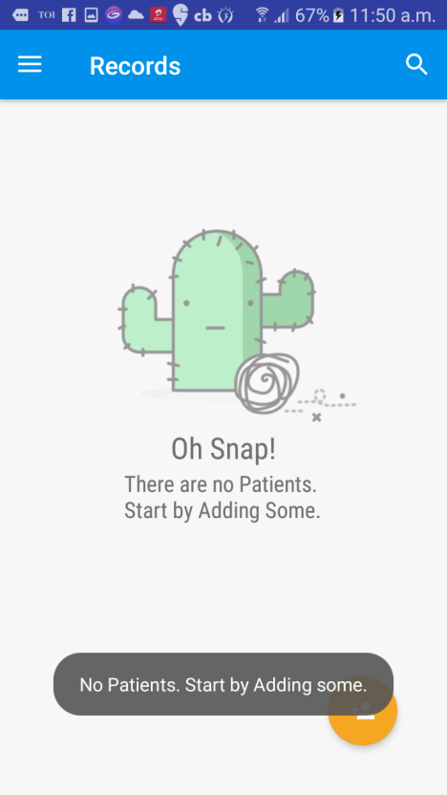

Fig 5.24 If No Patients Are Present



Fig 5.25 Fetching Data Of Patients

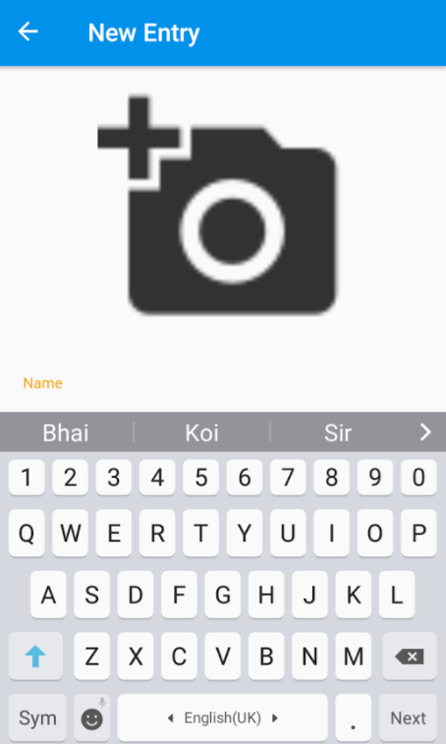

Fig 5.26 Adding Image Of Patient

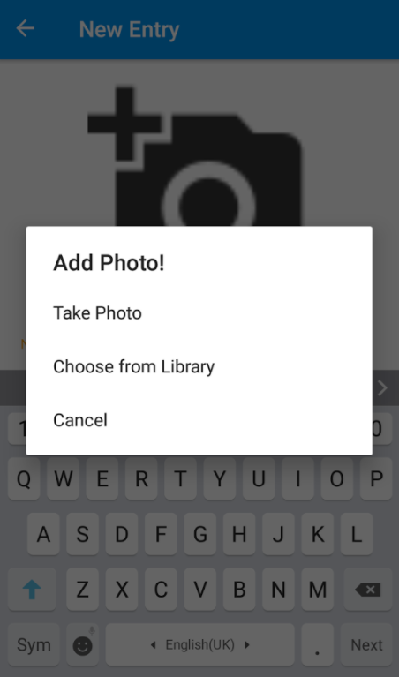

Fig 5.27 Options For Adding Image Of Patient

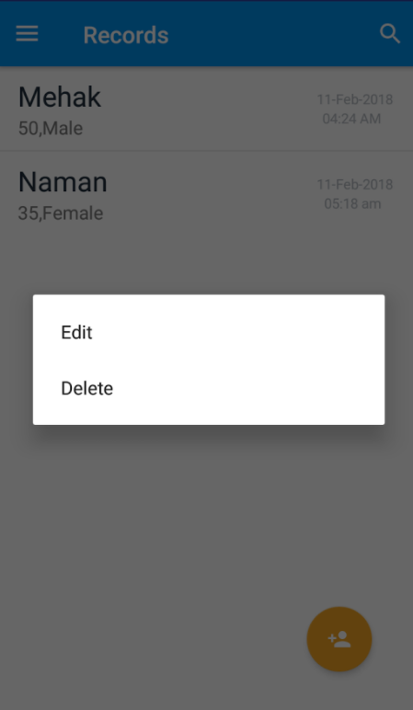

Fig 5.28 Edit Delete Operations Through Long Press

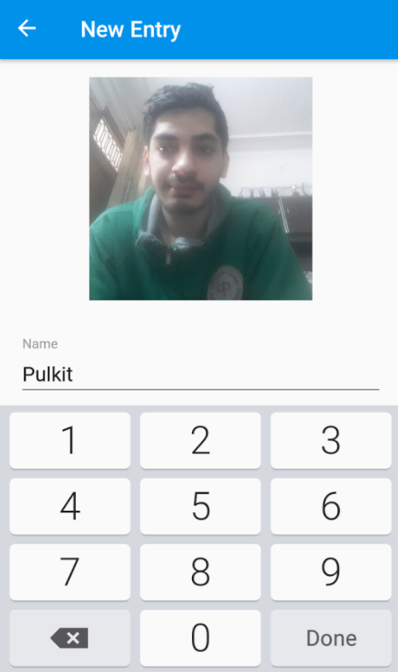

Fig 5.29 Processed Image Of Patient

Database With Screenshots

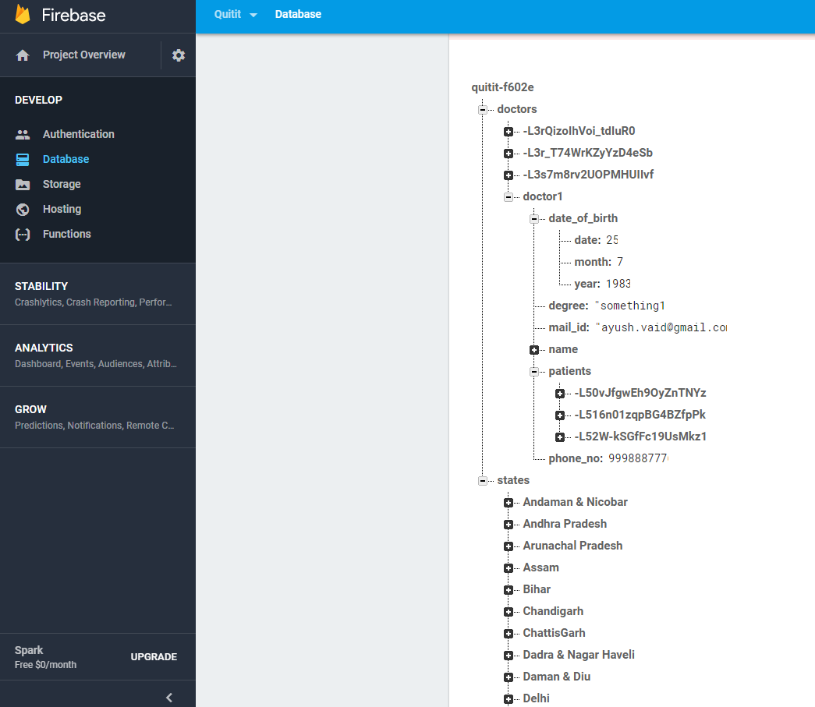

Fig 5.30 Doctors and Patients Database

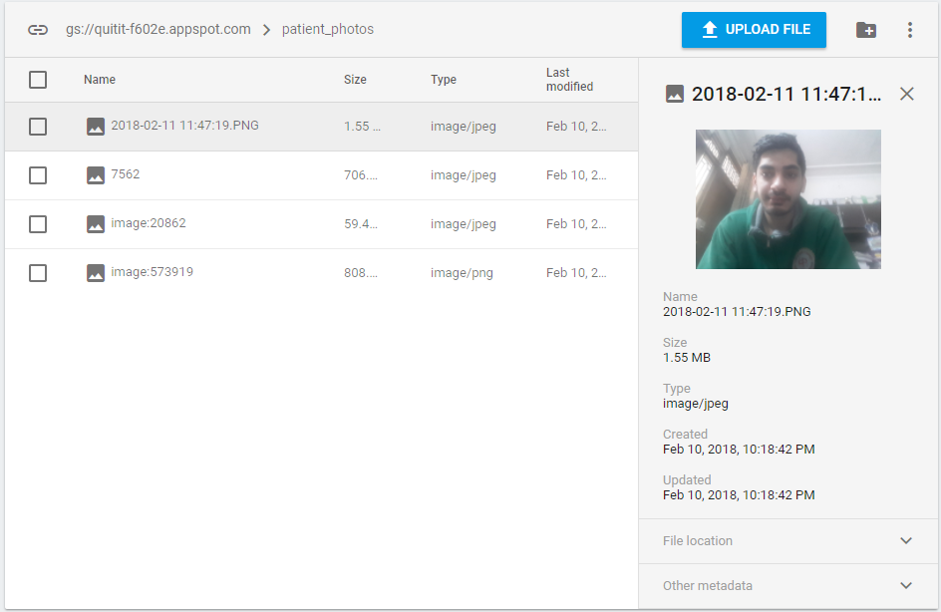

Fig 5.31 Patients Image Database

Chapter 6 : Conclusion

We all know that smoking is injurious or bad for health. Yet, young men and women are found puffing a cigarette and throwing out smoke at the company in which they are. Young people first begin smoking or chewing to get fun out of it. There is a curiosity among young adult and teenagers about the taste of a cigarette. Then, the gun takes the shape of a showmanship and in due course of time they find that they have got addicted to smoking and cannot give it up.

As the number of smokers are increasing day by day so as its life threatening effects like lung cancer, heart attacks etc. People know it, still they go on with it.  The habit of smoking, once formed is hard to be given up. This application involves various features which makes the process of quitting a simple step by step procedure. It motivates you to your core which eventually forces the people to quit.

This application is broadly divides into two phases. First phase concentrates on data storage. Doctors or other researchers can use this application to store their huge volumes of data efficiently. They can use this application to take concerned information from smoking or chewing patients as entry form covers all the relevant information. Also they can use the analytics functionality to view the various trends like age wise, gender wise, medical history wise etc. They can use these valuable trends to take appropriate measures. They can print the reports of patients or can save it for later considerations. The printing report consists of the most important feature of personalized message for the patient that targets the immediate effects of this habit motivating him/her to quit. Second phase of the application is majorly concentrated on motivating the user to quit the habit of smoking or chewing. It involves various measures like user is shown movies, or can listen music or can play some small game, whatever he/she is fond at the time when the craving is at its peak.

Overall this application consists of various features and can be a milestone in eradicating this society threatening habit of smoking and chewing.

## Chapter 7 – Future Work

Quit It has begun its second phase. The phase where it can be used to help out user quit their habit of consumption of tobacco. There, the user shall enter his details that may include, but are not restricted to, their consumption details, their personal information and their interests. Quit It shall include the features to measure user’s daily intake, Reduction or increase in their habit, Timing, mental state as well as physical state as of when they usually consume or when they get a craving for one. All this data will then be used by our app to help the user in their quest for quitting their addiction. The face processing part has started so that we can pictorially motivate the user what side effects it will have on his/her body .We are planning to start the part where he will get daily missions and notifications.

# References

1. <https://en.wikipedia.org/wiki/Smoking_in_India>
2. <http://timesofindia.indiatimes.com/city/nagpur/tobacco-use-causes-1-death-every-6-seconds/articleshow/58914675.cms>
3. <http://www.thehindubusinessline.com/news/science/smoking-causes-over-11-deaths-india-among-top-4-countries-report/articl9618981.ece>
4. http://www.tiionline.org/facts-sheets/tobacco-consumption/