Chapter 1

Introduction

Smoking in India has been known since at least 2000 BC when cannabis was smoked and is first mentioned in the *Atharvaveda*, which dates back a few hundred years BC. Fumigation and fire offerings are prescribed in the Ayurveda for medical purposes and have been practiced for at least 3,000 years while smoking, *dhumapana*(literally "drinking smoke"), has been practiced for at least 2,000 years. Tobacco was introduced to India in the 17th century. It later merged with existing practices of smoking (mostly of cannabis).There are approximately 120 million smokers in India.According to the World Health Organization (WHO), India is home to 12% of the world’s smokers. Approximately 900,000 people die every year in India due to smoking as of 2009. As of 2015, the number of men smoking tobacco in rose to 108 million, an increase of 36%, between 1998 and 2015 [1].

About 6 million people die of tobacco use globally every year and India accounts for 1/6th of the total deaths. Tobacco use has assumed epidemic proportions and kills more people than tuberculosis, accidents, homicides, suicide, AIDS and malaria combined.Deputy Director, RST Regional Cancer Hospital, Dr. B K Sharma, says that this figure is estimated to grow to more than 8 million a year by 2030.An Indian Council of Medical Research (ICMR) report says that use of tobacco accounts for about 30% of all cancers in men and women in India. Cancer of mouth is most common among men followed by lung cancer. Tobacco related cancer accounts for 42% of the male deaths and 18.3% of female cancer deaths [2].

With this increasing consumption of smoking and tobacco the diseases associated with these are also on an increase. So steps are required to control these product’s consumption. Our app keeps record of the people consuming such products. It stores all their details like their name, age, address, age when they start consuming, per day consumption, salary, type of products they consume etc. Then the data is analyzed graphically depending on patient’s starting age, gender, literacy etc. Also a report with a personalized message is generated for the user. The message is generated depending on the details provided by the user like salary, profession, per day consumption etc.

Chapter 2

Related Work

As the smoking and chewing habits are increasing day by day so the applications that motivates to quit smoking and chewing are need of an hour. Even though there are multiple applications available but still they all lack in some aspect or another

The existing applications require higher android versions or hardware but our application works on the basic android versions and on simple smart phones, with no special features or hardware required. Also these existing applications are very time consuming and uses processes that are not efficient, leading to poor performances and excessive use of resources, thus making the system slow. Most important all these existing apps focuses on letting the user quit but uses the words smoking and chewing or related content again and again, which reminds the user of this habit so instead of making him/her quit, to some extent it forces the user to smoke or chew again. We have given a special attention on this aspect and had minimized the use of such content to almost negligible.

Our application also focuses on doctors or experts who help their patients to quit. They can store there large volumes of data on our application and can view various trends in our analytics section. These trends than can be used to take valuable steps against smoking and chewing.

Moreover the existing applications did not provide any special features which can help the user to divert his/her time when the craving is at its peak. We have also kept this aspect in our mind while developing this application and have offered features that are really helpful like playing music if the user is fond of music or offering an interesting game to play, or playing movies etc. Also our app focuses on pictorial presentations for motivating like taking photo of image and then applying wrinkles on face making them conscious of their physical appearance.

Moreover our application generates a personal message for each user that targets the certain immediate effects of such habits like if an individual is a student so the message would contain, how smoking and chewing will effect his/her carrier, professional life etc. These messages strike the user the most and strongly motivate him/her to quit these habits.

Chapter 3

System Analysis and Design

System Analysis is a process of collecting and interpreting facts, identifying the problems, and decomposition of a system into its components. System Design is a process of planning a new business system or replacing an existing system by defining its components or modules to satisfy the specific requirements.

Organization

Organization implies structure and order. It is the arrangement of components that helps to achieve predetermined objectives. Our application is simply structured into various simple modules like new entry, printing, analytics, viewing etc.

### Interaction

It is defined by the manner in which the components operate with each other. The modules in our application are less coupled leading to only necessary inter modular interaction. Like whenever a new patient record is entered a notification is sent to the admin which is necessary to avoid irrelevant or inaccurate data.

### Interdependence

Interdependence means how the components of a system depend on one another. For proper functioning, the components in application are coordinated and linked together according to a specified plan. The output of one subsystem is the required by other subsystem as input and this has been properly implemented.

### Integration

Integration is concerned with how a system components are connected together. It means that the parts of the system work together within the system even if each part performs a unique function. The modules in this application are highly integrated leading to an effective functioning of the application.

### Central Objective

The objective of system must be central. It may be real or stated. It is not uncommon for an organization to state an objective and operate to achieve another. The main motive of our application is to store huge bulk of data efficiently and to motivate the user to quit the smoking or chewing. In context of our project, the existing quitting applications had many shortcomings. All these existing apps focuses on letting the user quit but uses the words smoking and chewing or related content again and again, which reminds the user of this habit again and again so instead of making him/her quit to some extent it force the user to smoke or chew again.

3.1Software Requirement Specifications

3.1.1 System Requirement for running on Computer using emulator

Processor: Intel I3 or above with clock speed 3.0 GHz or more

Ram Size: 3 GB or more

Hard disk capacity: 50GB

3.1.2 Software Requirements for running on computer

IDE – Android Studio 2.0 or above

Emulator – Screen Size at least 1080*720

3.1.3 Hardware Requirements for running on mobile

Ram Size: 512 MB

Free Hard disk Space: 100MB

3.1.4 Software Requirements for running on mobile

OS: Android

SDK Version: 19 or above

3.1.5 Database Used

Firebase Real Time Database

Fire-Base Storage

3.1.6 Library for Charts

MP-Android-Charts

3.1.7 Connectivity Requirements

Internet Connection-128kbps or above

3.2Use Case Diagram

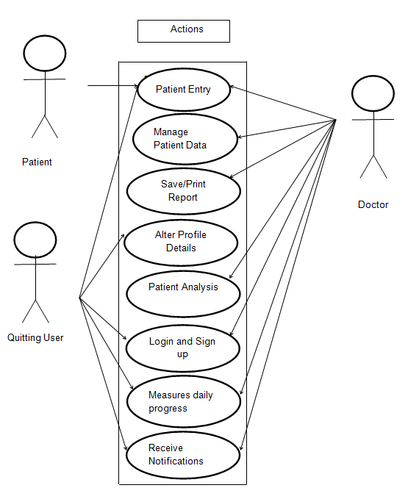

Fig 3.1Use Case Diagram Showing Interaction of Various Actors and Use Cases in our System.

3.3 Activity Diagram For Doctors

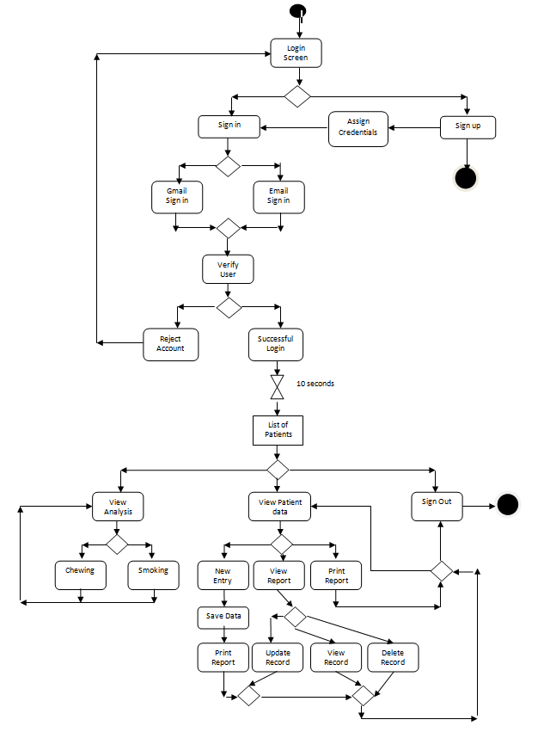

Fig 3.2 Activity Diagram for User Doctor

3.4Activity Diagram For Patients

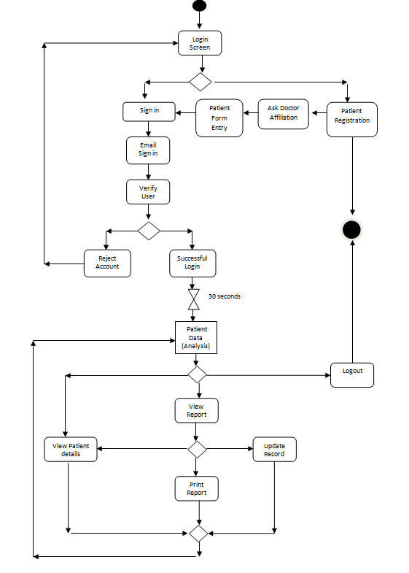

Fig 3.3 Activity Diagram for User Patient

Chapter 4

Proposed Work

4.1First Phase

Our project focuses on a very general society issue that is tobacco intake and it harms and motivate people to quit this habit hence the name Quit It .Our app is divided into two phases where the first phase is for doctors who have lots of patients who come to their clinic regarding this problem and want to be free from such habits. Maintaining such enormous data and its analysis for doctors is a major task so our app helps such doctors to collect patient data which reduces queue and also helps doctors to maintain patient data and can talk to them personally .The patient can also fill the form from home as our app can be distributed to everyone and he can directly contact a doctor or visit him without having to enter his details on a paper in the clinic which saves time. Also meeting can be arranged with the doctor through our app. Our app also helps the doctors to view the patients list and also conduct study and analysis on the data. The study can be conducted through interactive charts which are formed based on the data from the database. The doctor can also search the list of patients according to the name. He can delete update or create patients data. The doctor can see details of all patients that have visited their clinic but the patient can only view his details. The details of the patient can be sent to him through mail or other features depending on the doctor and our app also generates a personalized message for the patient which can be edited by the doctor and can be sent to the patient via mail, whatsapp or message(inclusive of normal message cost). Our app also allows the doctor to generate a report just by a click of a button which is downloaded in pdf format and can be printed or mailed to the user depending upon the doctor or patients preference.

4.2 Second Phase

The second phase of our app focuses on patients who want to quit smoking and based on their data helps them to quit smoking. This quit smoking is a broad term and contains various forms and features. Like presenting daily missions to the user and motivating them to complete them by giving them some rewards. Also providing them data to read or some games which can distract their mind on the basis of their interest during their craving time. An alert could be sent to the users mobile at the time of craving which will help them to resist their craving. Also we can provide them with regular incidents and videos of how tobacco affects their life. We can notify them about their health status progress since they have joined the app. The money they have saved and also of their increased life expectancy. We can also make a small community where users of our app can discuss with each others their daily problems and difficulties faced and get motivated. Our app can take pictures of the user and notify them of the wrinkles and other problems that they can get if they continue their habit. Our app needs to be extended in Hindi so that it can be used in rural areas where this problem is too much. The app has lots of scope for future purposes all of which cannot be discussed.

4.3 Implementation

Ours is Android based project and uses firebase as the database which is free storage up to 15 GB and is a free product by Google. The app starts with a login page where you can login or signup as a patient or as a doctor. Based upon the user credentials you will see the details of all the patients if you are a doctor. The patients along with their image if any will be fetched from firebase as soon as the doctor sign in. We have made use of firebasedatabase reference to access the objects from firebase real-time database and firebase storage reference to fetch images from firebase storage and link them to each patient. The image is provided by patient at time of filling his details which he can provide from gallery or take a selfie .Once he provide the image we will process the image to detect his face and remove the unnecessary background so that we can process it further .A folder is created where image is stored and the path of image is linked to patients other data. The user can search the patients based on the names. We also have a side drawer for navigation like analysis on various aspects such as age, gender, state etc. MP-Charts have been used for chart-making. The doctor can also print the report .Our app generates a report which is nothing but a canvas drawing which is seen in pdf format. The message in the report is in points form for readability. The doctor can send a message generated through our app and edit the message accordingly the send button passes an implicit intent to other apps and prompts the user to choose one. The message is generated through a if-else ladder. All the data is handled in an entry activity and data to other activities is send as a parcel. Also crud operations are handled using firebase objects and user sign in is handled by firebase-auth. The data entered by the user is packed in an object of entry type and sent to firebase database. Firebase also allows us to sync the data at real time so if it changes somewhere the changes will be reflected at each part.

Chapter 5

Implementation/Results

5.1Login-Activity

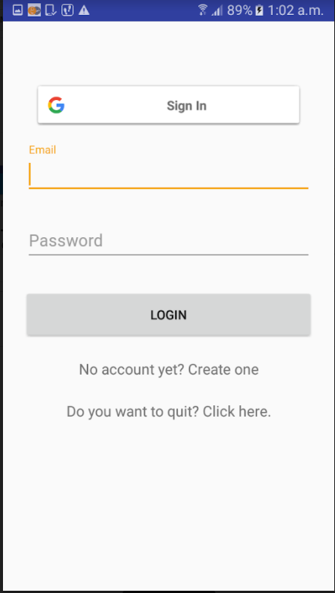

Fig 5.1 Login Page

This activity is first activity which the user encounters. The user may be the Doctor handling patients or the patient itself wanting to quit. Gmail sign in allows the doctors to directly sign in and create their account. However, the quitting user cannot use that to create an account. He or She must click on “Do you want to quit?” in order to get registered with our application.

* 1. Doctor home no patients

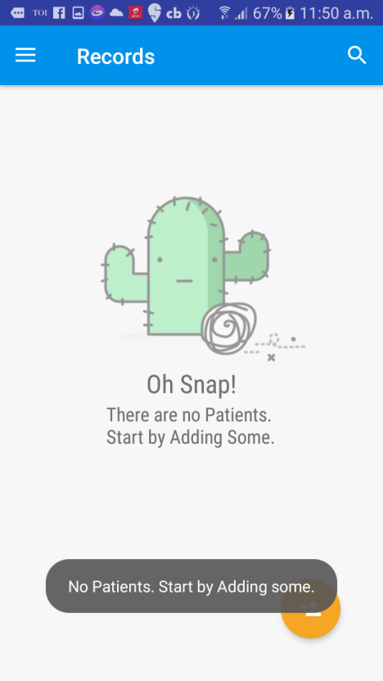

Fig 5.2Doctor Home If No Patients Are Present

This is what the Doctor User will see when they register with the application for the first time or when they do not have any patients associated with them. The doctor can add new patients by clicking on that Floating-Action-Button. It will lead the Doctors to New-Entry-Activity

* 1. Doctor home with patients

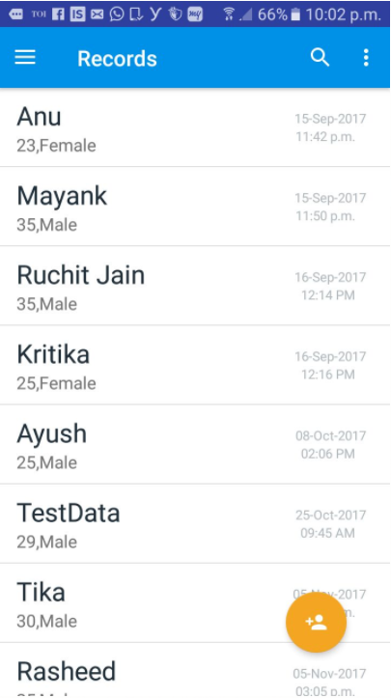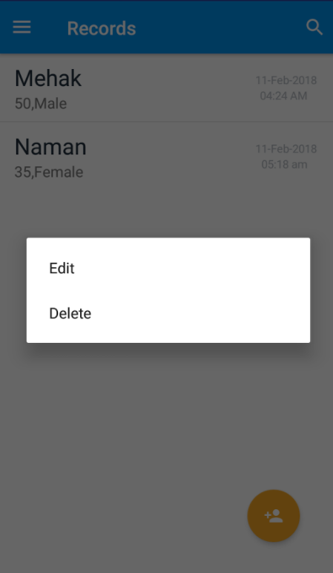

Fig 5.3List Of Patients Fig 5.4Edit Delete Operations Through Long Press

This is the activity is basically the home doctor. Here we display all the patients. Doctors can search through the list of patients. These entries are clickable. A click on them will lead us Report-Activity. These entries are sorted by the date-time they were entered.

* 1. Navigation Drawer

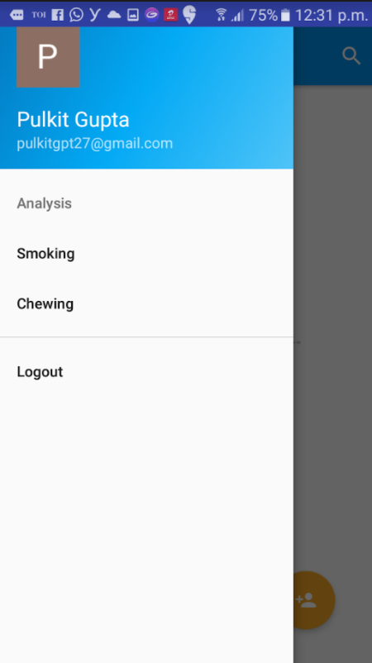

Fig 5.5Navigation drawer

This is the Navigation Drawer of our application. It is associated primarily with the Home-Screen. It lets the doctor to navigate to analysis activities. And also allows the doctor to logout of their account.

* 1. Smoking Analysis.

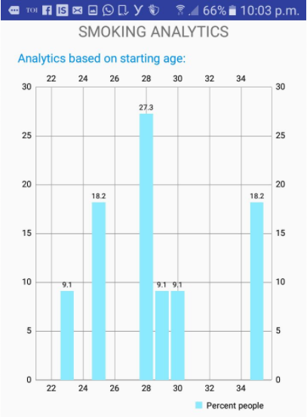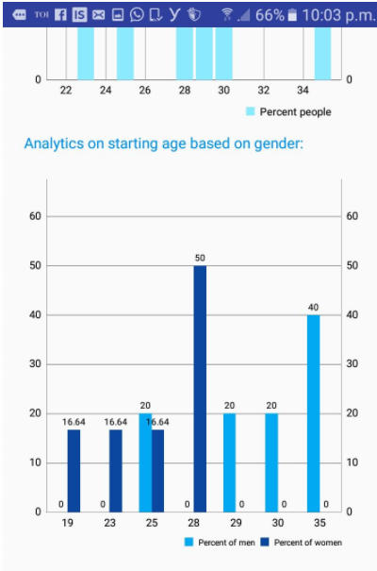

Fig5.6 Analysis On Starting Age Fig 5.7 Gender Analysis

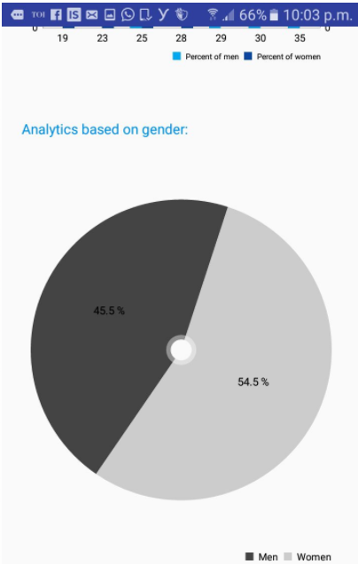

Fig 5.8 Pie Chart For Gender Analysis

This activity allows the doctor to analyse the type of patients who smoke he or she is attending. The analysis is done on the basis Gender, Starting age and a combination of both. This way the doctor is able to guide them more appropriately and figure out better ways to sympathise with his or her patients.

* 1. Chewing Analysis

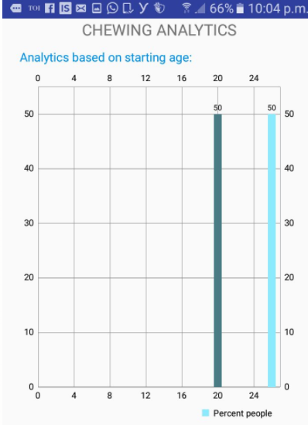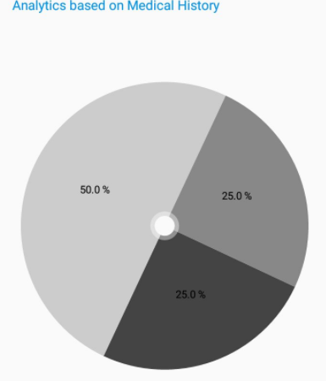

Fig 5.9 Bar chart for starting age Fig 5.10 Pie Chart For Medical History

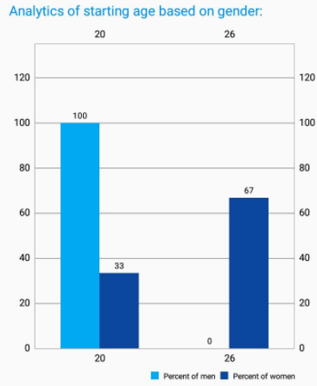

Fig 5.11 Medical History for Chewing analysis

This is similar to Smoking Analysis. The only difference being that here we take the chewers

* 1. Report Activity

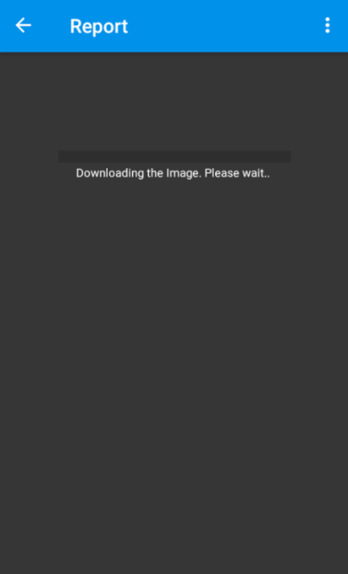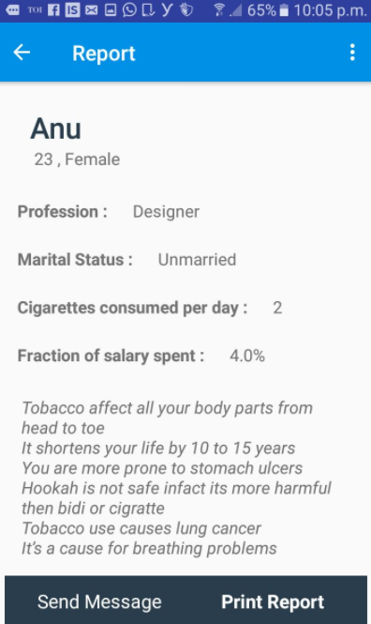

Fig 5.12 Fetching Data Of Patient Fig 5.13 Details Of A Patient

This is the activity that gets loaded the doctor clicks on one of the patients. The patient’s data gets loaded on the screen from the firebase real-time database and the image, if present, is loaded from firebase storage. There is progress bar that shows how much of the report has been loaded. It houses options like “Send Message” which will let you mail the personalised message to the patient, “Print report” which will load the Print-Adapter. This print adapter will help us save the report as well as send it to printer to print.

5.8Report-Activity with photo set.

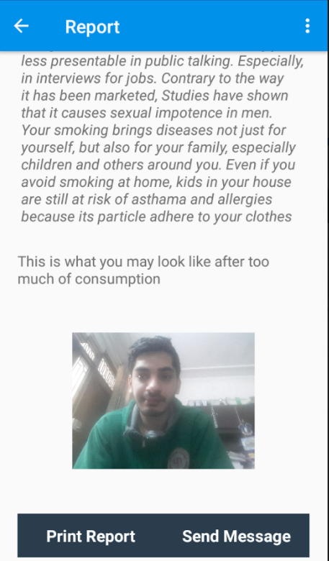

Fig 5.14Report activity with photo set.

This photo was set in the New-Entry-Activity when the patient or the user clicked on the camera icon. In this photo, face is detected and future work includes addition of wrinkles and marks with stains in order to show the patient what they may look like after prolonged consumption of tobacco.

5.9Deletion, Updating and Viewing of the form that Patient Filled.

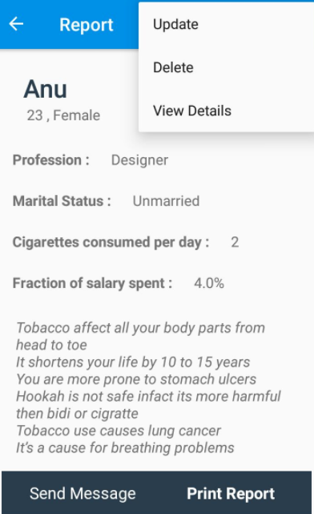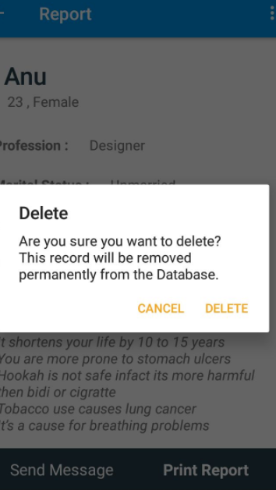

Fig 5.15 Delete Operation For PatientFig 5.16 Crud Operation on Patient

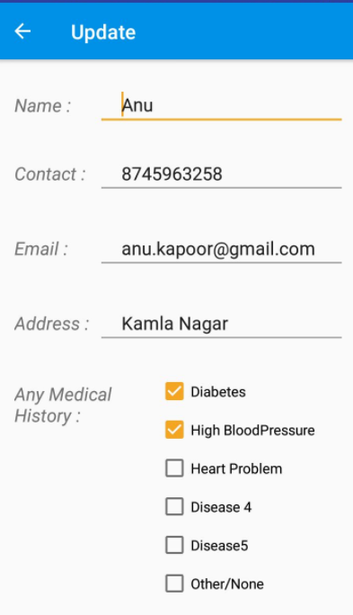

Fig 5.17 Update For A Patient

These options will let the doctor delete the patient’s entry in their records. They may update it or simply view the data that was filled by patient. .

* 1. Print-Adapter-Activity

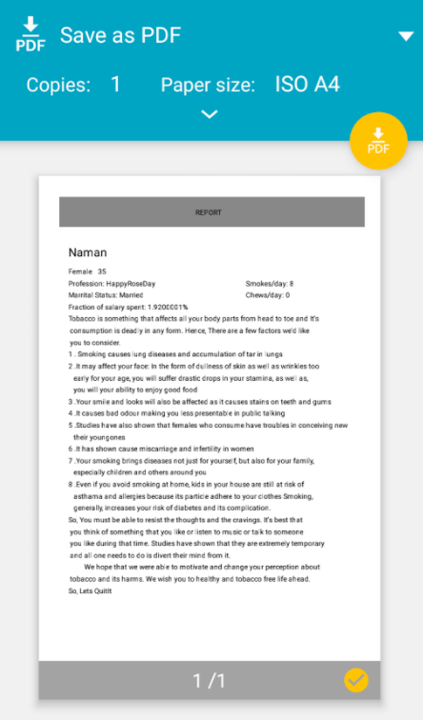

Fig 5.18 Report Generated.

This activity Is loaded when Doctor click on the “Print report” button in Report-Activity. This Activity enables the Doctor to generate the report as PDF. He or She can now save this report and send it afterward via any medium the user finds convenient. Also, that PDF file can be directly printed by the app itself using a cloud or Wi-Fi enabled printer. This helps in providing a kind of hard evidence of patient’s entry. It primarily consists of the personalised message generated.

* 1. Intent to Gmail.

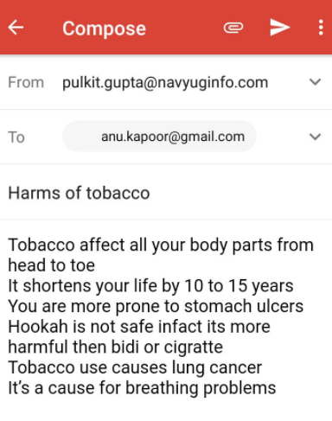

Fig 5.19 Sending Mail To Patient

This is loaded when the “Send Message” button is clicked on the Report-Activity.

* 1. Search-View

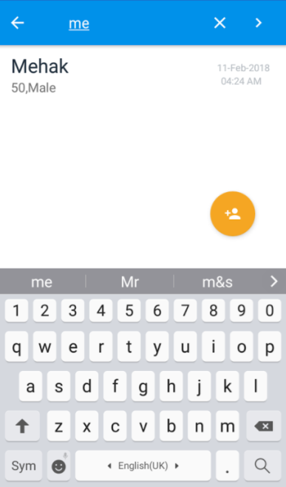

Fig 5.20 Search Operation

Doctors can search the patients that are associated/registered under them.

* 1. New-Entry-Activity

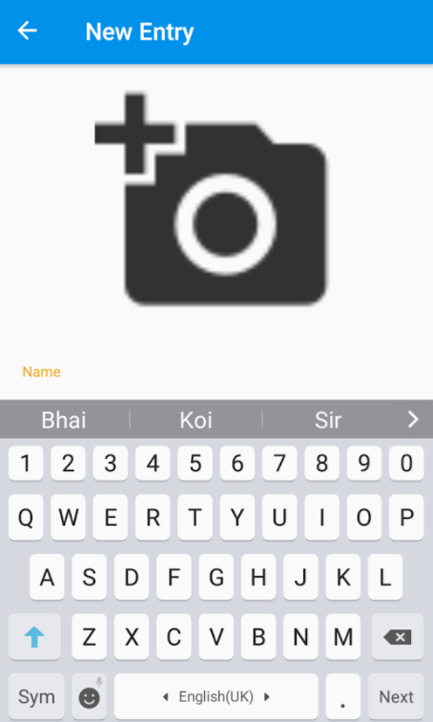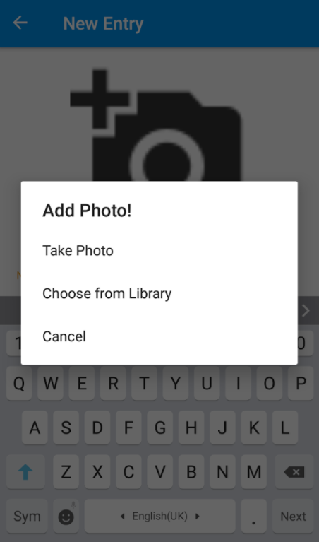

Fig 5.21 Options For Adding Image Of PatientFig 5.22 Adding Image Of Patient

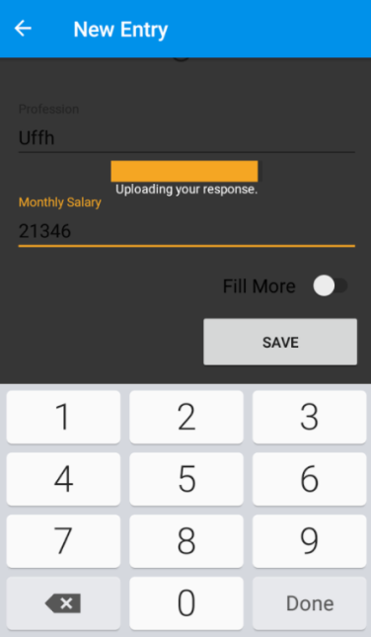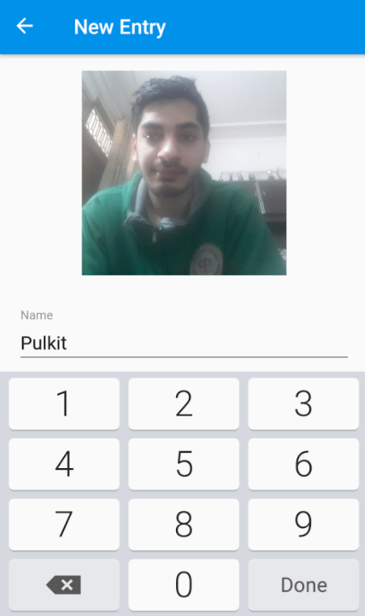

Fig 5.23 Saving Your Data to DatabaseFig 5.24 Processed Image Of Patient

New-Entry-Activity is the activity in which a Patient of Doctor can fill the form or a quitting patient will fill the form. This form is essential as it forms the basis of our entire data. We take every sort of information that includes but is not limited to: their frequency about the habit, the usual time on which the patient gets a craving, how they got introduced to this habit, have they been trying to quit it, does anyone else in their family that is habitual to tobacco consumption and many thing else. This activity pushed the entry’s textual information to firebase real time database and the image and other photo related data in firebase storage. We also ask for user permissions in this activity when we need to access the gallery or access the camera. This dynamic permission asking is dependent on the device on which the application is running. It works on devices that are running on Android Version 6.0.0 (Marshmallow) and above. It is however backward compatible that is our app will still have its permissions granted but now on the runtime.

* 1. Patient Registration

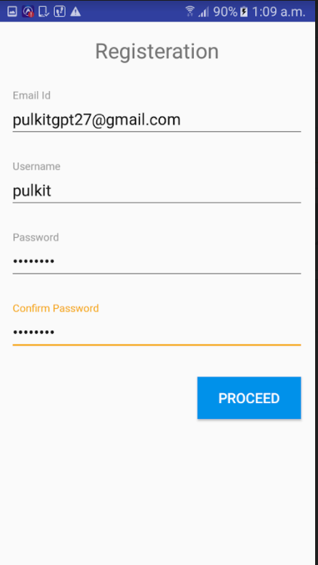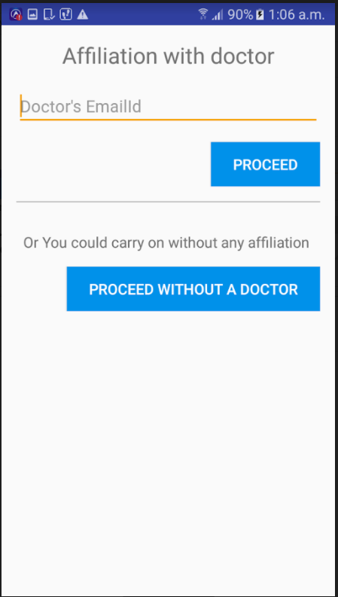

Fig 5.25 New Patient RegistrationFig 5.26 If patient is to affiliate to doctor

When a new patient is registered to our app the mail and password is verified and a user is created in firebase authentication .Once created we will check if data is already present in some doctor if found then he will go to patient home else we will ask if he wants to be affiliated to any doctor or not. If no then his data is not maintained by any doctor else he will provide doctor id and if present patients record can be seen by that doctor and he will fill his data as the next step.

* 1. Patient Home

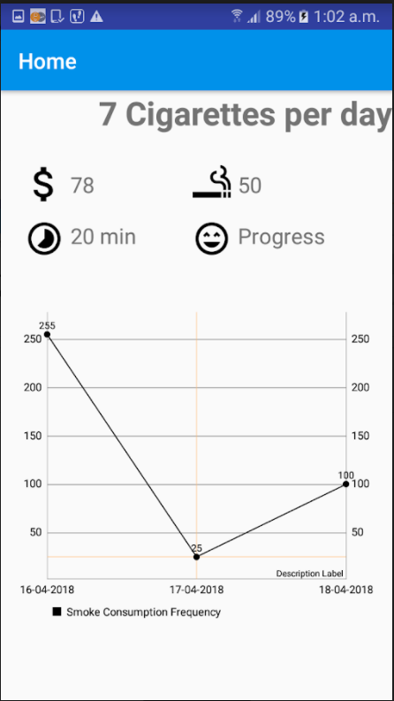

Fig 5.27 Patient Home

This is the personalized home of the patient where he can see his monthly and daily progress and track his progress also he can update his profile info and our app will generate a report for him that would contain a motivating message .His monthly expenditures and life that he has lost can be observed by him to make him aware of the harms.Each ciagarette cause a loss of 9 minutes of your life [5].

* 1. Updating through Notification

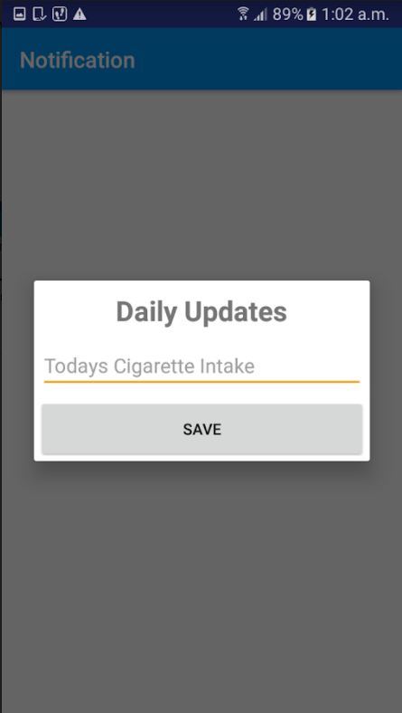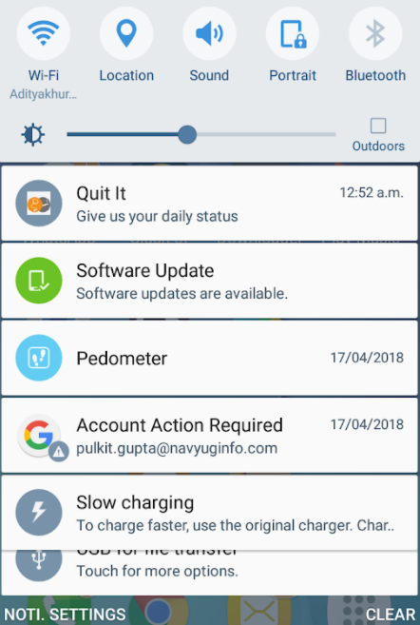

Fig 5.28Daily Update Fig 5.29 Daily Notifications

The user of the app will get daily notifications to update his data and he can update the data regularly so that his home becomes more informative. The permissions for notification is allowed by the user at runtime only once.

* 1. DatabaseScreenshots

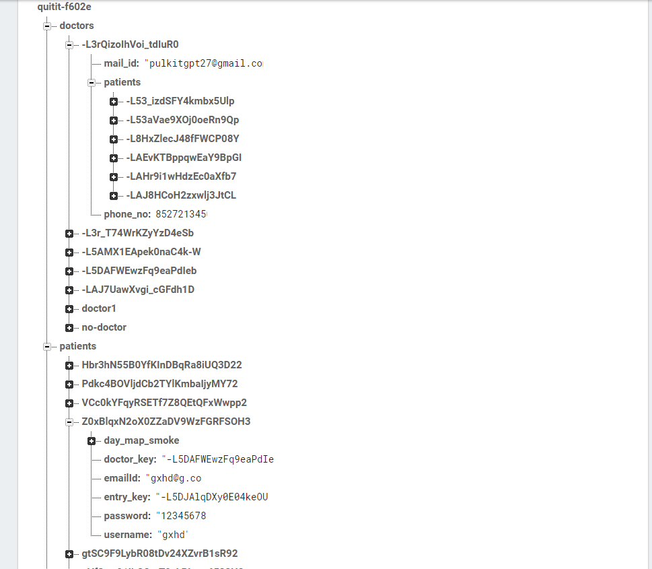

Fig 5.30 Doctors and Patients Database

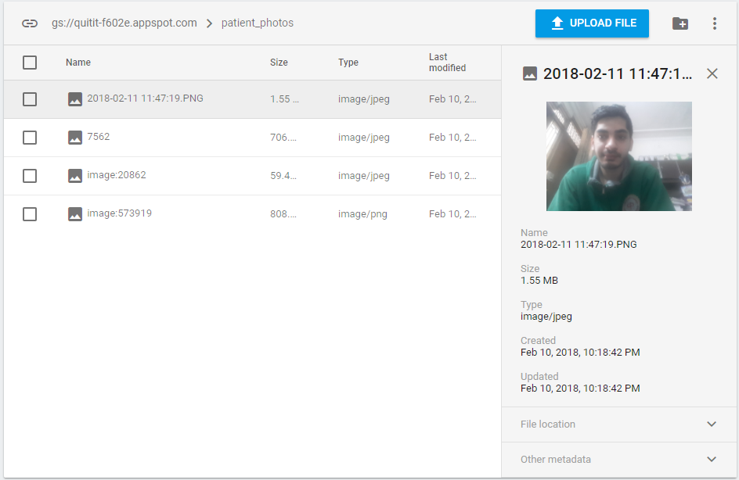

Fig 5.31 Patients Image Database

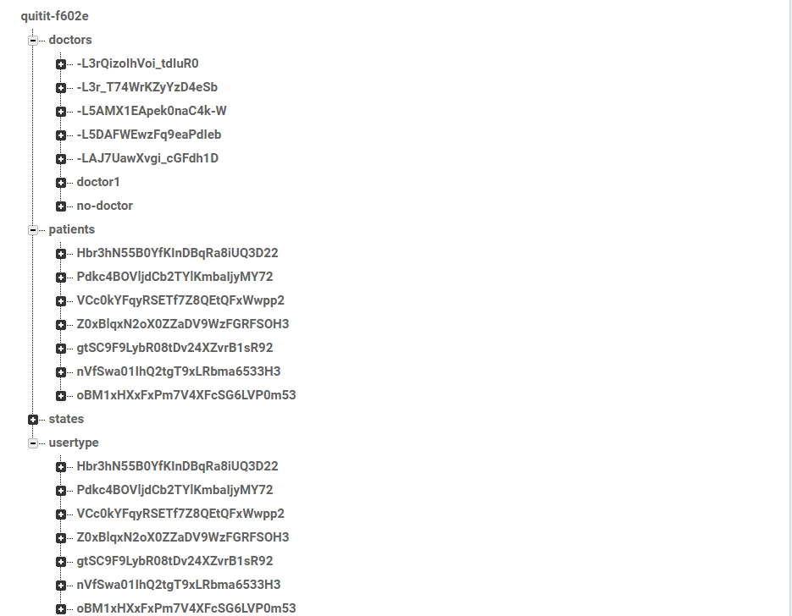

Fig 5.32 Patients Doctors and user Type Database

Chapter 6

Conclusion

We all know that smoking is injurious or bad for health. Yet, young men and women are found puffing a cigarette and throwing out smoke at the company in which they are. Young people first begin smoking or chewing to get fun out of it. There is a curiosity among young adult and teenagers about the taste of a cigarette. Then, the gun takes the shape of a showmanship and in due course of time they find that they have got addicted to smoking and cannot give it up.

As the number of smokers are increasing day by day so as its life threatening effects like lung cancer, heart attacks etc. People know it, still they go on with it.  The habit of smoking, once formed is hard to be given up. This application involves various features which makes the process of quitting a simple step by step procedure. It motivates you to your core which eventually forces the people to quit.

This application is broadly divides into two phases. First phase concentrates on data storage. Doctors or other researchers can use this application to store their huge volumes of data efficiently. They can use this application to take concerned information from smoking or chewing patients as entry form covers all the relevant information. Also they can use the analytics functionality to view the various trends like age wise, gender wise, medical history wise etc. They can use these valuable trends to take appropriate measures. They can print the reports of patients or can save it for later considerations. The printing report consists of the most important feature of personalized message for the patient that targets the immediate effects of this habit motivating him/her to quit. Second phase of the application is majorly concentrated on motivating the user to quit the habit of smoking or chewing. It involves various measures like user is shown movies, or can listen music or can play some small game, whatever he/she is fond at the time when the craving is at its peak.

Overall this application consists of various features and can be a milestone in eradicating this society threatening habit of smoking and chewing.

## Chapter 7

## Future Work

Quit Ithas begun its second phase. The phase where it can be used to help out user quit their habit of consumption of tobacco. There, the user shall enter his details that may include, but are not restricted to, their consumption details, their personal information and their interests. Quit It shall include the features to measure user’s daily intake, Reduction or increase in their habit, Timing, mental state as well as physical state as of when they usually consume or when they get a craving for one. All this data will then be used by our app to help the user in their quest for quitting their addiction. The face processing part has started so that we can pictorially motivate the user what side effects it will have on his/her body .We are planning to start the part where he will get daily missions and notifications. The app is published and now we are incorporating multiple languages in it (Hindi, English). Also the patient must be able to fill his entry through voice.

# References

1. <https://en.wikipedia.org/wiki/Smoking_in_India>
2. <http://timesofindia.indiatimes.com/city/nagpur/tobacco-use-causes-1-death-every-6-seconds/articleshow/58914675.cms>
3. <http://www.thehindubusinessline.com/news/science/smoking-causes-over-11-deaths-india-among-top-4-countries-report/articl9618981.ece>
4. http://www.tiionline.org/facts-sheets/tobacco-consumption/
5. http://www.educationtobacco.org