Deplosite : a simplistic web application that deploy websites of all kinds easily

Pulkit Jain
MCA 4th Sem , PES University
------------------------------------------------------------

Abstract-Background:Website deployment is easy for users who know it all , people like System Admins , Operations Engineers but is difficult for users who nowhere know the technical terms. Websites running on different tech stacks require distinct configuration and managing it all is complicated. This is where deplosite comes into play . It is a set of configured instructions for distinct tech stacks where a user could choose a configuration, upload its website zip and host on a machine.​ It makes website deployment a breeze.

Methods: The way static site and dynamic site are being deploying is completely different . The former depends more on functional approach depending on AWS CLI , AWS Python Boto3 SDK where the singular progress is contributed by functions while the latter is following rigid structured process with all instructions written line by line awaiting to be executed on the remote server. Below is detailed explanation.

Results: When making application that deploys other application on remote machine is a great task. If undertaken by anyone layman would result in a big failure or partial success depending upon the complexity of website but since deplosite is designed in a way that user say one word that is ‘Amazing’ on deploying applications with deplosite. The Units are immeasurable in terms of minimalism , simplicity and feedback gained after the whole process in comparison to other Products available.

Conclusion: With Deplosite as a Interface to help users to deploy website has made many benefits over traditional site deployment host providers and mechanisms .
Index Terms-

I. Background
Problem Statement
A business that is doing well in the offline space which is in markets , surrowndings with Restricted reach. The owner wants to increase its reach with a website that he has but Is not able to find easy options where he can deploy the website . For him/her to be Successful in Wider Market , the website has to be online but with current providers this does’nt seem to be happening anytime soon.To understand what the the service ​ Providers are providing , one has to dig deep on each service’s terms and conditions , ​ Dashboard and functionalities that they are bringing for the business.​ A Business is concerned more about its operations than to mantaining a website. ​This happens to be same with freelancers , portfolio managers and other users.
Problem Solution
Deplosite is a website , it offers all users from different profession to host website​ Using its platform .​Deplosite will use s3 service from AWS for static site deployment. EC2 would be ​
Used for dynamic sites integrating with backends like Javascript , PHP and​
Databases like MySQL , mongoDb. ​
​Each deplosite user could come , login to service and host multiple website​

Purpose
The main aim for project is to let users to have a working zip file containing​ project assets and code , zip file Would be uploaded to service and can be seen hosted on AWS.​
Scope
1) AWS S3 and EC2 for Deployment . Not open to other platforms​
2) Fixed to deploying website , neither creating nor designing them​
3) A single interface to carry out tasks

4) Works on provided set of Technologies

Existing Literature Study
AWS , Firebase Hosting , Netlify , GoDaddy , Hostinger , Azure , Heroku ,GCP and many other exists that Provides services to deploy websites . They have their infrastructure available and some services use available cloud infrastructure .​
​There are players like Firebase , Heroku , Netlify that provide free static site hosting , whereas other have Free tiers for a time period and paid subscription models.​
​This domain is cluttered with existing solutions . some providers provide full blown support for different Use cases like from databases , hosting solution , domain registry , blockchain , notification system ,Machine learning and Networking , whereas others are niche to their hosting domain.

Firebase-Firebase provides serverless deployment models,Spark–Free with Limits​,Blaze –Pay as you go Hosting , Realtime Db ,Cloud Functions , ML and analytics Suited for serverless ,users who want working without backends

Netlify - Deploy modern static websites with CDN, Starter - Free ​Pro - $45 pm​Business - $1500 Static website deployment Best for Static Hosting only or web apps build on SPA

Azure & GCP - Both Microsoft Azure and Google Cloud Platform are same providing wide range of computing , storage and networking services Storage - Azure provides a well-rounded set of storage services and features, but can have a steep learning curve .Compute – GCP has flexible pricing and big kubernetes support .Networking – Both competetive in this domain

Hardware & Software Requirements

Software:
- Python
- Javascript
- Linux OS
- AWS Client SDK

Hardware
- CPU – i3 >1400MHz
- HardDisk – 500 GB
- RAM – 8 GB

System Analysis

Functional Requirements
- Wide Options from Static and Dynamic Sites (Nodejs and PHP)
- Automatic Configuration Management
- Statistics Monitoring

Non Functional Requirements
- Usability – Unlike Services which stick to a platform, deplosite gives various running environment
- Supportability – Static Sites and Dynamic Sites are both runnable on any Platform
- Reliability – Repetitive Tasks done with Scripts

Architecture

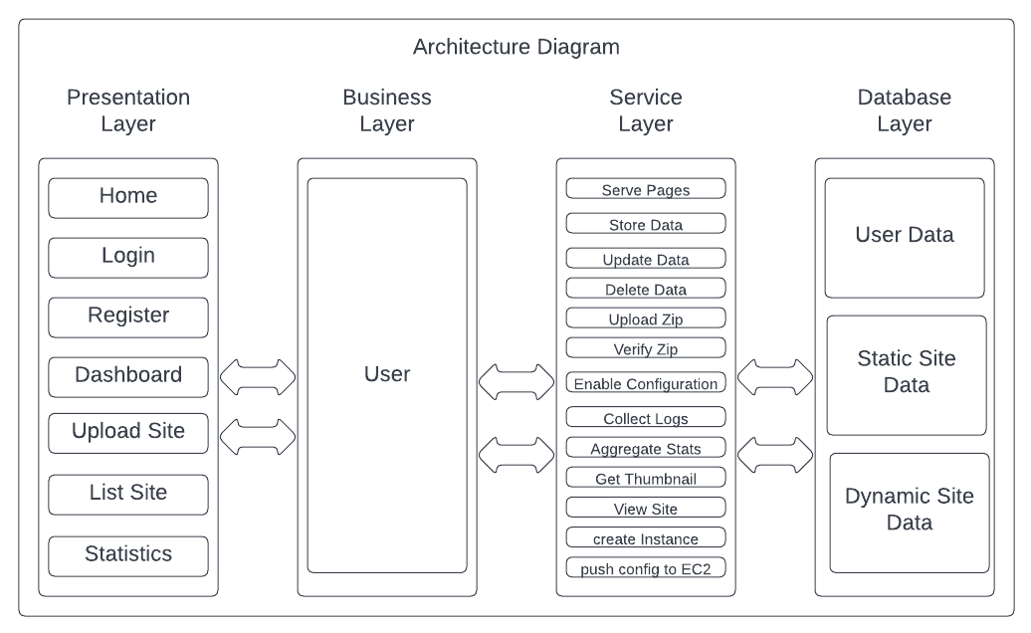

This architecture diagram shows various layers of application ‘deplosite’.
Briefly describing each one as
- Presentation
- Home
- Login
- Register
- Dashboard
- List Sites
- Statistics
- Business
- User Layer
- Service Layer
- Consisting of all function required to perform tasks
- Databases
- User
- Static Site
- Dynamic Site

II. Methods

Static Site Deployment Process

Deploying a static site is rather simpler than deploying a dynamic site but is not correct as it depends on the process provided by host provider. One just has to upload a single html file with a few js,css,images files. But a catch comes as Monitoring a Static Site is not easy , as host provider provides API for monitoring of Compute Servers that is not same with Content Delivery Networks . ​
For these sites one has to manually download logs from provider and parse it to provide it to user as in case for metrics . Here is where Boto3 came that made it easy to enable logging for these sites and download the same log files and later parsed with Pandas and provided as Graphs with Chartjs Javascript Library.

Dynamic Site Deployment Process​

Ansible is a Configuration Management & Application Deployment Tool . It can connect to varoius hosts or make them as group to run certain configuration commands or scripts. It helps developers , testers to save time on repetitive tasks . It has blocks that make running , writing ansible scripts easy and efficient as :​
Hosts – Group against which scripts are run​
Playbook – Set of Tasks ​
Role - Defined Activity making a Play​
Deplosite provides few parameters to Script which are root_file , db_name , project_path , ssh_key , host_user.​
All these parameters help ansible to perform procedures on host to deploy a website . Eg Install Server Packages , Uploading Project , Changing Instances of Database Connection , Writing Apache , Nginx Configuration File.​

III. Conclusion
With Deplosite as a Interface to help users to deploy website has made many benefits over traditional site deployment host providers and mechanisms as :-​

- Non reliance for user on AWS and other multi tier platforms that look too overwhelmed for simple tasks to layman users​
- A simple interface with defined options that gives user a clear cut picture of what option to choose
​
- Abstracting complexities using functional and procedural approach
​
- Cutting down time on deployment process for static and dynamic sites by choosing simplifed tech stacks , method of deployment and fixed approach towards a defined problem​
- Concealing Technical Jargon to platform itself , making user non exposible to difficult terms
​
- Making Static Deployment process and Resultant Site a Freebie , as no employed method relies on AWS billing (choosing s3 over ec2 for content and s3 server access logs over cloudwatch)

IV. Results and Future Enhancements

With Deplosite as a Interface to deploy website holds a lot more scope for enhancements and adding additional features​

- The Site allows defined stack as of now (Javascript and PHP) , support for further languages like Python , Go , C# could be added
- The Site allows Zips with simple structure to be deployed , website relying on framework don’t have an option now to be deployed . This can be added with writing deployment scripts for different frameworks with different versions on different programming languages.
- A Interface could be provided with AWS that could help users to choose for Domain Names
- Elastic IP could be assigned , allowing fixed address for the site
- Different Sites could be hosted on same hosts with taking advantages of Proxy Servers like Nginx

References

- Welcome to Flask — FlaskDocumentation(2.1.x)(palletsprojects.com)
- aws — AWS CLI 1.22.90 Command Reference (amazon.com)
- Boto3 documentation — Boto3 Docs 1.21.34 documentation (amazonaws.com)
- HTML/CSS to Image API - HTML/CSS to Image (htmlcsstoimage.com)
- Intelligent Diagramming | Lucidchart
- Add Google Oauth2 login in your flask web app (bitwiser.in)
- https://www.ansible.com/

