Department of Mechanical Engineering

Indian Institute of Technology Bombay
ME415: Computational Fluid Dynamics & Heat Transfer Autumn 2016
Assignment # 1: Computational Heat Conduction for Cartesian Geometry
Weightage: 10% Instructor: Prof. Atul Sharma
Date Posted: 22nd Aug. (Monday) Due Date: 31st Aug. (Wednesday, Early Morning 2 AM)
ONLINE SUBMISSION THROUGH MOODLE ONLY (No late submission allowed): Create a single zipped file consisting on (a) filled-in answer sheet of this doc file converted into a pdf file and (b) all the computer programs. The name of the zipped file should be rollnumber_A1
Note: Both problem and answer sheet are provided below. SCILAB or MATLAB should preferably be used for programming as well as generating graphical results.
Refer http://spoken-tutorial.org/tutorial-search/?search_foss=Scilab&search_language=English, for getting started to SCILAB for programming as well as generating graphical results. To save figure: Go to “Graphic window number”, click on “File”, then click on “Export to”, select “Windows BMP image” in the “Files of type”. Make sure to save the file in the same location where you have this file. More details are given in the next page.

- Flux based methodology for CFD development and code-verification for 1D unsteady state heat conduction problem, on a uniform grid.
Consider 1D conduction in a long stainless-steel (density ρ: 7750 kg/m3, specific-heat c_{p}: 500 J/Kg K, thermal-conductivity k: 16.2 W/m-K) sheet of thickness L=1 cm. The sheet is initially at a uniform temperature of 30ºC and is suddenly subjected to a constant temperature of T_{wb} = 0ºC on the west and T_{eb} = 100ºC on east boundary.
Using the flux based solution methodology of CFD development, a computer program (A1_1D_Prob1.sci) for explicit method on a uniform 1-D Cartesian grid is given along with this assignment sheet. Present a testing of the code for a volumetric heat generation of 0 and 100, MW/m³. Consider maximum number of grid points as imax=12 and the steady state convergence tolerance as ε_{st}=10⁻⁴. Plot the steady state temperature profiles with and without volumetric heat generation and compare with the exact solution.

- Flux based methodology for CFD development and code-verification for 2D unsteady state heat conduction problem, on a uniform grid.
Consider 2D conduction in a square shaped (L₁=1m and L₂=1m) long stainless-steel plate. The plate is initially at a uniform temperature of 30ºC and is suddenly subjected to a constant temperature of T_{wb} = 100ºC on the west boundary, T_{sb} = 200ºC on the south boundary, T_{eb} = 300ºC on the east boundary, and T_{nb} = 400ºC on north boundary.
- Using the flux based solution methodology of CFD development, develop a computer program for explicit method on a uniform 2-D Cartesian grid. Use the steady state stopping criterion for non-dimensional temperature, given (slide # 5.58 & 5.59) as
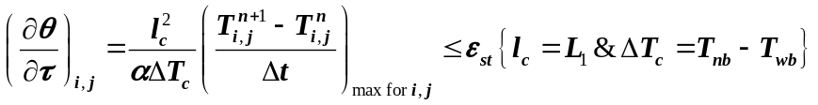
- Present a CFD application of the code for a volumetric heat generation of 0 and 50 kW/m³. Consider maximum number of grid points as imax×jmax=12×12 and the steady state convergence tolerance as ε_{st}=10⁻⁴. Plot the steady state temperature contours with and without volumetric heat generation.

- Coefficient of LAEs based methodology for CFD development and code-verification for 1D unsteady state heat conduction problem, on a non-uniform grid.
Consider 1D conduction in a long stainless-steel sheet of thickness L=1 cm. The sheet is initially at a uniform temperature of 30ºC and is suddenly subjected to a constant temperature of T_{wb} = 0ºC on the west and h=1000 W/m².K and T∞=100ºC on east boundary.
- Generate a non-uniform 1D Cartesian grid, using an algebraic method (can be found in slide no. 5.63 to 5.66). The method involves a transformation of a uniform grid, in a ξ- coordinate based 1D computational domain of unit length, to a x- coordinate based physical domain of length L, using an algebraic equation given (Hoffmann and Chiang, 2000) as
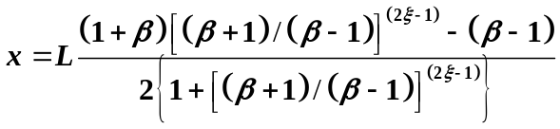
This equation results in a grid which is finest near the two ends of the domain and gradually become coarser at the middle of the domain. It is called as equal clustering of grids at both the ends of the domain. Consider maximum number of grid points as imax=12 and β=1.2 (which controls the non-uniformity in the grid size).
- Using the coefficient of LAEs based solution methodology of CFD development, a Gauss-Seidel method based computer program for implicit method on the non-uniform 1-D Cartesian grid (A1_1D_Prob3.sci) is given along with this assignment sheet. Present a CFD application of the code for a volumetric heat generation of 0 and 100, MW/m³. Consider the convergence tolerance as ε_{st}=10⁻⁴ for steady state, and ε=10⁻⁴ for iterative solution. Plot the steady state temperature profiles with and without volumetric heat generation, and compare with the exact solution.

- Coefficient of LAEs based methodology for CFD development and code-verification for 2D unsteady state heat conduction problem, on a non-uniform grid.
Consider 2D conduction in a square shaped (L₁=1m and L₂=1m) long stainless-steel plate. The plate is initially at a uniform temperature of 30ºC and is suddenly subjected to a constant temperature of T_{wb} = 100ºC on the west boundary, insulated on the south boundary, constant incident heat flux of q_{W} = 10 kW/m² on the east boundary, and h=100 W/m².K and T∞ = 30ºC on north boundary.
- Generate a non-uniform 2D Cartesian grid, using an algebraic method, using the equation given above for the non-uniform grid generation in the x-direction. However, this equation is also used in the y-direction to generate the 2D grid. This equation results in a grid which is finest near the two ends (east and west as well as north and south boundary) of the domain and gradually become coarser at the middle of the domain. It is called as equal clustering of grids at both the ends of the domain. Consider maximum number of grid points (for the temperature) as imax×jmax=12×12 and β=1.2.
- Using the coefficient of LAEs based solution methodology of CFD development, develop a Gauss-Seidel method based computer program for the implicit method on a non-uniform 2-D Cartesian grid. Use the stopping criterion presented in the previous problem, with ΔT_{c}=T_{wb}-T∞.
- Using the non-uniform grid and the program, present a CFD application of the code for a volumetric heat generation of 0 and 50 kW/m³. Consider the convergence tolerance as ε_{st}=10⁻⁴ for the steady state, and ε=10⁻⁴ for iterative solution by the Gauss-Seidel method. Plot the steady state temperature contours with and without volumetric heat generation.

Best Wishes for your success in the insightful field of Computational Fluid Dynamics
Keep Playing with the codes in future also.

NOTE: CODE EXECUTION IN SCILAB
To open a Scilab console:
Linux: Applications→Programming→Scilab or Applications→Science→Scilab
Windows: Start→All programs→Scilab→Scilab.exe
To load a source code (or a Scinote file):
In the Scilab console, go to top menu bar
File→Open a file…→(Browse for the *.sci file path)
The source code opens in a new Scinote window.
NOTE: Once this window is open, subsequent loading of a new *.sci file will open a new tab in the same Scinote window.

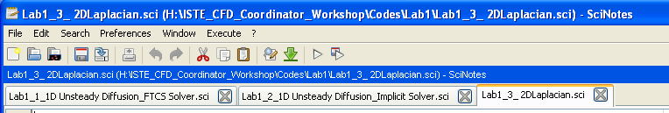
MULTIPLE SCINOTE TABS

To execute a program written in Scinote:
In the Scinote window (with the desired program tab open), go to top menu bar
Execute→…file with no echo (please do not select …file with echo)
The execution begins in the Scilab console window.

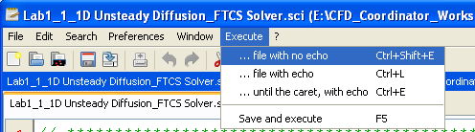

NOTE: Only one Scilab code can be executed at a time. Once an execute command is given and the code is to be stopped at an intermediate stage, use the method given below. If another execute command is given without completing/aborting the previous run, erroneous results may be produced.
To abort a running program:
Go to the Scilab console window and press CTRL+C. This interrupts the code execution. A prompt appears asking for user input. Enter “abort” here to stop the code execution.

Answer Sheet
Problem # 1: Flux based methodology, with explicit method and uniform grid: 1D Conduction
Plot the steady state temperature profiles with and without volumetric heat generation and compare with the exact solution. (2 figures).

(a) | (b)

Fig. 1.1: Testing of the explicit method based 1D code on uniform Cartesian grid, for unsteady state heat conduction, (a) without and (b) with heat generation. The figure shows comparison of the numerical with the analytical solution for steady state temperature profile.

Discussion on the Fig. 1.1: Write your answer, limited inside this text box only

Problem # 2: Flux based methodology, with explicit method and uniform grid: 2D Conduction
Plot the steady state temperature contours with and without volumetric heat generation. (2 figures).

(a) | (b)

Fig. 1.2: CFD Application of the explicit method based 2D code on uniform Cartesian grid: Steady state temperature contour for unsteady state heat conduction, (a) without and (b) with heat generation.

Discussion on the Fig. 1.2: Write your answer, limited inside this text box only

Problem # 3: Coefficient of LAEs based methodology, with implicit method and non-uniform grid: 1D conduction
Plot the steady state temperature profiles with and without volumetric heat generation and compare with the exact solution. (2 figures).

(a) | (b)

Fig. 1.3: Testing of the implicit method based 1D code on non-uniform Cartesian grid, for unsteady state heat conduction, (a) without and (b) with heat generation. The figure shows comparison of the numerical with the analytical solution for steady state temperature profile.

Discussion on the Fig. 1.3: Write your answer, limited inside this text box only

Problem # 4: Coefficient of LAEs based methodology, with implicit method and non-uniform grid: 2D conduction
Plot the steady state temperature profiles with and without volumetric heat generation. (2 figures).

(a) | (b)

Fig. 1.4: CFD Application of the implicit method based 2D code on non-uniform Cartesian grid: Steady state temperature contour for unsteady state heat conduction, (a) without and (b) with heat generation.

Discussion on the Fig. 1.4: Write your answer, limited inside this text box only

