EE 746 Introduction to Neuromorphic Engineering

Q1.
A)In this first part of the question what is being done is the fact that as lambda = 10 so approximately five spikes are being issued per 500ms so basically the poisson Random Variable is being used for this fact.
As a random number generator is being used actual instants of the spike changes every time the code is being run.
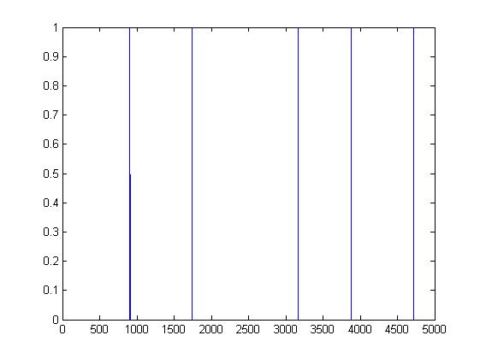

B)In this part we see the formula given in the question to determine the current at every instant of time as shown in the figure below.
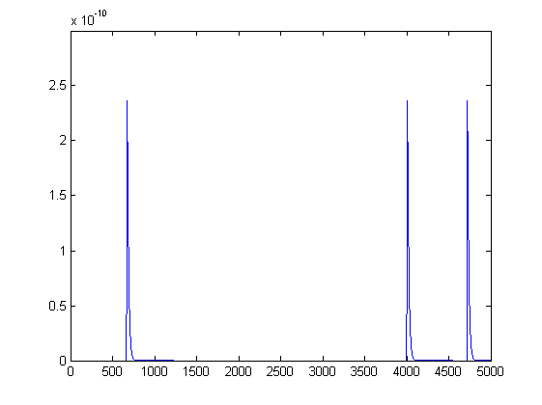

C) In the third Question basically the Current input as shown above is given to a AEF Neuron and the response is as under.
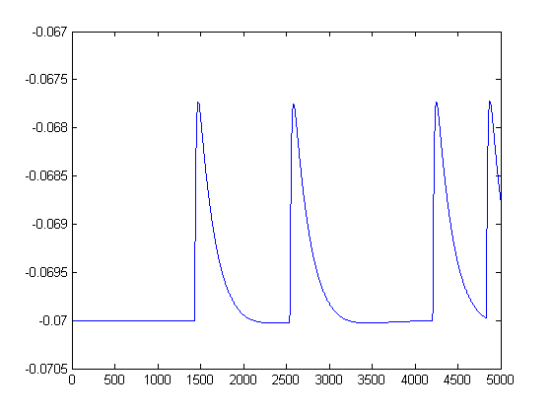

Q2 Note lamda=10 in this case due to quite slow response
A) When we look at response of 100 synapse then such small current variations addition leads to quite an Input Current response as under:
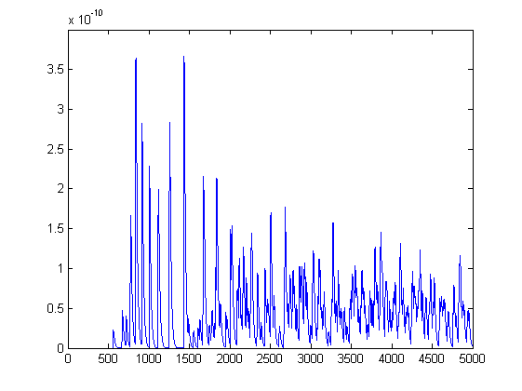

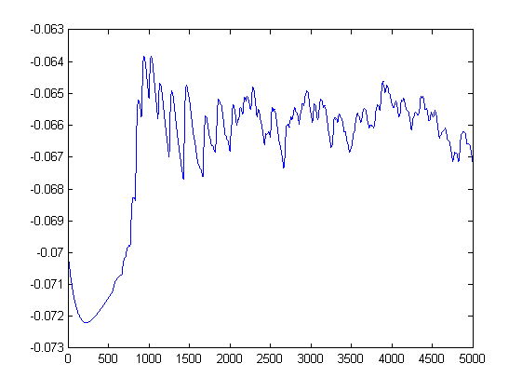
Which elicits a neuron response as under:

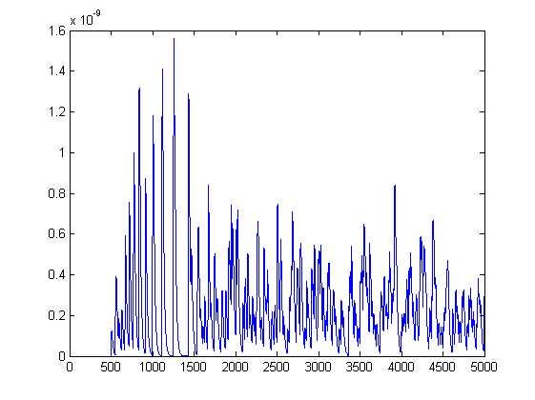
B) If the average of the weights of the synapse is increased then we see the response of the current is much stronger than the last time.

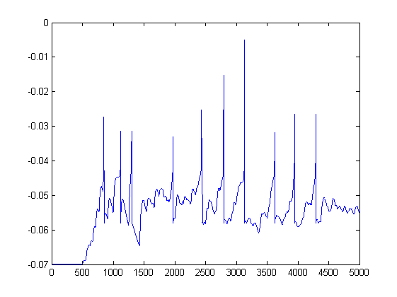
The response of the neuron and yes it does spike in the graph given below it does spike 10 times

Q3 Lambda=10 in this case too.
A) The response of the neuron is very slow in this case as the weights are very less so it takes time to adjust their spikes but here is it the final response when neuron finally spikes. Approximately 4to 5 iterations
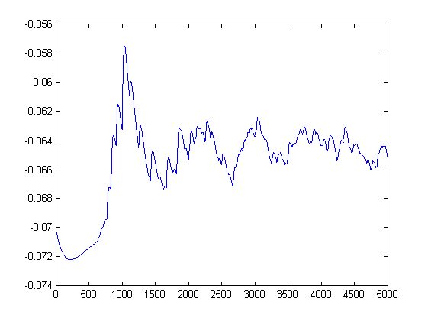
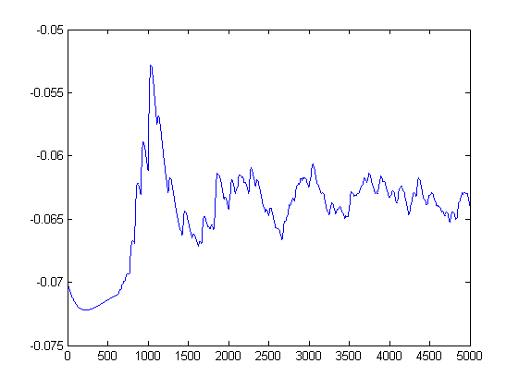

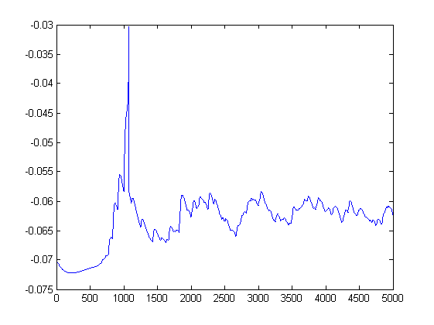
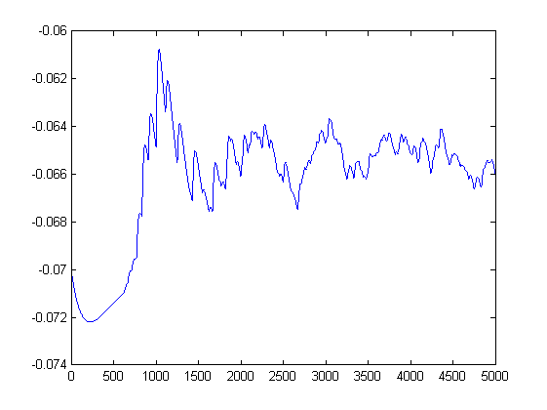

B) The variation of Del_w_e vs del_t is as under:
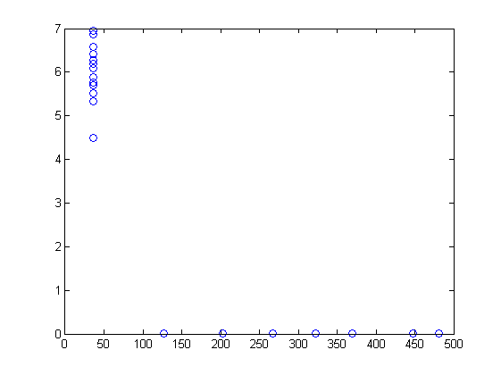

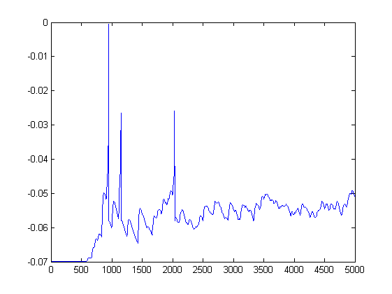
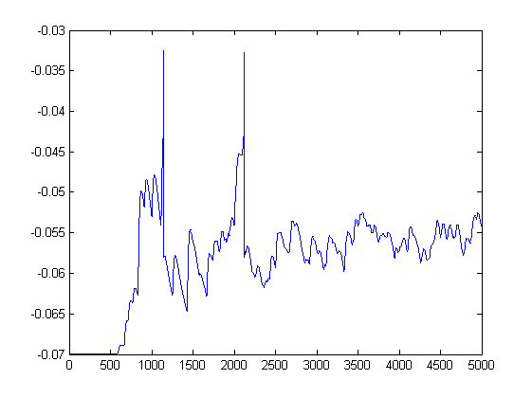
Q4.In the 4th Question we see that the number of Iterations coming out are as under. Following is the plot of the graph.

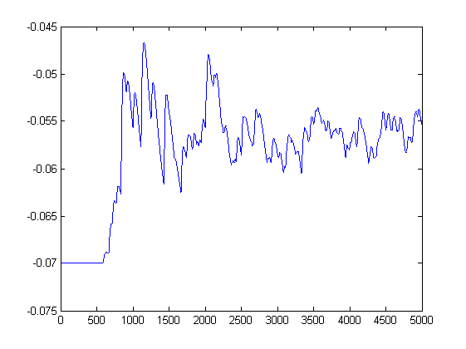

B)The following is the plot:

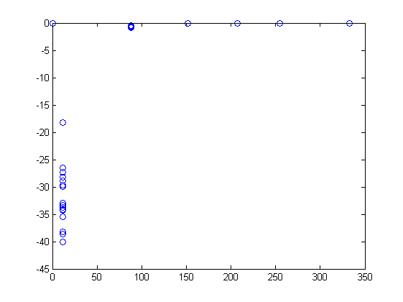

Q5.
A)The number of iterations everything is being done in the code of the 5th Question as given in the solution.

