input parameters 1
get mean velocity profile 1
get the resolvent matrix and take the SVD 1
enforce channel symmetry 1
plot the results 1
clear
clc
% channel resolvent in primitive variable formulation

input parameters
kx = 7;
kz = 12;
c = 0.667;
omega= c*kx;
Re = 187;
N = 201;
Nsvd = 16; %(even number)

get mean velocity profile
[y, ~, ~, ~, U0] = channelMeanVel(Re, N); %length(U0) = length(y)

get the resolvent matrix and take the SVD
[u, s, v] = getResolventSVD(kx, kz, omega, Re, N, Nsvd, U0);

enforce channel symmetry
[u, v] = channelSym(u, v, s, Nsvd);

plot the results
plotResolventModes(y, u, s, v, N, Nsvd, 0);
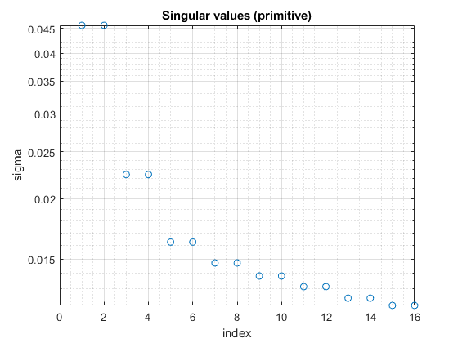
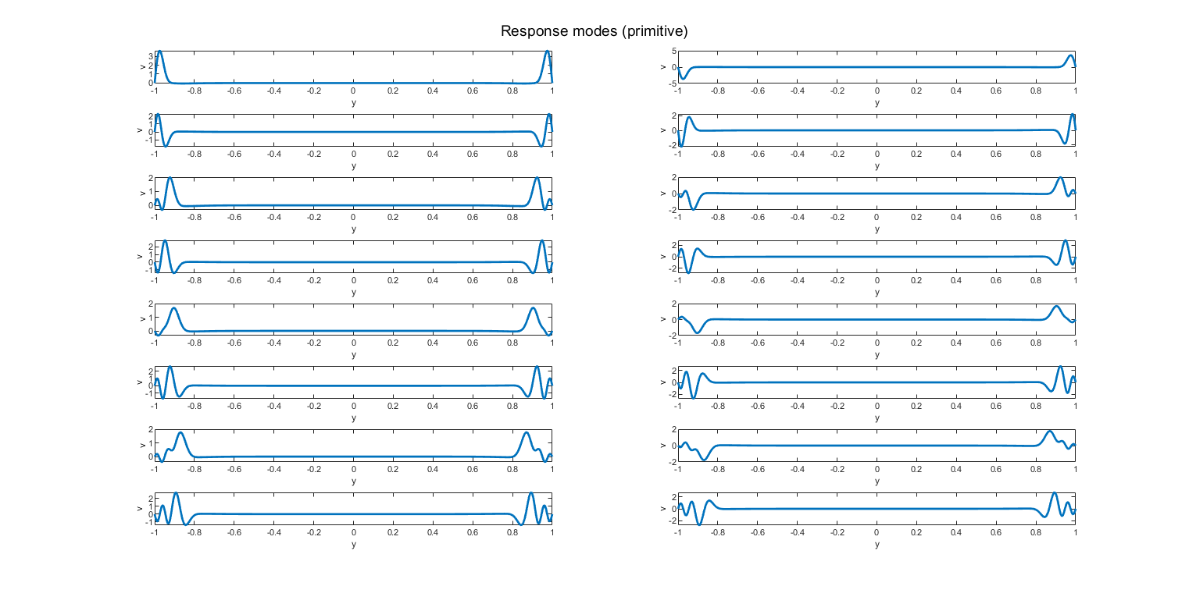
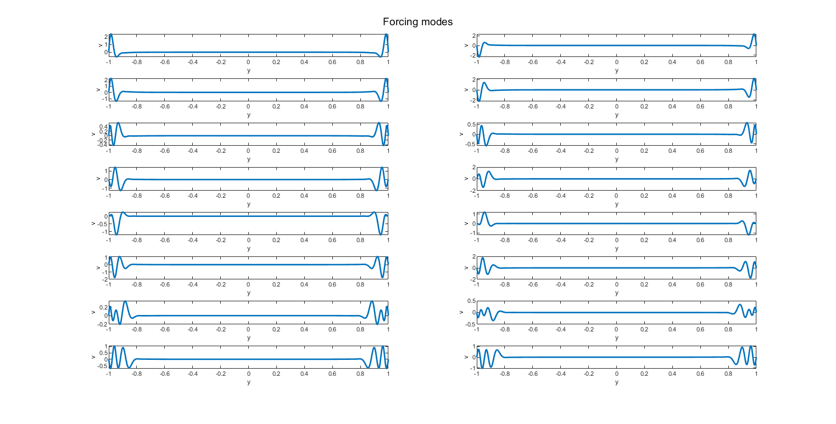
Published with MATLAB® R2021a

