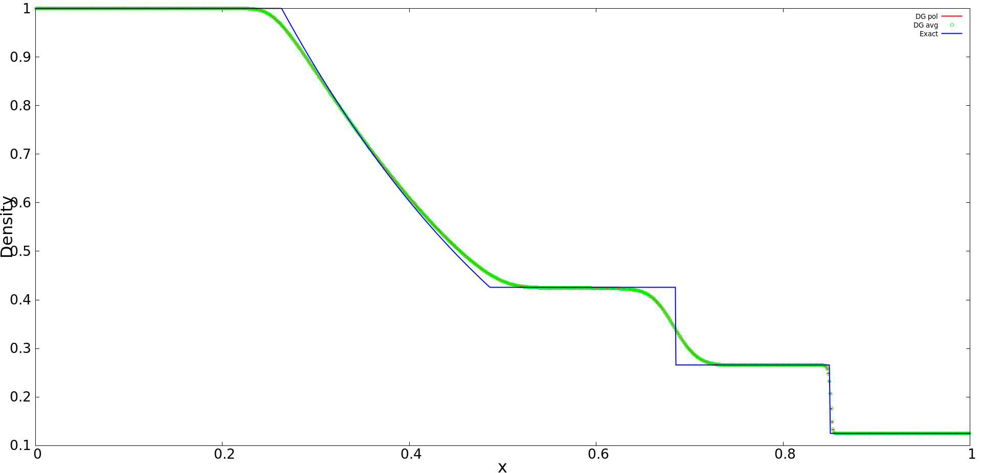

Test Case – SOD
pord = 1
no of cells = 1000
finaltime = 0.2

d_left = 1.0;
u1_left = 0.0;
u2_left = 0.0;
p_left = 1.0;
d_right = 0.125;
u1_right = 0.0;
u2_right = 0.0;
p_right = 0.1;

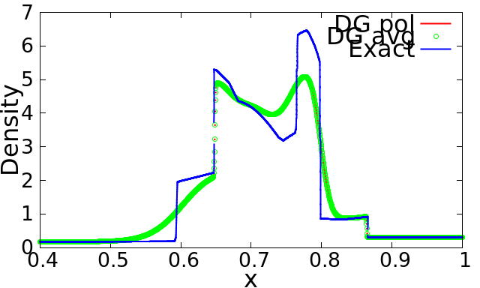
Test Case – BLAST
pord = 1
no of cells = 3000
finaltime = 0.038

if (x < 0.1) {
V[0] = 1.0;
V[1] = 0.0;
V[2] = 0.0;
V[3] = 1000.0;
} else if (x > 0.9) {
V[0] = 1.0;
V[1] = 0.0;
V[2] = 0.0;
V[3] = 100.0;
} else {
V[0] = 1.0;
V[1] = 0.0;
V[2] = 0.0;
V[3] = 0.01;
}

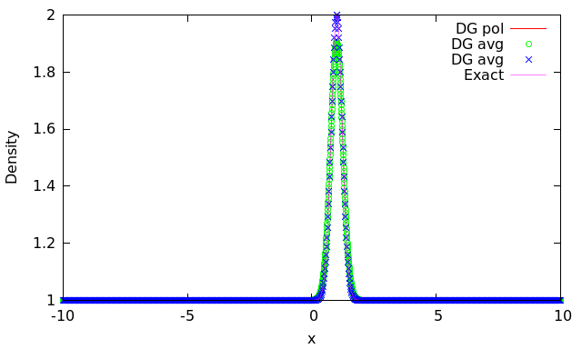
Test Case – PULSE
pord = 1
no of cells = 3000
finaltime = 1

d_left = 1.0;
u1_left = 0.0;
u2_left = 0.0;
p_left = 1.0;
d_right = 0.125;
u1_right = 0.0;
u2_right = 0.0;
p_right = 0.1;

