Q1. Write a program to replace a substring inside a string with other string ?

import java.util.*;
class First{
private String str;
public void StrReplace(String s, String s1, String s2)
{
str=s;
System.out.println("Older String:"+str);
System.out.println(str.replace(s1,s2));
}
public void inp(){
System.out.println("Enter the String Value");
Scanner sc=new Scanner(System.in);
String st=sc.nextLine();
System.out.println("Enter What you Want to Replace:");
String s1=sc.nextLine();
System.out.println("Enter With Which String You Want to Replace:");
String s2=sc.nextLine();
this.StrReplace(st,s1,s2);
}
public static void main(String[] args) {
First f1=new First();
f1.inp();
}
}
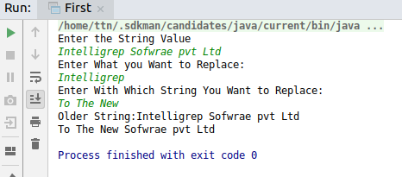

Q2. Write a program to find the number of occurrences of the duplicate words in a string and print them ?

import java.util.Scanner;
public class Second {
public void rep(String str)
{
String[] Sarr=str.split(" ");
int wc=1;
for (int i=0;i<Sarr.length;i++){
for(int j=i+1;j<Sarr.length;j++){
if(Sarr[i].equals(Sarr[j])){
wc+=1;

Sarr[j]="0";
}
}
if(Sarr[i]!="0"){
System.out.println(Sarr[i]+" "+wc);
}
wc=1;
}
}
public void inp(){
System.out.println("Enter String Having Repeated Words:");
Scanner sc=new Scanner(System.in);
String st=sc.nextLine();
this.rep(st);
}
public static void main(String[] args) {
Second s1=new Second();
s1.inp();
}
}

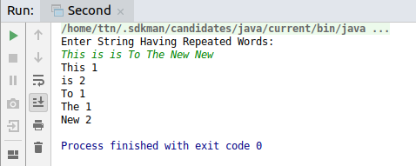

Q3. Write a program to find the number of occurrences of a character in a string without using loop?
import java.util.*;
public class Third {
String str;
public void inp(){
System.out.println("Enter String:");
Scanner sc=new Scanner(System.in);
str=sc.nextLine();
this.ReplaceCount(str);
}
public void ReplaceCount(String str)
{
int l=str.length();
System.out.println("String Length before and replacement of Repeated word:"+ l);
System.out.println("Enter Character You want to replace:");
Scanner sc = new Scanner(System.in);
String c=sc.next();
int l1=str.replace(c,"").length();
int l2=l-l1;
System.out.println("No, of Occurance of Entered Charater:");
System.out.println(l2);
}
public static void main(String[] args) {
Third t1=new Third();
t1.inp();

}
}
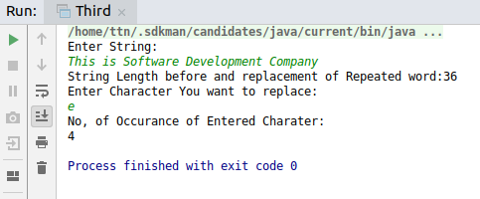

Q4. Calculate the number & Percentage Of Lowercase Letters,Uppercase Letters, Digits And Other Special Characters In A String
public class Fourth {
String str;
public Fourth(String str)
{
this.str=str;
}
public void cal(){
int l1= this.str.length();
int uPCL=0;
int lWCL=0;
int numType=0;
int Spec=0;
for(int i=0;i<l1;i++)
{
char c=str.charAt(i);
if(Character.isUpperCase(c))
{
uPCL++;
}
else if(Character.isLowerCase(c)){
lWCL++;
}
else if(Character.isDigit(c)){
numType++;
}
else{
Spec++;
}
}
double Up=(uPCL*100)/l1;
double lw=(lWCL*100)/l1;
double num=(numType*100)/l1;
double spe=(Spec*100)/l1;
System.out.println("Percentage of UpperCase Letter:"+Up+"%");
System.out.println("Count Of Uppercase Letter:"+uPCL);
System.out.println("Percentage of LowerCase Letter:"+lw+"%");
System.out.println("Count Of LowerCase Letter:"+lWCL);
System.out.println("Percentage of NumType Letter:"+num+"%");
System.out.println("Count Of NumType Letter:"+numType);
System.out.println("Percentage of Special Letter:"+spe+"%");
System.out.println("Count Of Special Letter:"+Spec);
}
public static void main(String[] args) {
Fourth f1=new Fourth("My Name is Pulkit I Am MCA Student Pj.pulkit241@gmail.com 12/12/12");
f1.cal();
}
}
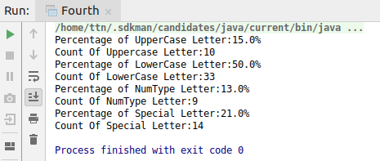

Q5. Find common elements between two arrays.

import java.util.Scanner;
class Fifth
{
private int arr1[];/*= {1, 2, 4, 5, 6};*/
private int arr2[];/* = {2, 3, 5, 7};*/
public Fifth()
{
arr1=new int[]{1, 2, 4, 5, 6};
arr2=new int[]{2, 3, 5, 7};
}
public void ini(){
System.out.println("Enter ELement in Array 1");
Scanner sc=new Scanner(System.in);
System.out.println("ELement in Array 1:");
for(int i=0;i<arr1.length;i++){
System.out.println(this.arr1[i]);
}
System.out.println("ELement in Array 2:");
for(int i=0;i<arr2.length;i++){
System.out.println(this.arr1[i]);
}
int l1=arr1.length;
int l2=arr2.length;
this.common(arr1,arr2,l1,l2);
}
public void common(int arr1[], int arr2[], int l1, int l2)
{
int i = 0, j = 0;
while (i < l1 && j < l2)
{
if (arr1[i] < arr2[j])
i++;
else if (arr2[j] < arr1[i])
j++;
else
{
System.out.println("Common Element:");
System.out.println(arr2[j++]+" ");
i++;
}
}
}
public static void main(String args[])
{
Fifth f1=new Fifth();
f1.ini();
}
}
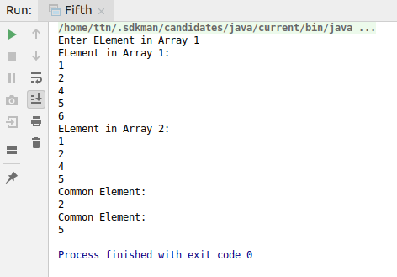

Q6. There is an array with every element repeated twice except one. Find that element
import java.util.Scanner;
public class Sixth {
private int arr[];
public Sixth() {
arr = new int[]{2, 2, 4, 5, 5, 10, 6, 6, 10};
}
public int ini() {
Scanner sc = new Scanner(System.in);
System.out.println("ELement of Array:");
for (int i = 0; i < arr.length; i++) {
System.out.println(arr[i]);
}
int l = arr.length;
return (this.find(arr, l));
}
public int find(int arr[], int l) {
int r1 = arr[0];
for (int i = 1; i < l; i++) {
r1 = r1 ^ arr[i];
}
return r1;
}
public static void main(String[] args) {
Sixth s1 = new Sixth();
int once= s1.ini();
System.out.println("Value Appear Only Once:"+once);
}
}

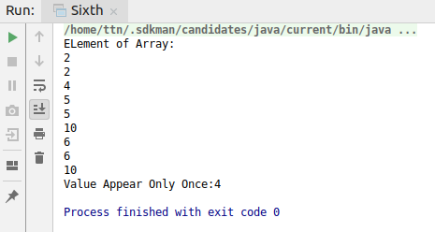

Q7. Write a program to print your Firstname,LastName & age using static block,static method & static variable respectively
public class Seventh {
static String FirstName="Pulkit";
static String LastName="Kumar";
static int Age=24;
static void print()
{
System.out.println("In Static Method FirstName:"+FirstName+" "+"LastName:"+LastName+" "+"Age:"+Age);
}
static{
System.out.println("IN Static Block FirstName:"+FirstName+" "+"LastName:"+LastName+" "+"Age:"+Age);
}
public static void main(String[] args) {
System.out.println("Using Static Variable:");
System.out.println(Seventh.FirstName);
System.out.println(Seventh.LastName);
System.out.println(Seventh.Age);
Seventh.print();
}
}
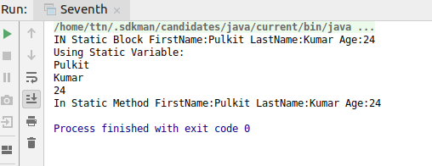
Q8. Write a program to reverse a string and remove character from index 4 to index 9 from the reversed string using String Buffer
import java.util.Scanner;
public class Eight {
private StringBuffer sb=new StringBuffer();
private String str;
public void reverseFun()
{
System.out.println("Enter String To Reverse:");
Scanner sc =new Scanner(System.in);
str=sc.nextLine();
for(int i = str.length() - 1; i >= 0; i--)
{
sb.append(str.charAt(i));
}
System.out.println("Reversed String:"+sb);
sb.delete(4,9);
System.out.println("Reversed String After Removal of letter from 4 to 9 index");
System.out.println("Reversed String:"+sb);
}
public static void main(String [] args)
{
Eight e1=new Eight();
e1.reverseFun();
}
}

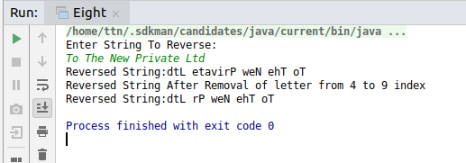
Q9.Write a program to display values of enums using a constructor & getPrice() method (Example display house & their prices)
public class Ninth {
enum House {
Antella(900),Mannat(2),Jannat(50),Swarg(15),Mandir(12);
private int price;
House(int p) {
price = p;
}
int getPrice() {
return price;
}
}

public static void main(String args[]){
System.out.println("All House prices:");
for (House c : House.values()) System.out.println(
c + " costs " + c.getPrice() + " thousand dollars.");
}
}
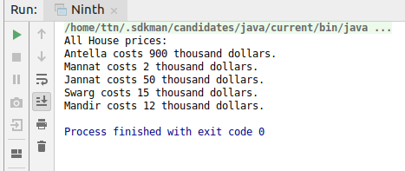

Q10.Write a single program for following operation using overloading
A) Adding 2 integer number
B) Adding 2 double
C) multiplying 2 float
D) multiplying 2 int
E) concate 2 string
F) Concate 3 String

public class Tenth {
public void calc(int i1,int i2){
System.out.println(i1+i2);
}
public void calc(double d1, double d2){
System.out.println(d1+d2);
}
public void calc1(float f1,float f2){
System.out.println(f1*f2);
}
public void calc1(int it1, int it){
System.out.println(it1*it);
}
public void calc2(String s1, String s2){
System.out.println(s1.concat(s2));
}
public void calc2(String s1, String s2, String s3){
System.out.println(s1.concat(s2.concat(s3)));
}
public static void main(String[] args) {
Tenth th=new Tenth();
th.calc(1,2);
th.calc(20.11f,10.11f);
th.calc1(10.0f,20.0f);
th.calc1(1,2);
th.calc2("String1","String 2");
th.calc2("String1","String2","String3");
}
}
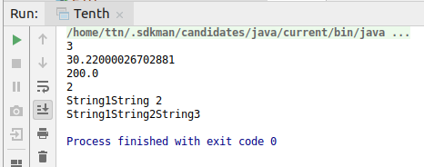

Q11.Create 3 sub class of bank SBI,BOI,ICICI all 4 should have method called getDetails which provide there specific details like rateofinterest etc,print details of every banks
public class Eleventh {
private String BankName;
private String Branch;
private int ROI;
public void getDetails(){
System.out.println(BankName);
System.out.println(Branch);
System.out.println(ROI);
}
public void setDetails(String BN, String Br, int R)
{
BankName=BN;
Branch=Br;
ROI=R;
}
public static void main(String[] args) {
SBI sbi=new SBI();
sbi.setDetails("State Bank of India","Janakpuri",10);
sbi.getDetails();
BOI boi=new BOI();
boi.setDetails("BOI","Tilak Nagar",7);
boi.getDetails();
ICICI ic=new ICICI();
ic.setDetails("ICICI","Noida",20);
ic.getDetails();
Eleventh e=new SBI();
e.setDetails("SBI","Janakpuri",12);
e.getDetails();
}
}
class SBI extends Eleventh{
@Override
public void getDetails()
{
System.out.println("SBI Details");
super.getDetails();
}
@Override
public void setDetails(String BN, String Br, int R)
{
System.out.println("This is SBI");
super.setDetails(BN,Br,R);
}
}
class BOI extends Eleventh{
@Override
public void getDetails()
{
System.out.println("BOI Details");
super.getDetails();
}
@Override
public void setDetails(String BN, String Br, int R)
{
System.out.println("This is BOI");
super.setDetails(BN,Br,R);
}
}
class ICICI extends Eleventh{
@Override
public void getDetails()
{
System.out.println("ICICI Details");
super.getDetails();
}
@Override
public void setDetails(String BN, String Br, int R)
{
System.out.println("This is ICICI");
super.setDetails(BN,Br,R);
}
}

