- Console "Hello Word" in document.ready function

HTML COURSE:
<!DOCTYPE html>
<html>
<head>
<title>Hello World</title>
<script src="https://ajax.googleapis.com/ajax/libs/jquery/3.3.1/jquery.min.js"></script>
<style>
body {
width: 80%;
margin: 0px auto;
}
</style>
<script lang="javascript">

$(document).ready(function(){
$("#head").html("Hello World");
});

</script>
</head>
<body>
<h1 id="head"></h1>
</body>
</html>

OUTPUT:
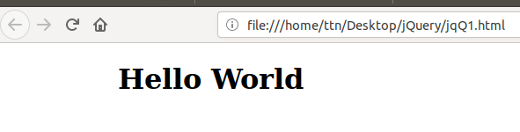

- Select a ID name "#test" and add class "load" when DOM is loaded

HTML SOURCE:

<!DOCTYPE html>
<html>
<head>
<title>Class Load</title>
<script src="https://ajax.googleapis.com/ajax/libs/jquery/3.3.1/jquery.min.js"></script>
<style>
body {
width: 80%;
margin: 0px auto;
}
.load {
color: red;
font-size: 18px;
texta-align: center;
}
</style>
<script lang="javascript">

$(document).ready(function(){
$("#test").addClass("load");
});

</script>
</head>
<body>
<h1 id="test">Heading</h1>
</body>
</html>
OUTPUT:
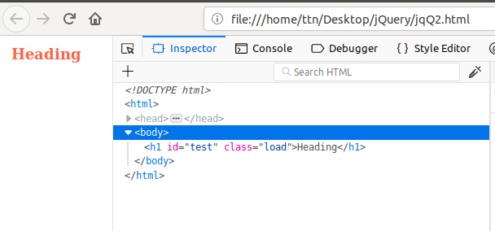

- Change the color of element which class name end with "-new"

HTML SOURCE:
<!DOCTYPE html>
<html>
<head>
<title>Colour Change</title>
<script src="https://ajax.googleapis.com/ajax/libs/jquery/3.3.1/jquery.min.js"></script>
<style>
body {
width: 80%;
margin: 0px auto;
}
.head-new, .main-head, .bottom-new {
color: Blue;
font-size: 20px;

}
</style>
<script lang="javascript">

$(document).ready(function(){
$("[class$=-new]").css("color","red");
});

</script>
</head>
<body>
<h1 class="head-new">Top Heading</h1>
<h2 class="main-head">Bottom Heading</h2>
<h3 class="bottom-new">Heading</h3>
</body>
</html>
OUTPUT:

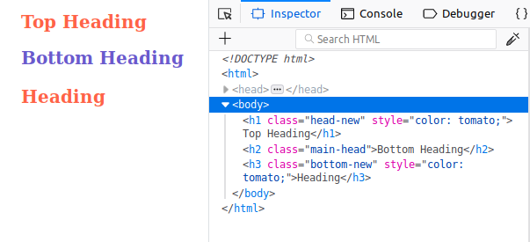

- Disable submit button using jquery attr method

HTML SOURCE:

<!DOCTYPE html>
<html>
<head>
<title>Disable Button</title>
<script src="https://ajax.googleapis.com/ajax/libs/jquery/3.3.1/jquery.min.js"></script>
<style>
body {
width: 80%;
margin: 0px auto;
}
</style>
<script lang="javascript">

$(document).ready(function(){
$("#btnAddition").prop('disabled','false');
});

</script>
</head>
<body>
<br />
<input type="button" id="btnAddition" onClick="alert('Testing button.')" value="Addition" />
</body>
</html>
OUTPUT:

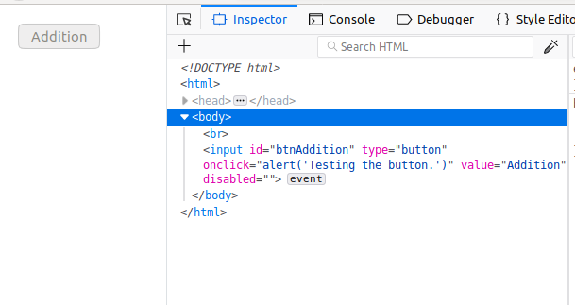
- Change the font size of ".target" which has parent element with id name "#main"

HTML SOURCE:
<!DOCTYPE html>
<html>
<head>
<title>Font Change</title>
<script src="https://ajax.googleapis.com/ajax/libs/jquery/3.3.1/jquery.min.js"></script>
<style>
body {
width: 80%;
margin: 0px auto;
}
.target {
font-size: 15px;
color: red;
}
</style>
<script lang="javascript">

$(document).ready(function(){
$("#main > .target").css('font-size','20px');
});

</script>
</head>
<body>
<div id="main">
<p class="target">Child of main with target class.</p>
<p>Child without target class<p>
</div>
<p class="target">Other element with class target.</target>
</body>
</html>

OUTPUT:
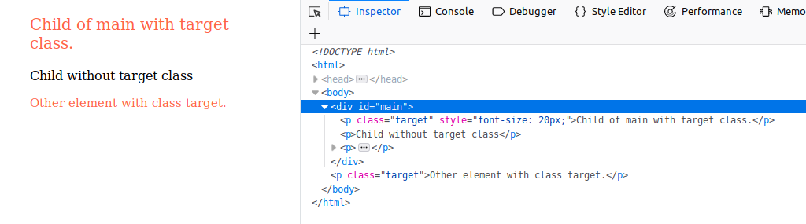

- After page load change the HTML of div element with "p" element

HTML SOURCE:

<!DOCTYPE html>
<html>
<head>
<title>Element Type Change</title>
<script src="https://ajax.googleapis.com/ajax/libs/jquery/3.3.1/jquery.min.js"></script>
<style>
body {
width: 80%;
margin: 0px auto;
}
div {
color: Tomato;
}
</style>
<script lang="javascript">

$(document).ready(function(){

$('div').css("background-color","red");
$("div").replaceWith(function(){
return $("<p />").append($(this).contents());
});

});

</script>
</head>
<body>
<div id="contentONE">Content are written inside this element.</div>
<div id="contentTWO">Content are written inside this element</div>
<div id="contentTHREE">Content are written inside this element</div>
<div id="contentFOUR">Content are written inside this element</div>
<div id="contentFIVE">Content are written inside this element</div>
</body>
</html>
OUTPUT:
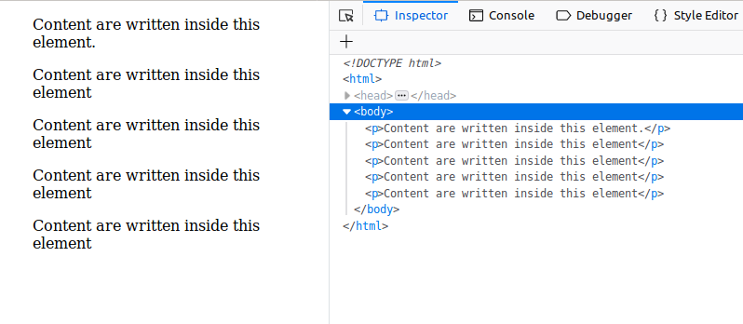

- Bind a click function to an "click" element and append next "click" next to it.
HTML SOURCE:
<!DOCTYPE html>
<html>
<head>
<title>Content Append on Click</title>
<script src="https://ajax.googleapis.com/ajax/libs/jquery/3.3.1/jquery.min.js"></script>
<style>
body {
width: 80%;
margin: 0px auto;
}
div {
color: red;
}
</style>
<script lang="javascript">

$(document).ready(function(){

$("#content").click(function(){
$('#content').append(' click');
});

});

</script>
</head>
<body>
<br />
<div id="content">click</div>
</body>
</html>
OUTPUT:
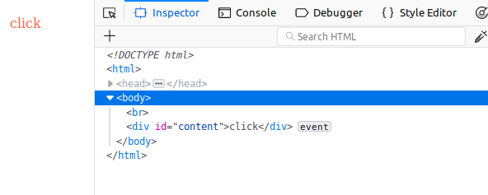
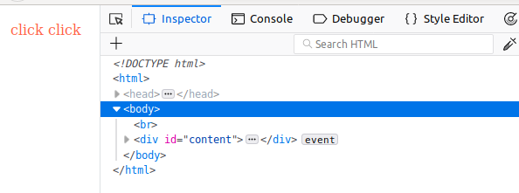

- Click event not working on element which added dynamicly or via script, make it work using .on method

HTML SOURCE:
<!DOCTYPE html>
<html>
<head>
<title>Click Event on Dynamic Elements</title>
<script src="https://ajax.googleapis.com/ajax/libs/jquery/3.3.1/jquery.min.js"></script>
<style>
body {
width: 80%;
margin: 0px auto;
}
p {
color: Tomato;
font-size: 20px;
}
</style>
<script lang="javascript">

$(document).ready(function(){

$("#message").append('<br /><p id="link">Click Here</p>');

$("#link").on("click", function(e) {
alert('Testing Click Event.');
});
});
</script>
</head>
<body>
<br />
<p id="message">Click Event On Dynamic Contents Like <a> Tag.</p>

</body>
</html>
OUTPUT:

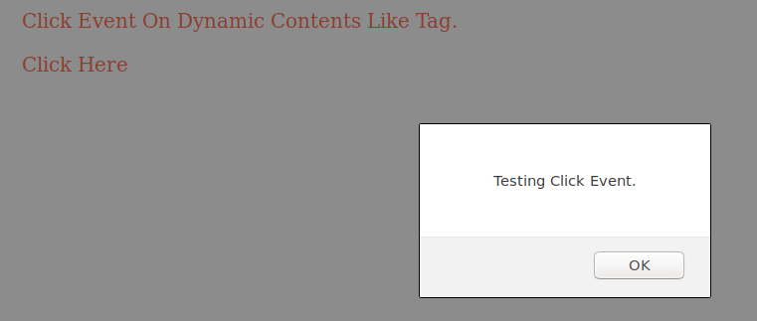
- Get dropdown selected value on onchanage event and append in div container

HTML SOURCE:
<!DOCTYPE html>
<html>
<head>
<title>Dropdown Data Display</title>
<script src="https://ajax.googleapis.com/ajax/libs/jquery/3.3.1/jquery.min.js"></script>
<style>
body {
width: 80%;
margin: 0px auto;
}
p {
color: red;
font-size: 20px;
}
</style>
<script lang="javascript">

$(document).ready(function(){

$("#dd_list").change(function(){

var datalist = $(this).children("option:selected").val();
$("#container").append(datalist+"<br />");
});
});
</script>
</head>
<body>
<br />
<select id="dd_list">
<option id="1">Data One</option>
<option id="2">Data Two</option>
<option id="3">Data Three</option>
<option id="4">Data Four</option>
<option id="5">Data Five</option>
<option id="6">Data Six</option>
</select>
<div id="container">
</div>
</body>
</html>
OUTPUT:




- Create a dropdown menu using hover method in jquery

HTML SOURCE:
<!DOCTYPE html>
<html>
<head>
<title>Create Dropdown</title>
<script src="https://ajax.googleapis.com/ajax/libs/jquery/3.3.1/jquery.min.js"></script>
<style>
body {
width: 80%;
margin: 0px auto;
}
p {
color: red;
font-size: 20px;
}
</style>
<script lang="javascript">

$(document).ready(function(){

$('#container').hover(function(e) {
$('body').append("<select name='dd'><option id='1'>first data</option><option id='2'>second data</option></select>");
});

});

</script>
</head>
<body>
<br />
<p id="container">Hover to Create DropDown List</p>
</body>
</html>
OUTPUT:



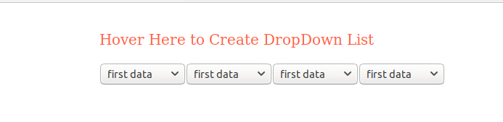

- On clicking on "google" tag. It is taking us to google home page. Stop it from happening.
HTML SOURCE:
<!DOCTYPE html>
<html>
<head>
<title>Open Link Disable</title>
<script src="https://ajax.googleapis.com/ajax/libs/jquery/3.3.1/jquery.min.js"></script>
<style>
body {
width: 80%;
margin: 0px auto;
}
p {
color: Tomato;
font-size: 20px;
}
</style>
<script lang="javascript">

$(document).ready(function(){

$('#openlink').on("click", function(e) {
e.preventDefault();
alert('This link is disabled.');
});

});

</script>
</head>
<body>
<br />
<p>Click on <a id="openlink" href="https://www.google.com">Google</a> to open google.com </p>
</body>
</html>
OUTPUT:


- We have bind a click funtion to parent div but we want stop it from performing when user clicks on its child li
HTML SOURCE:
<!DOCTYPE html>
<html>
<head>
<title>Parent-Child Div Click</title>
<script src="https://ajax.googleapis.com/ajax/libs/jquery/3.3.1/jquery.min.js"></script>
<style>
body {
width: 80%;
margin: 0px auto;
}
#parent {
width: 200px;
height: 200px;
background-color: Tomato;
}
#child {
width: 100px;
height: 100px;
background-color: Green;
margin: 50px auto;
}
</style>
<script lang="javascript">

$(document).ready(function(){

$('#parent').on("click", function(e) {
e.stopPropagation();
alert('Parents Clicked!');
});
$('#child').on('click', function(e) {
// clicked on descendant div
e.stopPropagation();
alert('child Clicked!');
});

});

</script>
</head>
<body>
<br />
<div id="parent">This is parent div.
<div id="child">This is child div.
</div>
</div>
</body>
</html>
OUTPUT:
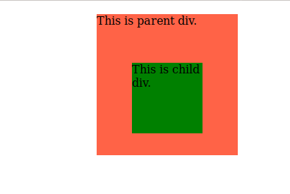

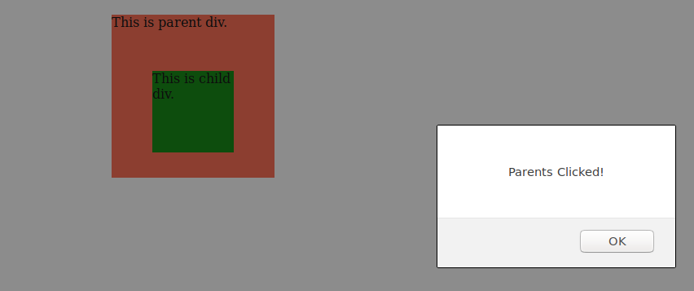

- Get the max height of elements using jquery each method
HTML SOURCE:

<!DOCTYPE html>
<html>
<head>
<title>Maximum Height of Element</title>
<script src="https://ajax.googleapis.com/ajax/libs/jquery/3.3.1/jquery.min.js"></script>
<style>
body {
width: 80%;
margin: 0px auto;
}
span {
background-color: slateBlue;
color: white;
font-weight: 900;
}
#head {
width: 200px;
height: 110px;
background: Tomato;
}
#content {
width: 200px;
height: 140px;
background: Tomato;
}
#menu {
width: 200px;
height: 150px;
background: Tomato;
}
#foot {
width: 200px;
height: 70px;
background: Tomato;
}
</style>
<script lang="javascript">

$(document).ready(function(){

var large = null;
var hi = 0;
$("div").each(function(){
var h = $(this).height();
if(h > hi){
hi = h;
large = $(this);
}
});
large.css("background-color", "slateBlue");

});

</script>
</head>
<body>
<br />
<p>Element with max height is displayed in <span>slateBlue</span> colour.</p>
<div id="head">
This is head div.<br />Height: 110px
</div>
<div id="content">
This is content div.<br />Height: 140px
</div>
<div id="menu">
This is menu div.<br />Height: 150px
</div>
<div id="foot">
This is foot div.<br />Height: 70px
</div>
</body>
</html>
OUTPUT:

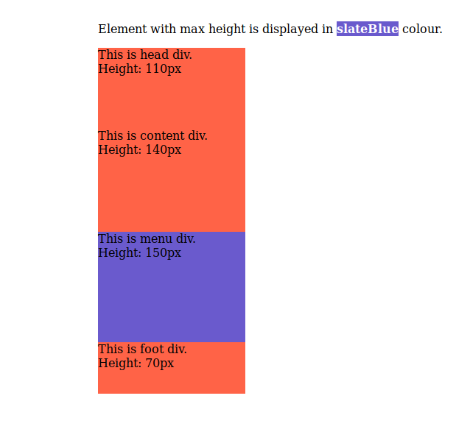

- Change color of every cell which has number larger than 10.

HTML SOURCE:

<!DOCTYPE html>
<html>
<head>
<title>Highlight Cells</title>
<script src="https://ajax.googleapis.com/ajax/libs/jquery/3.3.1/jquery.min.js"></script>
<style>
body {
width: 80%;
margin: 0px auto;
}
span {
background-color: slateBlue;
color: white;
font-weight: 900;
}

</style>
<script lang="javascript">

$(document).ready(function(){

var large = null;
$("td").each(function(){
var h = $(this).text();
if(parseInt(h) > 10){
large = $(this);
}
large.css("background-color", "slateBlue");
large.css("color", "white");
});
});

</script>
</head>
<body>
<br />
<p>Table cell value with greater than 10 is highlighted in colour.</p>
<table border="1px">
<tr>
<td>15</td>
<td>8</td>
<td>1</td>
<td>11</td>
</tr>
<tr>
<td>15</td>
<td>8</td>
<td>1</td>
<td>7</td>
</tr>
<tr>
<td>5</td>
<td>8</td>
<td>99</td>
<td>2</td>
</tr>
<tr>
<td>11</td>
<td>81</td>
<td>1</td>
<td>3</td>
</tr>
</table>
</body>
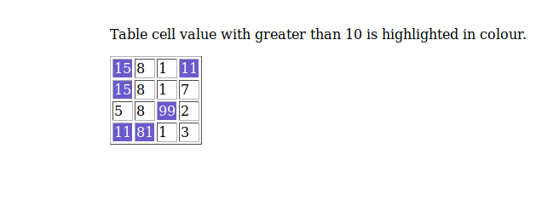
</html>
OUTPUT:

- Retrive the data from server using ajax get call
HTML SOURCE:
<!DOCTYPE html>
<html>
<head>
<script src="https://ajax.googleapis.com/ajax/libs/jquery/3.3.1/jquery.min.js"></script>
<script>
$(document).ready(function(){
$("button").click(function(){
$.ajax({url: "https://jsonplaceholder.typicode.com/todos/1", success: function(result){
$("#div1").html(JSON.stringify(result));
}});
});
});
</script>
</head>
<body>

<div id="div1"><h2>Let jQuery AJAX Change This Text</h2></div>

<button>Get External Content</button>

</body>
</html>
OUTPUT:
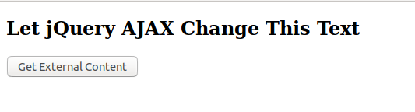
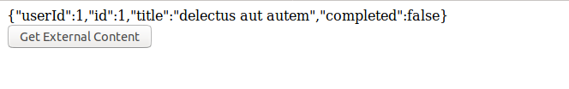
- Add cross button on row and bind click function which make a delete request to server, after success event remove the row from dom
HTML SOURCE:
<!DOCTYPE html>
<html>
<head>
<meta charset="utf-8">
<title></title>
</head>
<body>
<table border="1">
<tr id="row1">
<td>
abc
</td>
<td>
<input type="button" value="X" id="1">
</td>
</tr>
<tr id="row2">

<td>def</td>
<td>
<input type="button" value="X" id="2">
</td>
</tr>

</table>

<script src="https://ajax.googleapis.com/ajax/libs/jquery/3.3.1/jquery.min.js"></script>

<script lang="javascript">

$(document).ready(function () {

$(":button").click(function(){
bid=$(this).attr("id");
bid="#row"+bid;
$.ajax({url:"https://jsonplaceholder.typicode.com/todos/1",success: function(result){
$(bid).remove();
}});
});

});

</script>

</body>
</html>
OUTPUT:
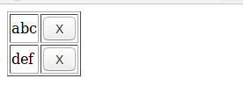

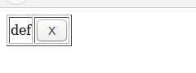

- Create a image array and in div create a slide show to animate images of delay of 500ms.
HTML SOURCE:

<!DOCTYPE html>
<html>
<head>
<title>Image Slider</title>
<script src="https://ajax.googleapis.com/ajax/libs/jquery/3.3.1/jquery.min.js"></script>
<style>
body {
width: 80%;
margin: 0px auto;
}
div {
background-size: auto;
background-position: center;
width: 500px;
height: 500px;
}

</style>
<script lang="javascript">

var array = new Array("slide1.png","slide2.png","slide3.png","slide4.png");

$(document).ready(function(){

var i = 0;
$("#slider").css("background-image", "url(" + array[i] + ")");
setInterval(function () {
i++;
if (i == array.length) {
i = 0;
}
$("#slider").fadeOut("slow", function () {
$(this).css("background-image", "url(" + array[i] + ")");
$(this).fadeIn("slow");
});
}, 500);
});

</script>
</head>
<body>
<br />
<div id="slider"></div>
</body>
</html>

