- Prompt for amount, interest rate and no. of years and calculate simple interest.
HTML SORCE:
<!DOCTYPE html>
<html lang="en" dir="ltr">
<head>
<script type="text/javascript">
function calculate()
{
var p = document.getElementById("principal").value;
if (isNaN(p) || p=='')
{
alert("Not A number Or Empty")
}
var r = document.getElementById("rate").value;
if (isNaN(r) || r =='')
{
alert("Not A number Or Empty")
}
var t = document.getElementById("time").value;

if (isNaN(t) || t=='')
{
alert("Not A number Or Empty")
}
var rest = document.getElementById("res");
var res=p*r*t/100;
rest.innerHTML="Interest is:" +res;
}
</script>
<meta charset="utf-8">
<title></title>
</head>
<body>
Enter Principal: <input type="text" id="principal">
Enter Rate:<input type="text" id="rate">
Enter Time in Years:<input type="text" id="time">
<button type="button" onclick="calculate()">Calculate Interest</button>
<p id="res"></p>
</body>
</html>
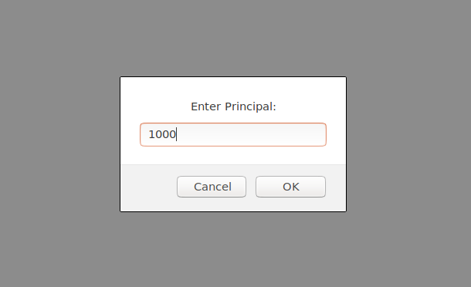

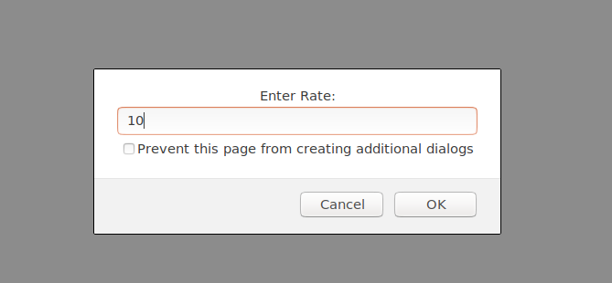
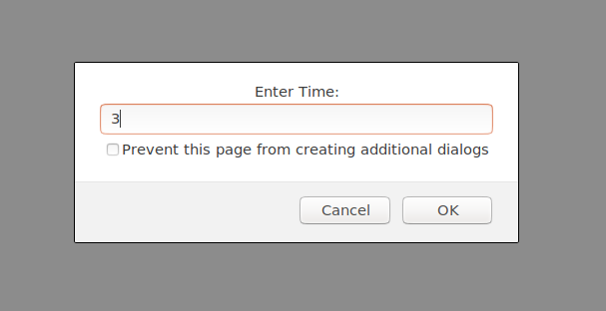

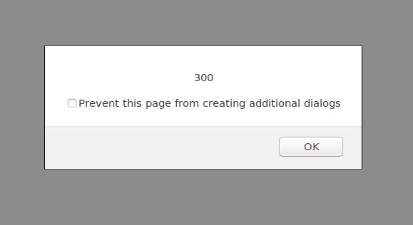
- is palindrome string
<!DOCTYPE html>
<html lang="en" dir="ltr">
<head>
<meta charset="utf-8">
<script type="text/javascript">
var letter=/^[a-zA-Z]+$/;
function fCp()
{
var string=document.getElementById("str").value;

if(!(string.value.match(letter)))
{
alert('Input must be a String');
}
if(string.length>=2)
{
var res=cp(string,string.length);
if(res==true)
{
document.getElementById("result").innerHTML="Palindrome";
}
else
{
document.getElementById("result").innerHTML="Not Palindrome";
}
}
function cp(s, sl)
{
cRev=sl-1;
for(i=0;i<sl;i++,cRev--)
{
if(s[i]==s[cRev])
{

}
else{
return false;
}
}
return true;
}
}
</script>

<title></title>
</head>
<body>
<p >Enter String To check Palindrome:</p>
<input type="text" id="str">
<button type="button" name="button" onclick="fCp()">Check Palindrome</button>
<p id="result"></p>
</body>
</html>
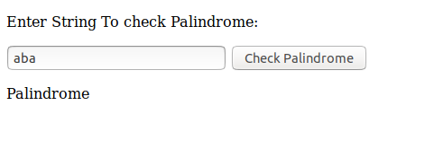

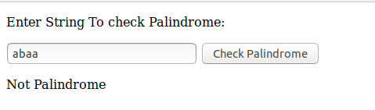

- Area of circle
HTML SOURCE:
<!DOCTYPE html>
<html lang="en" dir="ltr">
<head>
<script type="text/javascript">
function calArea()
{
var r = document.getElementById("rad").value;
if(isNAN(r) || r=='')
{
alert("Enter Numeric Value");
}
var a=3.14*r*r;
document.getElementById("res").innerHTML="Area of Circle:" + a;

}
</script>
<meta charset="utf-8">
<title></title>
</head>
<body>
<p>Enter Radius of circle:</p>
<input type="text" id="rad">
<button type="button" name="button" onclick="calArea()">Calculate Area</button>
<p id="res"></p>
</body>
</html>

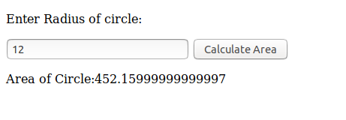

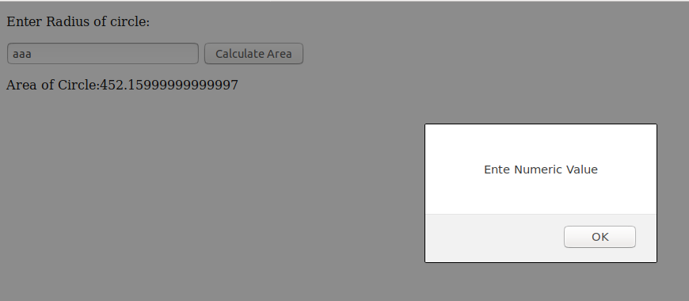
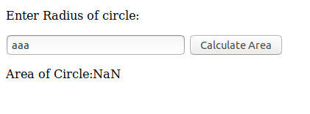

- Copy information of one object to another and log it to console.
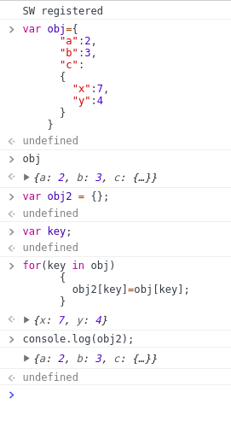

- create a list of objects of Employee with info as follow :
  - Name, age, salary ,DOB
  - filter all employees with salary greater than 5000
  - group employee on the basis of their age
  - fetch employees with salary less than 1000 and age greater than 20. Then give them an increment 5 times their salary.

HTML SOURCE:

<html lang="en" dir="ltr">
<head>
<script type="text/javascript">
var emp={};
var c=0;
var emps=new Array();
function obj()
{
var n = document.getElementById("name").value;
var a = document.getElementById("age").value;
var s = document.getElementById("salary").value;
var dob = document.getElementById("dob").value;

//alert(a+""+n+""+s+""+dob);
emp[c]={
"Name":n,
"Age":a,
"Salary":s,
"DOB":dob
};
console.log(emp[c]);
c++;
document.getElementById("name").value='';
document.getElementById("age").value='';
document.getElementById("salary").value='';
document.getElementById("dob").value='';
}

function f1()
{
for(var key in emp){

if(emp[key].Salary >= 5000)
{
document.getElementById("S5000").innerHTML=document.getElementById("S5000").innerHTML+"<br />Employee having Salary Greater than 5000:"+ emp[key].Name;
}<!--Again and again printing same records-->
}
}

function f2()
{
for(var i in emp){
if(emp[i].age in emps){
emps[emp[i].age].push(emp[i]);
}else{
let arr=new Array();
arr.push(emp[i]);
emps[emp[i].age]=arr;
}
}
console.log(emp);

}
function f3()
{
for(var key in emp)
{
if(emp[key].Salary < 1000 && emp[key].Age > 20)
{
emp[key].Salary=(parseInt(emp[key].Salary) + parseInt(emp[key].Salary))*5;
document.getElementById("into5").innerHTML=document.getElementById("into5").innerHTML+"<br/>Increments for Employees:"+ emp[key].Name;
}
}

}

</script>
<meta charset="utf-8">
<title></title>
</head>
<body>
<p>Employee Details:</p>
<p>Name:</p>
<br/>
<input type="text" id="name">
<br>
<p>Age:</p>
<br />
<input type="text" id="age"><br>
<p>Salary:</p>
<br/>
<input type="number" id="salary">
<br>
<p>DOB:</p>
<br/>
<input type="text" id="dob"><br><br>
<button type="button" name="button" onclick="obj()">Submit</button>

<p id="S5000">Click here to know Whose salary is Greater than 5000:<br></p>
<button type="button" name="button" onclick="f1()">Click Me</button>

<p >Click Here To Group People on the basis of there Age:<br></p>
<button type="button" name="button" onclick="f2()">Click Me</button>

<p >Click Here to fetch employees with salary less than 1000 and </p>
<p>age greater than 20 and to give them an increment 5 times their salary.</p>
<br>
<p id="into5"></p>
<br>
<button type="button" name="button" onclick="f3()">Click Me</button>

</body>
</html>

