

EEE4003

GENERATION AND UTILIZTION OF ELECTRIC ENERGY

**J COMPONENT**

**REPORT**

**TOPIC:**

**IoT based Smart Plug for energy efficiency and power management**

**SUBMITTED TO:**

Prof. Saravanan B

School of Electrical Engineering

Done By:

Shivani Mishal 18BEE0075  
Pulkit Mahajan 18BEE0127

Nishith Nayan 18BEE0166

**ABSTRACT**

The integration of renewable energy and energy use optimization are the key to mitigating climate change and meet the ever-increasing power consumption. Energy consumption can be significantly reduced by making people aware of their behaviour as energy consumers. Modern technologies such the Internet of Things (IoT) offer a wide number of applications in the energy sector, i.e, in energy supply, transmission and distribution, and demand. IoT can be employed for improving energy efficiency, increasing the share of renewable energy, and reducing environmental impacts of the energy use. In this project we implement a Smart and Sustainable technology by adapting IoT based methodologies using Smart plugs for capturing data which is transferred through the Wireless-gateway to the central database. The system is designed in way that the Smart plugs can be switched on/off when not in use from the central server. Due to this facility a system has been enabled to turn off the smart plugs apart from office hours. We have also performed analysis of the amount of energy consumed after by implementing our system by comparing it with the total energy consumed before implementing the system.

**INTRODUCTION**

Increasing economic growth and consumption patterns are leading to ever growing demand for energy. Since most of the energy supply is from fossil fuels, the resource is depleting thus increasing cost of energy. Burning fossil fuels has also increased concentration of carbon-di-oxide in the environment leading to extreme weather patterns. Hence it is imperative that Industries and commercial enterprises take steps to reduce energy wastage, become energy efficient and reduce costs. Industry in India consumes 45% of the 900 billion Units of power produced. 35% of electric power produced is lost, and the losses are due to Transmission & Distribution (16%), theft (10%), Inefficiencies among users (10%). This leads to a drop in power factor and higher utilization of energy leading to higher rate slabs and penalties. According to a recent study the plug loads account for more than 20 percent of total energy consumption of the building. There arises a necessity for a cyber-physical energy monitoring system for both commercial and office environment. So, with the upcoming of machine-to-machine communication where devices can be connected wirelessly leading to IoT. While the majority of the energy monitoring system focus on Air conditioners, Heaters, Hard-wired lighting, the energy impact by the plug load systems has received less attention. The plug loads are monitored in an intrusive way by installing smart plugs at desired plug points to measure the total energy consumption from the appliances. The system is designed in way that the Smart plugs can be switched on/off when not in use from the central server. Due to this facility a system has been enabled to turn off the smart plugs apart from office hours. We have also performed analysis of the amount of energy consumed after by implementing our system by comparing it with the total energy consumed before implementing the system.

**COMPONENT DETAILS**

**ACS712:** In this project we have used ACS712 IC as current sensing module ACS712 provides precise solutions for AC or DC current sensing in industrial, commercial, and communications systems. The device consists of a precise, low-offset, linear Hall sensor circuit with a copper conduction path located near the surface of the die. Applied current flowing through this copper conduction path generates a magnetic field which is sensed by the integrated Hall IC and converted into a proportional voltage. Device accuracy is optimized through the close proximity of the magnetic signal to the Hall transducer. A precise, proportional voltage is provided by the low-offset, chopper-stabilized BiCMOS Hall IC, which is programmed for accuracy after packaging. The ACS712 module used in this project can measure current AC or DC current ranging from +30A to -30A.

**ESP 32:** The project consists of hardware and software working in tandem with each other. The hardware consists of an ESP32 based Node MCU which has a Wi-Fi module inbuilt into the development board. This device can be used to communicate with the mobile device using a cloud interface. For the purpose of this project, we are using Firebase by Google as our communication medium. ACS 712 current sensing module and relay switch are interfaced in ESP 32.

**5V relay Channel**: In this project we have used 5V relay channel as a switch. Relay is an electromechanical device that uses an electric current to open or close the contacts of a switch. The relay uses an electric current to open or close the contacts of a switch. This is usually done using the help of a coil that attracts the contacts of a switch and pulls them together when activated, and a spring pushes them apart when the coil is not energized.

**METHODOLOGY**

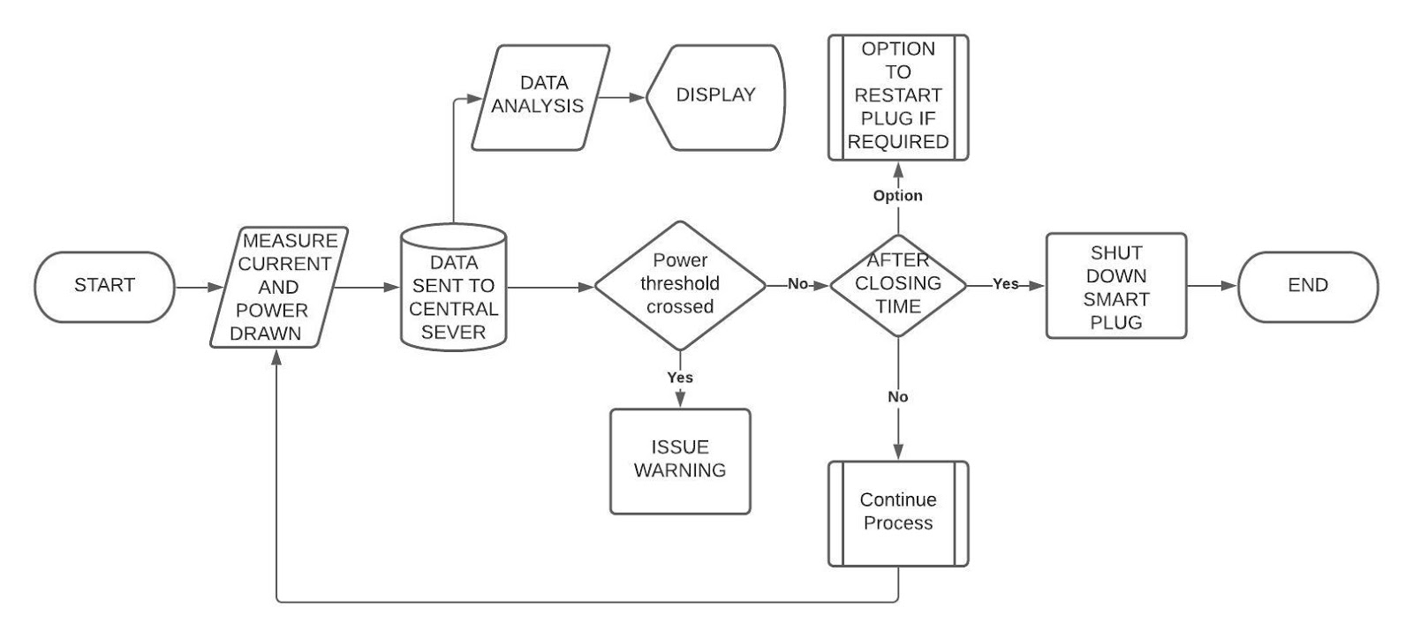

The ACS 712 current sensor module is used to measure the amount of current drawn by different elements. The measured values are sent to firebase via ESP 32 microcontroller. If the value of current drawn exceeds threshold value, the microcontroller closes the power supply with the help of relay channel. The 5V relay channel works as switch. The measure of current drawn, power consumption and energy consumed is calculated and send to firebase which is also accessed by a mobile app for data analysis. The app can also control the plug remotely i.e., if the user presses the button to shutdown the plug the firebase sends this status to microcontroller which cuts the power supply with the help of relay switch.

**RESULT**

**CONCLUSION**

By implementing the proposed system energy monitoring system, the occupants are directly EMS and therefore the consumer is made aware of their energy consumptions. The users can monitor the power and current consumption in real time and can thus control if and when to shut down the power plug remotely. Analysis of data send by the microcontroller is done so that user can easily understand the power and energy consumption. The proposed solution is highly scalable and can be integrated in numerous environments. This stands out to be a platform for many IoT enthusiasts as the data can be highly used to build connected environment. This system can be employed in large scale industries where a large number of machines needs to be simultaneously turned on/off and where numerous energy monitoring schemes can be employed. The amount of energy consumed is reduced to a great extent by implementing this system.

REFRENCES:

1. A. S. Musleh, M. Debouza and M. Farook, "Design and implementation of smart plug: An Internet of Things (IoT) approach," 2017 International Conference on Electrical and Computing Technologies and Applications (ICECTA), Ras Al Khaimah, 2017, pp. 1-4, doi: 10.1109/ICECTA.2017.8252033.
2. H. Morsali et al., "Smart plugs for building energy management systems," Iranian Conference on Smart Grids, Tehran, Iran, 2012, pp. 1-5.
3. Y. Thongkhao and W. Pora, "A low-cost Wi-Fi smart plug with on-off and Energsy Metering functions," 2016 13th International Conference on Electrical Engineering/Electronics, Computer, Telecommunications and Information Technology (ECTI-CON), Chiang Mai, Thailand, 2016, pp. 1-5, doi: 10.1109/ECTICon.2016.7561264.
4. T. M. Serrano, L. C. P. da Silva, L. Pereira, F. Andreoli, T. Ji and F. Fruett, "A Low-cost Smart Plug with Power Quality and Energy Analyzer Features," 2019 International Conference on Smart Energy Systems and Technologies (SEST), Porto, Portugal, 2019, pp. 1-6, doi: 10.1109/SEST.2019.8849112.
5. Prayongpun, N. & Sittakul, V.. (2017). Smart Plug for Household Appliances. 10.1007/978-981-10-1645-5_26.