**HOW TO RUN THE ANGULAR JS APPLICATION ON A LOCAL PC**

**Download and Install NodeJS**

If you don’t have nodejs installed on your machine, run the below msi file located under "**angularjs-app\formApp\angular\http-server**" and install using all the default options.

*node-v6.10.1-x64.msi*

**Install the http-server package from npm**.

Install the http-server globally on your machine using the node package manager (npm) command line tool, this will allow you to run a web server from anywhere on your computer.

Open a command prompt/command line window and enter the following:

*npm install -g http-server*

**Start a web server from a directory containing static website files**

Change to the directory where you have downloaded the “***angular-js***” app in the command line window.

cd /d C:\Users\angularjs-app\app

**Start the server with the below command**

http-server

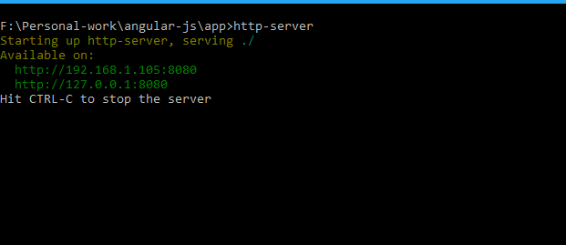

**Open your browser and go to the address**[**http://localhost:8080**](http://localhost:8080/)**and you should see the application up and running.**