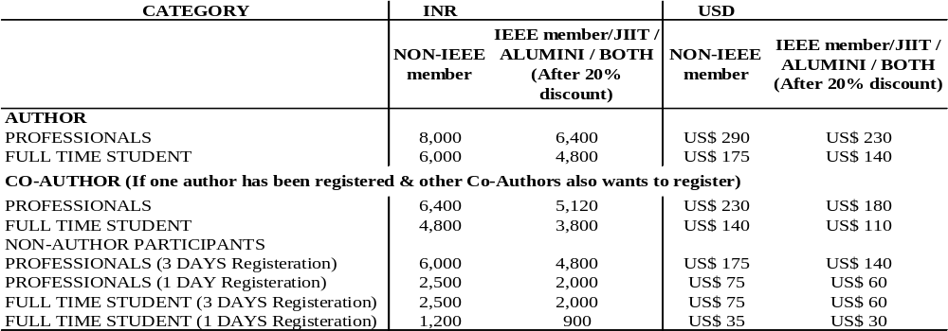

- A person availing discount in any category has to upload the valid supporting document (IEEE membership number / Student I-card / Payment details of first author) for availing the discount at the time of online registration.
- No separate acknowledgement will be sent. Payment receipt will be sent along with certificate via email.
- Any queries related to theregistration should be directed to ici.reg.conference@gmail.com.

Author’s Instructions for Registration

- For each accepted paper, it is mandatory for at least one author to register their paper in the conference.
- A paper must be presented by a registered participant (either registered as author or co-author).
- If one author has 2 accepted papers, then fee payment of one paper covers registration of both the papers. Although registration form for both the papers needs to be filled.
- In case one author / co-author is registering for more than 2 papers, then for 3rd paper, only 2000 INR fee will be charged. And for 4th paper, fresh registration has to be done.
- Checklist of documents required at the time of online registration via Google form.
- Proof for availing discount i.e. scanned copy of IEEE membership number / Student I-card.
- Make the payment and keep the proof of payment ready as mentioned below.

DD | Scanned copy of DD and original DD by post
NEFT/Wire Transfer | Scanned copy of the bank receipt Swift Copy (Wire transfer advice) or Funds transfer advice
Credit Card | Generated transaction receipt
- Author’s have to register mandatory via online registration formhttps://forms.gle/9fC1S17WAGj7tiRF8after payment has been successfully done.
- No separate acknowledgement slip will be sent.
Additional instructions

- All bank charges foreign/inland in connection with the registration fee remittance will be to the account of the Remitter. Shortage in the prescribed Fee amount, if any, on account of bank charges/short remittance received or credited to the Institute’s A/c shall be borne by the Remitter.
- It may be ensured that the Remitter’s (Participant/Author) name and the Purpose of remittance (Registration Fees) is clearly mentioned by the Remitter in the Funds Transfer Application.

For Co-Author(s)

- For each accepted paper, atleast one author must register under author category. All authors cannot register as "Co-Authors".
- If co-author wants to present the paper along with registered author, he/she must register under co-author category.
- If co-author wants to only attend the conference, he/she can register under participant category. In such case, he/she will be entitled for participation certificate only.
- Co-author registration discount can be availed only after one of the authors has successfully registered with full registration fee.
- Co-authors who wish to avail registration discount have to compulsorily indicate fee payment details of first author at the time of online registration.

Payment Modes

- Demand Draft: Demand Draft drawn in favour of "Jaypee Institute of Information Technology" payable at Noida, India.
Address to send your DD by post
Dr. Himani Bansal
Department of CSE & IT
Jaypee Institute of Information Technology (JIIT)
Jaypee Wish Town, Sector 128, Noida, India.
2. Payment Link (Net Banking/ Credit Card/ Debit Card/ UPI/ Wallet): The participant/author can pay the registration fee using the following link or QR code:

https://payments.cashfree.com/forms/JIIT-ICI

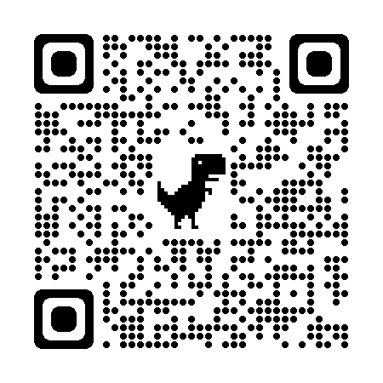
3. Wire Transfer (outside India): The participant/author can pay the registration fee through wire transfer. The wire transfer may be made to the following bank:

