**Movie Ticket Booking Application:**

**Requirement:**BookMyTicket is an online ticket booking system that enables users to book movie shows which are scheduled in different cinema halls . User can view the availability of seats in the show and book the show ticket. Design the web application for the same using Oracle,Servlets and JSP.

success.jsp

error.jsp

bookNow.jsp

Show

DB

<<DAO>>

<<Controller>>

<<Service>>

index.jsp

showDetails.jsp

1. Develop index.jsp and invoke ShowController servlet. The **ShowController.java(Controller)** will fetch Showdetails from database and store it in List<Show>.Which is then stored in session and displayed in **showDetails.jsp** as shown below **(15 Marks)**

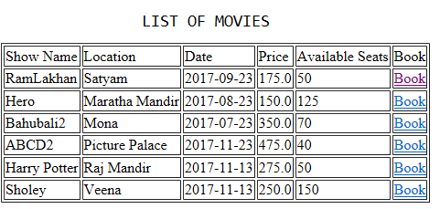

* If number of seats available for a particular show is greater than 0, then display “Book Now” link
* If number of seats available for a particular show is less than or equal to 0, then display “Sold” keyword.

1. Once “BookNow” link is clicked, navigate to **bookNow.jsp** page as shown below: **(10 marks)**

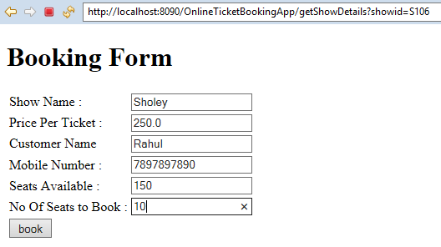

* ShowName, Price per Ticket and Seats Available needs to be populated

Perform following validations: (**10 marks**)

* All fields are mandatory.
* Name should accept only alphabets.
* Mobile Number should be valid of 10 digits.
* No. of seats to book should be positive digit and it should not accept number greater than number of seats available

**Note:** Validation for form data should be done at Client side (Java script or HTML5) wherever applicable.

Refer below screen after entering valid details:

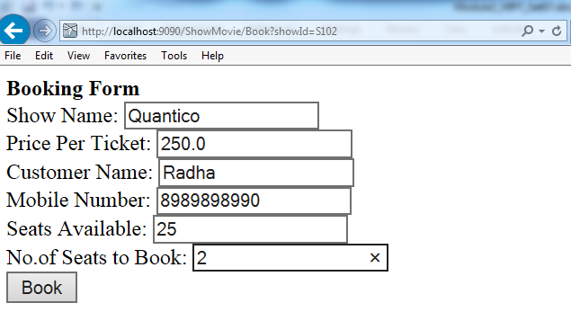

1. After the Book button is clicked:
   1. Update the seat column value as (No of seats available –No of seats wants to book) in shows table for the particular show. (**15 marks**)
2. When updation has been done successfully, then display the success page as shown below: (These details regarding customer can be displayed directly using request scope or session scope) (**10 marks**)

Refer **success.jsp** as below:

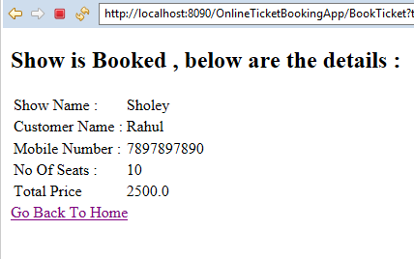

1. Ensure the usage of MVC pattern with Layered Architecture. **(5 marks)**
2. If tickets are not booked then navigate to error.jsp with appropriate error message.
3. Use appropriate custom exceptions where necessary (**5 marks**)

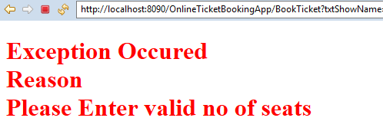

**Table Script:**

drop table shows;

CREATE TABLE Shows(ShowId VARCHAR(5) PRIMARY KEY,ShowName VARCHAR(30) UNIQUE, Location VARCHAR(20),ShowDate DATE,AvSeats NUMBER(3),PriceTicket NUMBER(5,2));

INSERT INTO Shows VALUES('S101','RamLakhan','Satyam','23-Sep-17',50,175);

iNSERT INTO Shows VALUES('S102','Hero','Maratha Mandir','23-Aug-17',125,150);

INSERT INTO Shows

VALUES('S103','Bahubali2','Mona','23-Jul-17',70,350);

INSERT INTO Shows

VALUES('S104','ABCD2','Picture Palace','23-Nov-17',40,475);

INSERT INTO Shows VALUES('S105','Harry Potter','Raj Mandir','13-Nov-17',50,275);

INSERT INTO Shows VALUES('S106','Sholey','Veena','13-Nov-17',150,250);

COMMIT;