MyAir Telecommunication systems wants to provide their customers with an online site for customer registration and for Bill Payment.

Design a web application for AirSpace.

Success.jsp

Register.jsp

CustomerHome.jsp

**<<Controller>>**

DB

**<<Service>>**

**<<DAO>>**

<<Bean>>

PayBill.jsp

1. **Register.jsp** accepts customer details and invokes **ProcessUser.java(Controller)** servlet.After inserting customer details, it displays **CustomerHome.jsp.**

**Register.jsp**

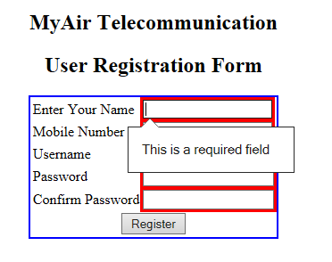

Take Care of the below validations:

1. All fields are mandatory
2. Username can contain only characters
3. Mobile number should be a ten digit number

**Note:** Validation for form data should be done at Client side (Java script or HTML5) wherever applicable.

1. After the user enters all details in above registration form and click on register button ,control will go to the **ProcessUser.java(Controller)** servlet which accepts user details from **Register.jsp** and will use **UserBean** and then inserts it to the database . The UserBean is stored in session and following **CustomerHome.jsp** will be displayed as follows.

**CustomerHome.jsp**

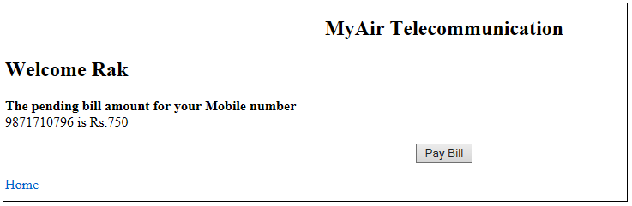

1. The **CustomerHome.jsp** displays the Customer details along with the pending Bill Amount. It has an option to Pay Bill that takes to **PayBill.jsp**

[Note: Pending Bill Amount should be fixed as Rs. 750 ]

1. After the customer click on PayBill button in above pagefollowing **PayBill.jsp** should be displayed which accepts the Amount to pay .

**PayBill.jsp**

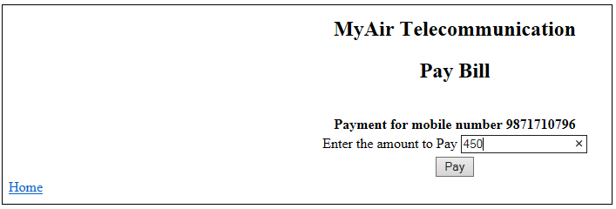

1. After the user enter the bill amount to pay in above page , displays the **Success.jsp** page with a message

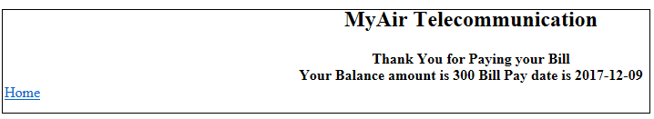

“Thank You for Paying your Bill.

Your Balance amount is <balance_amount> .

Bill Pay Date is <Current Date>”

Balance amount = 750-< Amount paid>

**[Note : amount entered in the above page for bill payment should be greater than than zero and less than 750**

**And**

**CurrentDate shown is LocalDate from java ].**

**errorpage.jsp**

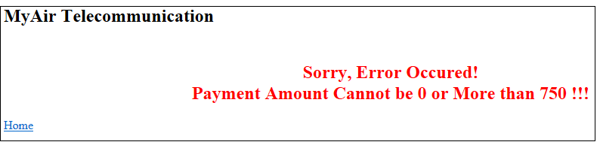

1. Ensure the usage of MVC pattern with Layered Architecture.

**Marks Distribution**

|  |  |
| --- | --- |
| Display Register.jsp as home page | 6 |
| Html or java script validation mention for register page | 4 |
| Insert all user data entered in registration page in userts table | 10 |
| Add UserBean in session before coming to CustomerHome.jsp | 5 |
| Display CustomerHome.jsp | 10 |
| Display PayBill.jsp page after clicking on PayBill button | 10 |
| Business logic to calculate balance amount | 5 |
| Display Success.jsp | 10 |
| Validation in PayBill.jsp for bill amount to pay | 2 |
| Usage of MVC pattern with Layered Architecture | 6 |
| Naming Convention and Coding Standards | 4 |

**Table Script:**

CREATE TABLE users(name VARCHAR2(20), user_name VARCHAR2(30) PRIMARY KEY, password VARCHAR2(12), mobile_number VARCHAR2(12));