A CASE-STUDY BASED REPORT
ON
Predicting Parking Space Availability Using Ensemble Machine Learning Regression with Flask Web Deployment
submitted in partial fulfilment of the requirements for the Course
MACHINE LEARNING
BACHELOR OF TECHNOLOGY
in
A.Y.: 2026-27
by
P. Laxmikanthreddy roll 2520030018
K. Sudheer roll 2520030470
Under the Esteemed guidance of
Jyothsna Datti
Asst.Professor, Dept. of CSE



Abstract
Finding a free space in a busy car park wastes time, fuel and adds to urban congestion. Because parking demand follows predictable patterns of time, place and recent activity, the number of free spaces can be estimated from historical data. This case study builds an end-to-end machine learning system that predicts the number of available parking spaces. It uses a public dataset of 35,399 records collected every half hour or so from 30 car parks in Birmingham, UK, between 4 October and 19 December 2016, and treats the task as a supervised regression problem.
EDA found a clean dataset (no missing values, no duplicates, and AvailableSpaces always equal to Capacity − Occupancy) with a strong daily rhythm: average occupancy climbs from 21% at 07:00 to about 61% at 14:00, is lower at weekends (39% vs 53%), and differs widely across sites. The availability of the previous time step is almost perfectly correlated with the target (r = 0.98). Eleven input features covering location, capacity, time context and recent-availability (lag and rolling-average) features were used, with 24,779 rows for training and 5,310 each for validation and testing. Three ensemble regressors – Extra Trees, Random Forest and Gradient Boosting – were compared using MAE, RMSE and R². Extra Trees performed best (MAE 23.58, RMSE 65.38, R² 0.9925 in the model comparison) and was selected; on the held-out test set it obtained MAE 27.64, RMSE 70.94 and R² 0.9911. The saved model is served by a Flask API and a browser dashboard that also shows occupancy, availability and congestion indicators. The work is a learning project on one city and one season and is not a production traffic-management system.
Keywords: smart parking, availability prediction, regression, Extra Trees, lag features, exploratory data analysis, Flask.
Introduction
Background
Drivers searching for parking account for a noticeable share of city-centre traffic. Parking availability changes during the day and across the week, and a driver who knows in advance how many spaces are likely to be free at a car park can choose a better destination, avoid circling, and reduce congestion and emissions. Operators and city planners also benefit from knowing which sites fill up and when.
Parking-availability prediction has been studied with several families of methods (Table 1). Deep sequence and spatio-temporal models – hybrid ConvLSTM, Bi-LSTM with wavelet denoising, attention-based LSTM, graph networks with GRU, meta-learning and Autoformer variants (Feng et al., 2022 and 2023; Zeng et al., 2022 and 2024; Ye et al., 2024; Kuang et al., 2025; Zeng et al., 2026) – give strong results but need heavy computation and large histories. Classical statistical models such as SARIMA/ARIMA, Markov and queueing models describe arrival and departure behaviour (Li, 2022; Ghoreishi et al., 2025; Chen et al., 2026) but can react poorly to sudden non-seasonal changes. Conventional machine-learning comparisons using Random Forest, Decision Tree, SVM, KNN and Linear Regression (Channamallu et al., 2023; Lilhore et al., 2024; Bagosher et al., 2025) are simpler and often competitive, and SHAP-based work (Errousso et al., 2022) shows how to explain such models.
The 20 papers reviewed share recurring limitations: most use data from a single city or a single lot, several use only a few days or weeks of observations, deep models are costly and hard to interpret, and some rely on simulated data or on extra real-time inputs (weather, cameras, connected vehicles) that smaller parking operators do not have. This case study therefore chooses a lightweight and interpretable route: tree-ensemble regressors fed with time, capacity and recent-availability features from 30 car parks over 73 days, followed by deployment as a working web application.
Table 1: Summary of the literature reviewed
# | Authors | Year | Methodology | Limitation
1 | Feng et al. | 2022 | Hybrid dConvLSTM-DCN learns spatial and temporal patterns for multi-step prediction. | Uses data from one city, and the deep model needs more computation than classical methods.
2 | Paidi | 2022 | LSTM, SARIMAX and an ensemble of tree models are compared for 60-minute forecasting. | Only one parking lot and 21 days of data were used, so broader validation is needed.
3 | Li | 2022 | Markov and queueing models represent changing arrival/departure behavior and forecast occupancy. | Behavioral assumptions may not reflect unusual demand caused by events, weather or disruptions.
4 | Chao et al. | 2022 | DWT removes noise before Bi-LSTM learns the remaining temporal patterns. | The two-stage preprocessing and Bi-LSTM design increases implementation complexity.
5 | Feng et al. | 2023 | Graph convolution with GRU captures relationships between nearby parking zones. | Performance depends on meaningful spatial links between parking zones and may not transfer directly to other cities.
6 | al. | 2023 | Random Forest, Decision Tree, Linear Regression and SVR are evaluated with MAE, RMSE and R². | Results come from one campus garage and do not fully examine weather, events or longer-term seasonality.
7 | al. | 2023 | Reviews machine-learning, deep-learning, hybrid and time-series approaches. | It summarizes existing work rather than introducing a new prediction model.
8 | Ye et al. | 2024 | Time-series decomposition is combined with LSTM and temporal-pattern attention. | Deep attention models require more training resources and sufficient historical observations.
9 | al. | 2024 | Several ML classifiers are compared, including Random Forest, KNN, SVM and Decision Tree. | The threshold-based setup may not represent every parking environment or availability definition.
10 | al. | 2024 | An attention-based MAT-LSTM is improved for parking time-series forecasting. | The neural architecture is less transparent and more demanding than simpler ML models.
11 | Kuang et al. | 2025 | Meta-learning combines spatial, temporal, attention and heterogeneous real-time features. | Requires heterogeneous real-time inputs that may not be available in smaller parking systems.
12 | Kaltenbrunner et al. | 2025 | A stochastic occupancy model estimates parking levels from commuter arrival/departure distributions. | Best suited to commuter parking and may miss irregular urban parking behavior.
13 | Ghoreishi et al. | 2025 | SARIMA forecasts parking conditions from camera-derived traffic flow information. | SARIMA may react poorly to sudden nonlinear changes that are not seasonal.
14 | Bagosher et al. | 2025 | Linear Regression, SVR, Random Forest Regression and LSTM are compared after hyperparameter tuning. | Only three days of observations were used, limiting long-term and seasonal generalization.
15 | Chen et al. | 2026 | Arrival and departure behavior is integrated into a stochastic occupancy forecasting framework. | Transferability can be affected by different driver behavior and unexpected demand changes.
16 | Zeng et al. | 2026 | An enhanced Autoformer uses wavelet and multi-scale decomposition for long-range forecasting. | Transformer-based forecasting can require substantial data and computing resources.
17 | Errousso et al. | 2022 | Multiple ML models are interpreted using SHAP to identify important parking factors. | Five months from one city may not capture all seasonal or geographic conditions.
18 | Bassetti et al. | 2022 | ML models use simulated user behavior to classify future parking availability. | Simulation-based training needs confirmation with real parking-sensor observations.
19 | Sebatlı et al. | 2023 | ARIMA, SARIMA and neural networks are compared for parking-space forecasting. | Model performance may change when external factors such as weather and events are added.
20 | Resce et al. | 2022 | Connected-vehicle features are used to train ML models for occupancy-level prediction. | Simulation data require real-world validation before deployment in operational parking systems.

Motivation for the Project
• Real everyday problem. Searching for parking increases travel time, fuel use and congestion; an availability estimate has direct value to drivers and operators.
• Strong, usable signal. Parking behaviour is not random: hour of day, weekday, site capacity and the recent state of the car park carry predictive information.
• Gap in the literature. Many published models are single-site, short-window or computationally heavy; a simple, explainable ensemble evaluated on 30 sites is a practical alternative.
• Complete ML lifecycle. The project covers data preparation, EDA, feature engineering, model comparison, evaluation and deployment, which matches what the Machine Learning course teaches.
Overview of the Work Carried Out
The work followed six steps: (1) the problem was framed as a supervised regression task whose target is the number of available parking spaces; (2) the dataset was audited for missing values, duplicates and consistency; (3) EDA was performed with distributions, hourly and weekday trends, busiest-location analysis, correlation heatmap and boxplots; (4) 11 model features were assembled from location, capacity, time context and lag/rolling availability; (5) three ensemble regressors – Extra Trees, Random Forest and Gradient Boosting – were trained and compared with MAE, RMSE and R² on separate training, validation and test sets; (6) the best model was saved as a Joblib file (best_parking_prediction_model.pkl) and served through a Flask backend with an HTML/CSS/JavaScript dashboard for prediction, analytics and model-performance views. The code is written in Python with pandas, NumPy, scikit-learn, matplotlib and seaborn.
Scope and Responsible-Use Statement
The scope is predicting the number of free spaces at a given car park from tabular historical and contextual features. The application derives occupied spaces, occupancy %, availability % and a congestion level from this single prediction; the model itself predicts only available spaces. Live sensor feeds, real-time streaming, map integration, mobile apps and cloud deployment are future work and are not part of the current system.
Responsible use. The data come from one city and cover about ten weeks in autumn 2016, so the model has not been validated for other cities, seasons, special events, weather disruptions or post-2016 mobility patterns. Predictions are estimates and should not be treated as guarantees; a driver or operator should not rely on them for safety-critical or legal decisions. Feature importance describes how the model uses its inputs and does not prove cause and effect. The dataset is aggregate occupancy per car park and contains no personal or vehicle-level information.
Problem Statement
Case-Study Scenario
A city has 30 car parks of very different sizes (from 220 to 4,675 spaces) – shopping-centre garages, council car parks and NCP sites. Each site reports how many spaces are occupied roughly every 30 minutes between 07:00 and 16:30. Drivers arriving in the centre have no reliable way of knowing which car park will have space when they arrive, and operators cannot easily see which sites will be under pressure later in the day. The city wants a prediction service that, given the site, the time and the recent availability history, returns the expected number of free spaces and presents it in a simple dashboard.
Central Case-Study Question
Can machine learning predict the number of available parking spaces from historical and contextual information – location, capacity, time of day and recent availability – accurately enough to support occupancy and congestion insights, and which ensemble regression model does it best?
Formal Problem Definition
Let x ∈ ℝ¹¹ be the feature vector of one observation (site identifier, capacity, hour, day, month, day of week, weekend flag, previous availability, lag-2 and lag-3 availability, and rolling-average availability) and let y ∈ ℝ, y ≥ 0, be the number of available parking spaces at that time. Given a training set D = {(xᵢ, yᵢ)}, i = 1…n with n = 24,779, the task is to learn a regression function f : ℝ¹¹ → ℝ that minimises the prediction error on unseen observations. Performance is measured by Mean Absolute Error (MAE = mean|y − ŷ|), Root Mean Squared Error (RMSE = √mean(y − ŷ)²) and the coefficient of determination (R² = 1 − SSres / SStot). Because this is regression, "accuracy" is not used as a metric.
Objectives that Guide the Study
• To prepare a model-ready parking dataset and verify its quality.
• To explore distributions, hourly and weekly trends, location differences and feature relationships through EDA.
• To use temporal, lag and rolling-availability features that describe the recent state of each car park.
• To train and compare three ensemble regressors (Extra Trees, Random Forest, Gradient Boosting) with MAE, RMSE and R².
• To select a final model, report its validation and held-out test performance separately, and examine which features it uses.
• To deploy the model through a Flask API and an interactive dashboard, and to state the limitations of the study.
Assumptions and Limitations
• The occupancy counts reported by the car-park systems are assumed to be accurate.
• Observations are assumed to be representative of future behaviour at the same sites; the data cover only 73 days (4 Oct – 19 Dec 2016), one city, and no full-year seasonality (October to December only).
• Opening hours in the data are 07:00–16:30, so evening and night behaviour is not modelled.
• Lag and rolling-average features are available because recent availability is known when a prediction is made; they are not available for a brand-new site or without a live feed. Predictions are therefore short-horizon estimates, not long-range forecasts.
• No weather, events, holidays, prices or traffic information is included.
• The three models were compared with default-style settings; extensive hyper-parameter search was not performed, so a better configuration of any model may exist.
• The model-comparison table and the final validation/test results come from separate evaluation runs of the project's model report and should not be compared number-for-number.
• The congestion level shown in the application is rule-based application logic, not a model output.
Dataset and Exploratory Data Analysis
About the Dataset
The dataset (parking_dataset.csv) is a car-park occupancy log from Birmingham, UK, covering 30 car parks (identified by SystemCodeNumber) from 4 October to 19 December 2016. It has 35,399 rows and 16 columns, of which 12 are numeric and 4 are text/categorical. About 1,300 records exist for each of the main sites; a few sites have much fewer (for example 144 records for NIA North and 85 for BHMBRTARC01) because they were added or reported for only part of the period.
Table 2: Summary of the parking dataset
Property | Value
Rows × columns | 35,399 × 16
Car parks (SystemCodeNumber) | 30
Period / days | 4 Oct 2016 – 19 Dec 2016 / 73 days; hours 07:00–16:00 (readings until 16:30)
Capacity | 220 – 4,675 spaces (mean 1,399.7)
Target variable | AvailableSpaces (mean 754.0, median 477, max 4,151)
Time features | Hour, Day, Month, DayOfWeek, IsWeekend (26.4% of rows are weekend)
Recent-availability features | Previous_Availability, Lag_2_Availability, Lag_3_Availability, Rolling_Average_Availability
Other columns | Occupancy, OccupancyRate, LastUpdated, Date
Missing values / duplicates | 0 / 0

Table 3 lists the 11 model features. Occupancy and OccupancyRate were not used as inputs because they are directly derived from the same measurement as the target (AvailableSpaces = Capacity − Occupancy holds for every one of the 35,399 rows), so using them would leak the answer.
Table 3: The 11 model input features
Group | Feature | Description
Location | SystemCodeNumber | Identifier of the car park
Capacity | Capacity | Total number of spaces at the site
Time | Hour, Day, Month | Hour of day, day of month, month
Time | DayOfWeek, IsWeekend | Weekday name; 1 if Saturday/Sunday
Recent availability | Previous_Availability | Free spaces at the previous reading
Recent availability | Lag_2_Availability, Lag_3_Availability | Free spaces two and three readings earlier
Recent availability | Rolling_Average_Availability | Rolling mean of recent availability

Purpose of EDA
EDA was carried out before modelling to (a) confirm that the data are complete and internally consistent, (b) understand how occupancy and availability are distributed, (c) discover daily, weekly and site-level patterns that justify the time and location features, (d) measure which variables are related to the target, so that feature engineering and model choice are evidence-based, and (e) identify variables that must be excluded to avoid leakage.
Preparation Steps Actually Performed
• Missing values. Missing counts and percentages were computed for every column and visualised with a heat-map; there were none (0.0% in all 16 columns).
• Duplicates. The dataset was checked for duplicate rows and drop_duplicates() was applied; 0 duplicates were found, so the shape stayed at 35,399 × 16.
• Type separation. Columns were split into 12 numerical features and 4 categorical/text features (SystemCodeNumber, LastUpdated, Date, DayOfWeek).
• Consistency checks. AvailableSpaces + Occupancy = Capacity for all rows, and no negative availability was found, so no records were corrected.
• Outliers. By the 1.5 × IQR rule, about 2,300–2,500 rows are flagged in Occupancy, AvailableSpaces and the availability features. They were kept: they come from the very large car parks (up to 4,675 spaces) and are genuine, not errors. Tree ensembles are insensitive to such values.
• Feature engineering. Time features (Hour, Day, Month, DayOfWeek, IsWeekend) and recent-availability features (Previous, Lag-2, Lag-3 and rolling-average availability) represent the recent state of each site. Target-derived columns (Occupancy, OccupancyRate) and the raw timestamp columns (LastUpdated, Date) were not given to the model.
• Encoding and scaling. The location and weekday identifiers were encoded numerically for model input. No feature scaling was needed because all three models are tree-based.
• Data split. The 35,399 rows were divided into 24,779 training (70%), 5,310 validation (15%) and 5,310 test rows (15%); validation supports model development and the test set is reported separately as the final evaluation.
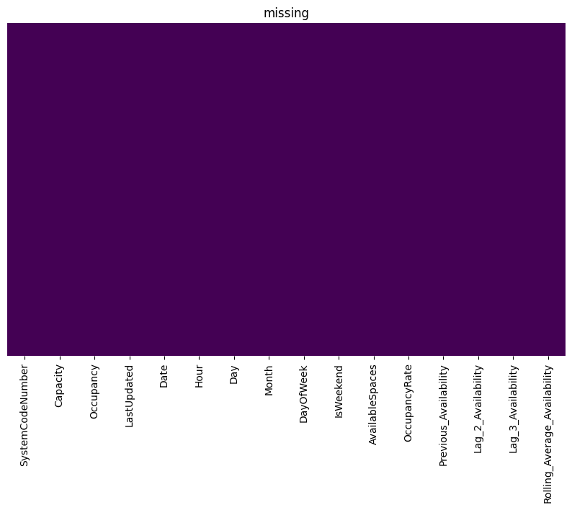
Figure 1: Missing-value heat-map of all 16 columns (no missing cells)
EDA Exploration - Implementation
Feature distributions. Figure 2 shows the histograms of the key variables. The occupancy rate is spread across the whole 0–1 range with most records between 0.15 and 0.8 (mean 0.496). Occupancy and Previous_Availability are strongly right-skewed: most readings are small and a few very large car parks produce counts above 3,000 (skewness 2.2 for Occupancy and 1.5 for the target AvailableSpaces; median available spaces 477 against a mean of 754). Rolling_Average_Availability has the same shape as Previous_Availability, confirming that the lag features follow the target closely. Hour is roughly uniform between 08:00 and 16:00, with fewer records at 07:00. Capacity is multi-modal – most sites hold 300–1,000 spaces and a few hold 2,000–4,700. Month shows that November has the most records and December the fewest (data end on 19 December). Car parks were completely full in 510 records (1.4%) and completely empty in 17.
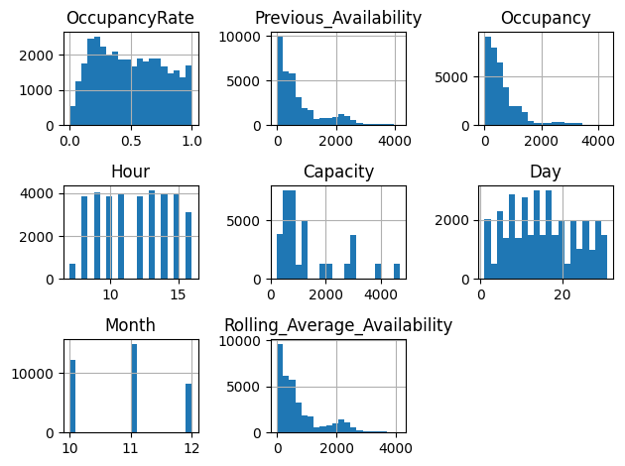
Figure 2: Histograms of key numerical features
Hourly trend. Mean occupancy rises steadily through the morning from 21.0% at 07:00 to 54.6% at 11:00 and peaks at about 60.7% at 14:00, then eases to 50.3% at 16:00 (Figure 3). Hour is therefore an informative time feature. The boxplots in Figure 4 show that the spread at each hour is wide, which is why site identity and capacity matter as well.
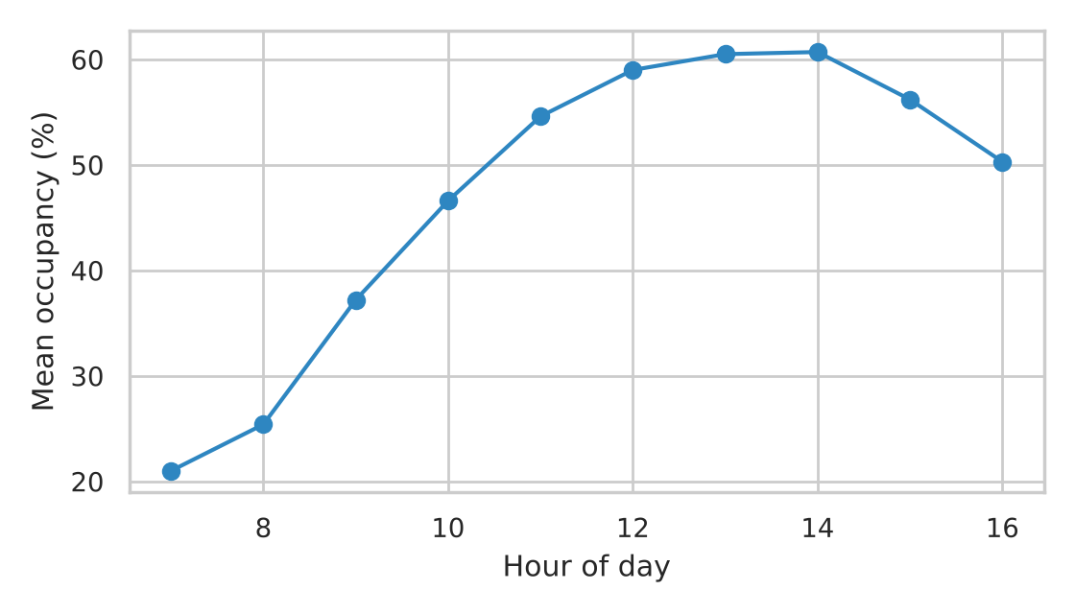
Figure 3: Mean occupancy rate by hour of day
Weekday versus weekend. Occupancy is highest on Thursday (54.7%), Tuesday (54.4%) and Wednesday (54.0%), and lower on Saturday (43.2%) and especially Sunday (35.3%). Weekend rows average 39.2% occupancy against 53.3% on weekdays, supporting the DayOfWeek and IsWeekend features.
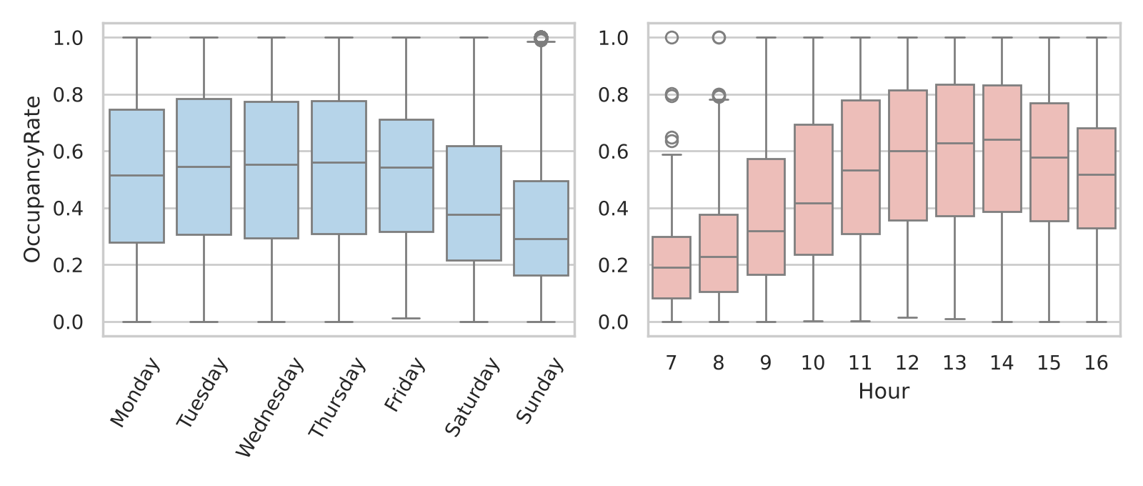
Figure 4: Occupancy rate by day of week (left) and hour of day (right)
Busiest locations. Site-level differences are large (Figure 5). BHMBRTARC01 (77.5%, only 85 records), BHMBCCTHL01 (74.3%), BHMNCPNHS01 (71.7%), BHMNCPLDH01 (70.4%) and BHMMBMMBX01 (69.6%) are the busiest sites, while NIA North (8.1%), NIA Car Parks (16.4%) and Others-CCCPS119a (19.3%) are the quietest. BHMBCCTHL01 has a capacity of only 387 spaces, so it fills up quickly. This justifies using the location identifier and capacity as model inputs.
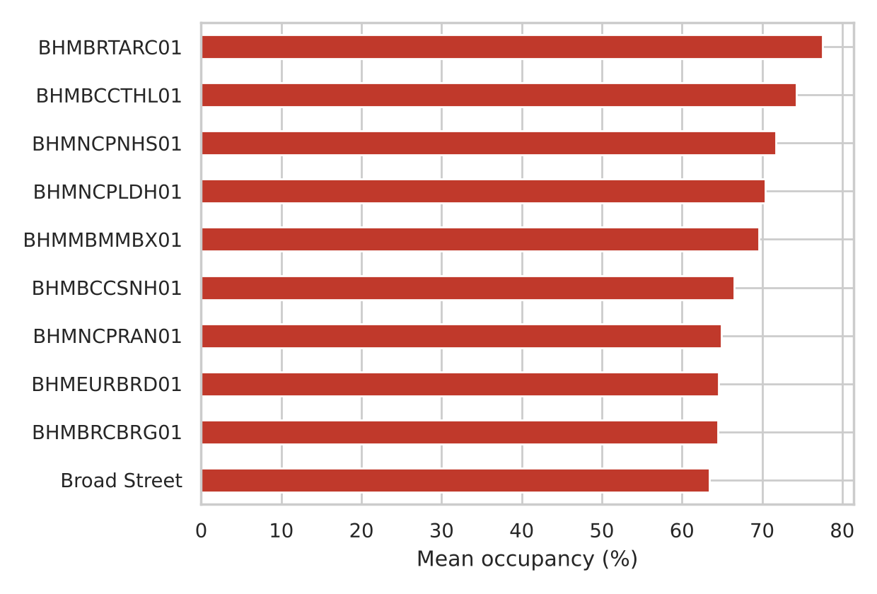
Figure 5: Ten busiest car parks by mean occupancy rate
Correlation analysis. Figure 6 and the correlation matrix show that the recent-availability features are almost perfectly related to the target: Previous_Availability (r = 0.98), Rolling_Average_Availability (0.96), Lag_2_Availability (0.95) and Lag_3_Availability (0.92). Capacity is also strongly related (0.85), while Occupancy (0.33), Hour (−0.16) and IsWeekend (0.09) have weaker linear relations; Day (−0.002) and Month (−0.04) carry almost no linear signal. Capacity and Occupancy are themselves correlated at 0.78. The lag features are highly collinear with each other, which is harmless for tree ensembles but would require care in linear models.
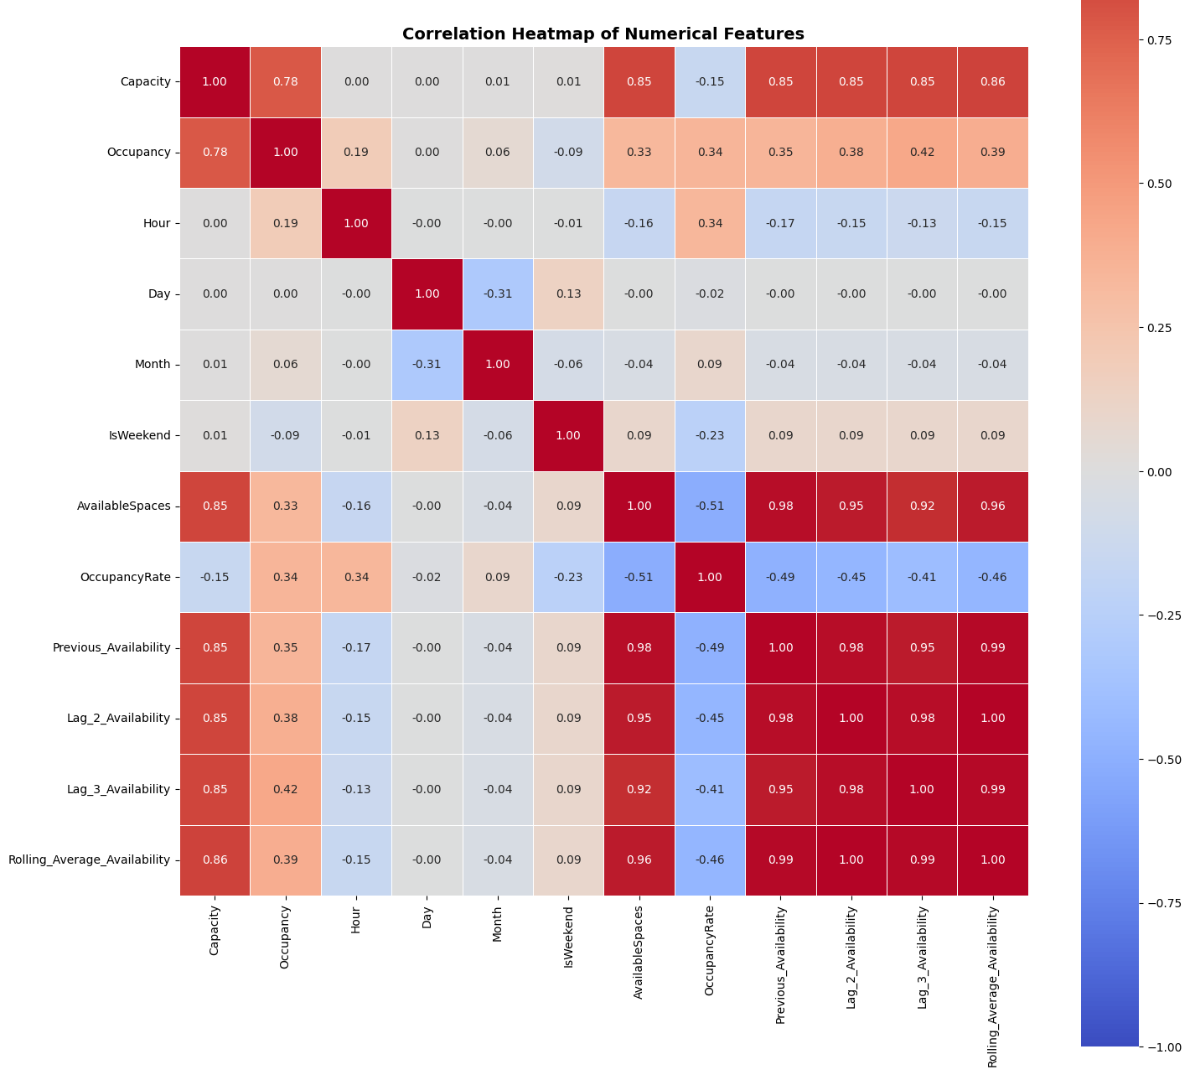
Figure 6: Correlation heat-map of numerical features
Summary of EDA Findings
• The data are clean and consistent: no missing values, no duplicates, AvailableSpaces = Capacity − Occupancy in every row.
• Demand follows a clear daily pattern (21% occupancy at 07:00 to about 61% at 14:00) and a weekly pattern (weekdays 53%, weekends 39%).
• Sites differ strongly in size and busyness (from 8% to 78% average occupancy), so location and capacity are essential inputs.
• The target is right-skewed and the large car parks produce many statistical outliers that are real and were kept.
• Previous, lag and rolling availability are the strongest predictors (r from 0.92 to 0.98), showing that the immediate recent state of a car park is the best guide to its near-future state.
• Occupancy and OccupancyRate must be excluded from the inputs to avoid target leakage.
• Strong non-linear interactions between site, capacity, hour and recent availability make tree ensembles a natural choice.
Algorithm Selection and Implementation
ML formulation. The target, the number of available spaces, is a continuous number, so the task is supervised regression, not classification. The inputs are location, capacity, time context and recent availability; the output is the predicted number of free spaces. The application then derives occupied spaces, occupancy %, availability % and a congestion level from that number.
Why ensembles of trees. EDA showed non-linear relationships and interactions (a given hour means different things at a 387-space car park and a 4,675-space one), skewed values with real outliers, and mixed numeric/categorical inputs. Tree ensembles handle all of these without feature scaling. Three ensemble strategies were compared:
Table 4: Candidate regression models
Model | Strategy | Why it was considered
Extra Trees Regressor | Many randomised decision trees whose predictions are averaged | Extra randomisation reduces variance; fast and strong on tabular data
Random Forest Regressor | Bootstrap-sampled trees whose predictions are averaged | Robust, widely used benchmark ensemble
Gradient Boosting Regressor | Trees built one after another, each correcting earlier errors | Reduces bias step by step; often highly accurate

Evaluation protocol. MAE (average error in spaces), RMSE (penalises large errors) and R² (share of variance explained) were used together instead of one single score. Models were trained on 24,779 rows, compared on the same evaluation data, and the final model was evaluated separately on validation (5,310 rows) and held-out test data (5,310 rows).
Table 5: Model comparison (lower MAE/RMSE and higher R² are better)
Model | MAE | RMSE | R²
Extra Trees | 23.5775 | 65.3839 | 0.9925
Random Forest | 25.9393 | 85.4433 | 0.9871
Gradient Boosting | 45.4396 | 88.0468 | 0.9863

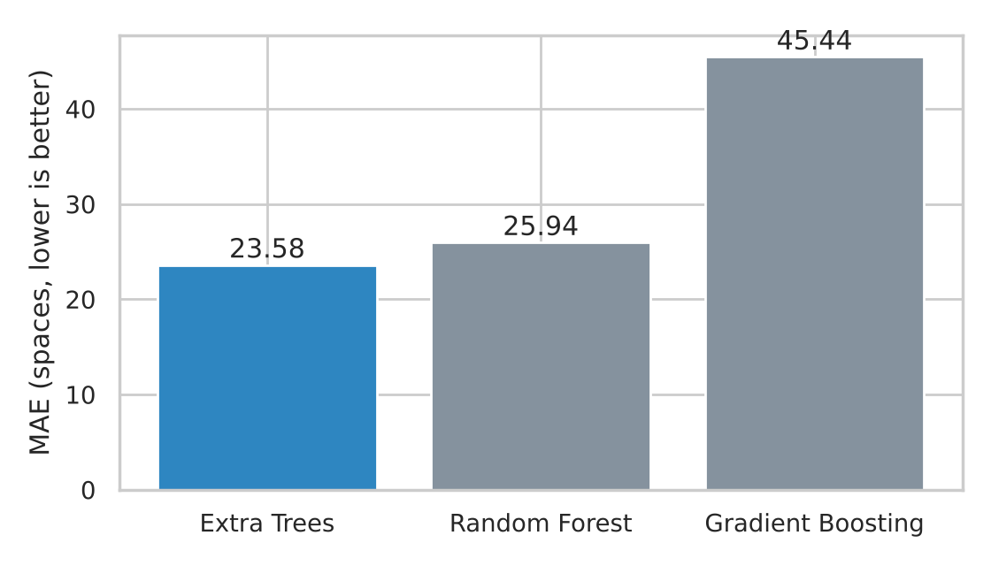
Figure 7: MAE of the three regressors (lower is better)
Results and discussion. Extra Trees had the lowest MAE (23.58 spaces), the lowest RMSE (65.38) and the highest R² (0.9925), so it was selected. Random Forest was close behind in MAE (25.94) but clearly worse in RMSE (85.44), meaning it makes more large errors. Gradient Boosting had the largest MAE (45.44), almost double that of Extra Trees. All three explain more than 98.6% of the variance in available spaces, which is expected because the lag features describe the immediate state of each car park.
Table 6: Extra Trees – validation versus final test performance
Evaluation set | Rows | MAE | RMSE | R²
Validation | 5,310 | 23.6344 | 65.7948 | 0.9924
Final test (held out) | 5,310 | 27.6430 | 70.9382 | 0.9911

On the held-out test set Extra Trees reaches MAE 27.64, RMSE 70.94 and R² 0.9911. The small gap to validation (MAE 23.63, R² 0.9924) shows that the model generalises rather than memorising the training data. Given an average car-park size of about 1,400 spaces, an average error of about 28 spaces is roughly 2% of capacity, and the typical error is small relative to the 754 spaces average availability.
Feature importance. Figure 8 shows what the selected model uses. Previous_Availability is the most important input (0.3218), followed by Rolling_Average_Availability (0.2302), Lag_2_Availability (0.1875), Capacity (0.1186) and Lag_3_Availability (0.1108); Hour contributes 0.0159. The four recent-availability features together account for about 85% of the importance, consistent with the correlations found in EDA. Importance describes how the model uses features; it does not show that these features cause availability.
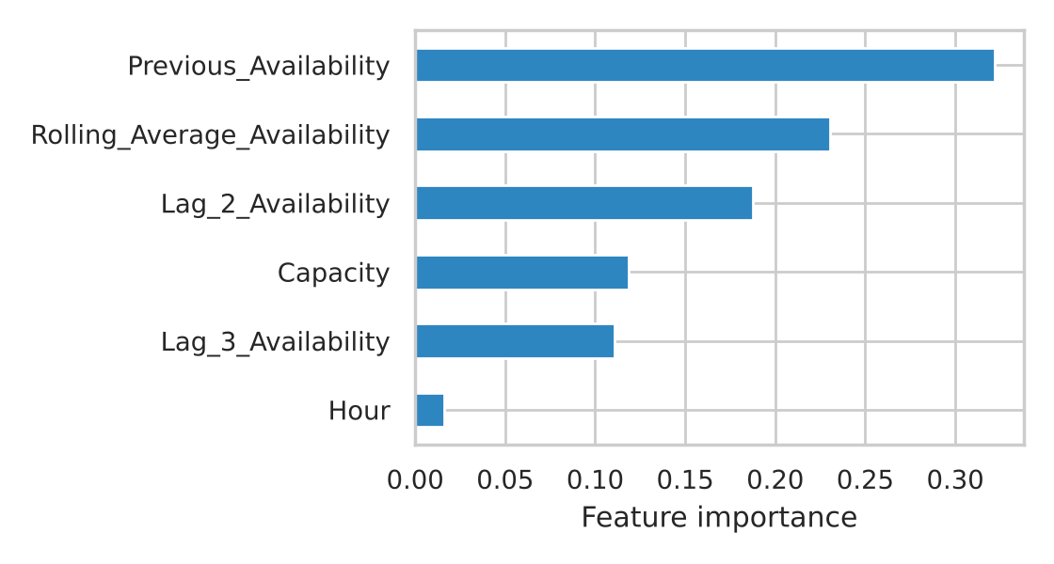
Figure 8: Feature importance of the Extra Trees model (six highest)
Implementation and deployment. The selected model was saved with Joblib as best_parking_prediction_model.pkl. A Flask backend loads it once and exposes JSON endpoints. In the Predictor Engine page the user selects a parking location and supplies capacity, date/day/hour, previous availability, lag values and rolling average; JavaScript posts these as JSON to /api/predict, Flask builds the 11-feature model input and the model returns the predicted free spaces. The application derives occupied spaces, occupancy %, availability % and a congestion level. The system performs inference only and does not retrain when the user clicks Predict. Additional pages present analytics charts (hourly occupancy trend, busiest locations, occupancy load distribution, actual versus predicted free spaces) and a model-performance dashboard with the comparison and feature-importance results.
Table 7: Application architecture
Layer | Technology | Role
Frontend | HTML, CSS, JavaScript | Input form, dashboard, charts
Backend API | Python, Flask | Receives inputs, builds features, returns JSON
Model | Extra Trees (Joblib .pkl) | Predicts available spaces
Outputs | Application logic | Occupied spaces, occupancy %, availability %, congestion level

Conclusion
This case study asked whether the number of free parking spaces can be predicted from historical and contextual information. On the Birmingham dataset of 35,399 records from 30 car parks, the answer is yes. EDA confirmed a clean, consistent dataset with a clear hourly and weekly rhythm, large differences between sites, and recent availability as the dominant signal (r up to 0.98). Using 11 features and three ensemble regressors, Extra Trees gave the best comparison results (MAE 23.58, RMSE 65.38, R² 0.9925) and on the held-out test set achieved MAE 27.64, RMSE 70.94 and R² 0.9911. The model was deployed in a Flask-based web application that turns the predicted number of free spaces into occupancy, availability and congestion insights, completing the lifecycle from data to a usable tool.
Limitations and future work. The data cover one city for about ten weeks in autumn, only daytime hours, and no weather or event information, so results cannot be assumed to hold elsewhere or in other seasons. The model relies on recent-availability inputs, which in practice require a live data feed, and the models were not extensively tuned. The congestion level is a rule applied after prediction. Future work includes live sensor and real-time feed integration, streaming predictions, map and mobile front-ends, cloud deployment, hyper-parameter tuning, time-based validation, adding weather and event data, and comparison with sequence models such as LSTM and SARIMA, which the literature review shows to be strong alternatives.
References
[1] Birmingham City Council car-park occupancy data, parking_dataset.csv (4 Oct – 19 Dec 2016), as supplied with the project.
[2] Feng, Y., Xu, Y., Hu, Q., Krishnamoorthy, S., & Tang, Z. (2022). Predicting vacant parking space availability zone-wisely: a hybrid deep learning approach.
[3] Paidi, V. (2022). Short-term prediction of parking availability in an open parking lot.
[4] Channamallu, S. S. et al. (2023). Examining parking occupancy prediction models: a comparative analysis; and Parking occupancy prediction and analysis – a comprehensive study.
[5] Lilhore, U. K. et al. (2024). Machine Learning-Based Prediction of Parking Space Availability in IoT-Enabled Smart Parking Management Systems.
[6] Errousso, H. et al. (2022). Exploring how independent variables influence parking occupancy prediction: toward a model results explanation with SHAP values.
[7] Bagosher, M. et al. (2025). A Cost-Effective Framework for Predicting Parking Availability Using Geospatial Data and Machine Learning.
[8] Pedregosa, F. et al. (2011). Scikit-learn: Machine Learning in Python. Journal of Machine Learning Research, 12, 2825–2830.
[9] Remaining papers cited in Table 1: see the project literature-review sheet.
Signature of the Team members
P. Laxmikanthreddy (2520030018) K. Sudheer (2520030470)

