No (rectangular parallelepiped) body is perfect
“All in all I’m just another brick in the wall.”

This is yet another try of mine to explain why I believe that no perfect cuboid exists. A cuboid is a rectangular parallelepiped where all edge and all face diagonal lengths are integer numbers. See Fig.1 on the next page.

1. What is a perfect cuboid?
A perfect cuboid is a rectangular parallelepiped where not only all edge and all face diagonal lengths, but also the space diagonal’s length are integer numbers.
Many years of (computerized) searching for a solution did not yield a result and there is neither a proof nor a disproof for the existence of a perfect cuboid until today.

2. What are Pythagorean Triples?
Pythagoras gave proof of the well known.
The triple of numbers,, andis a Pythagorean Triple (PT). The numbers in the triple are the lengths of the two cathetus and the hypotenuse of a rectangular triangle.
In case the three numbers have no common divisor this triple is a Primitive Pythaogrean Triple (PPT). Its numbers are mutually prime i.e. have no common divisor.

3. Two Axioms for Pythagorean Triples
A1 In every PPT the one cathetus is odd, the other cathetus is even, and the hypotenuse is odd.
A2 Every PT is in exactly one way the multiple of a PPT and an integer factor.

4. The face triangles of the cuboid
The three PT on the faces of the cuboid are ,, and . They are multiples of the three PPT,, andand a factorin this way

See Fig. 2 and Fig. 3 on the following page.
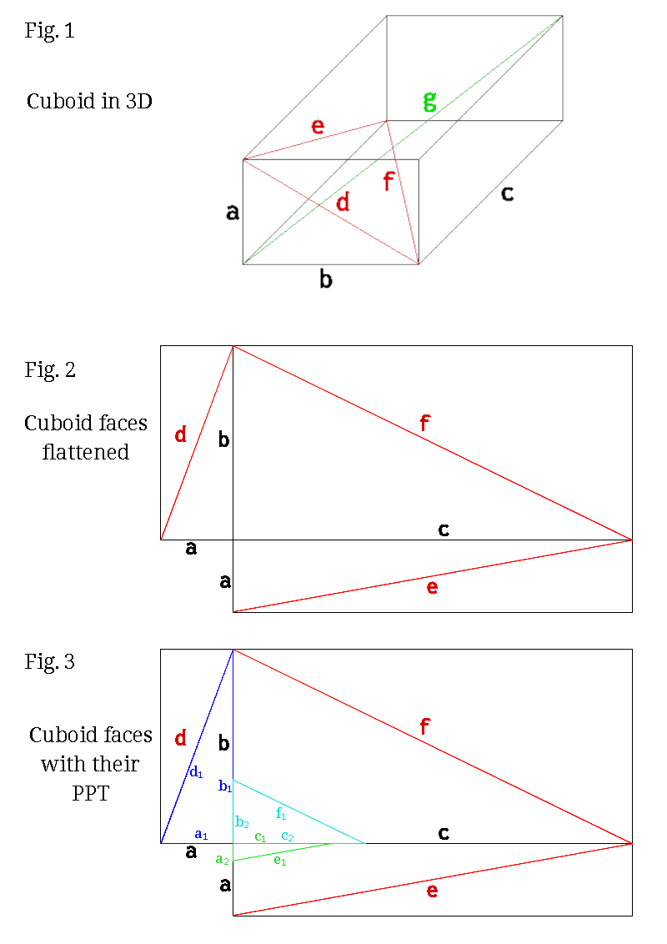

5. Lemma
In a cuboid the three face triangles have lengths which are PT, where each PT is a specific PPT multiplied by a Factor . The edges of the cuboid are each the multiples of two cathetus of two of the three PPT on the faces. This are the three tuples ,,. In every cuboid one of the tuples has two odd numbers, one has two even numbers, and the third one has one odd and one even number.

6. Proof
Assume there exists a smallest solution for a cuboid where the three tuples ,,each have one odd an one even number. As a result each of the cuboid’s edges ,, andas well as the face diagonals,, andlengths would share a common factor of 2. This means the smallest solution for a cuboid would be evenly divisble by 2 and the result be a yet smaller cuboid. This is absurd and so the assumption must be wrong.

7. Consequence for the existence of a perfect cuboid
As a direct consequence of this lemma and proof, a perfect cuboid can not exist. One of its edges is the multiple of an odd number – in two ways. The opposite face diagonal is always a multiple of an odd number because it is the hypotenuse of a PT. According to axiom A1 there is no PPT with two odd cathetus and thus there is, according to axiom A2, no PT where the space diagonal could be the integer hypotenuse.
This consequence can be also stated as:
The diophantine equation does not have a solution.
No sum of three perfect squares is itself a perfect square.

9. The smallest non perfect cuboid
The smallest non-perfect cuboid has the edge lengths

The face diagonal between edges a and b is

The face diagonal between edges a and c is
The face diagonal between edges b and c is
The length of the space diagonal is
The reason that the space diagonal is not an integer number is because of the arrangement of the PPT which are the base for the three PT. Always one edge of the cuboid is the multiple of two odd cathetus of two PPT and can thus not be the even cathetus of the PPT where the other cathetus is the face diagonal on the opposite PT, which is always the multiple of an odd number anyway.
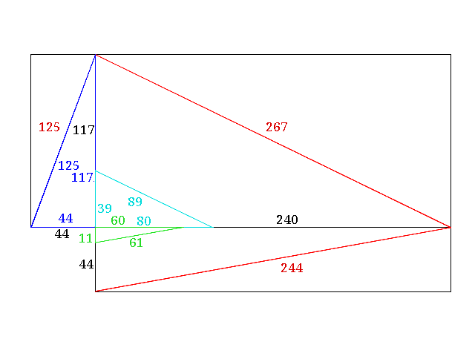
Published 2021-01-22 by Jürgen Buchmüller <pullmoll@t-online.de>

