About the non-existence of the Perfect Cuboid.

Pythagorean triples for relatively prime cathetus.
In a primitive Pythagorean Triple (pPT) two of the three numbers, which represent the length of the cathethus of a rectangular triangle, are replative prime. They share no common divisor. In each such triple the smaller two of the three numbers are the lengths of the cathethus, one of which is even while the other is odd. The largest of the three numbers is the length of the hypotenuse and it is always odd. The smallest pPT consists of the three numbers 3, 4, 5.

Pythagorean triples in general.
The side lengths of every rectangular triangle are the three numbers which represent a general Pythagorean Triple (PT).

Rule for building PT.
Every PT is in exactly one way the product of a pPT and an integer factor f ∈ ℤ.

The Cuboid.
A cuboid (Euler brick) ist brick in which the lengths of the sides x, y, z, and also the lengths of the diagonals a, b, c of the face rectangular triangles are integer numbers. Die three lengths of the face triangles ⊿xya, ⊿xzb und ⊿yzc are thus PT and they are built from their three pPT ⊿x_{a}y_{a}a_{a}, ⊿x_{b}z_{b}b_{b} and ⊿y_{c}z_{c}c_{c}. Die subscript indices a, b, and c indicate the pPT, from which the PT is built as a multiple, i.e. by multiplying with one of the respective factors f_{a}, f_{b}, and f_{c}.
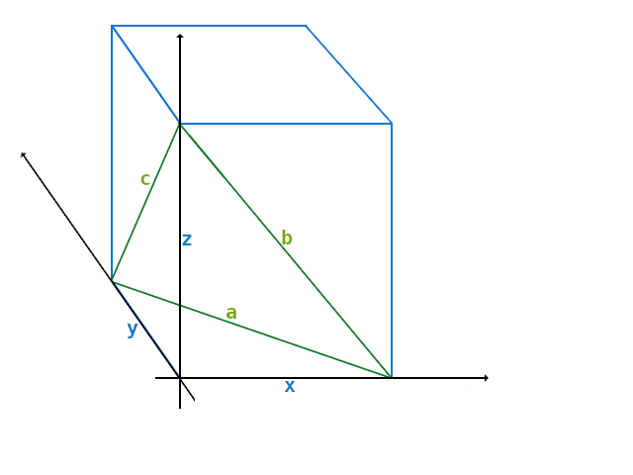

N.B.
The smalles Cuboid is x=44, y=117, z=240.
Therefore it has a=125, b=244, c=267.

The PT are ⊿xya = 44, 117, 125, ⊿xzb = 44, 240, 244 and ⊿yzc = 117, 240, 267.

Its pPT are with f_{a}=1; ⊿x_{a}y_{a}a_{a} = 44, 117, 125, with f_{b}=4;⊿x_{b}z_{b}b_{b} = 11, 60, 61, and with f_{c}=3; ⊿y_{c}z_{c}c_{c} = 39, 80, 89.

Possible configurations.
There are exactly two possible configurations in which the cathethus of the pPT of the face triangles can be connected to each other in the edges of a Cuboid.

All pPT are in regular order.
There is always one odd cathethus of one pPT connected with the even cathethus of the next pPT in each of the three edges of the cuboid. The cathetus of the pPT meet in the edges x, y, z of the cuboid always one‘s even to the other‘s odd: x_{a} to x_{b}, y_{a} to y_{c} and z_{b} to z_{c}.

One of the pPT is flipped.
One of the pPT of the face triangles is flipped, which means the cathetus of the pPT in the edges of the cuboid could for example be like this:

x: two odd length cathetus: x_{a} and x_{b}
y: two even length cathetus: y_{a} and y_{c}
z: one even and one odd cathetus: z_{b} and z_{c}

The perfect cuboid.
A perfect cuboid ist a cuboid (Euler brick), in which also the length of the space diagonal g, which goes from one corner through the brick to the opposite corner, is an integer number. Until today it is not known whether such a cuboid exists, or if there is a proof for its existence or against it. The length of the space diagonal g of a cuboid with the edge lengths x, y und z ist defined by the equation:

A perfect cuboid with 5.1?
We assume there is a smallest possible solution for a perfect cuboid. The configuration 5.1 can not be the one of a solution, because all of the edges lengths x, y, and z, and the face diagonals, a, b, and c, as well as the length of the space diagonal g would be multiples of even numbers (remember: each edge is, by one pPT, the multiple of an even number). As a consequence the smalles possible solution would be divisible by two, which of course contradicts the assumption.

A perfect cuboid with 5.2?
Because of the commutativity of the three summands in the square root, and because „Pythagoras 3D“ can be calculated by two consecutive applications of the Pythagoras rules, the following three equations are equivalent:

In these equations each of a, b and c is the multiple of a hypotenus a_{a}, b_{b}, or c_{c} of one of the pPT and as such the multiple of an odd number. Because of 3. Rule for building PT the cathetus x, y, and z all must be multiples of even numbers. But in configuration 5.2 exactly one of the edge lengths x, y, and z of the cuboid is the multiple of two of the odd length cathethus of three pPT of the face triangles.
In the example give the edge x is a multiple of x_{a} and also x_{b}, both of which are odd.
The last of the three equations above does not match the condition of 3. Rule for building PT.

As a consequence the system of the three equaions can not have a solution either.

Bonn in September 2019
Jürgen Buchmüller <pullmoll@t-online.de>

