LAB 10 – CODE REVIEW AND QUALITY
Using AI to Improve Code Quality and Readability
Name:P.Manvith
Rollno:2503a52378
Batch-13

Task 1 – Syntax and Logic Errors

Question
Use AI to identify and fix syntax and logic errors in the given Python script that calculates a student’s average score.

Prompt:
“Review this Python code, fix syntax and logic errors, keep the same purpose, and briefly explain every correction.”

Code
def calc_average(marks):
if not marks:
return 0
total = 0
for mark in marks:
total += mark
average = total / len(marks)
return average
marks = [85, 90, 78, 92]
print("Average Score is", calc_average(marks))

Output:
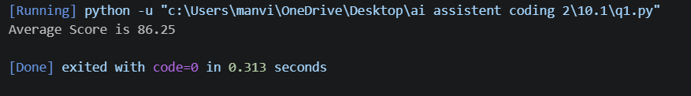

Justification
The variable name ‘avrage’ was misspelled; it was corrected to ‘average’. A closing parenthesis was added to the print statement. The function now handles an empty list to avoid division by zero. The average of 85, 90, 78, and 92 is 86.25.

Task 2 – PEP 8 Compliance

Question
Refactor the rectangle-area program to follow PEP 8 style guidelines.

Prompt
“Rewrite this Python code using PEP 8 naming, spacing, and formatting. Keep the calculation and result unchanged.”

Corrected Code
def area_of_rectangle(length, breadth):
"""Return the area of a rectangle."""
return length * breadth
print(area_of_rectangle(10, 20))

Output:
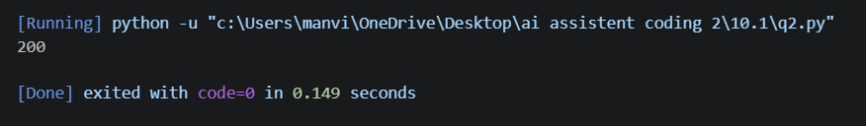

Justification
The function name is descriptive, parameters use lowercase words, spaces are placed around operators, and the function body is formatted across multiple lines. A docstring explains the function. The logic remains length × breadth, so the output is still 200.

Task 3 – Readability Enhancement

1. Question
Improve readability without changing the logic. Use descriptive variable names, inline comments, and clear formatting.

Prompt
“Improve the readability of this code without changing its calculation. Use meaningful names, clear formatting, and a helpful comment.”

Code
def calculate_percentage(value, percentage):
"""Calculate a percentage of a given value."""
# Multiply the value by the percentage and divide by 100.
return value * percentage / 100
total_value = 200
percentage_rate = 15
result = calculate_percentage(total_value, percentage_rate)
print(result)

Output:
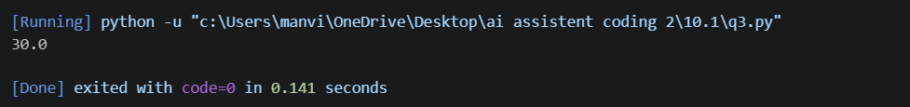

Justification
The unclear function name ‘c’ was changed to ‘calculate_percentage’, and short variable names were replaced with descriptive names. A docstring and inline comment explain the calculation. The formula and values remain unchanged, so the result is 30.0.

Task 4 – Refactoring for Maintainability

Question
Refactor repetitive welcome messages into a reusable function.

Prompt
“Refactor the repeated welcome print statements into a reusable function and loop through the student list. Keep the same messages.”

Code
def welcome_student(student_name):
"""Print a welcome message for one student."""
print("Welcome", student_name)
students = ["Alice", "Bob", "Charlie"]
for student in students:
welcome_student(student)

Output:
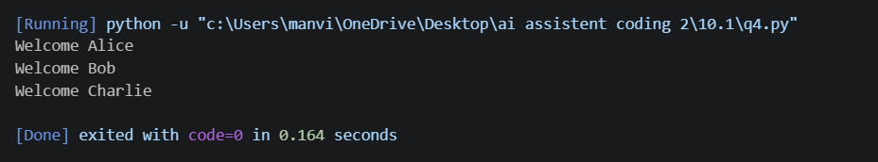

Justification
The repeated print statements were moved into the reusable welcome_student() function. A loop processes every name in the list, reducing duplication and making the program easier to maintain. If more students are added, no extra print statements are required.

Task 5 – Performance Optimization

Question
Optimize the program that calculates squares of numbers from 1 to 999,999.

Prompt
“Optimize this Python code for speed and simplicity. Avoid creating an unnecessary intermediate list of numbers, preserve the final count, and explain the change.”

Code
# Generate squares directly using a list comprehension.
squares = [number ** 2 for number in range(1, 1_000_000)]
print(len(squares))

Output:
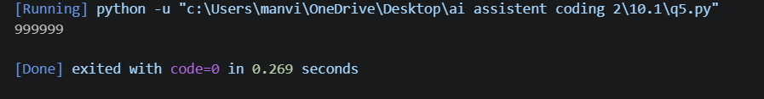

Justification
The separate nums list and append loop were removed. A list comprehension creates the square values in one concise expression and avoids storing a separate list of the original numbers. The program still stores the squares because the task asks to build a squares list and print its length. If only the count were required, len(range(1, 1_000_000)) would be even more memory-efficient.

Task 6 – Complexity Reduction

Question
Simplify the nested if-else logic used to assign a grade based on a score.

Prompt
“Simplify the nested grade function using elif. Preserve the existing grade boundaries and return values, and include a few test cases.”

Code
def grade(score):
"""Return a letter grade based on the score."""
if score >= 90:
return "A"
elif score >= 80:
return "B"
elif score >= 70:
return "C"
elif score >= 60:
return "D"
else:
return "F"
print(grade(95))
print(grade(82))
print(grade(74))
print(grade(65))
print(grade(40))

Output:
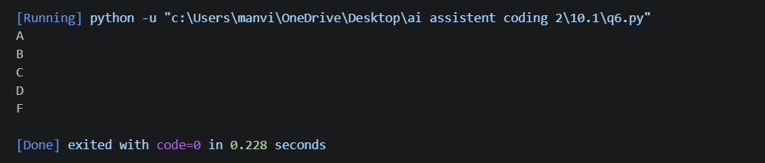

Justification
The nested if-else statements were replaced with a clear if-elif-else chain. Since conditions are checked from highest to lowest score, the first matching condition returns the correct grade. The score thresholds and grade labels are unchanged, while readability and maintainability are improved.

