AI-BASED CODING LAB – EXPERIMENT 6
AI-Based Code Completion: Working with Classes, Loops and Conditionals
Name: P.Manvith
Roll No: 2503a52378
Batch: 13

Task Description #1 – AI-Based Code Completion for Loops
Prompt: “Generate Python code to print all even numbers between 1 and N using a loop.”

Python Code
def print_even_numbers(n):
print("Even numbers between 1 and", n, ":")
for number in range(1, n + 1):
if number % 2 == 0:
print(number, end=" ")
n = 20
print_even_numbers(n)

Output
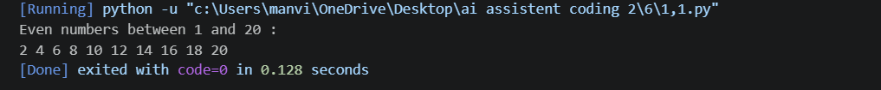

Explanation / Review
A for loop visits every number from 1 to N. The if condition checks number % 2 == 0. For N = 20, the program correctly prints all even numbers.

Task Description #2 – AI-Based Code Completion for Loop with Conditionals
Prompt: “Generate Python code to count how many numbers in a list are even and odd.”

Python Code
def count_even_odd(numbers):
even_count = 0
odd_count = 0
for number in numbers:
if number % 2 == 0:
even_count += 1
else:
odd_count += 1
return even_count, odd_count
numbers = [10, 15, 22, 31, 40, 53, 64, 77]
even, odd = count_even_odd(numbers)
print("List:", numbers)
print("Even numbers:", even)
print("Odd numbers:", odd)

Output
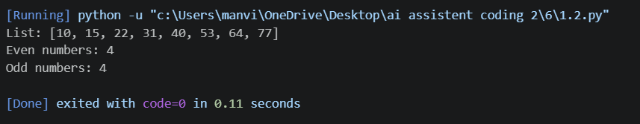

Explanation / Review
The loop processes each list element. The conditional checks divisibility by 2 and increments the appropriate counter. The sample has four even and four odd values.

Task Description #3 – AI-Based Code Completion for Class Attributes Validation
Prompt: “Generate a Python class User that validates age and email using conditional statements.”

Python Code
class User:
def __init__(self, name, age, email):
self.name = name
self.age = age
self.email = email
def validate(self):
age_valid = self.age >= 18
email_valid = "@" in self.email and "." in self.email
if age_valid and email_valid:
return True, "User details are valid."
elif not age_valid and not email_valid:
return False, "Age must be 18 or above and email is invalid."
elif not age_valid:
return False, "Age must be 18 or above."
else:
return False, "Email is invalid."
user1 = User("P.Manvith", 19, "manvith@example.com")
print("Test 1:", user1.validate()[1])
user2 = User("Student1", 16, "student1@example.com")
print("Test 2:", user2.validate()[1])
user3 = User("Student2", 20, "student2example.com")
print("Test 3:", user3.validate()[1])

Output
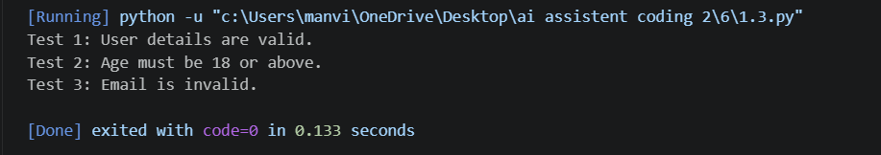

Explanation / Review
The User class stores name, age and email. The validate method uses conditional statements to check age and email format. The three tests cover valid input, invalid age and invalid email.

Task Description #4 – AI-Based Code Completion for Classes
Prompt: “Generate a Python class Student with attributes (name, roll number, marks) and methods to calculate total and average marks.”

Python Code
class Student:
def __init__(self, name, roll_number, marks):
self.name = name
self.roll_number = roll_number
self.marks = marks
def calculate_total(self):
return sum(self.marks)
def calculate_average(self):
if len(self.marks) == 0:
return 0
return self.calculate_total() / len(self.marks)
def display_details(self):
print("Name:", self.name)
print("Roll Number:", self.roll_number)
print("Marks:", self.marks)
print("Total Marks:", self.calculate_total())
print("Average Marks:", self.calculate_average())
student = Student("P.Manvith", "2503a52378", [85, 90, 78, 88, 92])
student.display_details()

Output
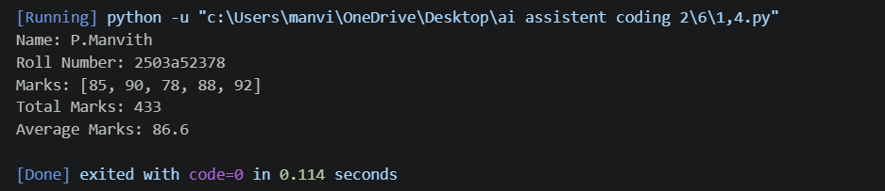

Explanation / Review
Manual improvement: calculate_average checks for an empty marks list before division. This prevents ZeroDivisionError and makes the class safer.

Task Description #5 – AI-Assisted Code Completion Review
Prompt: “Generate a Python program for a simple bank account system using class, loops, and conditional statements.”

Python Code
class BankAccount:
def __init__(self, account_holder, balance=0):
self.account_holder = account_holder
self.balance = balance
def deposit(self, amount):
if amount > 0:
self.balance += amount
print("Deposit successful.")
else:
print("Invalid deposit amount.")
def withdraw(self, amount):
if amount <= 0:
print("Invalid withdrawal amount.")
elif amount > self.balance:
print("Insufficient balance.")
else:
self.balance -= amount
print("Withdrawal successful.")
def display_balance(self):
print("Account Holder:", self.account_holder)
print("Current Balance:", self.balance)
account = BankAccount("P.Manvith", 5000)
while True:
print("\n--- Bank Account Menu ---")
print("1. Deposit")
print("2. Withdraw")
print("3. Display Balance")
print("4. Exit")
choice = input("Enter your choice: ")
if choice == "1":
amount = float(input("Enter deposit amount: "))
account.deposit(amount)
elif choice == "2":
amount = float(input("Enter withdrawal amount: "))
account.withdraw(amount)
elif choice == "3":
account.display_balance()
elif choice == "4":
print("Thank you for using the bank system.")
break
else:
print("Invalid choice. Please try again.")

Output
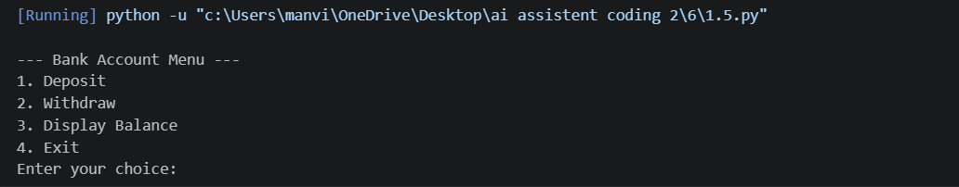

Explanation / Review
Strengths: AI quickly generated the class, loop, menu and conditional logic. Limitations: the code still needs testing and exception handling for invalid non-numeric input. Reflection: AI provides a fast starting point, but human review is required for correctness, safety and understanding.

