LAB EXPERIMENT: DOCUMENTATION GENERATION
Automatic Documentation and Code Comments
Name: P.Manvith
Rollno: 2503a52378
Batch-13

Problem 1: Documenting find_max(numbers)

Question:
Document the given function return max(numbers) in (a) docstring, (b) inline-comment, and (c) Google-style formats. Compare all three and recommend one for a mathematical utilities library.
Prompt:
Document the find_max(numbers) function in three formats: regular docstring, inline comments, and Google-style docstring. Explain arguments, return value, and possible exceptions. Do not change the function logic.

Code:
# (a) Docstring format
def find_max(numbers):
"""Return the largest value in a non-empty iterable.

Args:
numbers: A non-empty iterable of comparable values.

Returns:
The largest value in numbers.

Raises:
ValueError: If numbers is empty.
"""
return max(numbers)

# (b) Inline comments format
def find_max_comments(numbers):
# Return the largest value from the given numbers.
# max() raises ValueError if the iterable is empty.
return max(numbers)

# (c) Google-style docstring format
def find_max_google(numbers):
"""Return the maximum value from a collection of numbers.

Args:
numbers: A non-empty iterable of comparable numbers.

Returns:
The maximum value.

Raises:
ValueError: If numbers is empty.
"""
return max(numbers)

# Testing
values = [10, 25, 7, 40, 15]

print("Maximum:", find_max(values))
print("Maximum using comments:", find_max_comments(values))
print("Maximum using Google style:", find_max_google(values))

help(find_max_google)

Output :
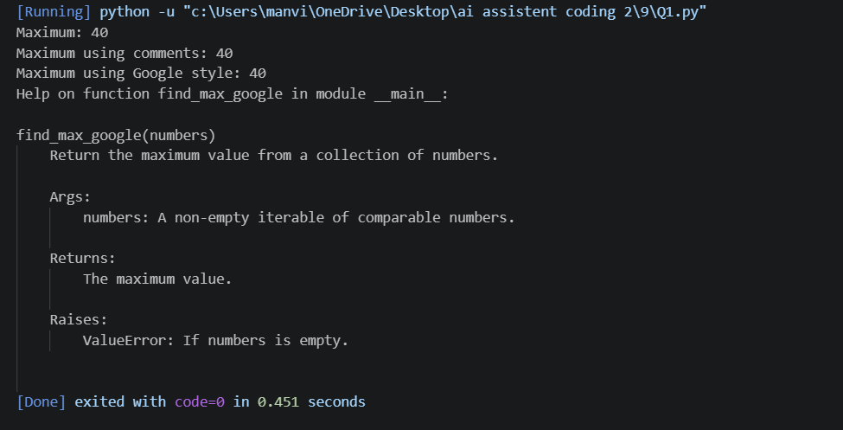

Justification:
The structured Google-style format gives reusable mathematical functions a consistent, maintainable public reference. The stated empty-input behavior follows Python's built-in max().

Problem 2: Documenting login(user, password, credentials)

Question:
Document the given login function in all three formats, compare the approaches, and recommend a style that helps new developers onboarding to a project.
Prompt:
Document login(user, password, credentials) using a regular docstring, inline comments, and Google-style docstring. Explain parameters, return value, and security limitations. Keep the same function logic.
Code:
# (a) Docstring format
def login(user, password, credentials):
"""Check whether the supplied password matches the stored value.

Args:
user: Username to check.
password: Password supplied by the user.
credentials: Dictionary containing usernames and stored values.

Returns:
True if the values match; otherwise False.
"""
return credentials.get(user) == password

# (b) Inline comments format
def login_comments(user, password, credentials):
# Get the stored value for the given username.
# Compare it with the password supplied by the user.
return credentials.get(user) == password

# (c) Google-style docstring format
def login_google(user, password, credentials):
"""Check the supplied password against the stored user value.

Args:
user: Username being checked.
password: Password supplied by the user.
credentials: Mapping of usernames to stored values.

Returns:
bool: True if the values match; otherwise False.
"""
return credentials.get(user) == password

# Testing with sample data only
credentials = {
"student": "demo123",
"teacher": "teach456"
}

print("Correct password:", login("student", "demo123", credentials))
print("Incorrect password:", login("student", "wrong", credentials))
print("Unknown user:", login("guest", "abc", credentials))

help(login_google)

Output :
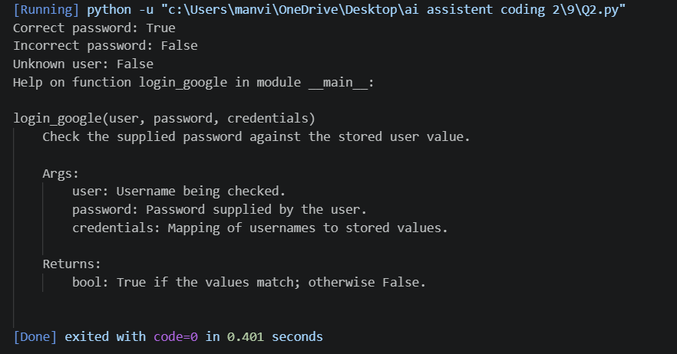

Justification
Structured documentation makes the function easier for a new developer to understand. The security note is important because the one-line comparison alone does not communicate production password-handling requirements.

Problem 3: Calculator Module

Question
Create calculator.py with add, subtract, multiply, and divide; add docstrings; display documentation in the terminal; export HTML with pydoc and open it in a browser.
Prompt:
Create calculator.py with add(a, b), subtract(a, b), multiply(a, b), and divide(a, b). Add clear docstrings and handle division by zero appropriately. Include sample tests.

Code:
"""Basic arithmetic utilities: addition, subtraction, multiplication, division."""
def add(a, b):
"""Return the sum of a and b."""
return a + b
def subtract(a, b):
"""Return a minus b."""
return a - b
def multiply(a, b):
"""Return the product of a and b."""
return a * b
def divide(a, b):
"""Return a divided by b.
Raises:
ZeroDivisionError: If b is zero.
"""
return a / b
if __name__ == "__main__":
print("add(8, 2) =", add(8, 2))
print("subtract(8, 2) =", subtract(8, 2))
print("multiply(8, 2) =", multiply(8, 2))
print("divide(8, 2) =", divide(8, 2))

Output :
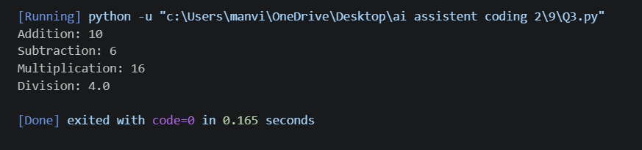

Justification
Docstrings make the module self-documenting. pydoc reads the module and function docstrings to display terminal help and generate HTML without requiring a separate manual.

Problem 4: Conversion Utilities Module

Question
Create conversion.py with decimal_to_binary(n), binary_to_decimal(b), and decimal_to_hexadecimal(n). Use Copilot for docstrings, show terminal documentation, export HTML, and open it in a browser.
Prompt:
Create conversion.py with decimal_to_binary(n), binary_to_decimal(b), and decimal_to_hexadecimal(n). Add Google-style docstrings, validate inputs, and include example tests.

Code:
"""Utilities for converting integers between decimal, binary, and hexadecimal."""
def decimal_to_binary(n):
"""Convert a non-negative integer to binary without a 0b prefix.
Args:
n: Non-negative integer.
Returns:
Binary representation as a string.
Raises:
ValueError: If n is negative.
"""
if n < 0:
raise ValueError("n must be non-negative")
return format(n, "b")
def binary_to_decimal(b):
"""Convert a non-empty binary string to a decimal integer.
Args:
b: String containing only 0 and 1 characters.
Returns:
Decimal integer represented by b.
Raises:
ValueError: If b is empty or contains other characters.
"""
if not b or any(ch not in "01" for ch in b):
raise ValueError("b must be a non-empty binary string")
return int(b, 2)
def decimal_to_hexadecimal(n):
"""Convert a non-negative integer to lowercase hexadecimal without 0x.
Args:
n: Non-negative integer.
Returns:
Hexadecimal representation as a string.
Raises:
ValueError: If n is negative.
"""
if n < 0:
raise ValueError("n must be non-negative")
return format(n, "x")
if __name__ == "__main__":
print("13 in binary:", decimal_to_binary(13))
print("1101 in decimal:", binary_to_decimal("1101"))
print("255 in hexadecimal:", decimal_to_hexadecimal(255))

Output :
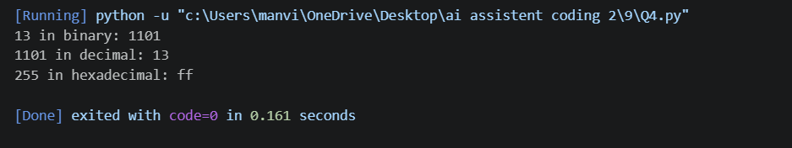

Final Justification
The docstrings explain valid inputs, results, and invalid-input errors. pydoc can automatically use these docstrings to create terminal and HTML references.

Problem 5: Course Management Module

Question:
Create course.py with add_course(course_id, name, credits), remove_course(course_id), and get_course(course_id). Add Copilot docstrings, display terminal documentation, export HTML, and open it in a browser.
Prompt:
Create course.py with add_course(course_id, name, credits), remove_course(course_id), and get_course(course_id). Use a dictionary for storage, add Google-style docstrings, validate input, and include sample tests.

Code:
"""Simple in-memory course catalogue management."""
_courses = {}
def add_course(course_id, name, credits):
"""Add a course to the catalogue.
Args:
course_id: Unique course identifier.
name: Course name.
credits: Positive number of course credits.
Returns:
The stored course record.
Raises:
ValueError: If fields are invalid or the ID already exists.
"""
if not course_id or not name:
raise ValueError("course_id and name must not be empty")
if credits <= 0:
raise ValueError("credits must be positive")
if course_id in _courses:
raise ValueError("course ID already exists")
course = {"course_id": course_id, "name": name, "credits": credits}
_courses[course_id] = course
return course
def remove_course(course_id):
"""Remove a course by ID.
Args:
course_id: Identifier of the course to remove.
Returns:
True if removed; otherwise False.
"""
return _courses.pop(course_id, None) is not None
def get_course(course_id):
"""Return a course record by ID, or None if not found.
Args:
course_id: Identifier of the course to retrieve.
Returns:
Course dictionary, or None when the ID is unknown.
"""
return _courses.get(course_id)
if __name__ == "__main__":
add_course("CS101", "Introduction to Programming", 4)
add_course("MA101", "Engineering Mathematics", 3)
print("CS101:", get_course("CS101"))
print("Removed MA101:", remove_course("MA101"))
print("MA101 after removal:", get_course("MA101"))

Output :
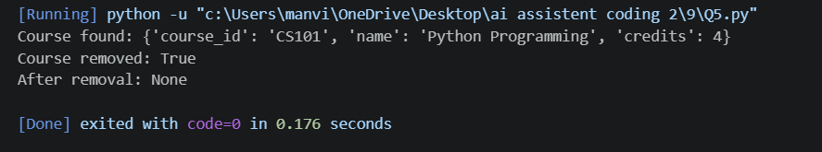

Justification
The module documents the three course operations and their return behavior. pydoc automatically collects these docstrings into terminal help and an HTML reference.

