The idea: Months ago, when we finished the initial version of the Spatz integration into the TeraNoC architecture, we found that, compared to Snitch, the Spatz vector core has a much higher compute density and can tolerate much higher memory access latency and sustain more in-flight memory transactions. At this point, considering the future integration of tensor cores like RedMulE, which have even more compute power and in-flight memory transactions, the performance bottleneck has fully shifted to traffic congestion and bandwidth limitations on the global core-to-L1 NoC. To solve this problem and further scale the cluster, we came up with several ideas that attack it from different angles. One idea, which Yinrong Li is working on, is to use a wide data path, which has a much better payload-to-meta ratio for the NoC flit and therefore moves more data over the same number of NoC wires. What I am working on is exploiting the data reuse among cores in the same group: coalescing their requests so that less traffic reaches the global NoC at all.
- Spatz VLSU burst support. The vector LSU splits aligned unit-stride loads into 16-word bursts, converting many single-word remote requests into a few burst requests that the MSHR can coalesce efficiently. The current design supports bursts of up to 64B, the width of a tile SPM: a 64B vector load turns 16 x 4B requests into 1 burst request, reducing request-side NoC traffic by 16x.
- Group MSHR coalescing. For LLM inference workloads, the dominant kernels are GEMM and batch GEMV, which are essentially the matmult kernels we use. In the matmult, to compute one output element C[m][p] a core must read an entire row of A (row m) and an entire column of B (column p). So two cores computing different outputs in the same row of C read exactly the same row of A. Two cores in the same column of C read exactly the same column of B. The sharing is not a coincidence of our tiling; it is forced by which index each operand depends on. In light of this, and based on the workload partition of the cores in the same group, we get the data access pattern shown in Figure 1: for the 512xNxP shapes the accesses to both matrix A and matrix B from the same group are 4:1 merged, so both request-side and response-side traffic are reduced by 4x. The two sharing degrees follow from the work split and shift with M: the group's 16 cores form a split_m x split_p grid, in which A is shared split_p ways and B is shared split_m ways. At 256xNxP that grid is 2x8, giving 8:1 on A and 2:1 on B. Because A is fetched by scalar loads while B is fetched in 16-word bursts, A generates about 4x more requests, so the traffic-optimal grid is not the square one - the 2x8 shapes reach a 5.0x aggregate reduction against 4.0x for the square 4x4 grid. Across every shape we measured, the merge ratio the hardware achieves matches the degree predicted from (M, N, P) exactly.
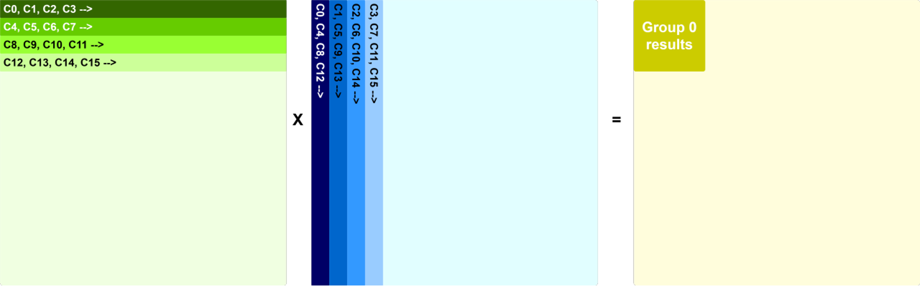
Fig 1, Data sharing of the cores within a group for the matmul workload. Based on the above observation, we can design a per-group MSHR that merges those outstanding remote loads into one NoC request and multicasts the single returned line back to every requester, cutting request pressure and redundant response bandwidth.
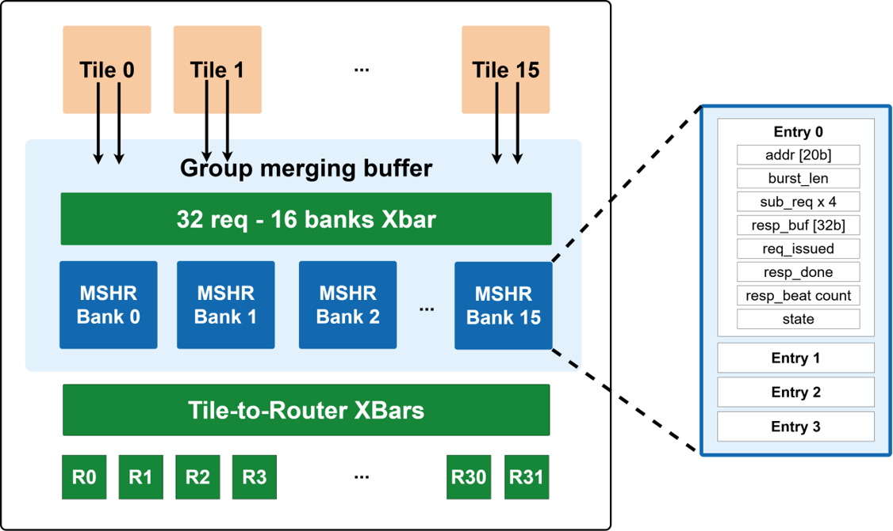
Fig 2, Group MSHR architecture. As shown in Figure 2, each group has 64 MSHR entries, divided into 16 banks to ensure physical feasibility, and all of the tile-to-MSHR, MSHR-to-NoC, NoC-to-MSHR and MSHR-to-tile interconnects are banked as well, to relieve backend wiring pressure. Each MSHR entry is 186 bits, giving about 1.5KB of register per group MSHR module. A simple target-address-based hash spreads requests that target different addresses in the same inner iteration across different MSHR banks. Each entry holds the merge key, the burst length, and a per-requester record array indexed by merge slot (sub-requests). Nine of the MSHR's parameters are also writable at run time from software through a small per-group CSR file, which turns a rebuild-plus-sweep per configuration into several configurations per simulation; at the shipping configuration this costs about 0.2% in cycles. The MSHR handles single-word scalar loads and vector burst loads in different ways:
  - For scalar loads, mshr will send out the request to NoC once it is allocated, and it will continue to merge the new requesters, and even after it receives the resp data, it will continue to act as a 1-word cache until it is reallocated for other new requests.
  - For vector burst loads, the MSHR only sends the request to the NoC once it has collected all the sub-requests it is waiting for - for example the 4 burst loads to the same address in the case above. This is because we cannot hold a full burst of data in the MSHR module, so once the burst of response data comes back it will not serve new sub-requests. This target is derived per shape from the B sharing degree, and it is worth noting that getting it wrong is expensive: for the 128xNxP shapes B is private to each core, so the target can never be reached, and a parameter-derivation bug that set it to 2 anyway cost up to 48.8% on those four shapes until it was fixed.
Results and comparison with the baseline: the performance results look good. The table below uses a 4x4 mesh with 16 groups and 256 Spatz4 core complexes. Compared with the baseline, which has neither Spatz burst loads nor the group MSHR coalescer, we achieve a 1.25x median speedup, which raises median FPU efficiency from 67% to 84%; on several shapes we reach the high 90s. As the waveform in Figure 3 (512x256x512) shows, the hot part of the run is close to full utilisation. The drop occurs at the group synchronisation after each P-iteration performs a set of vector stores: store requests cannot be merged, and this phase lets the cores in one group drift apart, so we need a group-level barrier to re-synchronise them in the middle of the hot loop. For a shape such as 256x512x256 there is only one P-iteration and therefore no group-level synchronisation is needed, so its utilisation stays very high, as shown in Figure 4.
M | N | P | Ideal cycles | Baseline (no MSHR/burst) | Baseline eff. | Burst+Mshr | Burst+Mshr eff. | Burst+Mshr speedup
128 | 1024 | 512 | 65536 | 86902 | 75.41% | 67860 | 96.58% | 1.28
256 | 1024 | 256 | 65536 | 88671 | 73.91% | 67887 | 96.54% | 1.31
128 | 512 | 512 | 32768 | 44292 | 73.98% | 34301 | 95.53% | 1.29
256 | 512 | 256 | 32768 | 44618 | 73.44% | 34671 | 94.51% | 1.29
128 | 256 | 512 | 16384 | 20446 | 80.13% | 17800 | 92.04% | 1.15
256 | 256 | 256 | 16384 | 20785 | 78.83% | 18067 | 90.68% | 1.15
256 | 512 | 512 | 65536 | 94078 | 69.66% | 74720 | 87.71% | 1.26
512 | 512 | 128 | 32768 | 45309 | 72.32% | 37732 | 86.84% | 1.20
128 | 128 | 512 | 8192 | 10850 | 75.50% | 9514 | 86.10% | 1.14
512 | 256 | 256 | 32768 | 48505 | 67.56% | 38652 | 84.78% | 1.25
256 | 128 | 256 | 8192 | 12181 | 67.25% | 9794 | 83.64% | 1.24
512 | 256 | 512 | 65536 | 105766 | 61.96% | 78424 | 83.57% | 1.35
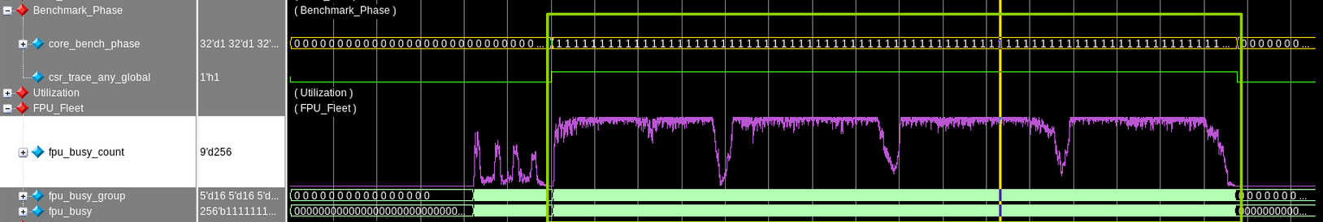
Fig 3, the fpu util of 512x256x512 matmult
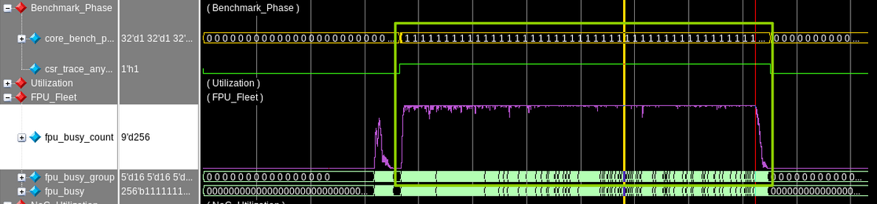
Fig 4, the fpu util of 256x512x256 matmult
Further scale up: as the results on the 4x4 mesh are very promising, I scaled the cluster up to an 8x8 mesh, with 64 groups and 1024 Spatz core complexes, to check the scalability of the design, and ran the matmul kernel at size 2048x512x512. It reaches 77.5% FPU efficiency (ideal/actual, the same metric as the table above; the testbench's raw lane-occupancy counter reads 82.2% for the same run). Part of its utilisation waveform is shown in Figure 5; the full simulation was run without waveform dumping for speed. The initial result shows that even scaled up to an 8x8 mesh with 1024 Spatz core complexes, this architecture still sustains a higher efficiency than the 4x4 baseline, whose median is 67%.
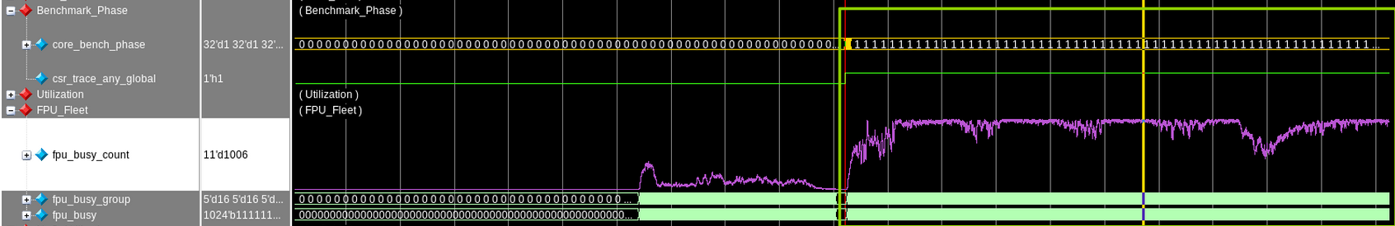
Fig 5, the fpu util of 2048x512x512 matmult, with 8x8 mesh size
Backend implementation: for the backend evaluation, the initial estimate of the area and the interconnect complexity looks feasible - the entry array is about 1.5KB of register per group, so roughly 190k flops across the 16-group 4x4 cluster, and 78% of each entry is written only once or twice in its lifetime and is therefore clock-gated. We still need realistic backend results to confirm this. I am now working on a 7nm backend implementation based on the TeraNoC-Spatz top-down flow from Yichao.

