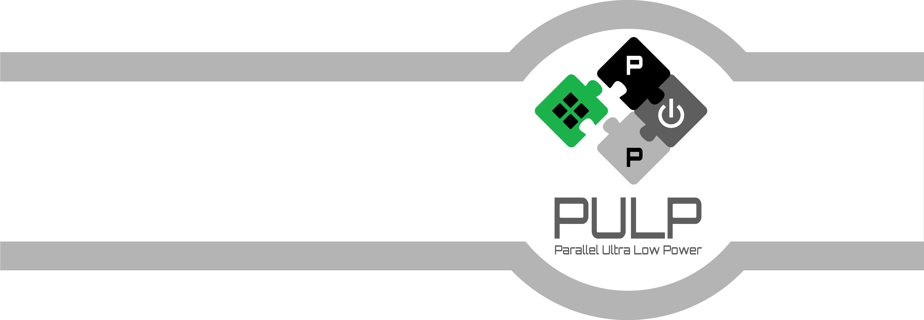
MCHAN User Manual
December 2018
Revision 1.1.0
Davide Rossi (davide.rossi@unibo.it)
Micrel Lab and Multitherman Lab
University of Bologna, Italy
Integrated Systems Lab
ETH Zürich, Switzerland

Copyright 2018 ETH Zurich and University of Bologna.
Document Revisions
Rev. | Date | Author | Description
1.0.0 | 09/03/16 | Davide Rossi | First Draft
1.0.1 | 14/06/16 | Davide Rossi | Updated programming FSM
1.1.0 | 07/12/2018 | Davide Rossi | Added support for 32-bit 2D COUNT and STRIDE
Table of Contents
1 Introduction 5
1.1 Scope and Purpose 5
1.1 Acronyms and Synonyms 5
1.2 Deliveries 5
1.3 MCHAN Architecture Overview 7
1.3.1 Control Unit 8
1.3.2 Ext Unit 8
1.3.3 TCDM Unit 9
1.3.4 TRANS Unit 9
2 Integration Guide 10
2.1 DMA Channel parameters 10
2.1 DMA Channel pinout 12
3 Programming Manual 15
3.1 Programming FSM 15

Introduction
MCHAN is a Direct Memory Access (DMA) engine specifically developed for integration in the PULP platform. MCHAN is a generic component that can be multi instantiated depending on features and performance requirement. The main features of the MCHAN are the following:
- MCHAN allows buffer transfer between memories (accessible from EXT interface to TCDM interface and vice versa)
- Supports several 1D and 2D buffer transfer types.
- Ultra-low-latency programming interface (10 cycles for linear transfer).
- Up to 4GB/s on memory interfaces (500Mhz).
- Up to 16 outstanding request on memory interfaces to hide memory latency.
- Lightweight implementation without need to store internally big data buffers.

Scope and Purpose
This document aims at describing the functional specification of the PULP cluster DMA channel. It includes:
- Main features of the DMA
- IP Parameters
- Pinout of the IP
- Application Programming interface

Acronyms and Synonyms
PULP: Parallel processing Ultra-Low-Power platform
TCDM: Tightly Coupled Data Memory
DMA: Direct Memory Access

Deliveries
Library | Verilog File Name | Description
mchan_lib | include/mchan_defines.sv | MCHAN defines
mchan_lib | top/mchan.sv | MCHAN top
mchan_lib | ctrl_unit/ctrl_unit.sv | Control unit
mchan_lib | ctrl_unit/core_if.sv | Core interface
mchan_lib | ctrl_unit/address_decoder.sv | Address decoder
mchan_lib | ctrl_unit/synch_unit.sv | Synchronization unit
mchan_lib | ctrl_unit/trans_splitter.sv | Transactions splitter
mchan_lib | ctrl_unit/trans_unpack.sv | Transactions unpack
mchan_lib | ext_unit/ext_unit.sv | External unit
mchan_lib | ext_unit/ext_rx_if.sv | AXI RX interface
mchan_lib | ext_unit/ext_tx_if.sv | AXI TX interface
mchan_lib | ext_unit/ext_tid_gen.sv | TID Generator
mchan_lib | ext_unit/ext_opc_buf.sv | Opcodes buffer
mchan_lib | ext_unit/ext_buffer.sv | Generic buffer for external interface
mchan_lib | ext_unit/ext_ar_buffer.sv | AXI AR register slice
mchan_lib | ext_unit/ext_aw_buffer.sv | AXI AW register slice
mchan_lib | ext_unit/ext_b_buffer.sv | AXI B register slice
mchan_lib | ext_unit/ext_r_buffer.sv | AXI R register slice
mchan_lib | ext_unit/ext_w_buffer.sv | AXI W register slice
mchan_lib | tcdm_unit/tcdm_unit.sv | TCDM unit
mchan_lib | tcdm_unit/tcdm_cmd_unpack.sv | TCDM command unpack
mchan_lib | tcdm_unit/tcdm_rx_if.sv | TCDM RX interface
mchan_lib | tcdm_unit/tcdm_tx_if.sv | TCDM TX interface
mchan_lib | tcdm_unit/tcdm_synch.sv | TCDM synchronization unit
mchan_lib | trans_unit/trans_unit.sv | Transfer unit
mchan_lib | misc/mchan_arbiter.sv | Generic Arbiter
mchan_lib | misc/mchan_arb_primitive.sv | Generic Arbiter Primitive
mchan_lib | misc/mchan_fifo.sv | Generic FIFO
mchan_lib | misc/mchan_rr_flag_req.sv | Round robin flag generator
Table 1: MCHAN deliveries

MCHAN Architecture Overview
A block scheme of the MCHAN DMA channel is presented in Figure 3.1. It is consists of four modules. The control unit (CTRL UNIT) handles the transfer requests coming from the processors, arbitrates and forwards command requests to the global command queue, and generates the control signals for the other units to properly handle data transfers. The external unit is responsible for providing an interface toward the external bus, implementing a full-featured AXI 4 protocol interface. The TCDM unit implements the interface toward the cluster local memory. The transfer unit contains two FIFOs, one for TX transfers, one for RX transfers used to decouple data packets flowing through the two interfaces.
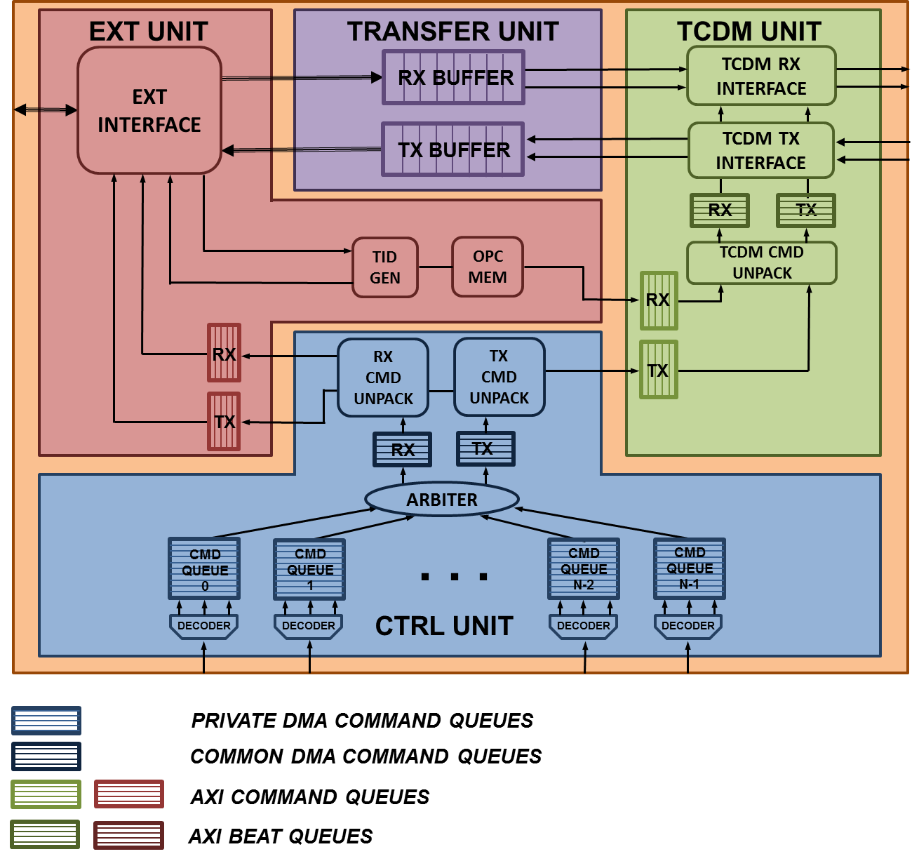
Figure 1: MCHAN architecture

Control Unit
The control unit is responsible for managing transfer requests coming from the processors, enqueue the requests to the global command queue, and generate the control and synchronization signals for the EXT unit, TCDM unit and TRANS unit.
The private command queues within the private per-core core interfaces include memory mapped registers implementing the three fields required to initialize one transfer. This entity, composed of TCDM address, external address and the operation required is called private command. Moreover, the core interfaces includes a mechanism to generate the termination events when a transfer issued by one core is being terminated.
The termination of a transfer is notified to the processor by an event generated by each core interface, or the core itself by polling on the status register can check it. To manage termination, each private DMA command queue features its own source identifier. When a DMA transfer is issued from a private command queue, the source ID associated to the private queue is forwarded to the common DMA command queue together with the DMA command. At the same time, a counter within each private command queue is incremented by the number of beats present in the operation submitted. Every time a transfer of the AXI command completes, both the EXT UNIT and TCDM UNIT notify the end of transfer to the command queue associated to the ID of the transfer, which decrement the value of the counter. When the value of the counter is equal to zero, the transfer is complete.
A round robin arbiter arbitrates commands incoming from the private command queues, and forwards them to a common global queue. An SID representing the source identification tag of the core is attached to the private command before being pushed to the global command queue. We call this entity global command. In order to decouple RX and TX commands, that can be completely overlapped on the AXI 4 interconnect due to its five-channel structure, the global command queue is implemented with 2 FIFOs, one for TX and one for RX transactions.
Two command unpack modules (one for TX operations and one for RX operations) splits the global commands incoming from the command queue into several commands and forward them to the interfaces, ensuring that they are fully compliant with AXI 4.0 protocol specifications. A command processed by the command unpack consists of a transfer implementing a subset of the operations supported by the DMA commands coupled with all the information necessary to perform the transfer on the AXI channels. According to AXI 4.0 specifications, these commands do not cross the 4K boundary, this means that if one command crosses the 4K boundary it is split into two smaller transfers, the latter aligned to 4K boundary. With the current configuration of the DMA (non-configurable 64-bit width AXI interface on the EXT unit), in accordance to the AXI 4.0 specifications, the maximum burst size is 2K ( AXI max size = 8 bytes, AXI max len = 256 ).

Ext Unit
The EXT unit is responsible for managing the data transfers through the EXT interface through the 5 AXI channels: AW, AR, W, R, B. The ingoing commands from the CTRL unit are stored into TX and RX command queues. TX commands are processed by the EXT TX interface and sent to the cluster bus through the AW, W, and B AXI channels. RX commands are processed by the EXT RX interface and sent to the cluster bus through the AR and R AXI channels.
The EXT unit supports up to 16 out-of-order outstanding transactions on the AXI AW and AR channels. To implement the multiple out-of-order outstanding transaction mechanism, the EXT unit includes two tables one for RX transfers, and one for TX transfers (OPC buffers) that associate to each transaction request identified by a transaction identifier (TID) all the information required to handle the response packet. When a new request packet is issued a new TID is generated by two dedicated modules (TX and RX TID GEN) and all the information is stored in the OPC buffer. Once the response packet comes back from the interconnect, the control data associated to the response packet TID is fetched by the OPC buffer, and the TID is released to allow another request packet to be issued. The information stored in the OPC buffer required to forward the RX packets to the TCDM unit includes the address in TCDM, the SID and the opcode. The TX OPC MEM forwards the SID to the ctrl unit that back routes the termination event to the proper core interface (or global ctrl interface).

TCDM Unit
The TCDM unit is responsible for management of transfer toward the TCDM interface. The ingoing commands from the CTRL unit and EXT unit are stored into the TCDM TX and RX command queues, respectively.
The TCDM TX and RX CMD unpack blocks process the commands coming from the command queues in the required number of 32-bit beats, and forward the beats to two decoupled beat queues. During the execution of a burst transfer the cmd unpack blocks are responsible for the calculation of the address of the current beat depending on the required kind of monolithic transfer (e.g, linear, 2D, not incrementing transfer of arbitrary size). The main difference between packed and unpacked commands consists in the size of the transfer encoded into the opcodes, that can be arbitrary within the command queue, and it is forced to be one into the beat queues.
The TCDM interfaces collect the data to be processed from/to the transfer unit through 4 32-bit busses (two 32-bit busses for RX operations and 2 32-bit busses for TX operations) and the control information (address, SID) from the beat queue. All the interfaces are decoupled, thus stalls on the TCDM interface with index 0 do not affect the flow on beat queues with index 1, and vice versa.
The synchronization blocks present within the TCDM units are responsible for notifying to the control interface the termination of commands associated to an SID transported through the beat command queues. Depending on the ID the control unit back-routes the termination signal to the proper core interface (or global ctrl interface).

TRANS Unit

Integration Guide
As shown in Figure 1, MCHAN DMA channel targets the integration in a tightly coupled cluster of processors, featuring three interfaces toward the control and memory access busses of the cluster: CTRL interface, TCDM interface and EXT interface.
The control interface consist of a set of per-core slave ports that allows to access memory mapped register and FIFOs used to control the DMA. The control interface ports are compliant with TCDM interconnect protocol. The cores communicates to the DMA ctrl interface through a port mapped on the DEMUX, in order to guarantee low latency access to the DMA control registers. The TCDM interface consists of 4x32-bit master ports (2 for read accesses, 2 for write accesses), used to access the TCDM of the pulp cluster. The TCDM interface ports are compliant with the TCDM interconnect protocol. The EXT interface consists of one 64-bit AXI4 master port and connects the DMA to the PULP cluster bus. The EXT interface port is compliant with AXI 4.0 protocol specifications.

DMA Channel parameters
Table 1 summarizes the main configuration parameters of the DMA channel.
NB_CORES defines the number of cores attached to the DMA control interfaces. Hence, this parameter defines the number of control ports and private command queues instantiated.
RX_BUFFER_DEPTH and TX_BUFFER_DEPTH define the depth of the FIFOs present on the transfer unit. Although this parameter does not directly affect the performance of the DMA, it defines the number of maximum number of stalls on the TCDM interface before the stalls propagation to the EXT interface and the maximum number of stalls on the EXT interface before the stalls propagation to the TCDM interface, respectively.
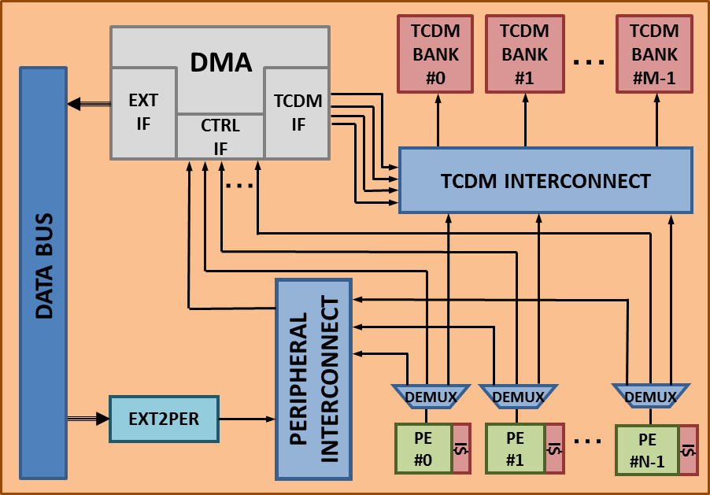
Figure 2: Integration of the MCHAN DMA on the PULP platform.
CORE_CMD_QUEUE DEPTH and GLOBAL_CMD_QUEUE_DEPTH define the depth of the private, per core command queue and of the global, shared command queue. These parameters defines the maximum number of commands that can be enqueued by a processor before being stalled from the control interface.
NB_OUTSTANDING_TRANS defines the maximum number of outstanding transaction on the EXT interface (on both AXI 4.0 AW and AR channels). This can be useful to hide the huge latencies of DDR memories.
TCDM_ADDR_WIDTH and EXT_ADDR_WIDTH defines the width of the TCDM and external address space. The size of the external address space is 32, as it is required to address 4 GB of global memory space, while TCDM_ADDR_WIDTH can be smaller, and depends on the actual size of the TCDM memory.

Parameter | Description | Valid values | Default value
NB_CTRLS | Number of DMA control ports | 1 - 16 | 4
NB_TRANSFERS | Maximum number of transfer that can be enqueued on the core command queues | 1 - 16 | 4
CTRL_TRANS_QUEUE_DEPTH | Depth of core command queues | 2 - 16 | 2
GLOBAL_TRANS_QUEUE_DEPTH | Depth of the global command queue | 2 - 64 | 8
TWD_QUEUE_DEPTH | Depth of 2d queue | 2 - 64 | 4
TCDM_ADDR_WIDTH | Width of TCDM interface address | 1 - 32 | 16
EXT_ADDR_WIDTH | Width of external interface address | 1 - 32 | 32
NB_OUTSND_TRANS | Number of outstanding transactions | 1 - 16 | 16
MCHAN_BURST_LENGTH | Length of MCHAN burst [bytes] | 64 - 2048 | 256
TWD_COUNT_WIDTH | Width of 2D transfers count | 4-32 | 8
TWD_STRIDE_WIDTH | Width of 2D transfers stride | 4-32 | 8

DMA Channel pinout
Port | Width | Direction | Description
Global Signals Bus
clk_i | 1 | Input | Global Clock signal
rst_ni | 1 | Input | Global Reset signal
Control Slave Bus [NB_CORES-1:0]
ctrl_targ_req_i | 1 | Input | Request
ctrl_targ_type_i | 1 | Input | Type: 0 = wr, 1 =rd
ctrl_targ_be_i | 4 | Input | Byte enable
ctrl_targ_add_i | 32 | Input | Address
ctrl_targ_data_i | 32 | Input | Input data
ctrl_targ_gnt_o | 1 | Output | Request granted
ctrl_targ_r_valid_o | 1 | Output | Output data valid
ctrl_targ_r_data_o | 32 | Output | Output data
TCDM Master data bus [3:0]
tcdm_init_req_o | 1 | Output | Request
tcdm_init_type_o | 1 | Output | Type: 0 = wr, 1 =rd
tcdm_init_be_o | 4 | Output | Byte enable
tcdm_init_add_o | 32 | Output | Address
tcdm_init_data_o | 32 | Output | output data
tcdm_init_gnt_i | 1 | Input | Request granted
tcdm_init_r_valid_i | 1 | Input | Input data valid
tcdm_init_r_data_i | 32 | Input | Input data
AXI Master data BUS
axi_master_aw_valid_o | 1 | Output | Write address valid
axi_master_aw_addr_o | 32 | Output | Write address
axi_master_aw_prot_o | 3 | Output | Write Protection type
axi_master_aw_region_o | 4 | Output | Write region
axi_master_aw_len_o | 8 | Output | Burst length
axi_master_aw_size_o | 3 | Output | Burst size
axi_master_aw_burst_o | 2 | Output | Burst type
axi_master_aw_lock_o | 1 | Output | Lock type
axi_master_aw_cache_o | 4 | Output | Cache type
axi_master_aw_qos_o | 4 | Output | Quality of service value
axi_master_aw_id_o | 4 | Output | Write ID tag
axi_master_aw_user_o | 6 | Output | Write address channel user
axi_master_aw_ready_i | 1 | Input | Write address ready
axi_master_ar_valid_o | 1 | Output | Read address valid
axi_master_ar_addr_o | 32 | Output | Read address
axi_master_ar_prot_o | 3 | Output | Read Protection type
axi_master_ar_region_o | 4 | Output | Read region
axi_master_ar_len_o | 8 | Output | Burst length
axi_master_ar_size_o | 3 | Output | Burst size
axi_master_ar_burst_o | 2 | Output | Burst type
axi_master_ar_lock_o | 1 | Output | Lock type
axi_master_ar_cache_o | 4 | Output | Cache type
axi_master_ar_qos_o | 4 | Output | Quality of service value
axi_master_ar_id_o | 4 | Output | Read ID tag
axi_master_ar_user_o | 6 | Output | Read address channel user
axi_master_ar_ready_i | 1 | Input | Read address ready
w_valid_o | 1 | Output | Write valid
w_data_o | 64 | Output | Write data
w_strb_o | 8 | Output | Write strobes
w_user_o | 6 | Output | Write user signals
w_last_o | 1 | Output | Write last
w_ready_i | 1 | Input | Write ready
r_valid_i | 1 | Input | Read valid
r_data_i | 64 | Input | Read data
r_resp_i | 1 | Input | Read response
r_last_i | 1 | Input | Read last
r_id_i | 4 | Input | Read ID tag
r_user_i | 6 | Input | Read user
r_ready_o | 1 | Output | Read ready
b_valid_i | 1 | Input | Write response valid
b_resp_i | 1 | Input | Write response
b_id_i | 4 | Input | Responde ID
b_user_i | 6 | Input | Write response user
b_ready_o | 1 | Output | Response ready
Termination Events Bus [NB_CTRL-1:0]
term_event_o | NB_CTRL | Output | Termination Events
term_int_o | NB_CTRL | Output | Termination Interrupts
Busy signal
Busy_o | 1 | Output | Pending transfers
Table 2: MCHAN pinout description

Programming Manual
This chapter provides details of the sequences to program DMA transactions and get information about termination of transfers with MCHAN. MCHAN is programmed through a per-core private interface mapped on the processors DEMUX that allow to access two memory mapped locations described in Table 3. CONTROL FSM is a R/W memory location used to access the FSM that enables the access to MCHAN control registers, allowing to configure the DMA to implement the supported DMA transfers. STATUS REGISTER is a read-only register and provides information about the status of the enqueued transfers.

Programming FSM
The programming FSM, illustrated in Figure 3, consist of a 6 states finite state machine that manages the access to the control registers of MCHAN. Each state acknowledge the access to one of the MCHAN program registers:
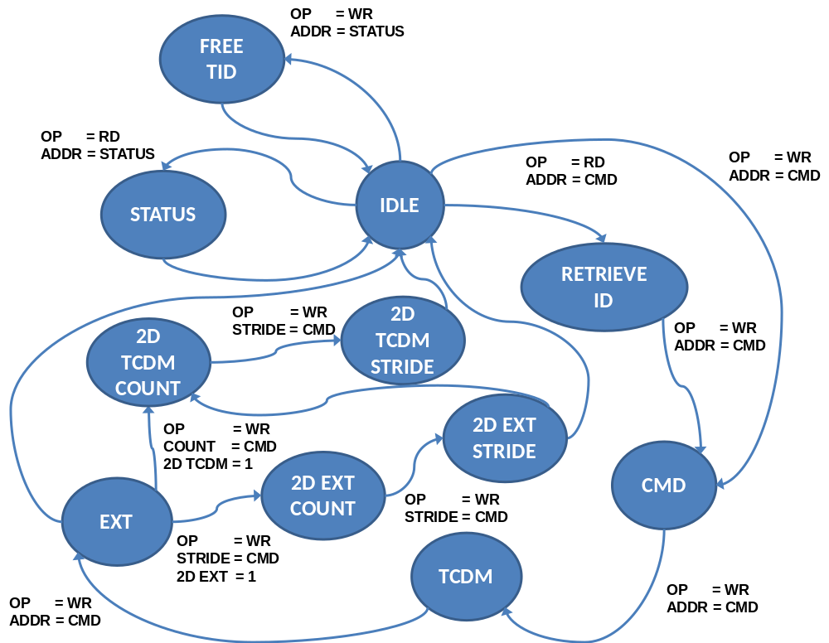

Figure 3: MCHAN CONTROL FSM
- IDLE: MCHAN ctrl FSM is in an idle state. Either configuration of a new transfer or the query of the status register can be done. The status of the MCHAN transfers can be retrieved reading the STATUS REGISTER from the IDLE state (read operation at address 0x4). In the STATUS REGISTER the status information (1=pending, 0=done) of each transfer ID can be retrieved by reading the bit in the associated position of the register. The number of actual transfer IDs is implemented in hardware is bounded to the value of the parameter NB_TRANSFERS (Table 4). A new transfer configuration can be initiated by retrieving the transfer id reading the CONTROL FSM at address 0x0 (Table 6).
- ID ACK: The cores have read a new transfer ID and initiated the configuration of a transfer with associated ID. In this state, the cores can push a new command in COMMAND REGISTER (Table 7) through a write operation at address 0x0.
- CMD ACK: The cores have pushed a new command to the COMMAND REGISTER. In this state, the cores can push the TCDM address of the transfer to the TCDM address register (Table 8) through a write operation at address 0x0.
- TCDM ACK: The cores have pushed the TCDM address of the transfer to the TCDM address register. In this state, the cores can push the EXR address of the transfer to the EXT address register (Table 9) through a write operation at address 0x0.
- EXT ACK: The cores have pushed the EXT address of the transfer to the EXT address register. If the 2D field of the COMMAND register was set to 1 (i.e. 2D transfer) during its configuration the cores can push the 2D information (i.e. count, stride) to the 2D register (Table 10) through a write operation at address 0x0. If the 2D TCDM or EXT field of the COMMAND register was set to 0 (i.e. linear transfer), the control FSM goes back to IDLE mode.
- 2D EXT COUNT ACK: The cores have pushed the count information for the 2D transfer toward external interface to the 2D register. The control FSM goes to 2D EXT STRIDE mode.
- 2D EXT STRIDE ACK: The cores have pushed the count information for the 2D transfer toward external interface to the 2D register. If there is a 2D TCDM transfer the control FSM goes to 2D TCDM COUNT mode, otherwise goes to IDLE STATE
- 2D TCDM COUNT ACK: The cores have pushed the count information for the 2D transfer toward tcdm interface to the 2D register. The control FSM goes to 2D TCDM STRIDE mode.
- 2D TCDM STRIDE ACK: The cores have pushed the count information for the 2D transfer toward external interface to the 2D register. The FSM goes to IDLE STATE.
Register Name | Offset | Description
CONTROL FSM | 0x00 | Used to program DMA transfers
STATUS REGISTER | 0x04 | Contains status of DMA transfers
Table 3: MCHAN registers address map
Bit # | R/W | Description
31 | R | Status of transfer allocator with TID 16 (1: reserved, 0: free)
30 | R | Status of transfer allocator with TID 15 (1: reserved, 0: free)
… | R
17 | R | Status of transfer allocator with TID 1 (1: reserved, 0: free)
16 | R | Status of transfer allocator with TID 0 (1: reserved, 0: free)
15 | R | Status of transfer with TID 15 (1: active, 0: not active)
14 | R | Status of transfer with TID 14 (1: active, 0: not active)
… | R | …
1 | R | Status of transfer with TID 1 (1: active, 0: not active)
0 | R | Status of transfer with TID 0 (1: active, 0: not active)
Table 4: Status register fields description (read operations)
Bit # | R/W | Description
31:16 | W | RESERVED
15 | W | Free transfer with TID 15
14 | W | Free transfer with TID 14
… | W | …
1 | W | Free transfer with TID 1
0 | W | Free transfer with TID 0
Table 5: Status register fields description (write operations)
Bit # | R/W | Description
31:4 | R | RESERVED
3:0 | R | TID: Transfer Identifier
Table 6: TID register fields description
Bit # | R/W | Description
31:23 | W | RESERVED
22 | W | TCDM 2D: 2D transfer (0=linear transfer; 1=2D transfer)
21 | W | BLE: Broadcast lines enable  0= disabled. Events or interrupts are routed to the core who initiated the transfer.  1=enabled. Events or interrupts are broadcasted.
20 | W | ILE: Interrupt lines enable (0= disabled, 1= enabled)
19 | W | ELE: Event lines enable (0= disabled, 1= enabled)
18 | W | EXT 2D: 2D transfer (0=linear transfer; 1=2D transfer)
17 | W | INC: Incremental transfer (0=not incremental; 1=incremental)
16 | W | TYP: Transfer type (0= from TCDM to L2; 1= from L2 to TCDM)
15:0 | W | LEN: Length of transfer
Table 7: Command register fields description
Bit # | R/W | Description
31:0 | W | TCDM ADDR: TCDM Address
Table 8: TCDM address register fields description
Bit # | R/W | Description
31:0 | W | EXT ADDR: External Address
Table 9: External address register fields description
Bit # | R/W | Description
31:0 | W | EXT COUNT: Count value for EXT 2D transfers
Table 10: 2D EXT COUNT register fields description
Bit # | R/W | Description
31:0 | W | STRIDE: Stride value for EXT 2D transfers
Table 11: 2D EXT STRIDE register fields description
Bit # | R/W | Description
31:0 | W | TCDM COUNT: Count value for TCDM 2D transfers
Table 12: 2D TCDM COUNT register fields description
Bit # | R/W | Description
31:0 | W | TCDM STRIDE: Stride value for TCDM 2D transfers
Table 13: 2D TCDM STRIDE register fields description

Transaction IDs management
The transaction queue has a number of entries that are retrieved during phase 1 of the DMA programming (ID is by the hardware) and explicitly enqueued.
If we are in idle and there is no read operation the core will push another transfer to the same ID.
When the core finished the transfers to a specified ID the core will explicitly free the ID.

