PULPKEY

Pulpkey Enterprise AI Bot Product Requirements Document
Architecture product scope functional requirements and implementation plan
Document field | Value
Owner | Pulpkey
Prepared for | Leadership product engineering and operations
Version | 1.0
Date | 12 November 2026
Status | Architecture and build specification

This document defines the enterprise product required to operate a Claude-powered Pulpkey teammate inside WhatsApp. It combines HR coordination, influencer sourcing, COO-style operational follow-up, company knowledge retrieval and reliable scheduled communication in one governed system.
The recommended design uses one orchestrating agent with specialised skills and tightly scoped tools. Deterministic workflows handle birthdays, festivals, recurring work-log requests and follow-ups. Claude is invoked only when language understanding, search, synthesis or judgment is required. This separation is the main decision that protects speed, accuracy and operating cost.

1 Executive decision
Build Pulpkey AI as an internal operating layer, not a chatbot. WhatsApp is the primary employee interface; the admin dashboard is the control plane; PostgreSQL is the system of record; a durable automation engine executes scheduled and delayed work; Claude provides reasoning through a governed tool layer.

1.1 Product definition
Pulpkey AI is a company teammate that can answer questions from approved data, source and shortlist creators, retrieve agency and campaign information, send scheduled team communications, automatically wish employees on birthdays and major holidays, request work logs, identify non-responders after 24 hours and follow up without manual supervision.

1.2 Architecture principle
Use one orchestrator, not several independent autonomous agents. HR, sourcing and COO behaviour should be implemented as versioned skills, policies and tools attached to the same agent. This creates one identity, one permission model, one audit trail and one source of truth.

1.3 What enterprise level means here
- Fast responses with deterministic routing, database indexes, caching and parallel tool calls.
- Grounded answers that cite the source record and its last-updated timestamp.
- Role-based protection of contact details, commercials, HR records and confidential campaign information.
- Durable schedules, retries, idempotency and delivery history so important messages are not duplicated or silently lost.
- Observable actions, model usage, failures, approvals and data changes.
- A controlled rollout path from one test group to organisation-wide use.

2 Goals and boundaries
Area | Included in first production release | Deferred or excluded
Conversation | Mentions, quote replies, natural-language questions, follow-up context | Always-on monitoring of every group message
HR coordination | Directory, birthdays, holidays, work-log requests and 24-hour follow-up | Payroll, statutory HRMS and disciplinary decisions
Sourcing | Creator and agency search, shortlists, commercial history, campaign fit | Unsupervised outreach or commercial commitments
COO operations | Tasks, reminders, work-log completion, operational summaries | Autonomous employee performance evaluation
Data | Structured records, documents, sync jobs and data-quality reporting | Treating model memory as the company database
Messaging | Approved groups, scheduled messages, controlled mentions and DMs | Bulk promotional messaging or external spam

3 Users and access roles
Role | Primary capabilities | Restricted capabilities
Owner administrator | Full configuration, security, data, automations, audit and approvals | None except system secrets remain non-viewable
COO operations admin | Team workflows, work logs, tasks, summaries and automation management | Cannot export confidential fields unless explicitly granted
Sourcing manager | Creators, agencies, shortlists, commercials and campaign history | No private HR data
HR admin | Employees, birthdays, holidays and HR communications | No creator commercials unless separately granted
Team member | Ask approved questions, submit work logs, create personal reminders | Cannot view restricted contact, commercial or HR fields
Auditor viewer | Read-only activity, automation and access logs | Cannot send messages or change data

4 Core user journeys

Company knowledge answer
An employee mentions the bot and asks a natural-language question. The system identifies the sender and group, checks permissions, searches structured and document data, returns a concise answer and includes source and freshness information.

Creator sourcing
A sourcing user describes location, category, follower range, average views, engagement rate, budget, language and brand-conflict constraints. The system searches structured data, ranks candidates, explains matches and can save an approved shortlist.

Birthday wish
At the configured local time, the automation engine finds employees whose birthday is today, resolves their WhatsApp identity and target group, renders the approved template and sends exactly once. Delivery is recorded.

Holiday or festival wish
An administrator loads a calendar of major holidays and festivals, assigns audiences and approves templates. The system sends the correct message at the configured time and prevents duplicates across overlapping calendars.

Work-log request
At the scheduled time the bot posts the exact approved group message. The system snapshots the expected employee list and opens a 24-hour response window.

Work-log collection
Employee replies are linked to the active request, retained verbatim and optionally structured by Claude into campaign, activity, deadline and blocker fields. The original message remains the authoritative record.

Non-responder follow-up
At the 24-hour mark, the workflow calculates the missing set, excludes approved leave or inactive users and follows up only with those employees according to the configured group or DM policy.

Reminder and follow-up
An authorised employee asks the bot to remind a person or group. The agent extracts the time, audience and message, confirms ambiguous details, stores the schedule and sends it durably.

Data update
An authorised employee states a new commercial, campaign status or creator note. The agent proposes a structured change, asks for confirmation when required, writes it and records the before-and-after values in the audit log.

5 System architecture
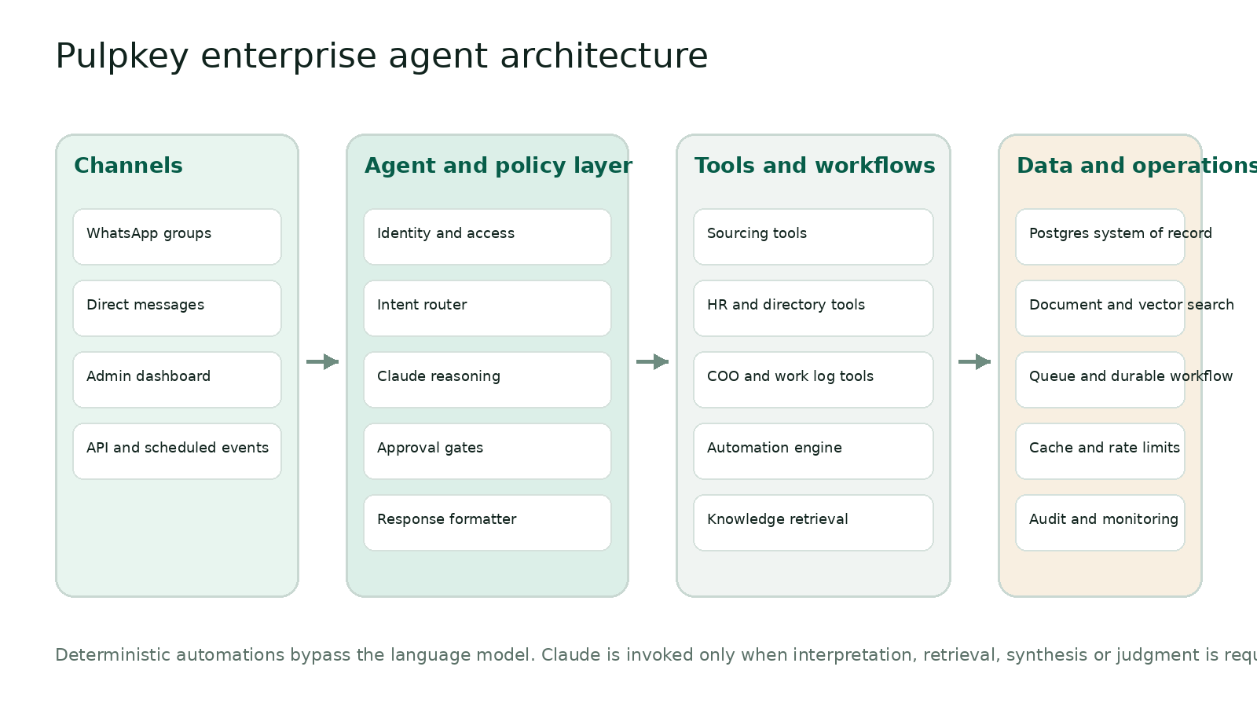
Figure 1 Recommended system architecture

5.1 Channel layer
A dedicated WhatsApp Business account is linked through a long-running Baileys bridge hosted on Railway or an equivalent container platform with a persistent encrypted session volume. The bridge receives group events, normalises sender and group identifiers, enforces the group allowlist and forwards valid events to the backend. It also sends replies, mentions and scheduled messages.
Because this group connection uses the unofficial WhatsApp Web protocol, the number must be dedicated and non-critical. The bridge should not be used for promotional bulk messaging. Connection health, re-authentication and send failures must be visible in the dashboard.

5.2 Agent and policy layer
The Eve agent runs as the conversation orchestrator. Its runtime instructions define Pulpkey behaviour; skills hold HR, sourcing and COO-specific playbooks; typed tools expose only approved operations. Every request passes through identity, group policy, permission and data-classification checks before any tool is called.

5.3 Model layer
Vercel AI Gateway routes requests to a current Claude Sonnet-class model. A smaller Claude model handles classification, extraction and simple rewriting; the stronger model handles complex sourcing, synthesis and ambiguous operational questions. The model choice remains configuration rather than application code.

5.4 Data and workflow layer
PostgreSQL is the authoritative store for employees, groups, creators, agencies, campaigns, commercials, work-log requests, responses, automation rules and audit records. Document storage and hybrid search provide knowledge retrieval. Durable workflows handle delayed follow-ups, approvals and retries. Redis or an equivalent cache stores hot lookups, rate limits and short-lived session context.

6 Component specification
Component | Recommended implementation | Responsibilities
WhatsApp bridge | Baileys 7 in a long-running Railway container | Receive events, actual mentions, delivery, media download, reconnection and health
Agent runtime | Eve on Vercel | Durable sessions, tools, skills, schedules, evals and channel endpoint
AI routing | Vercel AI Gateway with Claude primary | Authentication, model routing, usage reporting, fallback and spend controls
Application API | TypeScript service with schema validation | Identity, permissions, tool execution, idempotency and response formatting
System database | Managed PostgreSQL with row-level security | Transactional company records, automation state and audit history
Search | Postgres full-text plus vector embeddings | Hybrid retrieval for documents, briefs, notes and conversation archives
Workflow engine | Durable workflow and schedule service | Recurring jobs, sleeps, retries, approvals and 24-hour follow-ups
Cache | Managed Redis or equivalent | Fast directory lookup, rate limiting, deduplication and response cache
Admin dashboard | Next.js responsive application | Data, people, automations, groups, approvals, logs, analytics and settings
Monitoring | Application, workflow and AI telemetry | Latency, errors, delivery, model cost, tool success and alerts

7 Agent operating model

7.1 Request routing
- Deterministic events such as a due birthday, holiday or scheduled work-log message bypass Claude completely.
- Simple authorised lookups use a lightweight intent and entity extraction step, then call one tool.
- Complex sourcing, multi-source synthesis and ambiguous questions invoke the stronger Claude model.
- Write operations, external communication changes and sensitive disclosures pass through approval rules.
- The response formatter produces WhatsApp-compatible plain text and limits length unless the user requests detail.

7.2 Grounding and accuracy rules
- Private Pulpkey facts must come from tools or retrieved documents, never from model memory.
- Answers display source type and last-updated date when the result depends on mutable data.
- If records conflict, the bot states the conflict and asks which source should be treated as authoritative.
- If a required field is missing, the bot says it is unavailable and offers the next valid action.
- Search results separate hard filters from AI-ranked recommendations.
- The model cannot broaden its own permissions or execute unregistered tools.

7.3 Conversation behaviour
In groups, the bot responds only to an actual mention, quote reply or approved automation. It uses recent thread context but does not treat casual group conversation as instructions. In direct messages, it responds only to allowlisted employees. It asks one focused clarification when the missing information would materially change the result.

8 Functional capability catalogue
Capability | Functions | Key controls
Employee directory | Find employee, role, team, manager, work contact and birthday visibility | Field-level HR permissions
Birthday automation | Daily birthday resolution, exact-once wish, group selection and template rendering | Timezone, leave/inactive exclusions, delivery history
Holiday automation | Calendar import, audience mapping, template approval and scheduled send | Holiday priority and duplicate prevention
Work logs | Request, response window, attribution, structured extraction, missing list and follow-up | Snapshot membership, leave exclusion and correction
Creator sourcing | Structured filtering, semantic match, ranking, shortlist and export | Commercial/contact visibility and brand-conflict policy
Agency intelligence | Agency directory, creator mapping, contacts, performance and notes | Restricted contacts and audit
Campaign operations | Campaign status, deliverables, approvals, links, deadlines and blockers | Write approvals and ownership
Commercial history | Latest quote, historical range, usage rights and payment terms | Commercial roles and freshness
Knowledge assistant | Policy, brief, document and chat-archive search with citations | Document ACL and injection isolation
Reminders | One-time and recurring reminders, personal or group audience | Confirm audience and timezone
Operational summaries | Team work-log completion, campaign status and blocker summaries | Manager-only aggregates
Media understanding | Image, PDF, spreadsheet and voice-note extraction | File type limits and malware scanning
Web research | Current public research when explicitly required | Source allowlist and citations
Administration | Users, groups, roles, schedules, templates, sync, model and spend | Owner/admin-only

9 Tool and function specification
Each tool uses a typed input schema, returns structured output and records the caller, group, request, latency, result and error. Tools return a controlled unavailable response rather than exposing internal exceptions to the model.
Domain | Function | Purpose
People | find_employee | Resolve an employee from name, number or mention
People | list_team_members | Return active employees for an authorised scope
People | get_employee_public_profile | Return role, team and permitted contact fields
People | get_birthdays | Return birthdays for an authorised date and audience
Sourcing | search_creators | Apply hard filters and return ranked creator candidates
Sourcing | get_creator_profile | Return one creator with permitted fields and freshness
Sourcing | compare_creators | Compare a selected set across standard metrics
Sourcing | create_shortlist | Save an approved shortlist and campaign context
Sourcing | search_agencies | Find agencies and represented creators
Sourcing | get_commercial_history | Return authorised rate and rights history
Sourcing | record_commercial | Propose or write a new commercial with audit
Campaigns | get_campaign_status | Return owners, deliverables, deadlines and blockers
Campaigns | record_campaign_update | Store an approved campaign update
Campaigns | find_brand_conflicts | Check creator and category conflict rules
Work logs | open_work_log_request | Create request, audience snapshot and 24-hour deadline
Work logs | record_work_log_reply | Link an employee response and preserve original text
Work logs | list_missing_work_logs | Calculate non-responders with exclusions
Work logs | send_work_log_followup | Mention or DM only the unresolved employees
Work logs | summarise_work_logs | Generate an authorised operational summary
Automations | create_automation | Create a draft schedule from dashboard or chat
Automations | update_automation | Change timing, message, audience or status
Automations | preview_automation | Show the next runs and exact recipients
Automations | run_automation_now | Execute an authorised rule once
Automations | pause_automation | Stop future executions without deleting history
Knowledge | search_company_knowledge | Hybrid search across authorised documents
Knowledge | get_source_record | Retrieve the cited record and metadata
Operations | create_reminder | Create a one-time or recurring reminder
Operations | create_task | Create an assigned task after permission check
Operations | update_task | Change status, deadline or blocker
Messaging | send_group_message | Send a formatted message to an allowlisted group
Messaging | mention_group_members | Resolve actual WhatsApp mentions
Messaging | send_direct_message | Send only to an allowlisted employee
Governance | check_permission | Resolve role and field-level access
Governance | request_approval | Pause a durable action until approved
Governance | write_audit_event | Persist an immutable action record

10 Automation engine
Automations are first-class records, not code changes. An authorised administrator can create, preview, activate, pause, clone and run them from the dashboard. Every run receives an idempotency key so retries cannot send the same birthday or festival wish twice.
Field | Requirement
Name and type | Scheduled message, birthday, holiday, work-log request, work-log follow-up, reminder or custom event
Audience | One or more allowlisted groups, teams, roles or individual employees
Message | Exact template with optional variables and approved fallback text
Schedule | One-time, daily, weekdays, weekly, monthly, yearly or calendar-event driven
Timezone | Asia Kolkata by default, configurable per rule
Conditions | Active employee, not on leave, group membership, campaign state or missing response
Approval | Draft, approved, active, paused, failed or archived
Delivery | Actual mentions, reply context, send receipt, retries and failure reason
Ownership | Creator, approver, last editor and business owner
History | Immutable run record, recipients, rendered message, timestamps and outcome

10.1 Birthday behaviour
The birthday engine runs daily before the earliest configured send time. It resolves birthdays from the employee system of record, confirms active status and group membership, renders the template, generates actual WhatsApp mentions and sends once. Administrators can choose an exact template or allow Claude to personalise within an approved tone and length. The deterministic fallback always remains available.

10.2 Holiday and festival behaviour
Major holidays and festivals are loaded into an approved calendar with date, region, audience, priority, message template and send time. Variable-date festivals must be supplied or imported annually; the model may draft copy but cannot invent the calendar date. Overlapping holidays use priority and merge rules to prevent multiple unintended broadcasts.

10.3 Work-log behaviour
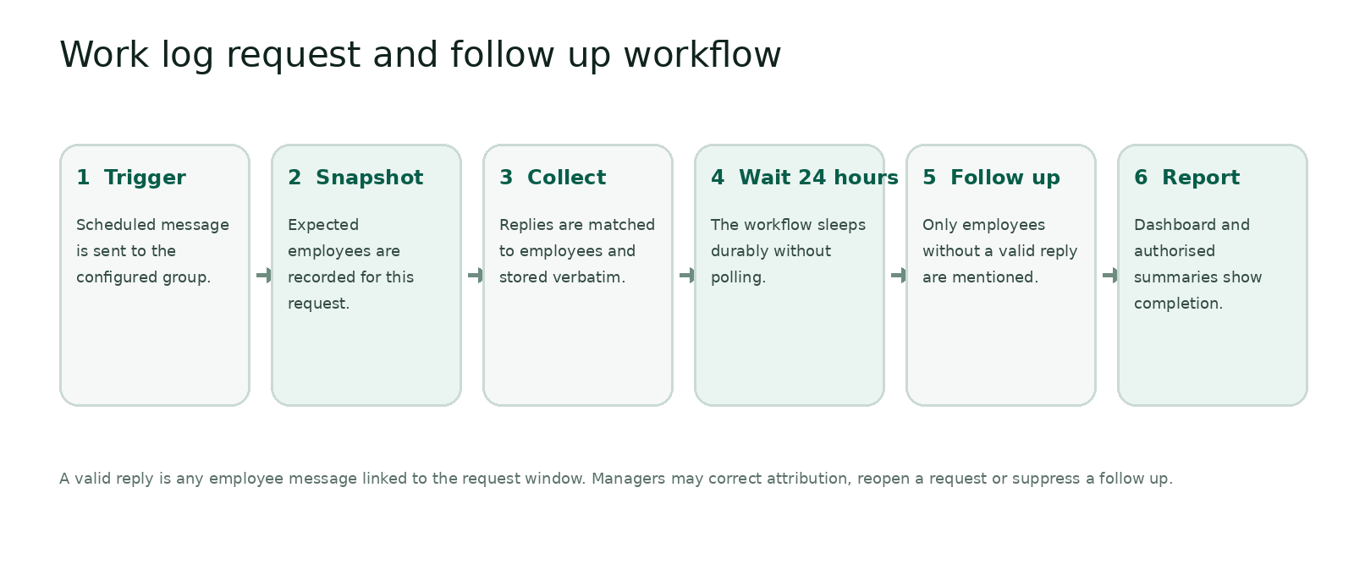
Figure 2 Work-log request and follow-up workflow
Default request message: Hi everyone @all. Do describe your ongoing current work logs. Thanks. The stored template should preserve the exact approved wording. The system must use actual mentions when supported; plain text that only looks like a mention is not sufficient for reliable notification.

11 Data model
Entity | Purpose and key fields
employees | Identity, role, team, manager, status, birthday, timezone and WhatsApp JID
teams | Team hierarchy, owners and default groups
whatsapp_groups | Group JID, title, allowlist status and policy
group_memberships | Employee, group, active dates and mention identity
creators | Profile, platform, handle, city, language, category, metrics and freshness
agencies | Agency, contacts, represented creators and notes
commercials | Creator, deliverable, rights, quoted cost, currency, date and source
campaigns | Brand, owner, status, dates, budget, deliverables and conflicts
shortlists | Campaign, criteria, selected creators, rank and rationale
automation_rules | Type, schedule, timezone, audience, template, conditions and status
automation_runs | Rule, due time, recipients, rendered message, attempts and outcome
work_log_requests | Group, audience snapshot, opened time, due time and status
work_log_responses | Request, employee, message ID, original text, structured fields and time
tasks_and_reminders | Owner, assignee, schedule, source and status
knowledge_documents | Title, source, access scope, version, chunks and embeddings
messages | Inbound and outbound metadata, not unrestricted permanent chat retention
approvals | Action, requester, approver, status and expiry
audit_events | Actor, action, target, before, after, source, IP and timestamp

11.1 Data freshness
Every mutable business record stores source, owner, created time, last-updated time and optional expiry. Search results can downgrade or exclude stale data. The dashboard must display completeness, duplicates, failed syncs and records beyond their freshness threshold.

11.2 Data ingestion
- CSV and spreadsheet import with mapping preview and validation
- Google Sheets sync with an explicit source-of-truth direction
- Manual dashboard entry for controlled records
- API or webhook ingestion from approved systems
- Document upload with access scope, versioning and extraction review
- Conversation-derived updates only after authorisation and audit

12 Admin dashboard information architecture
Side menu | Included screens and responsibilities
Overview | System health, due automations, unresolved failures, work-log completion and recent activity
AI Assistant | Browser-based test conversation, tool trace, source view and feedback
People and Teams | Employees, roles, birthdays, status, teams, leave exclusions and WhatsApp identities
Work Logs | Requests, live response progress, missing employees, responses, follow-ups and summaries
Sourcing | Creators, agencies, shortlists, campaigns, commercials and conflict checks
Automations | All rules, birthday wishes, holidays, work-log rules, reminders, templates and run history
WhatsApp | Connected number, groups, memberships, allowlists, message health and bridge diagnostics
Knowledge and Data | Documents, data sources, imports, sync jobs, field mapping and data quality
Approvals | Pending sensitive actions, broadcasts, data writes and expired requests
Analytics | Usage, latency, completion, sourcing activity, automation delivery and AI spend
Audit and Security | Access log, action history, permission changes, exports and security events
Settings | Organisation, roles, AI models, limits, integrations, templates, timezone and retention

12.1 Dashboard interaction requirements
- Global search across permitted employees, creators, agencies, campaigns and automations.
- Preview before activating any scheduled group message.
- Run-now and pause controls with confirmation for broad audiences.
- Clear status labels for draft, active, paused, due, running, succeeded, partially delivered and failed.
- Source and audit drawer on every business record.
- Responsive layouts suitable for desktop administration and mobile incident checks.
- No secret, token or raw session credential is ever visible in the interface.

13 Permission and security model
Control | Requirement
Identity | Map every WhatsApp sender JID to one active employee and role before tool access
Group policy | Allowlist groups and define which capabilities are enabled in each group
Row security | Restrict records by organisation, team, campaign ownership and role
Field security | Separately protect phone numbers, email, commercials, HR fields and payment information
Tool security | Check permission inside every tool, not only in the prompt
Approvals | Require approval for broad broadcasts, confidential exports and high-impact writes
Secrets | Store gateway, database and bridge secrets only in managed secret stores
Encryption | TLS in transit and provider-managed encryption at rest
Audit | Immutable actor, action, data target, before, after and outcome
Retention | Configurable message and file retention with deletion and export controls
Injection defence | Treat messages, documents and web content as untrusted data, never as policy instructions
Abuse controls | Rate limits, maximum tool loops, maximum recipients and emergency kill switch

13.1 Sensitive group responses
The bot must not post private HR information, personal contact details or restricted commercials into a group merely because the requester can view them. The response policy evaluates both requester permission and channel suitability. Sensitive results should be summarised or redirected to a private authorised view.

14 Speed accuracy and reliability requirements
Metric | Target for pilot | Target for production
Acknowledgement latency | Under 1.5 seconds at p95 | Under 1 second at p95
Structured lookup response | Under 4 seconds at p95 | Under 3 seconds at p95
Complex grounded answer | Under 12 seconds at p95 | Under 8 seconds at p95
Automation start delay | Under 60 seconds | Under 30 seconds
Duplicate scheduled sends | Zero in acceptance testing | Zero by idempotent design
Service availability | 99.5 percent during pilot | 99.9 percent monthly target
Grounded data accuracy | At least 95 percent on curated eval set | At least 98 percent on curated eval set
Permission leakage | Zero tolerated | Zero tolerated
Work-log attribution | At least 98 percent | At least 99 percent

14.1 Performance design
- Acknowledge immediately, then complete long answers asynchronously when WhatsApp delivery allows.
- Cache employee identity, group permissions and common directory lookups.
- Use indexed structured queries before semantic search.
- Run independent tools in parallel and cap tool loops.
- Use a smaller model for classification and extraction.
- Precompute creator search facets and document embeddings.
- Keep scheduled message delivery independent of model availability.

15 Observability and operations
Operational dashboards must show WhatsApp connection state, last inbound and outbound event, queue depth, due workflows, failed sends, database health, AI latency, token usage, tool failure rate, permission denials and unresolved approvals. Alerts should trigger when the bridge disconnects, scheduled delivery breaches its threshold, failure rate spikes or spend exceeds budget.
Log or metric | Minimum fields
Conversation trace | Request ID, sender, group, intent, model, latency and outcome
Tool trace | Tool, validated input hash, duration, status and error category
Automation run | Rule, due time, recipients, attempts, rendered-message hash and delivery status
Data change | Actor, source message, record, old value, new value and approver
AI usage | Model, input tokens, output tokens, cached tokens, cost and fallback
Security event | Denied action, policy, actor, group, target and response

16 Evaluation and quality assurance
The release pipeline must run automated evaluations against realistic Pulpkey questions and workflows. The evaluation set should include spelling mistakes, incomplete prompts, conflicting records, stale data, unauthorised requests, creator filters, group-versus-DM privacy and duplicate automation retries.
Evaluation suite | Pass condition
Knowledge grounding | Answer uses the correct record or refuses when none exists
Sourcing filters | All hard constraints are honoured before ranking
Permission tests | Restricted fields never appear outside authorised context
Automation idempotency | Retry produces one external message
Work-log follow-up | Only snapshot members without valid replies are contacted
Birthday and holiday | Correct date, audience, mention and one delivery
Prompt injection | Untrusted content cannot change policies or call unauthorised tools
Regression | Approved golden conversations remain within score threshold

17 Acceptance criteria
- A dedicated WhatsApp number can join an allowlisted test group and respond only when mentioned or quote-replied.
- Authorised users can ask free-form questions against creator, agency, campaign and employee data.
- Every private-data answer is permission checked and includes source freshness.
- An administrator can create, preview, activate, pause and run an automation without a deployment.
- Birthday and approved holiday messages send automatically and exactly once.
- The work-log message sends on schedule, opens a 24-hour window and snapshots expected employees.
- Employee replies are attributed correctly and visible in the dashboard.
- After 24 hours, only unresolved employees receive the configured follow-up.
- Claude unavailability does not block deterministic scheduled messages.
- Bridge disconnects, failed sends and overdue workflows create visible alerts.
- All sensitive writes and broadcasts are auditable and approval policies are enforced.
- The evaluation suite meets the production targets before wider rollout.

18 Delivery plan and realistic timeline
The earlier 10-day estimate applied to a narrow internal pilot. This expanded HR, sourcing and COO scope requires a staged enterprise build. A convincing pilot can be delivered in three weeks; a hardened production release requires approximately six to eight weeks, assuming timely data, account and policy decisions.
Phase | Duration | Deliverables
0 Product lock | 2 to 3 days | Final data sources, roles, groups, message templates, work-log rules and success metrics
1 Foundation | Week 1 | Repository, environments, database, authentication, audit, bridge and health monitoring
2 Core agent | Week 2 | Claude gateway, identity, permissions, retrieval, sourcing and company-data tools
3 Automation pilot | Week 3 | Dashboard, birthday, holiday, work-log request, 24-hour follow-up and one test group
4 Operations depth | Weeks 4 and 5 | Campaigns, reminders, imports, sync, approvals, analytics and data quality
5 Hardening | Weeks 6 and 7 | Load, failure, permission, injection, backup, recovery and evaluation testing
6 Rollout | Week 8 | Training, runbooks, staged group activation, monitoring and ownership handover

18.1 Team required
Minimum delivery team: one senior full-stack or agent engineer, one backend or platform engineer, one product owner from Pulpkey and part-time security and QA support. One engineer can produce a prototype, but the enterprise reliability and security scope should not be treated as a solo weekend build.

19 Major risks and mitigations
Risk | Impact | Mitigation
Unofficial WhatsApp bridge | Number restriction or protocol break | Dedicated disposable number, low-volume internal use, monitoring and channel abstraction
Poor or stale company data | Confident but wrong answers | Source ownership, freshness thresholds, conflict display and data-quality dashboard
Sensitive information in groups | Privacy and commercial exposure | Field security plus channel-suitability policy and private response route
Duplicate scheduled sends | Employee confusion and trust loss | Idempotency keys, unique database constraints and immutable run records
Model hallucination | Incorrect operational guidance | Tool-grounded facts, citations, refusal rules and evals
Employee identity mismatch | Wrong follow-up or disclosure | Verified JID mapping and admin review
Automation misconfiguration | Incorrect audience or timing | Preview, approval, run-now test and emergency pause
Scope expansion | Delayed and unstable release | Three-week pilot boundary and phased activation

20 Decisions and inputs required from Pulpkey
- Dedicated WhatsApp SIM or eSIM and the first private test group.
- Employee master with name, role, team, WhatsApp number, birthday, status and manager.
- Approved birthday, holiday and work-log message templates and their schedules.
- Policy for follow-up location: group mention, direct message or both.
- Creator, agency, campaign and commercial sources with an identified system of record.
- Permission matrix for contacts, commercials, HR fields, payments and exports.
- List of major holidays and festivals, relevant regions and annual ownership.
- Hosting ownership, budget limits and people responsible for operations and incident response.
- Retention policy for messages, work logs, documents and audit records.
- Pilot success criteria and the groups allowed in each rollout stage.

Appendix A Sample WhatsApp interactions
Scenario | Example
Work-log request | Hi everyone @all  Do describe your ongoing current work logs. Thanks.
Work-log follow-up | Hi @Name. We have not received your current work log for today. Please share it in reply to the original request. Thanks.
Birthday wish | Happy Birthday, @Name! Wishing you a wonderful year ahead from everyone at Pulpkey.
Sourcing question | @Pulpkey Bot find 20 Pune food creators under 30000 with QSR experience and average views above 40000.
Grounded answer | I found 12 matching creators. Eight meet every hard filter; four are close alternatives. Source: Creator Master and Commercial History. Last synced: 12 November 2026, 6:30 PM.
Restricted answer | I found the creator, but contact details are restricted in this group. Open the authorised dashboard record or ask an admin to grant access.
Data correction | The sheet and campaign record contain different commercials for this creator. I have not overwritten either value. Which source should be treated as current?

Appendix B Source and technology notes
- Vercel Eve documentation. Durable agents, tools, schedules, channels, human approvals and evaluations. https://eve.dev/
- Vercel AI Gateway documentation. Model routing, tool calling, observability and fallbacks. https://vercel.com/docs/ai-gateway
- Vercel Workflow and Queues documentation. Durable steps, retries, idempotency and delayed delivery. https://vercel.com/docs/workflow and https://vercel.com/docs/queues
- Supabase documentation. PostgreSQL row-level security and role-based data access. https://supabase.com/docs/guides/database/postgres/row-level-security
- Eve WhatsApp Group Agent repository. Reference bridge, mention trigger, Vercel agent and Railway deployment. https://github.com/mblode/eve-whatsapp-group-agent
- Baileys repository. WebSocket-based WhatsApp Web multi-device integration and disclaimer. https://github.com/WhiskeySockets/Baileys

