Pulvera, Clark Edzel V. BSIT-3E
Final Laboratory Exercise 2
5.6.6 Packet Tracer - Troubleshoot Common Network Problems
Part 1: Test connectivity
Step 1:
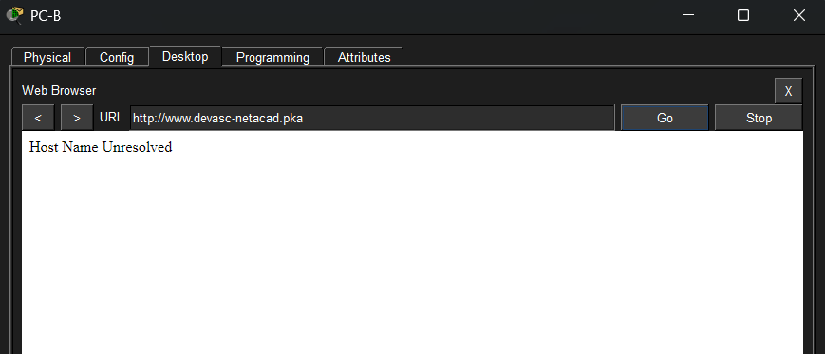
Step 2:
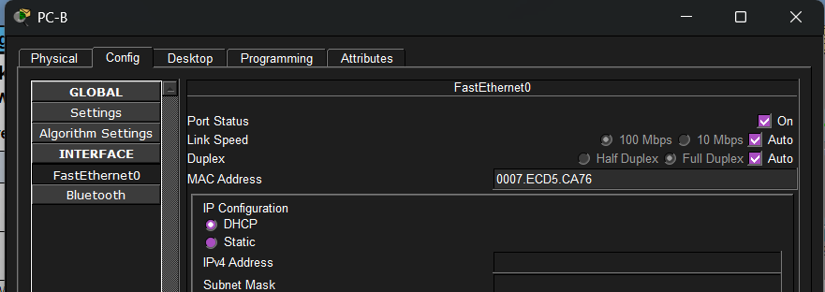Step 3:
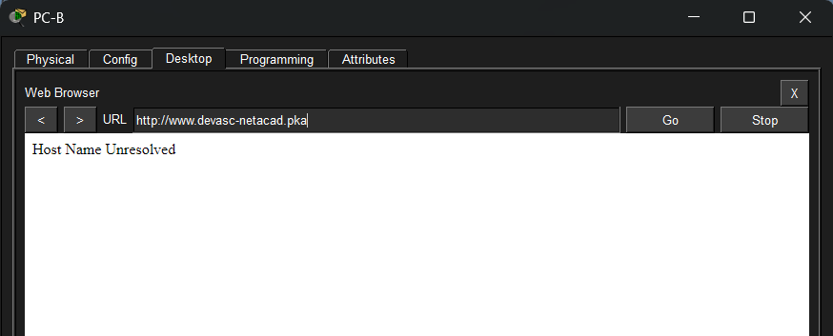
Part 2: Troubleshoot R3
Step 1:
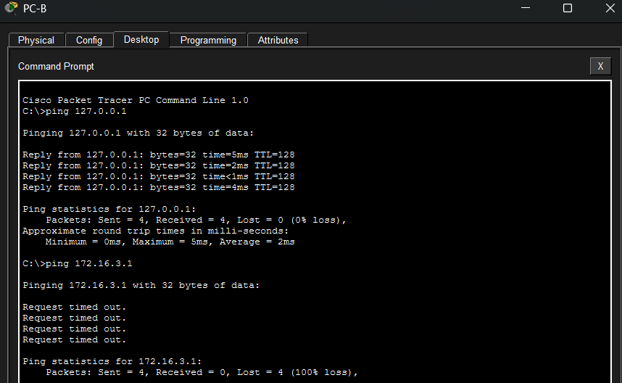

Step 2:
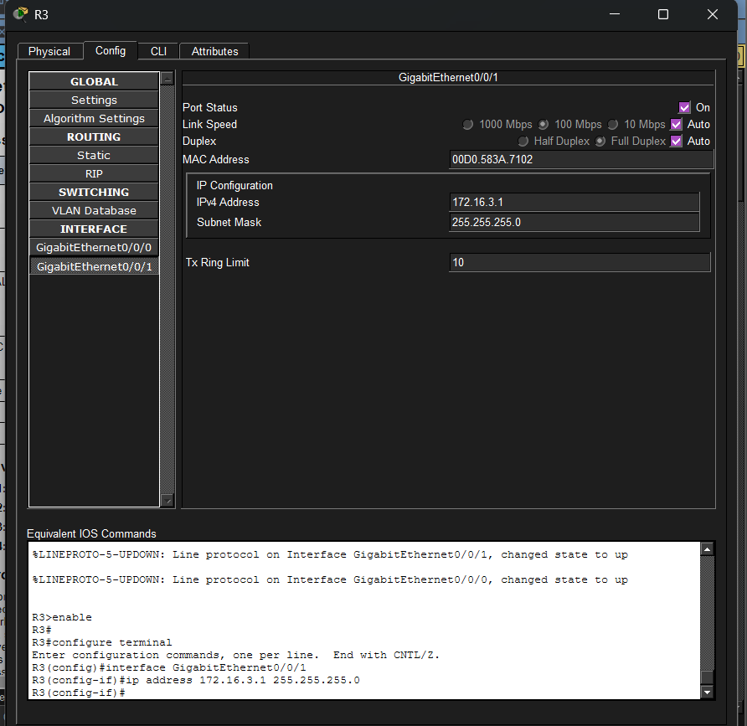
Step 3:
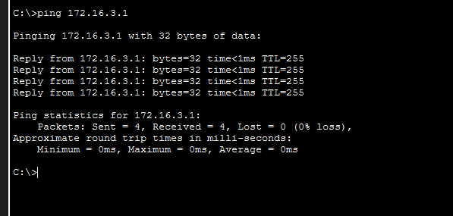
Part 3: Troubleshoot R1
Step 1:
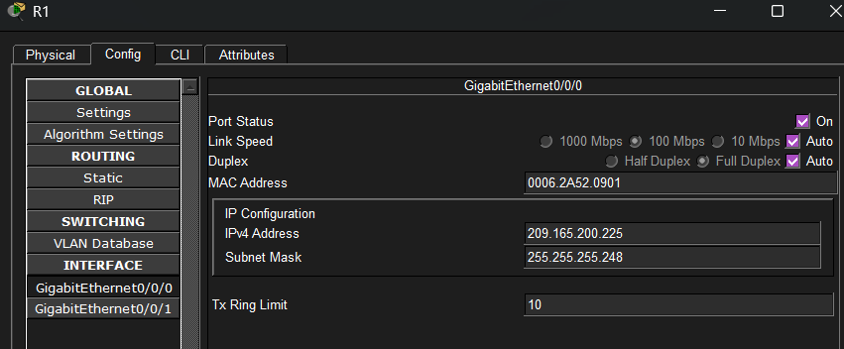
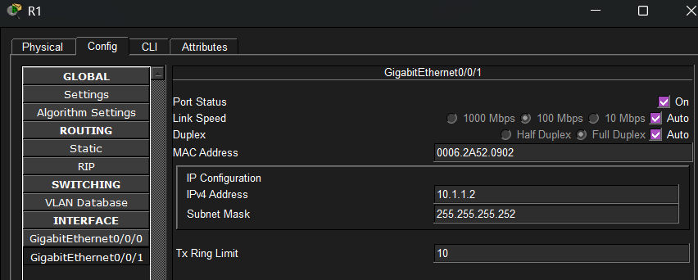

Step 2:
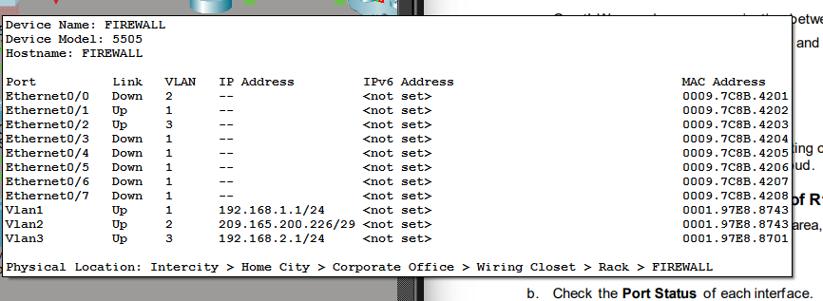
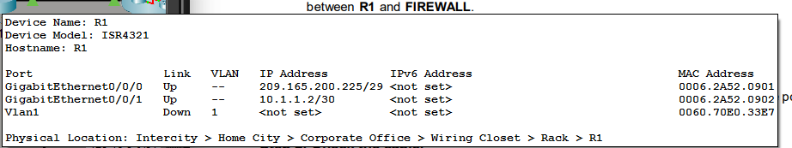
Step 3:
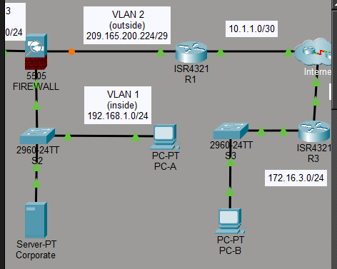

Step 4:
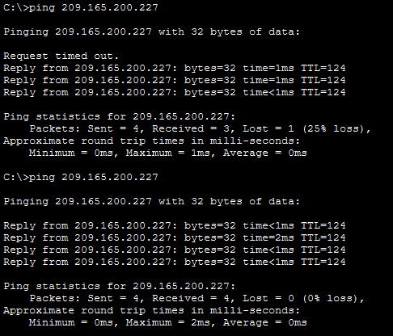
Part 4: Troubleshoot DNS
Step 1:
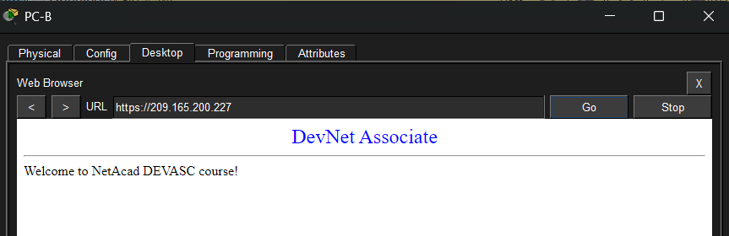

Step 2:
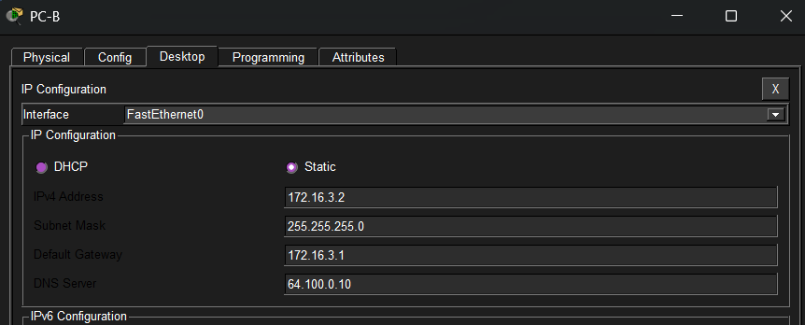
Step 3:
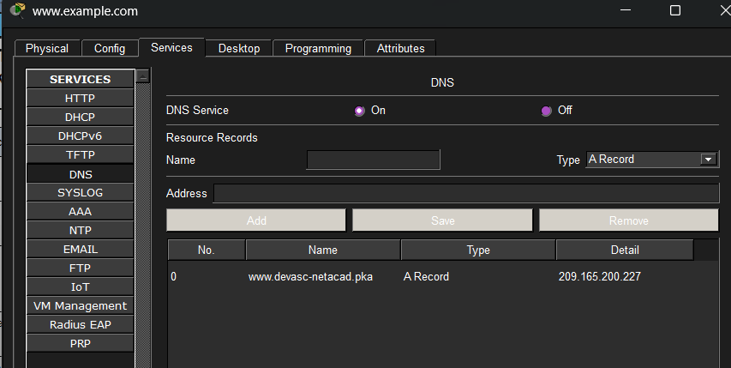
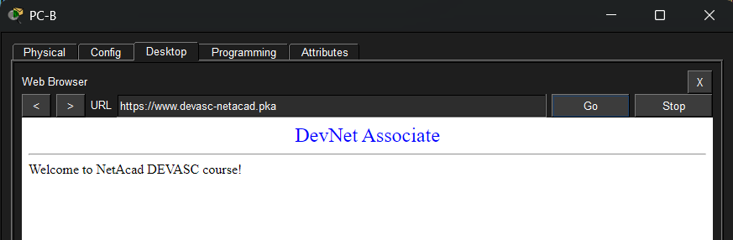

Completion Status:
