Pulvera, Clark Edzel V. BSIT-3E
Final Laboratory Exercise 3
5.6.7 Lab - Network Troubleshooting Tools
Part 1: Launch the DEVASC VM
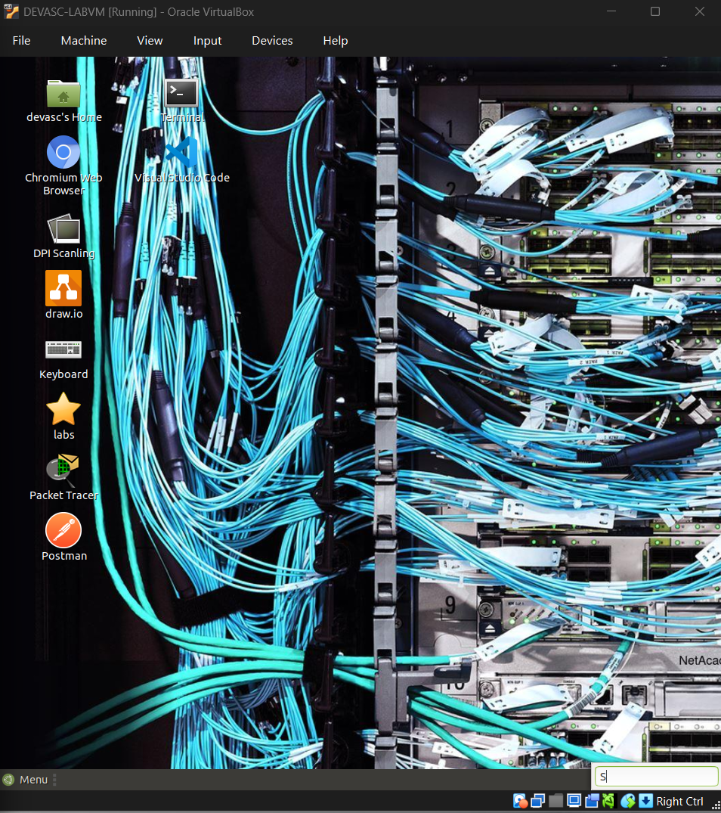
Part 2: Explore the ifconfig Troubleshooting Tool
Step 1: 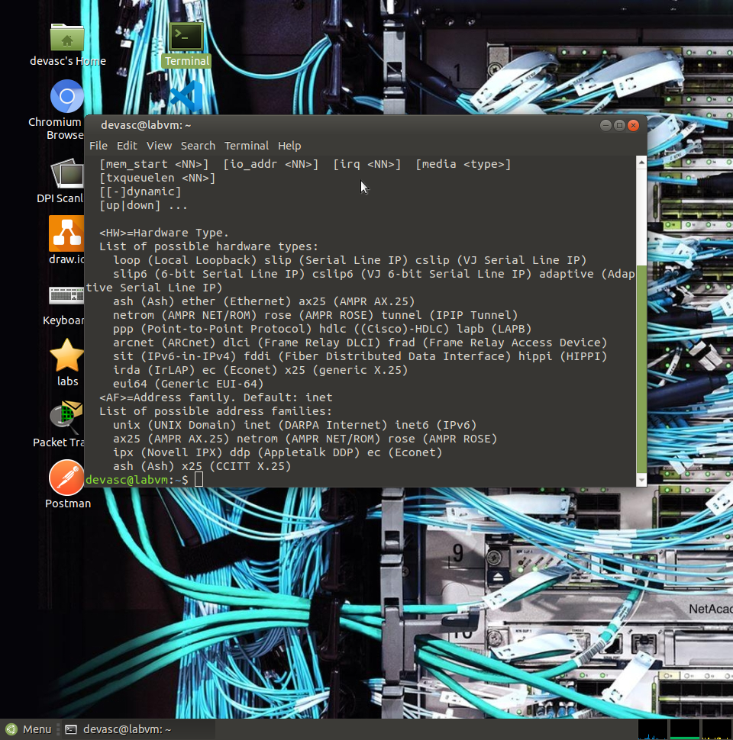

Step 2:
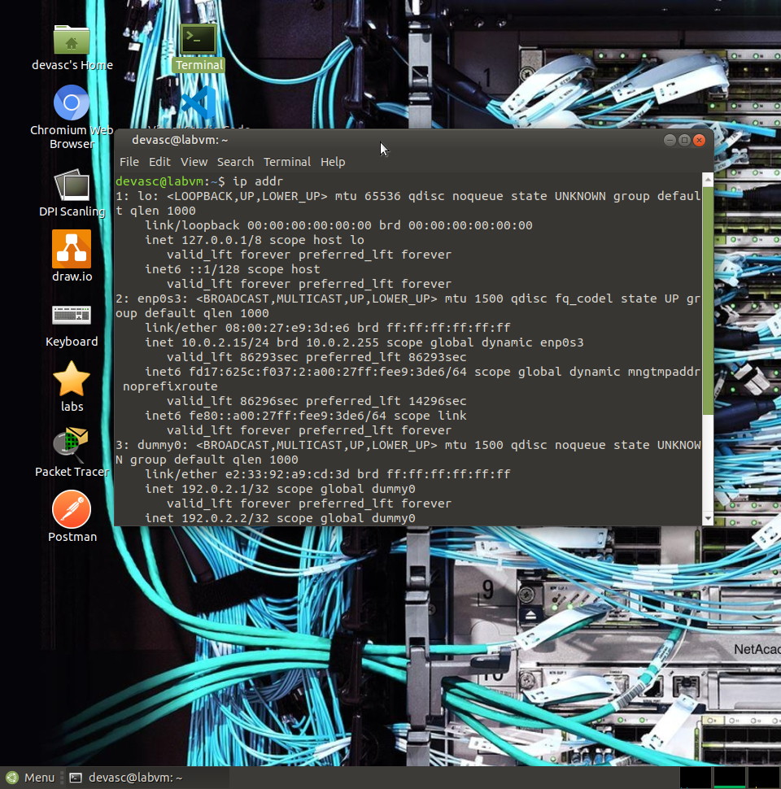

Part 3: Explore the ping Troubleshooting Tool
Step 1:
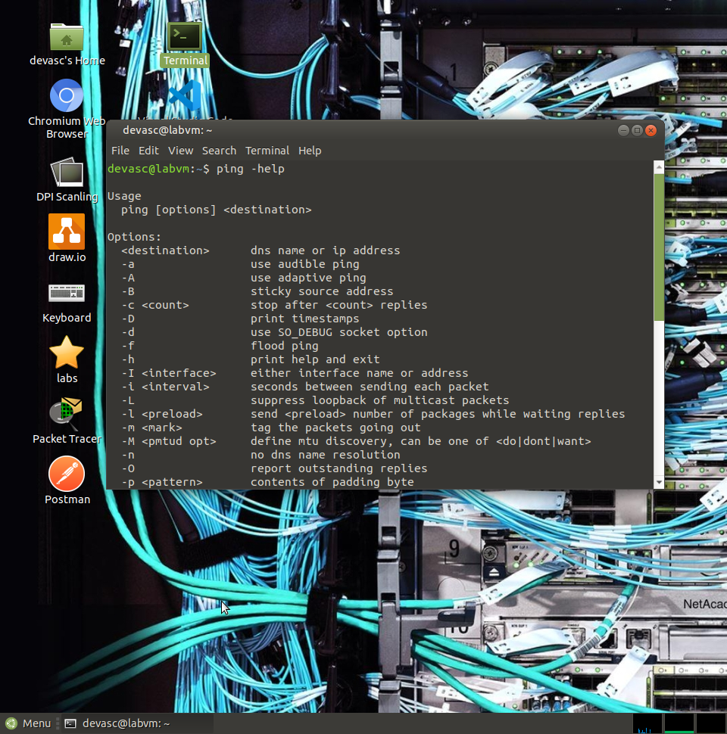

Step 2:
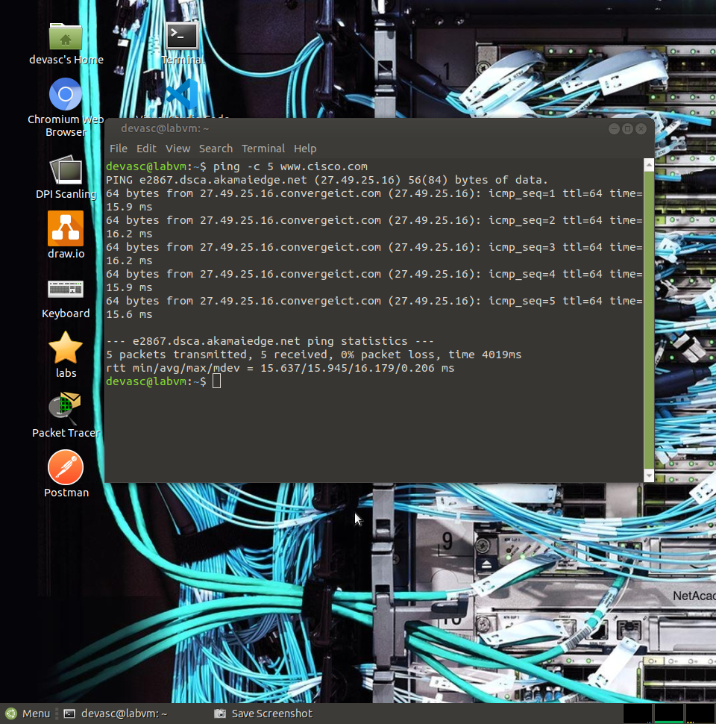

Part 4: Explore the traceroute Troubleshooting Tool
Step 1:
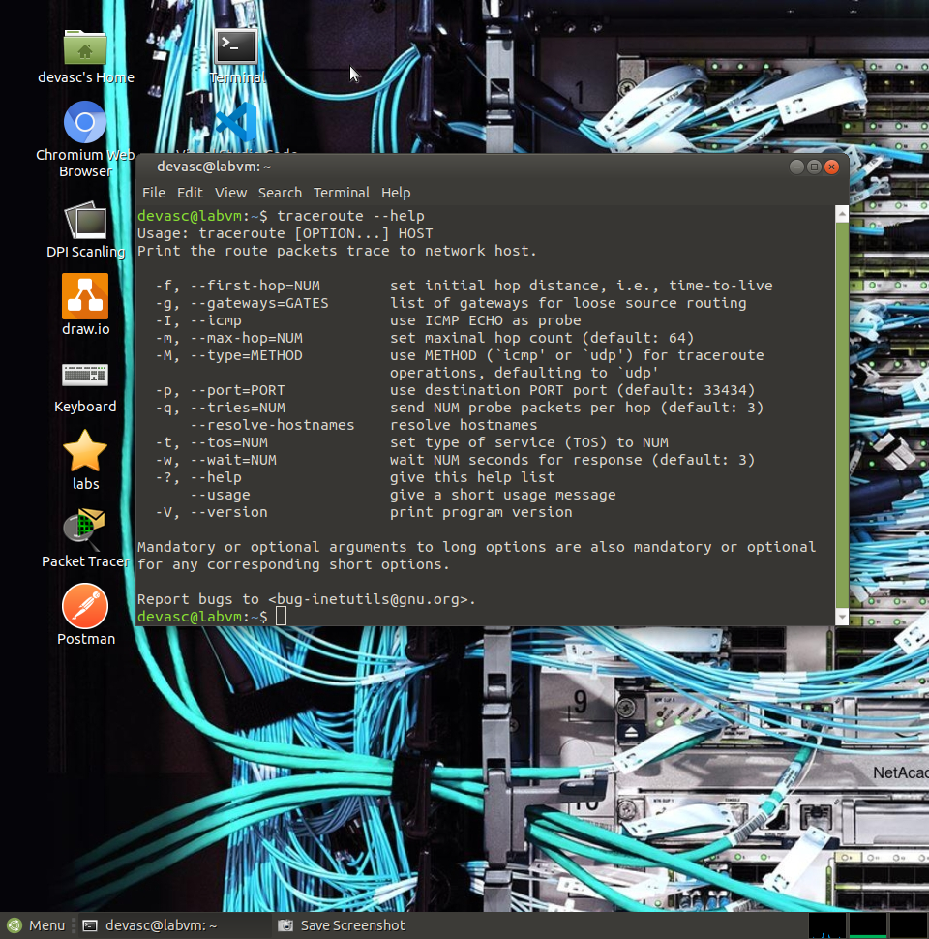

Step 2:
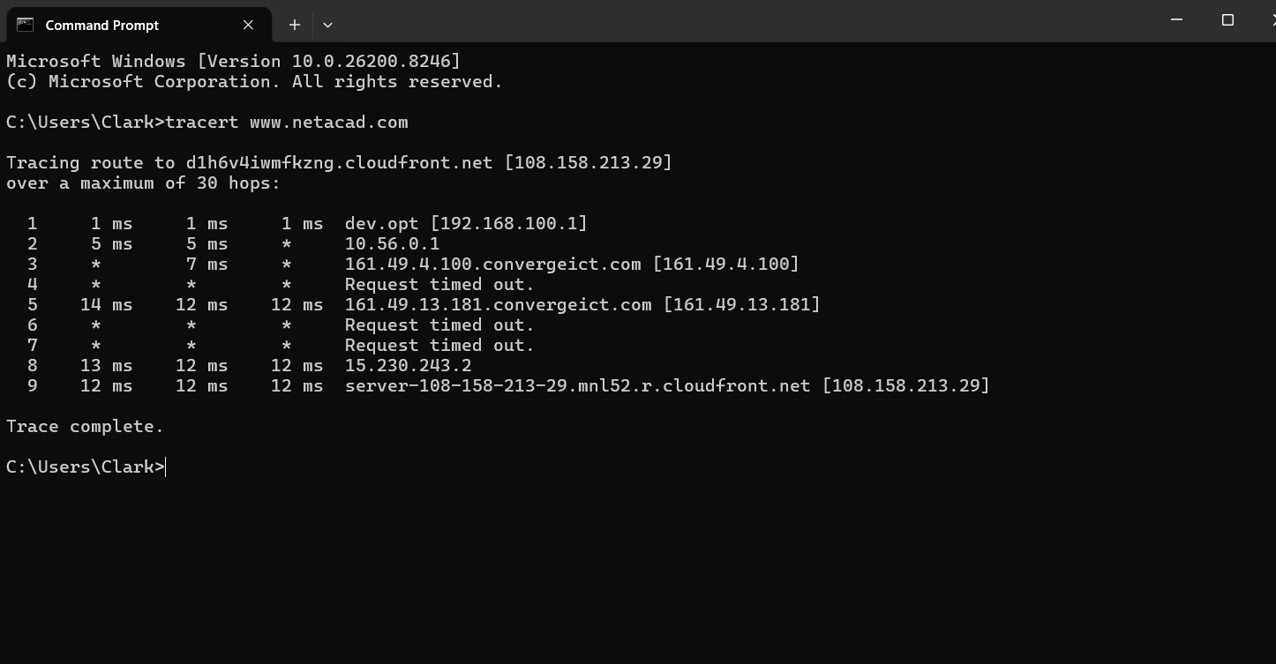

Part 5: Explore the nslookup Troubleshooting Tool
Step 1: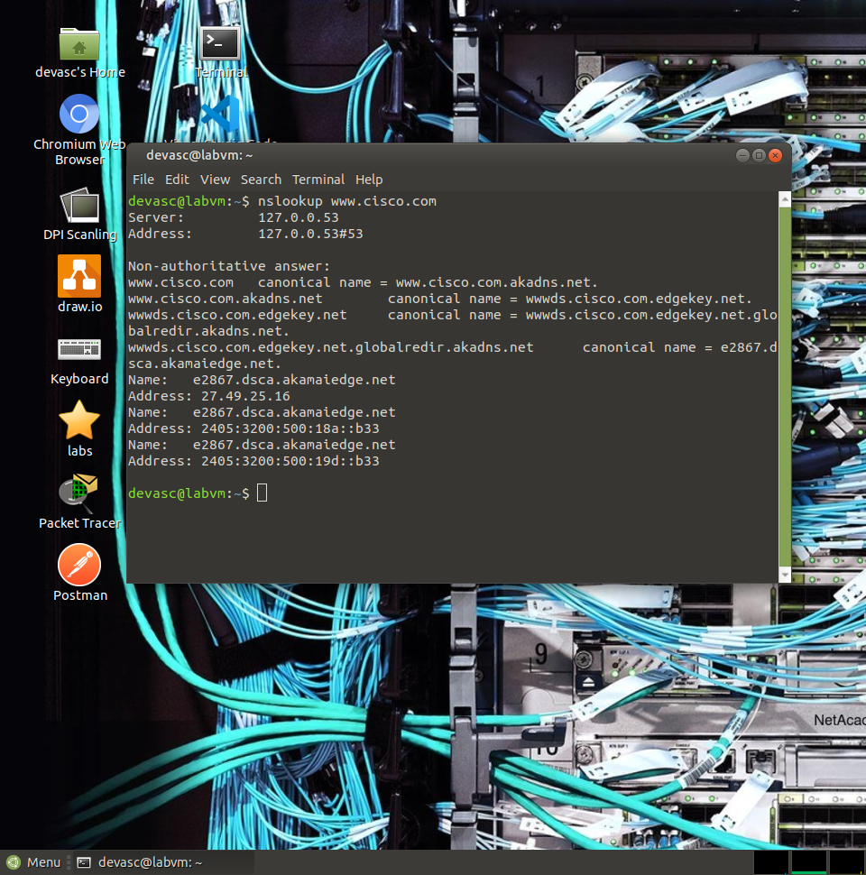

Step 2:
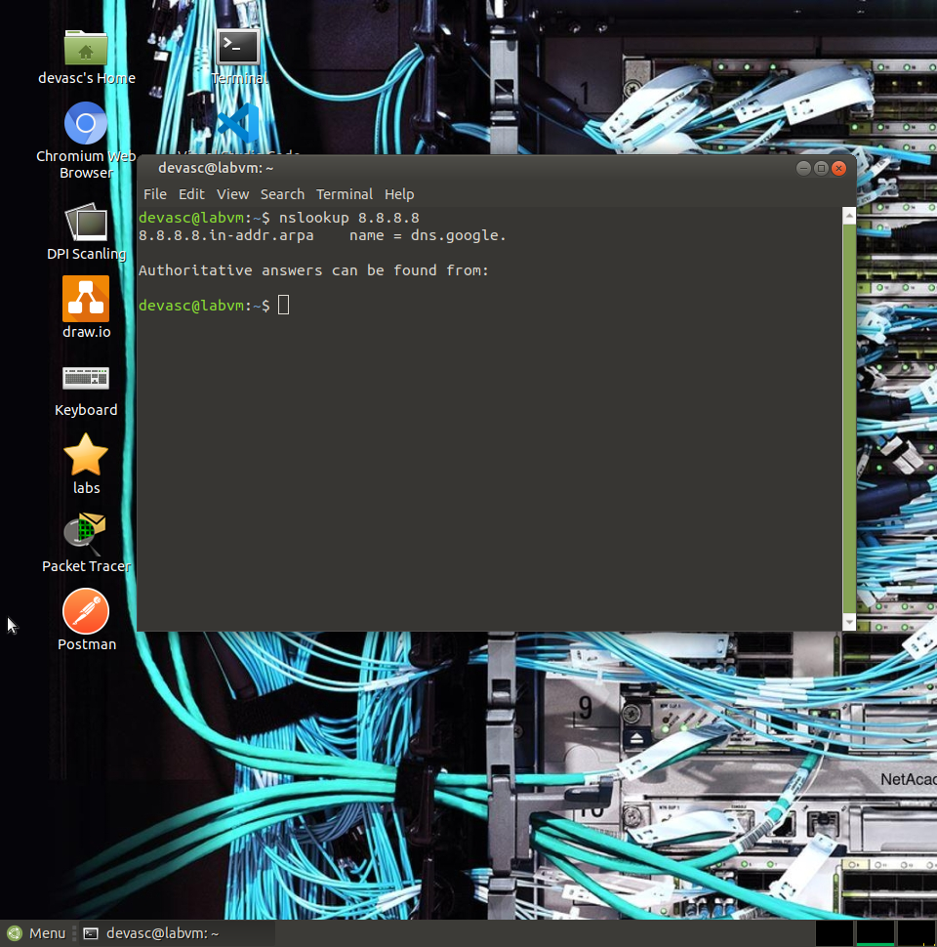

Step 3:
