SOURCE CODE :

import cv2
import matplotlib.pyplot as plt
img=cv2.imread("leaf.jpg",0)
img=cv2.resize(img,(300,400))
cv2.imshow("Image",img)
plt.hist(img.ravel(),256,[0,256])
plt.show()
cv2.imwrite('C:/Users/Lenovo/Desktop/newimg.jpg',img)
cv2.waitKey(0)
cv2.destroyAllWindows()

OUTPUT :
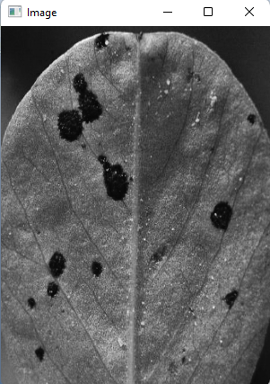
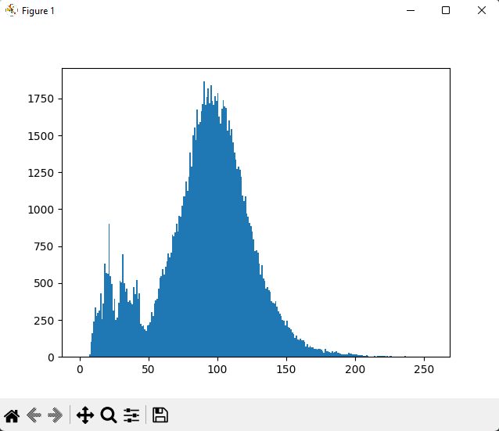

SOURCE CODE :
import cv2
img=cv2.imread('black.jpg',cv2.IMREAD_COLOR)
Value=img[10,10,:]
print("Accessing Pixel Values :",Value)
for j in range (10,50):
for i in range(11,55):
img[j,i,0]=255
Value=img[10,11,:]
print("Modifying Pixel",Value)
cv2.imshow("image",img)
cv2.waitKey(0)
cv2.destroyAllWindows()

OUTPUT :
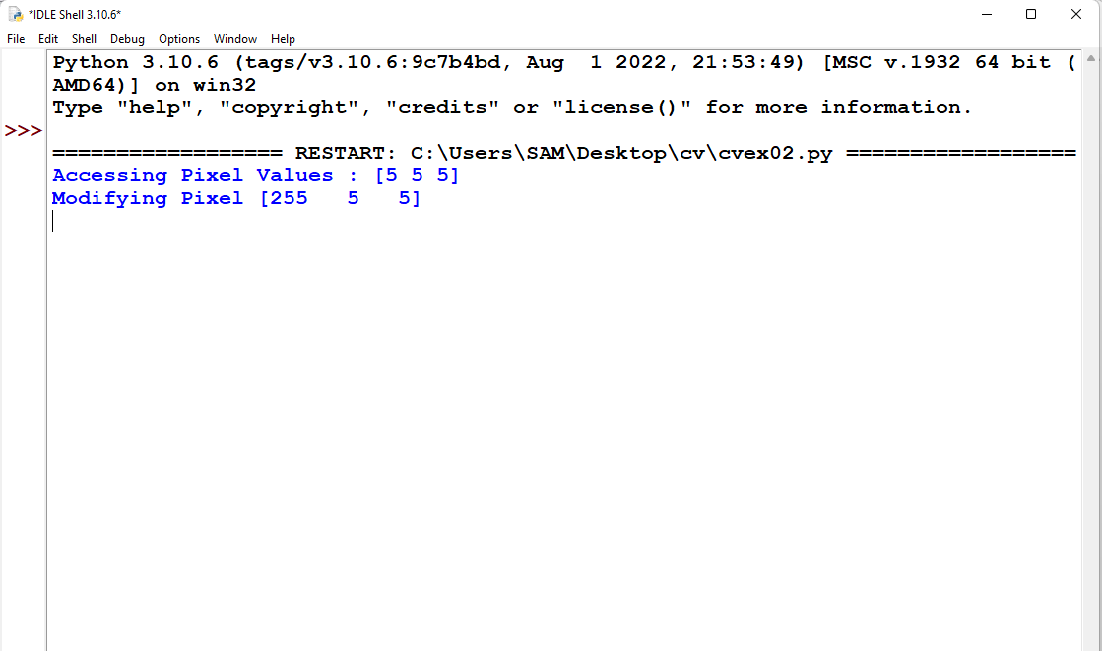
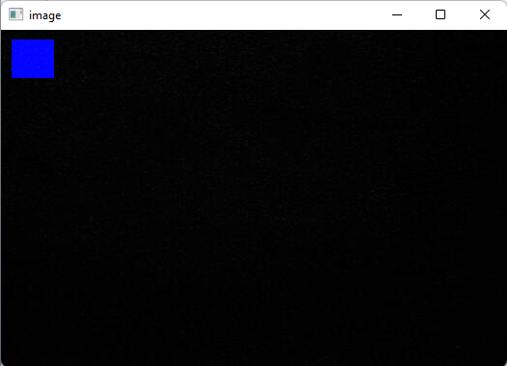

SOURCE CODE :
import cv2
img1=cv2.imread("rect1.jpg")
img2=cv2.imread("rect2.jpg")
img1=cv2.resize(img1,(400,300))
img2=cv2.resize(img2,(400,300))
res=cv2.addWeighted(img1,0.5,img2,0.5,0)
cv2.imshow("Merged",res)
cv2.waitKey(0)
cv2.destroyAllWindows()

OUTPUT:

