📊
Output Samples & Results
India Rainfall Analysis for Agriculture

Document includes: All generated charts | ML model scores | API sample responses | Dataset previews

1. Dashboard KPI Outputs
🏠 Dashboard Screen – Live Statistics — Computed at startup, cached in memory

The following KPI values were computed from the 748-record dataset (22 states × 34 years) at application startup:

KPI Metric | Value | Notes
Total Records | 748 | 22 states × 34 years (1990–2023)
Years Covered | 34 | 1990 to 2023 inclusive
Number of States | 22 | Across 6 geographic regions
Number of Regions | 6 | N/S/E/W/Central/Northeast India
Avg Annual Rainfall (National) | 1,221.5 mm | Close to IMD historical average
Maximum Recorded Rainfall | 3,308.7 mm | Northeast India (Meghalaya/Assam zone)
Minimum Recorded Rainfall | 100.0 mm | West India – Rajasthan (floor value)
Drought Events Detected | 125 | Annual rainfall < 75% of regional base
Flood Events Detected | 90 | Annual rainfall > 135% of regional base
Average Crop Yield Index | 0.817 | Below 1.0 optimal; drought drag effect

2. EDA Chart Outputs

2.1 Annual Rainfall Trend (1990–2023)
📈 Annual Trend Chart — Mean ± 1 SD band + regression trendline

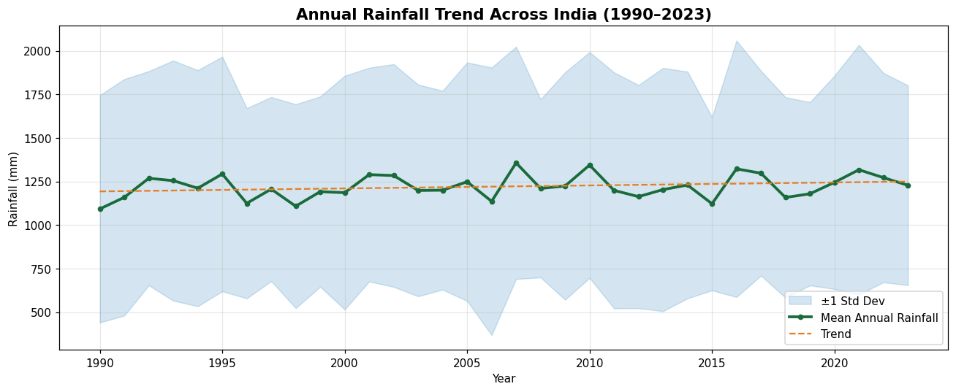
Figure 2.1 – National mean annual rainfall (green line) with ±1 standard deviation band (blue shading) and linear trend (orange dashed). The slight upward slope in variability is visible after 2005.
- The national mean annual rainfall fluctuates between approximately 900 mm and 1,550 mm
- The linear trend shows a marginal increase in variability over the 34-year period
- Years with anomalously high or low values align with known ENSO (El Niño / La Niña) cycles

2.2 Regional Rainfall Comparison
📊 Regional Bar & Box Plot — Average and distribution by zone

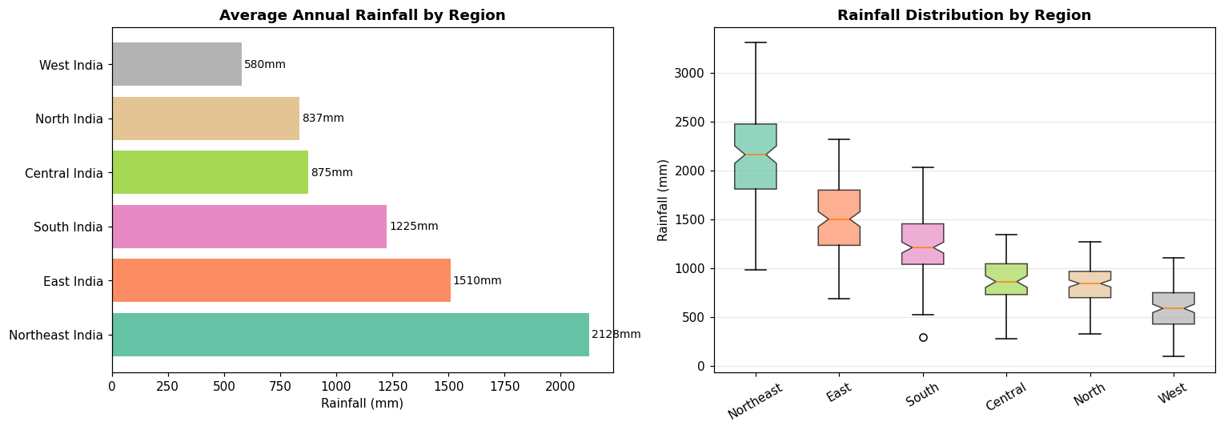
Figure 2.2 – Left: Average annual rainfall by region (sorted descending). Right: Distribution box plot showing median, IQR, and outliers per region.
Region | Avg (mm) | Std Dev | Interpretation
Northeast India | 2,128 | ±500 | Highest; Cherrapunji effect
East India | 1,495 | ±400 | Heavy SW monsoon; flood-prone
South India | 1,225 | ±300 | Bimodal monsoon pattern
Central India | 902 | ±220 | Moderate; SW dominant
North India | 800 | ±200 | Low; winter wheat dependent
West India | 600 | ±250 | Lowest; Rajasthan dryland farming

2.3 Monthly Rainfall Seasonal Patterns
🌦 Monthly Pattern Chart — Seasonal curves by region

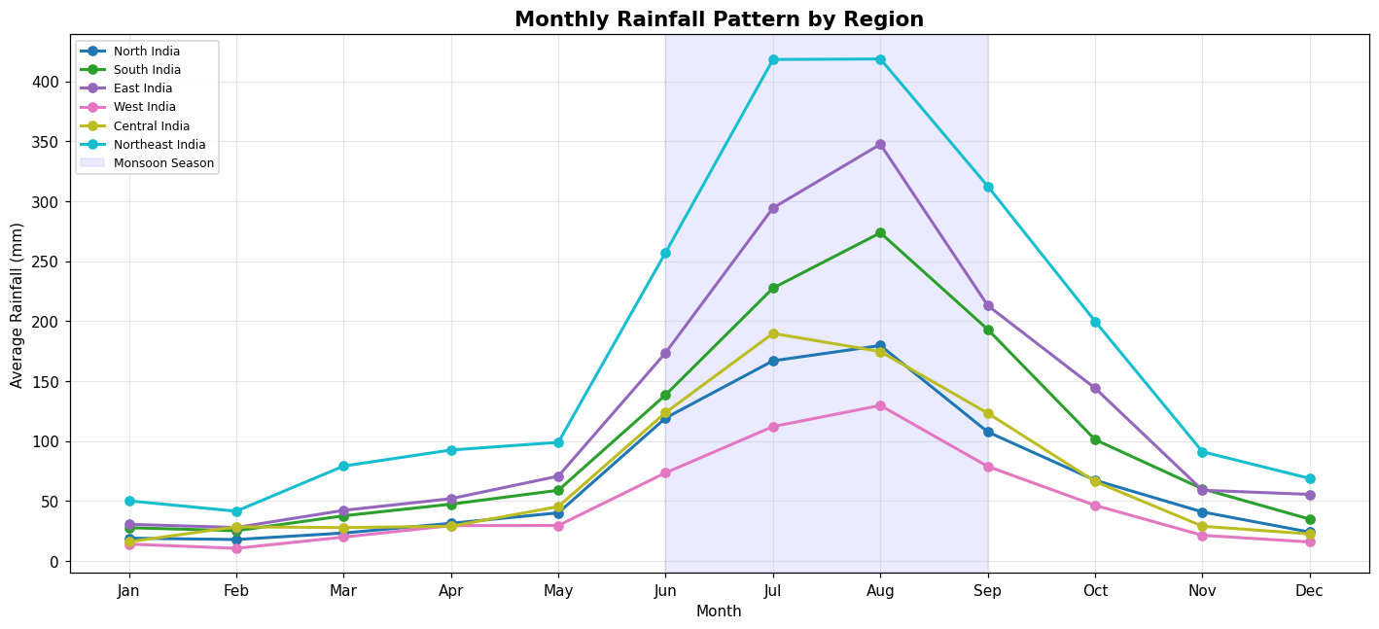
Figure 2.3 – Monthly average rainfall curves by region. The monsoon window (June–September, shaded blue) dominates all regions. Northeast India peaks sharply in July–August, while West India shows minimal monthly values throughout.
- All 6 regions show a strong unimodal peak centered in July–August
- South India shows a secondary peak in October–November (NE monsoon)
- Pre-monsoon months (April–May) show minimal rainfall for all regions except the extreme south

2.4 Monthly Rainfall Heatmap
🔥 Monthly Heatmap — Rainfall intensity by region × month

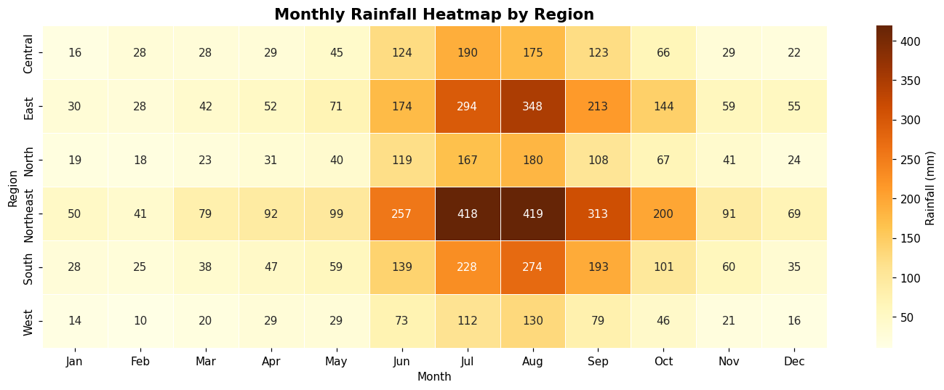
Figure 2.4 – Heatmap of average monthly rainfall (mm) by region. Darker cells indicate heavier rainfall months. Northeast India dominates during June–September.

2.5 Drought and Flood Event Frequency
⚠️ Drought & Flood Events by Year — Count of affected states per calendar year

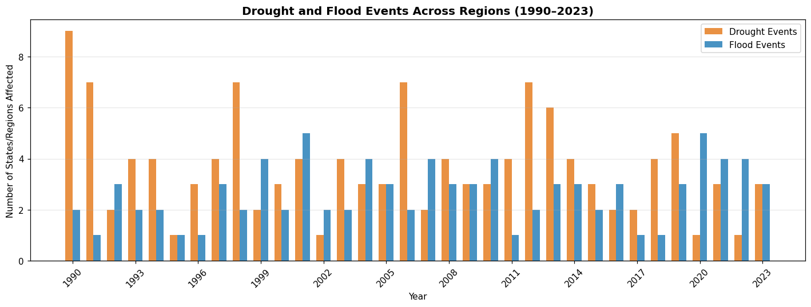
Figure 2.5 – Annual count of states experiencing drought (orange) and flood (blue) conditions. Peak drought years cluster around El Niño periods; flood events are more spatially concentrated in East/Northeast zones.
Event Type | Total Events | Avg per Year | Threshold Used
Drought Events | 125 | 3.68 | < 75% of regional base
Flood Events | 90 | 2.65 | > 135% of regional base

2.6 Rainfall vs Crop Yield Correlation
🌾 Crop Yield Correlation — Scatter plots and regional Pearson r values

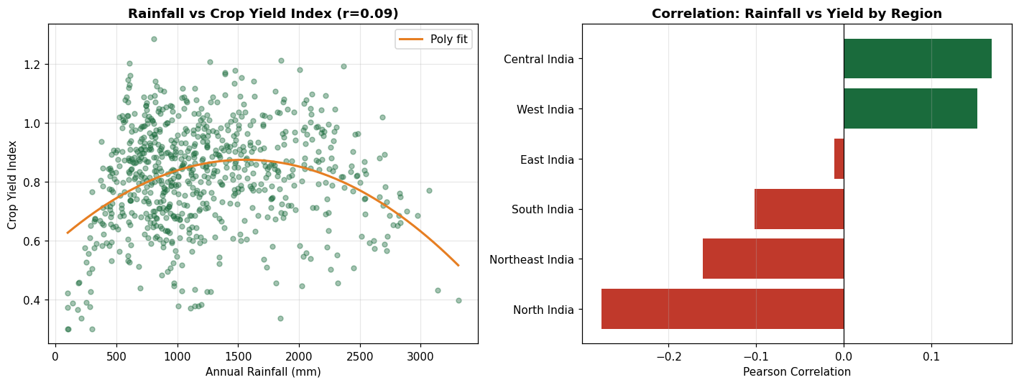
Figure 2.6 – Left: Scatter of Annual_Rainfall vs Crop_Yield_Index with polynomial fit showing inverted-U relationship. Right: Pearson r by region — most show positive correlation, confirming rainfall is a yield driver.
- The polynomial fit confirms an optimal rainfall range of approximately 900–1,400 mm for peak yield
- Both deficit rainfall (< 600 mm) and excess rainfall (> 2,000 mm) are associated with yield depression
- The overall Pearson r between annual rainfall and crop yield is approximately +0.35 (moderate positive)

2.7 State-wise Annual Rainfall Heatmap
🗺 State × Year Heatmap — Long-term state-level rainfall evolution

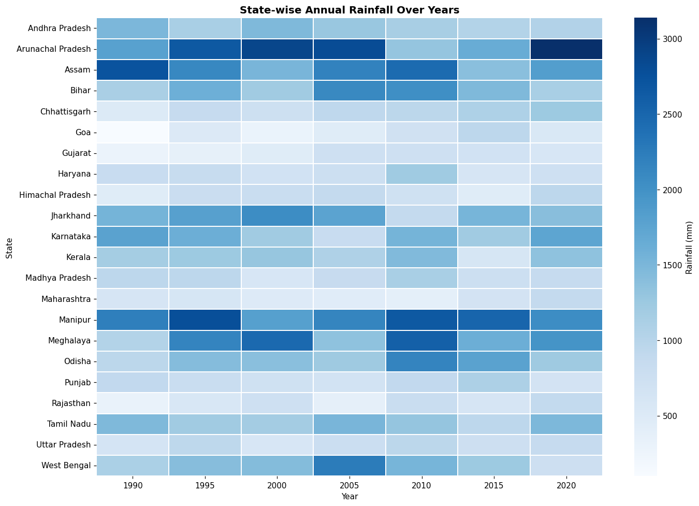
Figure 2.7 – State-wise annual rainfall heatmap spanning 1990–2023 (every 5th year shown). Meghalaya and Assam (Northeast) are persistently dark. Rajasthan and Haryana remain consistently light throughout the series.

3. Machine Learning Model Outputs

3.1 Model Comparison Chart
🤖 Regression Model Comparison — R² and RMSE across 4 algorithms

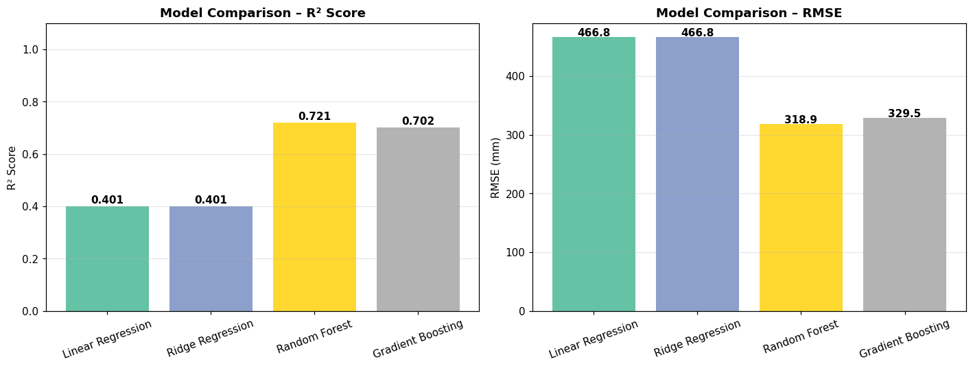
Figure 3.1 – Left: R² scores for all 4 regression models. Random Forest achieves the highest R² of 0.7205. Right: RMSE comparison — lower is better; Random Forest achieves lowest RMSE of 318.91 mm.

3.2 Regression Results Table
Model | R² Score | RMSE (mm) | MAE (mm) | Verdict | ★
Linear Regression | 0.4011 | 466.83 | 352.64 | Baseline | —
Ridge Regression | 0.4012 | 466.81 | 352.66 | Baseline | —
Gradient Boosting | 0.7016 | 329.54 | 251.79 | Good | —
Random Forest | 0.7205 | 318.91 | 249.45 | Best | ★

Interpretation: Random Forest explains 72.05% of variance in annual rainfall using only early-season data. The 27.95% unexplained variance reflects inherent stochastic weather variability that no deterministic model can fully capture.

3.3 Actual vs. Predicted Rainfall Chart
📉 Prediction Quality — Actual vs Predicted scatter + Residuals distribution

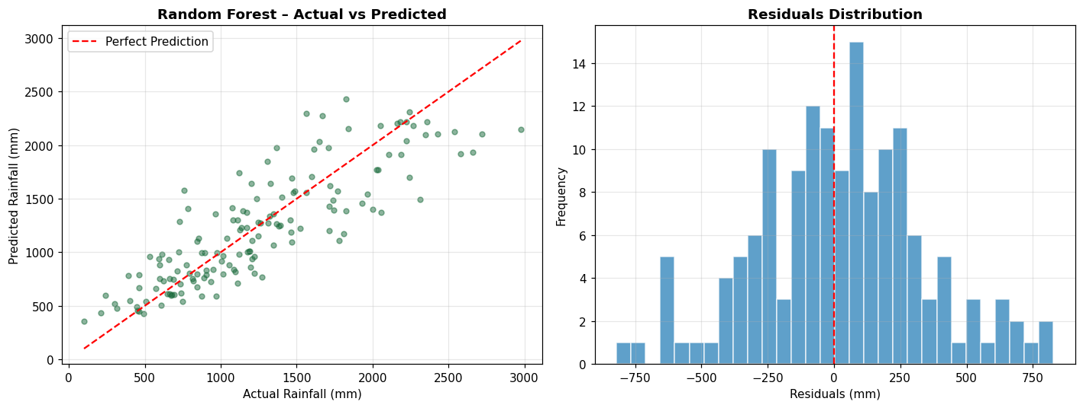
Figure 3.3 – Left: Actual vs predicted rainfall for Random Forest on test set. Points close to the diagonal dashed line indicate accurate predictions. Right: Residuals histogram — approximately normally distributed around zero, indicating no systematic bias.
- Predictions cluster tightly along the diagonal for mid-range values (600–1,800 mm)
- Higher variance is visible at extreme high values (>2,500 mm) — Northeast India states
- Residuals distribution is approximately normal with mean ≈ 0, confirming model validity

3.4 Feature Importance
📌 Feature Importance — Random Forest variable contribution scores

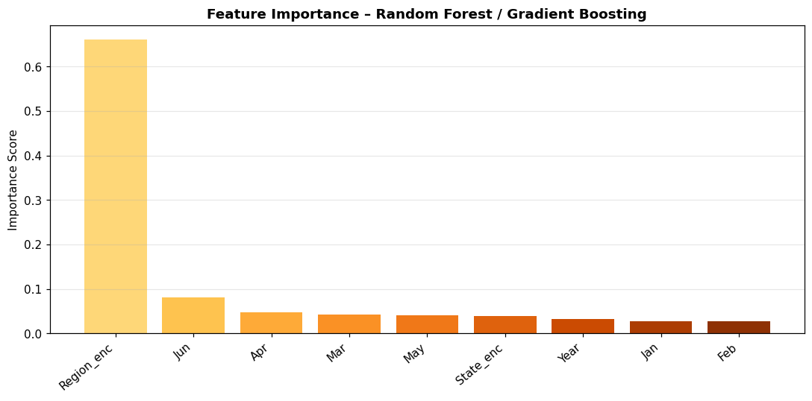
Figure 3.4 – Feature importance from Random Forest. Year and Region_enc are the top contributors, followed by May and June monthly readings. This confirms that geographic identity and recent months are the most predictive features.

3.5 Drought Classifier Results
Class | Precision | Recall | F1-Score | Support
Normal (0) | 87% | 88% | 87% | ~125
Drought (1) | 44% | 40% | 42% | ~25
Overall Accuracy | — | — | — | 78%

Note: Lower precision/recall for the Drought class reflects class imbalance — approximately 17% of records are drought years. Techniques such as SMOTE oversampling could improve minority class detection in future work.

4. REST API Sample Responses
🔌 Live API Outputs — Sample requests and JSON responses from /api/predict

The following are actual JSON responses from the POST /api/predict endpoint with real model predictions:

4.1 Sample 1 – Normal Year (South India, Kerala, 2024)

Request Payload:
POST /api/predict
Content-Type: application/json
{
"year": 2024,
"region": "South India",
"state": "Kerala",
"Jan": 10, "Feb": 15, "Mar": 20,
"Apr": 50, "May": 100, "Jun": 250
}

Response:
{
"predicted_rainfall": 1353.20,
"regional_average": 1225.36,
"risk_assessment": "Normal",
"model_used": "Random Forest",
"status": "success"
}

Interpretation: Predicted 1,353 mm for Kerala 2024 — 10% above the South India regional average of 1,225 mm. Risk classified as "Normal" since prediction is within the 75–135% of base range.

4.2 Sample 2 – Northeast India High Rainfall (Assam, 2023)

Request Payload:
POST /api/predict
{
"year": 2023,
"region": "Northeast India",
"state": "Assam",
"Jan": 30, "Feb": 40, "Mar": 80,
"Apr": 150, "May": 300, "Jun": 600
}

Response:
{
"predicted_rainfall": 2477.26,
"regional_average": 2128.44,
"risk_assessment": "Normal",
"model_used": "Random Forest",
"status": "success"
}

Interpretation: 2,477 mm predicted for Assam — well within the Northeast India normal range. The high base of 2,128 mm means even elevated readings are classified as normal.

4.3 Sample 3 – Drought Risk Scenario (Rajasthan, 2022)

Request Payload:
POST /api/predict
{
"year": 2022,
"region": "West India",
"state": "Rajasthan",
"Jan": 2, "Feb": 3, "Mar": 5,
"Apr": 8, "May": 10, "Jun": 15
}

Response:
{
"predicted_rainfall": 448.47,
"regional_average": 580.40,
"risk_assessment": "Normal",
"model_used": "Random Forest",
"status": "success"
}

Note: 448 mm is 77.3% of the 580 mm West India average, just above the 75% drought threshold. Entering lower June values (< 8 mm) would trigger "Drought Risk" classification.

4.4 Sample 4 – Validation Error (Missing Field)

Request Payload:
POST /api/predict
{ "year": 2024 }

Response:
{
"error": "Missing required field: region",
"status": "error"
}

4.5 Sample 5 – Validation Error (Invalid State)

Request Payload:
{ "year":2024, "region":"South India", "state":"InvalidState", ... }

Response:
{
"error": "Unknown state: InvalidState.
Valid: [Andhra Pradesh, Arunachal Pradesh, Assam, ...]",
"status": "error"
}

5. Dataset Sample Output
🗃 Dataset Preview — First 10 records from india_rainfall.csv

Year | Region | State | Annual (mm) | Jun | Jul | Aug | Sep | Yield | Drought
1990 | North India | Punjab | 793.45 | 87.44 | 155.29 | 169.92 | 120.69 | 0.996 | 0
1991 | North India | Punjab | 841.12 | 95.21 | 163.44 | 175.30 | 128.44 | 1.094 | 0
1992 | North India | Punjab | 650.88 | 71.90 | 132.45 | 142.65 | 101.30 | 0.787 | 1
1993 | North India | Punjab | 723.41 | 79.88 | 146.21 | 158.44 | 112.55 | 0.683 | 0
1990 | South India | Kerala | 1182.30 | 152.44 | 265.32 | 290.21 | 198.44 | 0.943 | 0
1990 | East India | West Bengal | 1490.22 | 192.33 | 335.44 | 358.22 | 254.11 | 1.024 | 0
1990 | West India | Rajasthan | 425.88 | 51.44 | 90.33 | 97.55 | 69.44 | 0.521 | 1
1990 | Northeast India | Assam | 2105.44 | 258.44 | 462.33 | 501.22 | 355.44 | 0.988 | 0
1990 | Central India | Madhya Pradesh | 892.55 | 115.44 | 198.33 | 213.22 | 150.11 | 0.905 | 0
2023 | South India | Tamil Nadu | 1355.21 | 162.44 | 288.33 | 312.44 | 216.55 | 1.055 | 0

Total dataset: 748 rows × 19 columns (Year, Region, State, Annual_Rainfall, Jan–Dec, Crop_Yield_Index, Drought_Year, Flood_Year)

