Ha Noi University

Faculty of Information Technology

Chat Application Report

Teacher: Đỗ Thị Phương Thảo

Student: Nguyễn Khắc Hiếu – 1801040082

Nguyễn Quỳnh Nga – 1801040158

Course: Network programing

Report

1. Introduction
2. Overviews

This Multi-Client Chat Application has a central server to receive and handle information. It allows users to register an account by username and password for identity, and join the server to chatting with the others. Server will receive request from clients and classify type of message and return corresponding response to client. This system also support sharing file to other people in network.

1. Description about thread of server and client

* In this project, we use SSLSocket for creating a secure channel for every to join and communicate.
* In particular, both server and client has an inner class which implements Runnable interface to receive and handle request from user or server.
* Because of serving a lot of people in the same time, it require server to implement multithread tasking.

1. Execution:
   1. Firstly, it require to run Server first to listen the request from client. To run the Server, enter the correct address and port, the default address we use in this project is localhost and port 9999.
   2. Run login form, enter the username and password.
      1. In case you have no account yet, click on register to create a new account. Because of using username for identity, it require your username to be unique, any duplicated username has been enter will be notify and require re-enter a new one.
      2. If you already has an account, just type it in to username and password field then click login button to join our system.
   3. After login successfully, the list of active users will be display in the left of chat window. Choose a user to connect then chat with he/she.
      1. Type your message in text area in the bottom of window, then click send button to send your message to corresponding user.
      2. If you want to send file, click on file button first then choose which file you want to send, then a name of file will be appear in text read. Just click send button to send it.
2. Frameworks & Tools

* Java Swing – a Java library, used to build graphic user interface
* Netbeans GUI Builder – a design tool, used to build application interface quickly by drag and drop.
* Maven framework used to manage dependency and build program.
* IntelliJ IDEA – a powerful IDE which help easier to write, run and build Java code
* Java TCP Socket: By using this library of Java, client and server will communicate to each other in a trusted thread through same port.

1. Source code:

Github: https://github.com/mrhagram/npr-final

1. Screenshots:

* Server View:

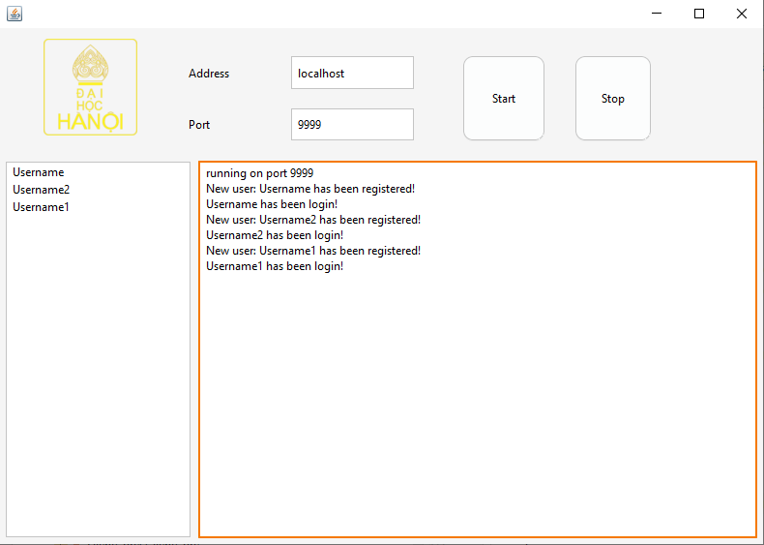

* Firstly, we need enter a port to start the server. In case that port already in used, the error message appears in the text box, and requires to enter another port.
* The text box also show the information of user who has been login in and out from chat application
* Login View:

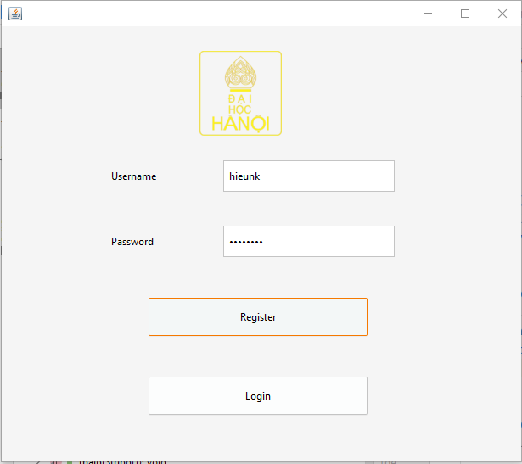

* To login, it require user to enter username, and port to connect, this port must correct with the port that server is listening.
* Chatting View:
* 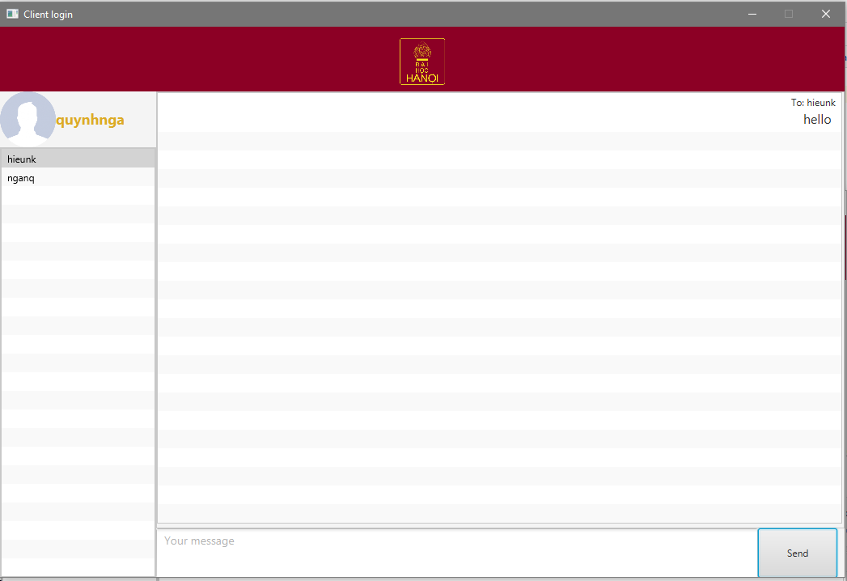The chatting view shows the list of users who are active and can be join chatting. User need to choose others user first to start communicate, in chase no one is chosen, a dialog will appear to warning user.
* On the right pane, there is a chat window which has a pane to display all incoming and outcoming message. On the bottom of chat window is the text field which help user to enter the message then click button to send

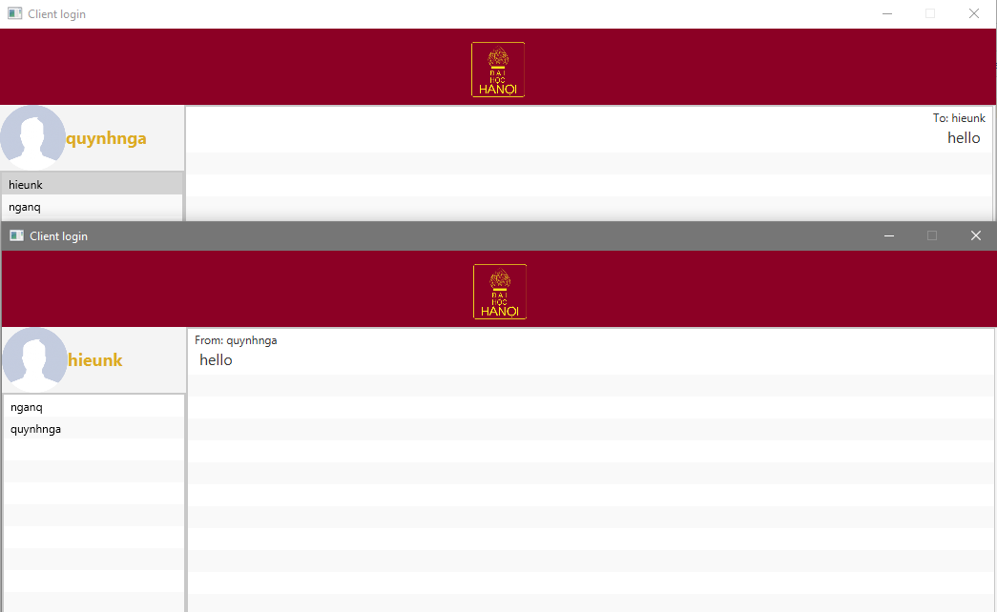

* Notification:

