Day_2 Assignment

- Can we write code without JSX?
- Yes, we can write code without JSX. JSX is syntactic sugar for calling React.createElement(). So anything we can with jsx can be done using javascript.
- JSX ---> babel ---> Javascript code of react library

- What is the benefit of writing ReactJs code with JSX?
- Makes writing your own components much easier.
- We can easily add HTML in react

- Does Browser understand JSX?
- Browsers can only read JavaScript objects but JSX is not a regular JavaScript object. Thus to enable a browser to read JSX, first, we need to transform a JSX file into a JavaScript object using JSX transformers like Babel and then pass it to the browser.

- What would happen if we directly run JSX in Browser?
- It will not run. But we can add babel.
- https://dev.to/devalnor/running-jsx-in-your-browser-without-babel-1agc

- Are there any advantages or disadvantages of using functional components?
- Fewer lines = better performance.
- i.e. functional components still transpile down to less code than class components, which means functional components = smaller bundles
- When we use a class component and extend it with React.component then the whole bundle is loaded i.e. all lifecycle methods, etc which makes class components slower than functional components.
- Easier to read and write

- Why does React maintain a Virtual DOM?
- Frequent DOM manipulations are expensive, hence react uses virtual DOM to enhance the performance.
- Virtual DOM is a blueprint of actual DOM. It exists in the memory and never actually rendered.
- When the state of the application changes, a new virtual DOM is created and it is compared with the previous virtual DOM. Creating a new DOM does not take much time as react elements are cheap. React uses an efficient diffing algorithm to find the differences and calculates the minimum number of operations necessary to update the real DOM. Once React knows which virtual DOM objects have changed, then React updates only those objects, in the real DOM. The updates to the real DOM are sent in batches, instead of sending updates for every single change in state.

- Are props mutable?
- props are immutable.
- the components that receive the props have no control over them because props are read-only.

- What can we pass in Props?
- javascript expression, object, component, string, functions, anything

- What is the state and why do we use it?
- The State of a component is an object that holds some information that may change over the lifetime of the component.
- When the state changes, the component responds by re-rendering.
- Only place to assign this.state is in a constructor.

- What is the use of props?
- used for passing data from parent component to child component (unidirectional flow)

- How do you update a state variable?
- We update the state by using the setState() method. Once the update is done the method implicitly calls the render() method to repaint the page.
- Calling this.setState(), React merges the passed object into the current state to create a new state object. Then it compares this new state to the previous state. If there is a change, React re-renders the component. This merging is shallow, only the passed object is replaced completely and the other state is left intact.

- Can we directly modify or update state?
- We can modify/update the state directly but it will not call the render() method implicitly.
- this.state.comment = “Hello” will not re-render a component. Instead use this.setState({comment: ‘Hello’})

- What is the use of state variables? Can’t we use normal variables?
- React components will only re-render when there are changes to props or state.
- Updating or using any other class variable does not trigger re-render.
- In order to use class variables, we need to take the responsibility of triggering the re-render when our data changes. By calling this.forceUpdate(), we can trigger the render method explicitly.

- Can anyone update the state variable?
- By passing a callback as a prop to the child component, we can update the state of parent by firing callback from child.
- https://blog.cloudboost.io/updating-state-of-a-parentless-component-in-react-e6b43047c91e

- Is there any other way of passing data between components?
- From parent to child ---> using props
- from child to parent --> by using a callback function and states
- between siblings --> to pass data between siblings, you have to use the parent as an intermediary. First pass the data from the child to the parent, as an argument into a callback from the parent. Set this incoming parameter as a state on the parent component, then pass it as a prop to the other child. The sibling can then use the data as a prop.
- Context API

- What are the lifecycle methods of class components and in which order are they called?
- React lifecycle methods are the series of events that happen from mounting of a component to its unmounting.
- render() --> Pure method. Only Required method within a class component. It handles the rendering of your component to the UI. Returns JSX that is displayed in the UI or can return a null if there is nothing to render for that component. We cannot modify state within render as we have other lifecycle methods for that.
- componentDidMount() --> runs after the component output has been rendered to the DOM. Can update state.
- componentDidUpdate([prevProps, prevState]) --> invoked as soon as the updating happens. We can use setState() in this with a condition to check for state or prop changes from previous state. Otherwise it will lead to infinite loop
- componentWillUnmount() --> called just before the component is unmounted and destroyed. Cleanup actions are performed. Cannot use setSate()
- shouldComponentUpdate(nextProps, nextState) --> Cannot update component state. Always returns a boolean value whether to render a component or not.
- static getDerivedStateFromProps(nextProps, prevState) --> return an object to update the state as the result of changes in props, or null to update nothing (used to set state value to initial props, used to compare its previous and next children to decide which ones to animate in and out.)
- getSnapshotBeforeUpdate(prevProps, prevState) --> called right before the DOM is updated. The value that is returned from getSnapshotBeforeUpdate() is passed on to componentDidUpdate().

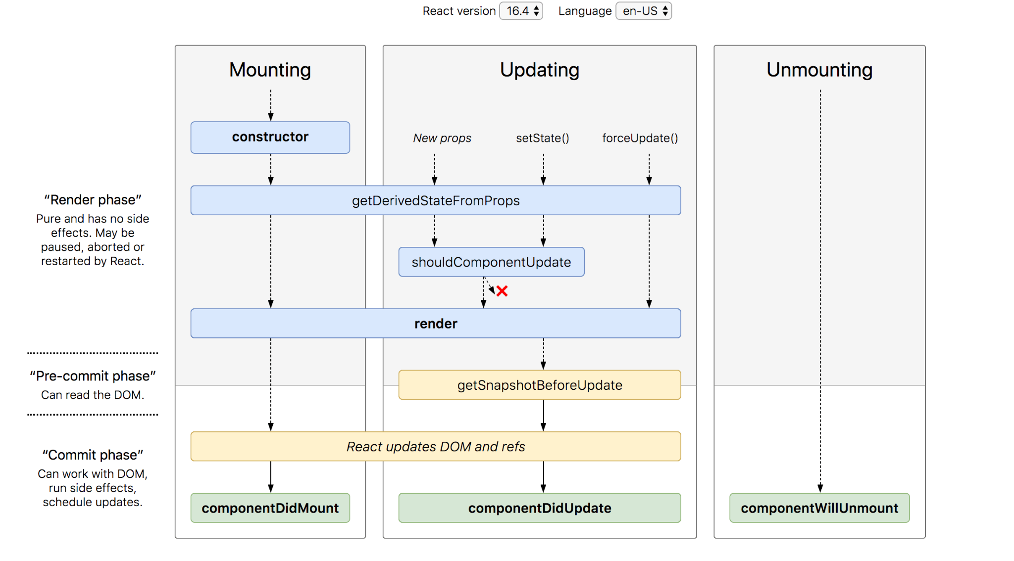

- What is the difference between javascript functions and class?
- Function
- JavaScript treats functions as first-class objects, so being an object, you can assign properties to a function.
- Hoisting is the JavaScript interpreter’s action of moving all variable and function declarations to the top of the current scope. Function Hoisting, declarations & expressions
- Class
- In a class-based object-oriented language, in general, state is carried by instances, methods are carried by classes, and inheritance is only of structure and behavior. In ECMAScript, the state and methods are carried by objects, and structure, behavior, and state are all inherited.
- https://stackoverflow.com/questions/11970141/javascript-whats-the-difference-between-a-function-and-a-class/45759444#:~:text=There%20is%20technically%20no%20class,to%20describe%20the%20above%20practice.
- https://stackoverflow.com/questions/17525450/object-vs-class-vs-function
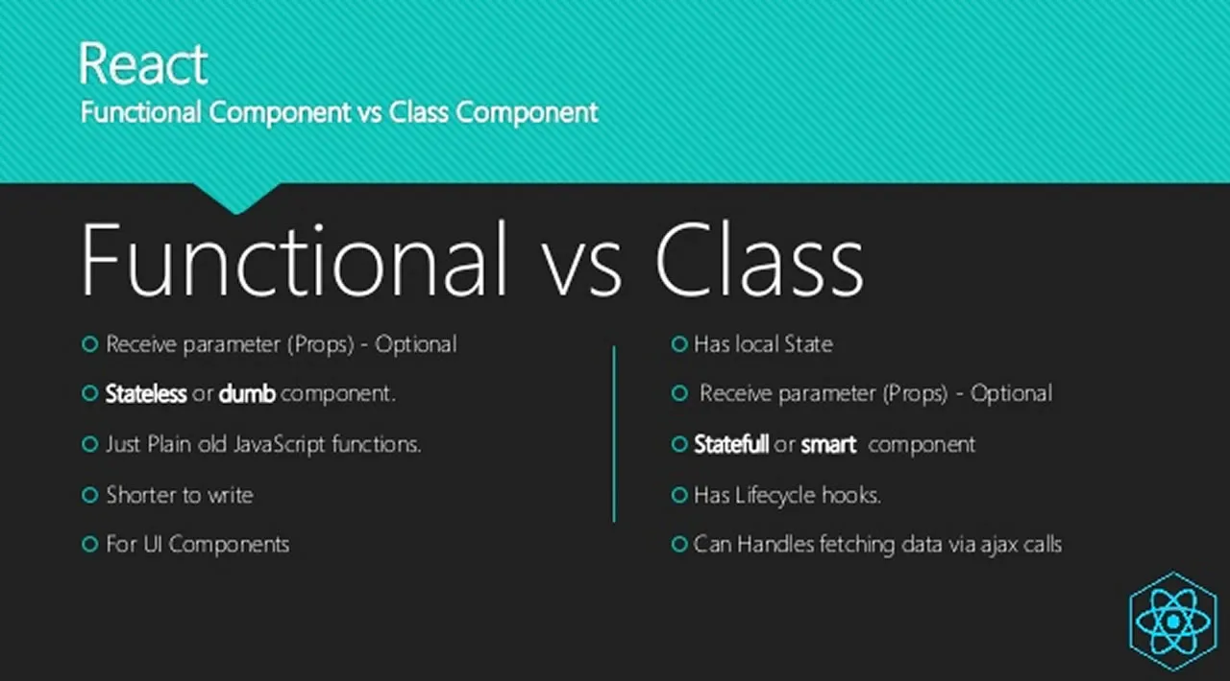
- How do functional components render without the render method?
- https://www.reddit.com/r/reactjs/comments/lre4qb/if_there_is_no_render_method_inside_the_component/
- Class components contain different lifecycle methods. So implicitly render is called to return JSX. While functional components directly return JSX.

- Why do we need to bind a function in a constructor?
this.handleRefreshClick.bind(something) returns a new function, in which references to this will refer to something. This is a way of saving the current value of this, which is in scope during the call to the constructor, so that it can be used later when the function is called.
If your functions don't require access to the state of your component, then sure, you don't need to bind them.

- https://stackoverflow.com/questions/38334062/why-do-you-need-to-bind-a-function-in-a-constructor

