Nginx Deployment on AWS using GitHub Actions

EC2 instance named Sample -instance created on AWS console
Public Ip Address: 65.2.142.250
Private Address : ip-172-31-7-10.ap-south-1.compute.internal
Key pair used : Task1-key-pair
Security Group used: sg-05862b773b16b2c25
EC2 instance
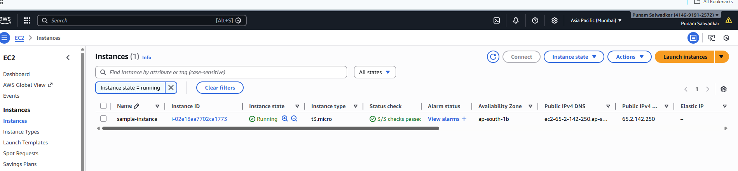
Instance details
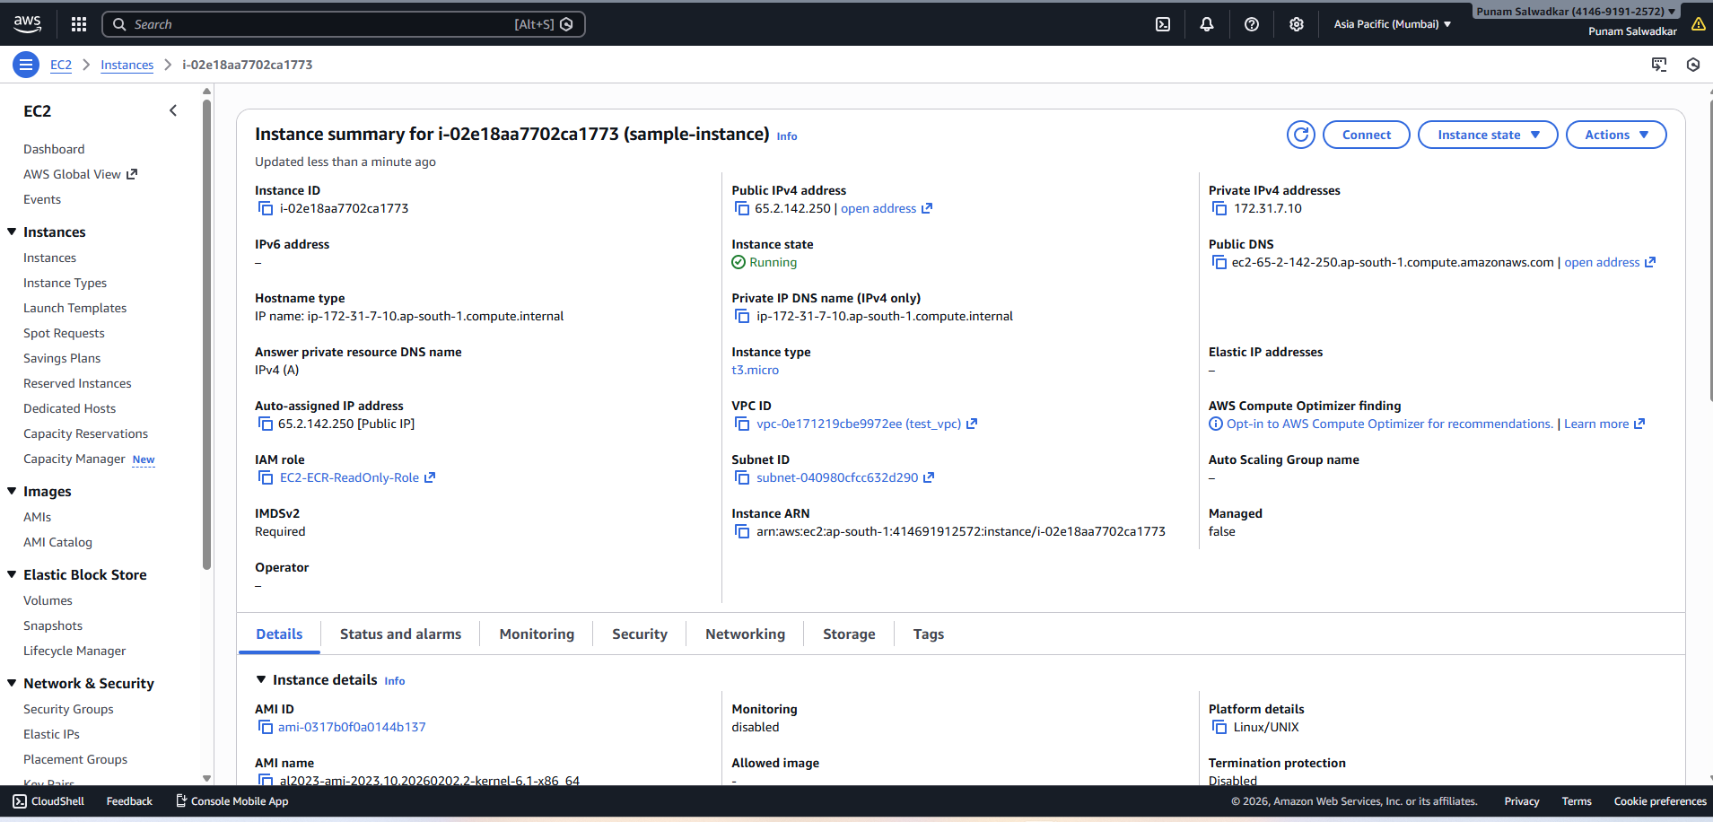

IAM user created
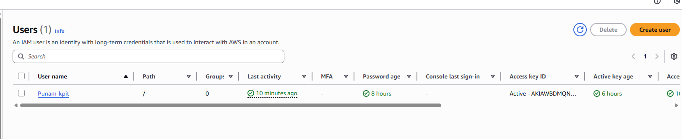

Below highlighted Roles Created

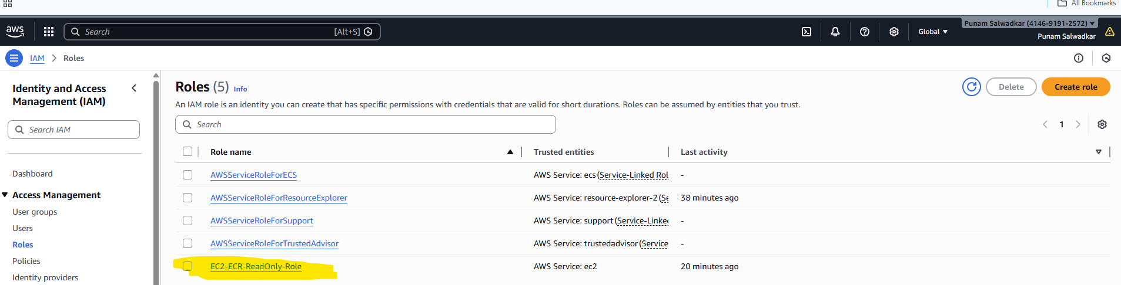

ECR created
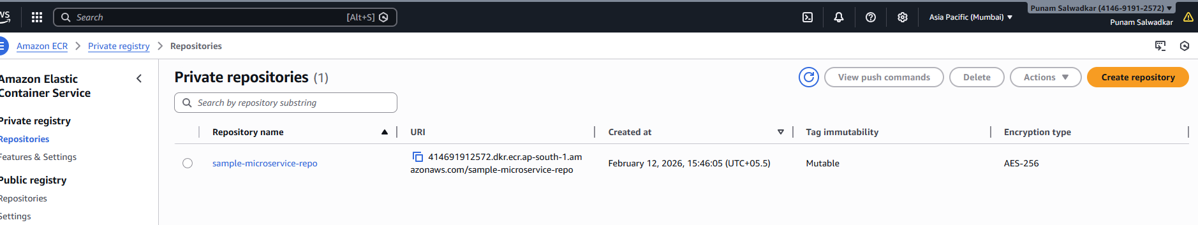
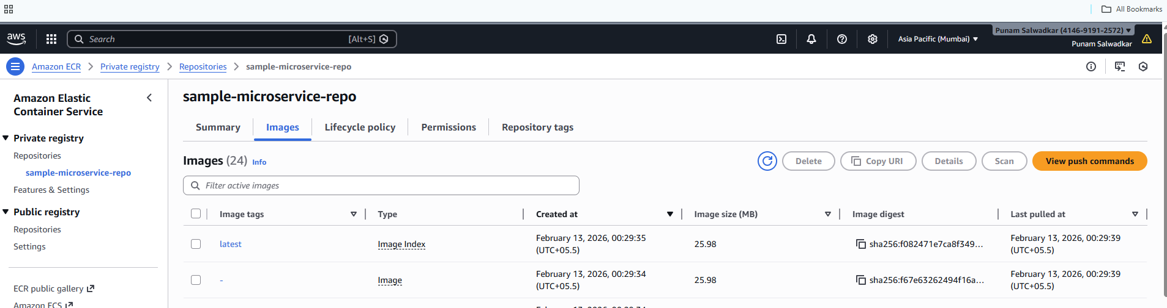

Docker installed on EC2 instance
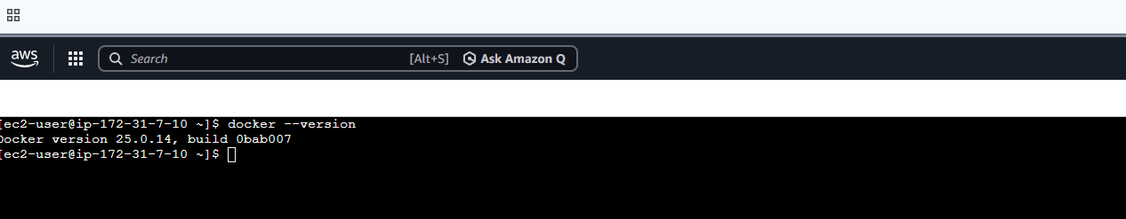

Public Repo created on GitHub

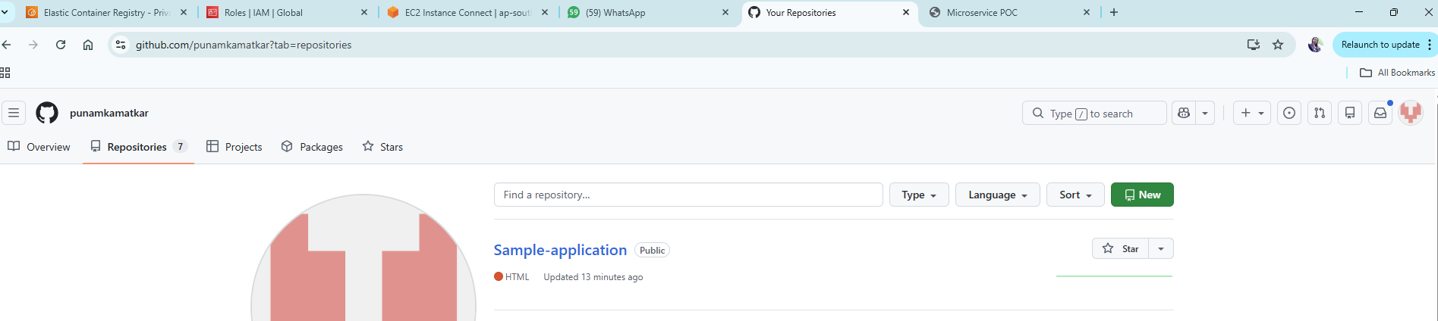

Created local repo for source code

Repo Link : https://github.com/punamkamatkar/Sample-application

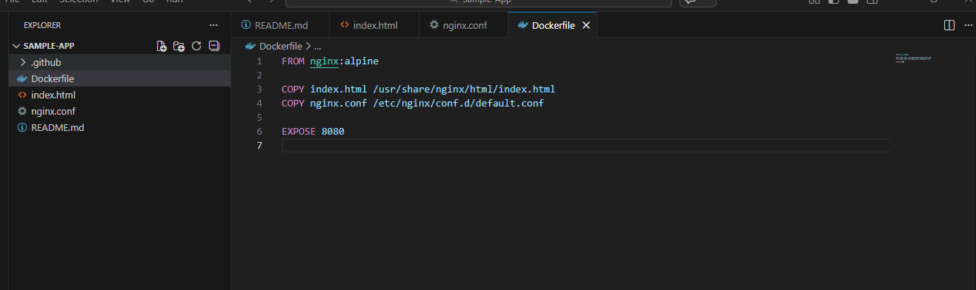

Code pushed to public remote git repo
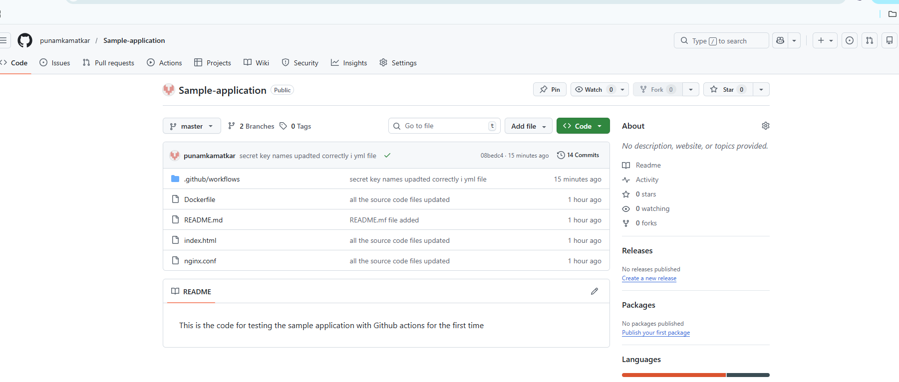

Added below secrets to Github repo
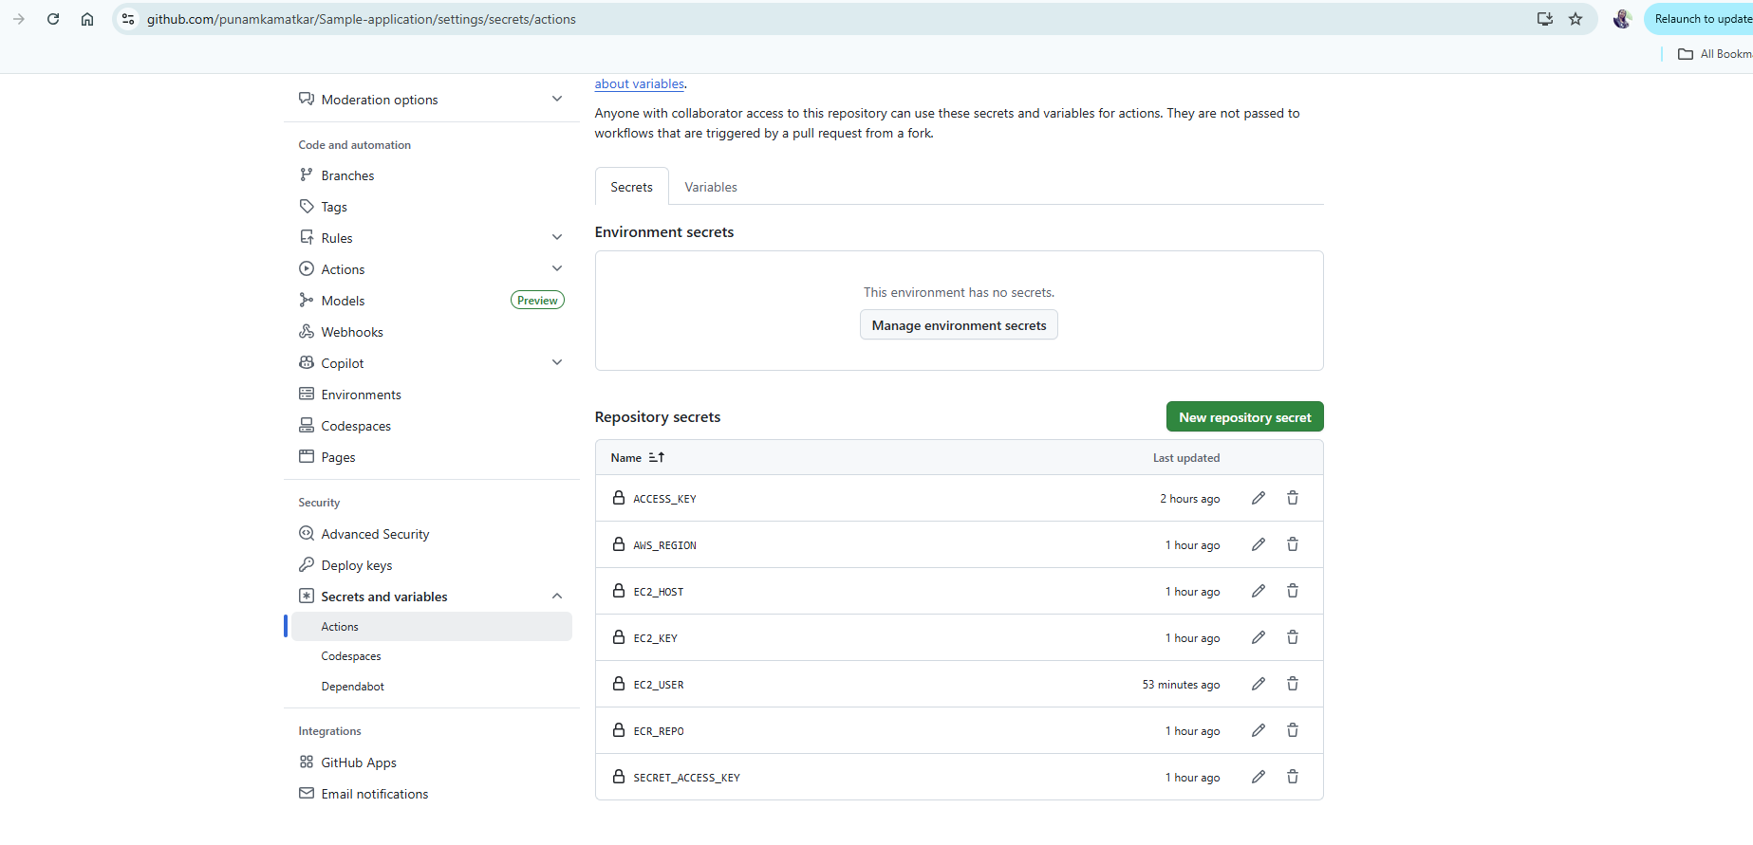
Created custom workflow action and created sample-app.yml file,

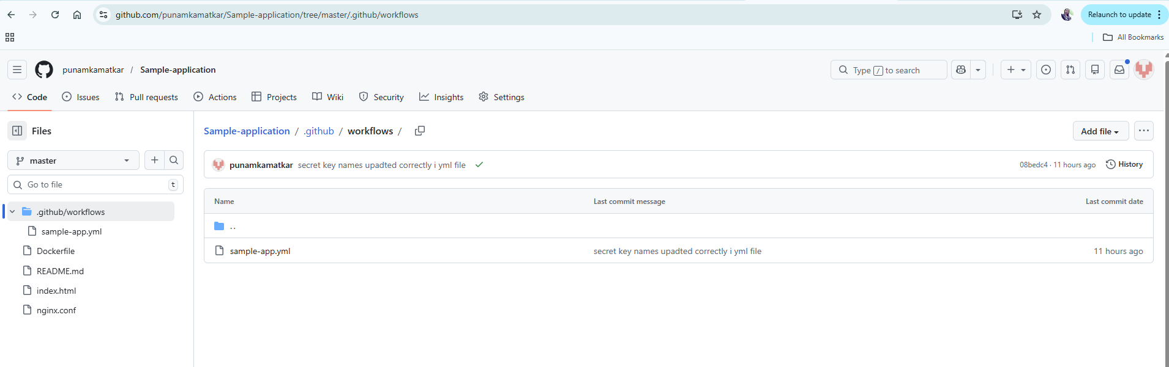

Pushed the changes and actions got triggered under Workflow Action
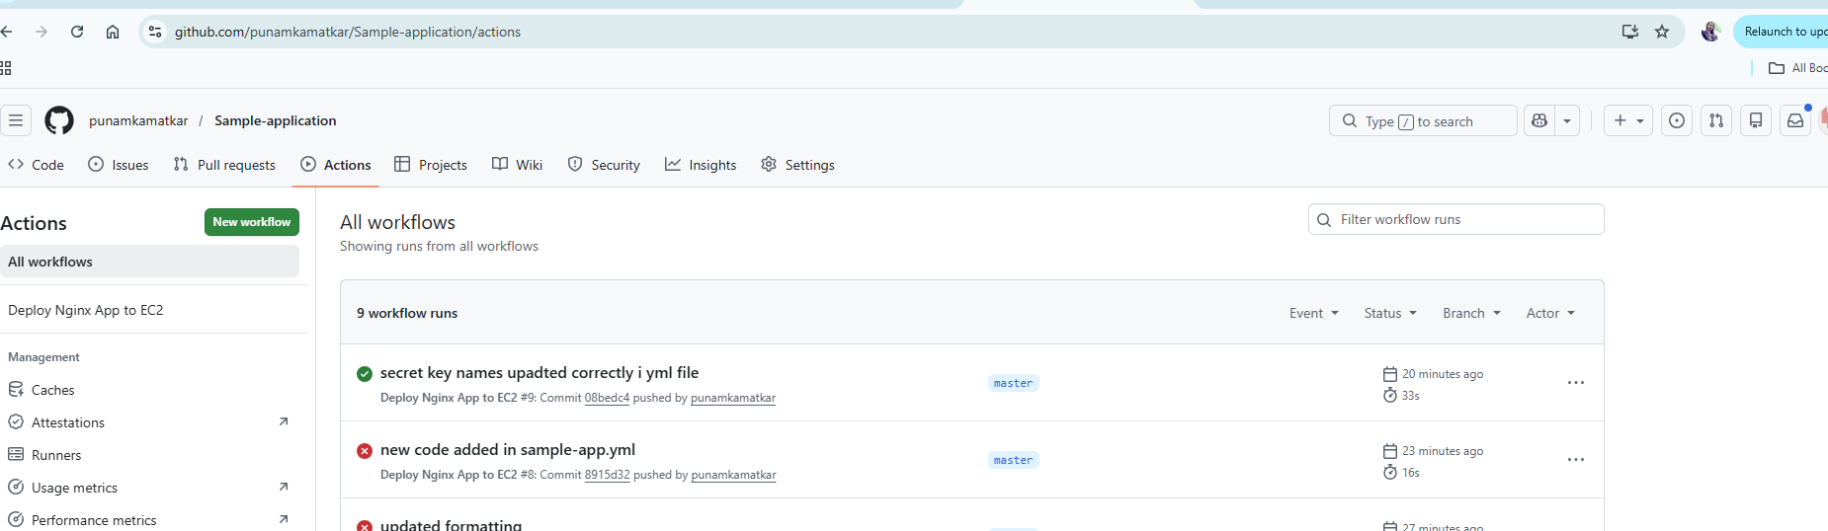

Application deployed on EC2 instance

