**HIRING MANAGEMENT SYSTEM**

**User Stories**

As an **administrator**, I should be able to:

1. Create, edit and view **candidate information** i.e.

* Candidate Name
* Oracle ID
* Candidate Location*
* Evaluated At: (select from drop down for appropriate cut offs)

1. Create, edit and view **PS information**
2. **Interview** Date
3. Type of Interview - **InterviewType**(Face-Face/ Telephonic/ Webcam / Domain/ AI/)
4. Type of **Ratings** (For e.g.: 1,2,3 or 1,2,3,4,5 etc)
5. **Skill bucket** and the specific **skills**
6. Skill **weightage** (in ratings provided), Expected **skill level**
7. **Cut off score**(Skill bucket wise and also overall)

As a PS lead, I should be able to edit :

1. **Interviewer** Details

* Full Name of Interviewer*
* Account Name of Interviewer*
* Location of Interviewer*

1. Interview Time

* Interview Start Time*
* Interview End Time*

As an Interviewer, I should be able to fill or edit:

1. Evaluated skill level
2. **Score of candidate** skill wise and overall
3. **Feedback** skill wise and overall
4. **Recommendation**( recommend if the candidate is eligible or not and if not then why not)
5. Decide if Candidate requires to give one interview more

**Domain Entities - One**

**Role**

**---------**

**Administrator**

**Interviewer**

**PS**

**User**

**Role -* Users**

**Interview –InterviewType**

**Interview - Candidate information**

**Interview - Position**

**Position -* Bucket**

**Bucket -* Skill**

**Skill**

**Skill – ExpectedSkillLevel**

**Skill - EvaluatedSkillLevel**

**Interview - Recommendation**

**Ratings**

**SkillLevel <- ExpectedSkillLevel**

**SkillLevel <- EvaluatedSkillLevel**

**Domain Entities – Two**

**Interview - Guidelines**

**Interview - CandidateInformation**

**Interview - Position**

**Interview - InterviewType**

**EvaluationGroup -* Job Level / Position (Sr. Mgmnt - Director, Sr.Mgr, Mgr)**

**Position -* HiringWorkflow**

**HiringWorkflow -* Assessment Level/Round (Screening, Domain Probe, AI, Written)**

**Assessment Level - AssessmentInformation**

**AssessmentInformation -* SkillBucket -* Skill**

**Skill - ExpectationCriteria**

**Skill - EvaluationResult**

**EvaluationResult - Rating**

**AssessmentInformation - AssesmentDocumentUpload**

**AssessmentInformation - FinalRecommendation**

**Rating <- BelowAvRating**

**Rating <- AvRating**

**Rating <- SolidRating**

**InterviewType <-Face-Face**

**InterviewType <-Telephonic**

**InterviewType <-Webcam**

**Role - User (PeopleSuccessTeam - HiringLead, Executive; InterviewerGroup - Interviewer)**

**Role -* Rights**

**DL -* User**

**Seed Data**

**AssessmentLevel**

**SkillBucket - Skill**

**Rating**

**InterviewType**

**Role - User**

**Role - Rights**

**Guidelines**

**System Integration**

**ActiveDirectory / Contacts**

**Grails 2.3.5**

**Nimble plugin**

**Wire Frames**

* **Menu**

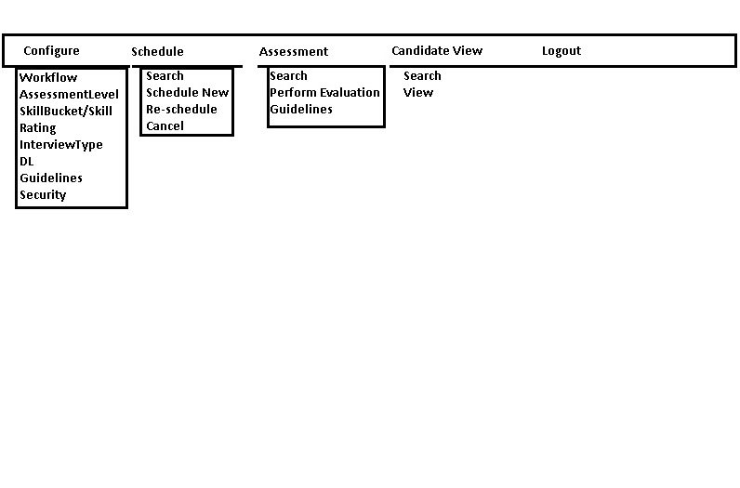

* **Schedule – Search**

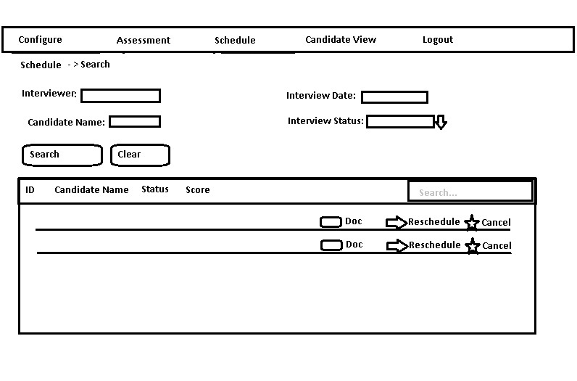

* **Schedule – New**

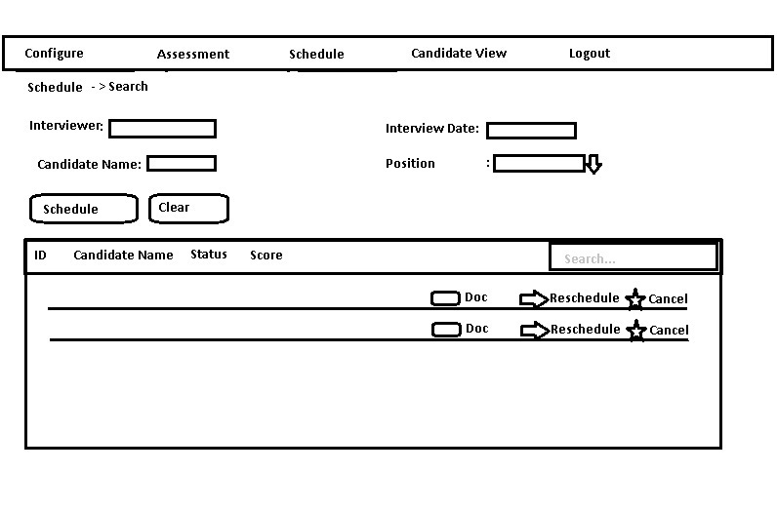

* **Assessment – Search**

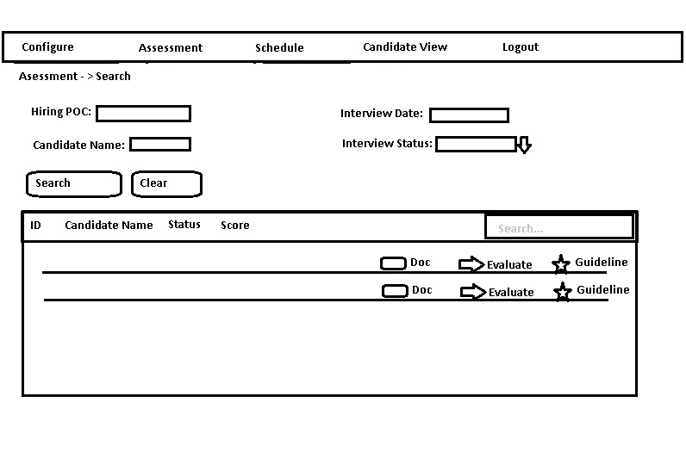

* **Assessment – Perform Evaluation  
  