**SUPPORTING DOCUMENTS GUIDE**

**ALERT: Before approving any Tuition Reimbursement requests please ensure the three requirements below are met.**

**Cook County Health Tuition Reimbursement Compliance Requirements**

**REQUIREMENTS FOR APPROVAL**

1. Nursing or Nursing related degree documentation
2. Official course curriculum for the Semester
3. Course schedule with start and end dates

**SAMPLE OFFICIAL COURSE CURRICULUM & NURSING or NURSING RELATED DEGREE**

* **Is the course requested for Tuition Reimbursement on the Official Course Curriculum?**
* **Is the employee obtaining a nursing or nursing related degree? Public Health degrees do not qualify**

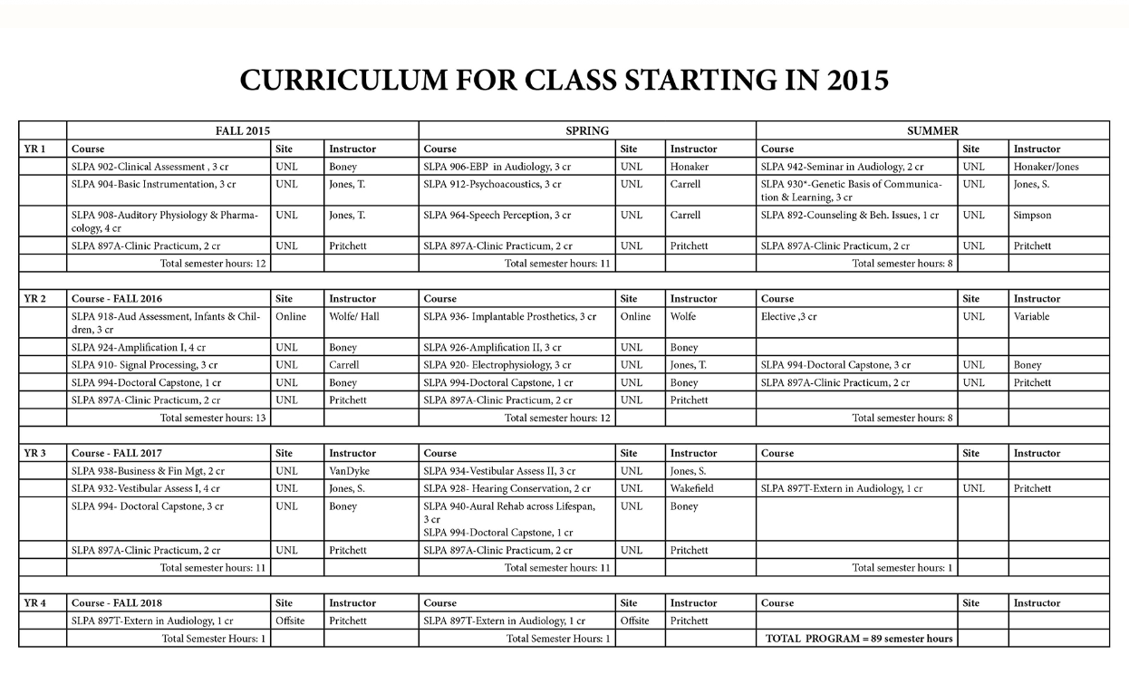

**SAMPLE OFFICIAL COURSE SCHEDULE**

* 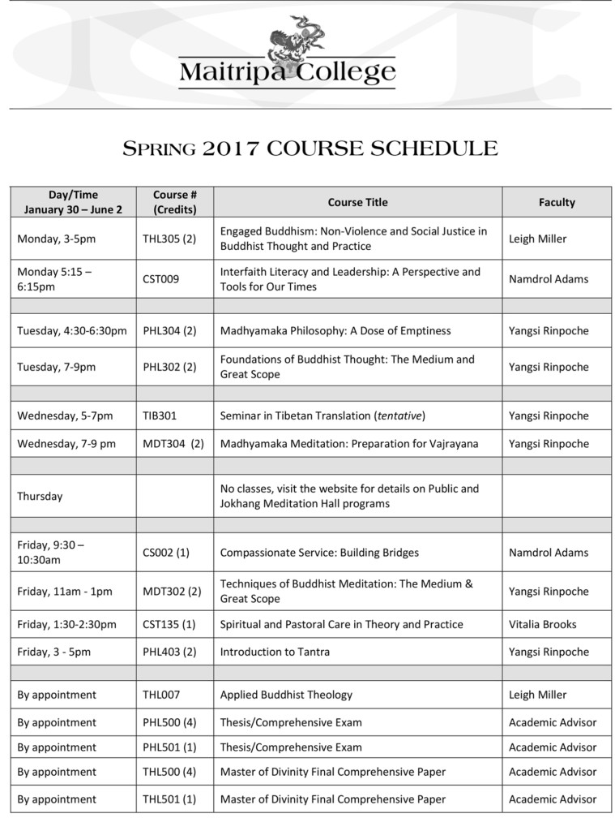**Did the employee submit evidence of the course start and end dates?**