**CA1**

**CSE531: Machine Learning**

**Name: _______________ Roll No: __________ Reg No: __________ Section: ____________**

**General Instructions**

1. **Turn off and submit all mobile phones to the invigilator before the exam starts.**
2. **Use blue or black ink for writing answers; pencils are allowed only for diagrams.**
3. **Maintain silence and do not communicate with other students during the exam.**
4. **Raise your hand to ask any questions; do not leave your seat without permission.**
5. **Submit your answer sheets promptly at the end of the exam; late submissions will not be accepted.**
6. **For MCQ questions, make sure to fill the table below with the correct option letter for the question.**

|  |  |  |  |  |  |  |  |  |  |
| --- | --- | --- | --- | --- | --- | --- | --- | --- | --- |
| **1** | **2** | **3** | **4** | **5** | **6** | **7** | **8** | **9** | **10** |
| **11** | **12** | **13** | **14** | **15** | **16** | **17** | **18** | **19** | **20** |
| **21** | **22** | **23** | **24** | **25** | **26** | **27** | **28** | **29** | **30** |

**1.** What is UI UX?

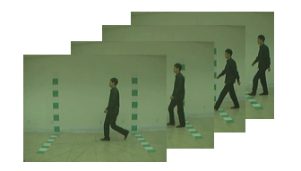

A. Text1

B. Text1

C. Text1

D. Text1