CA1
CSE316: Operating System
General Instructions
- Turn off and submit all mobile phones to the invigilator before the exam starts.
- Use blue or black ink for writing answers; pencils are allowed only for diagrams.
- Maintain silence and do not communicate with other students during the exam.
- Raise your hand to ask any questions; do not leave your seat without permission.
- Submit your answer sheets promptly at the end of the exam; late submissions will not be accepted.

1. What is UI?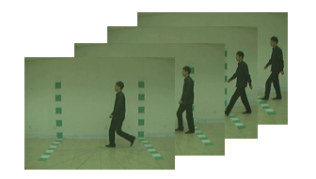
A. A software
B. A hardware
C. I don't know
D. I don't care

