ASSINGMENT 1

Linux Basics Assignment

1. Creating and Renaming Files/Directories
mkdir test_dir
Explanation: Creates a new directory named test_dir.
touch test_dir/example.txt
Explanation: Creates an empty file named example.txt inside test_dir.
mv test_dir/example.txt test_dir/renamed_example.txt
Explanation: Renames example.txt to renamed_example.txt using mv command.
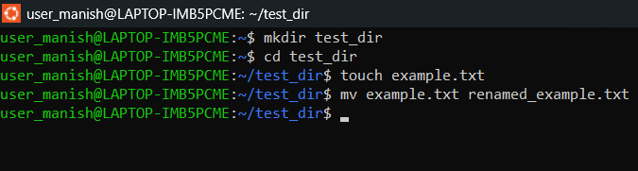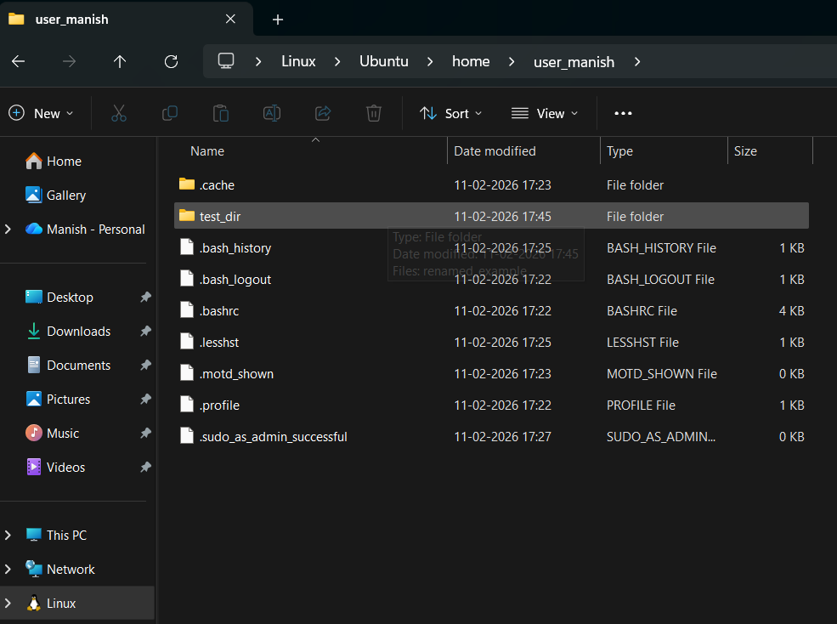
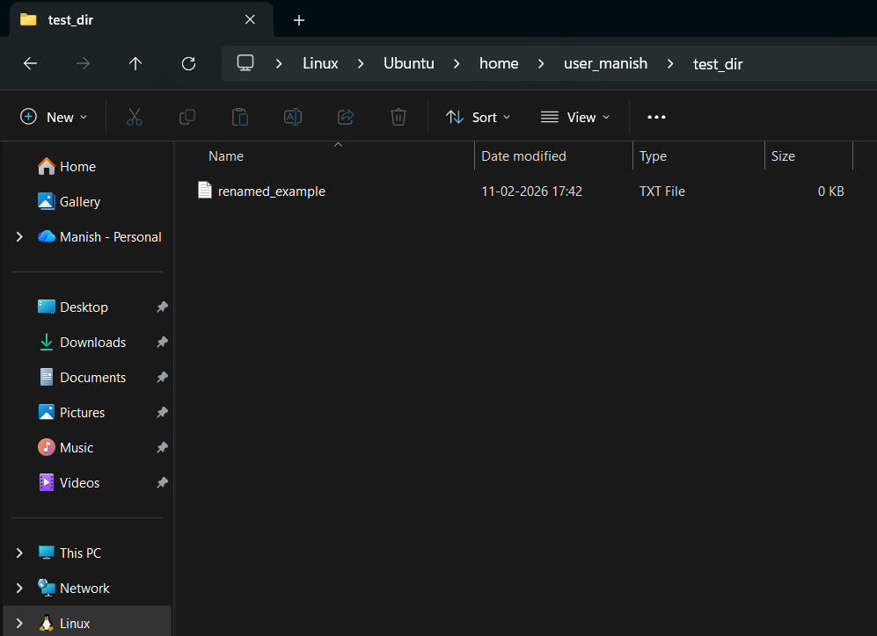

2. Viewing File Contents
cat /etc/passwd
Explanation: Displays the entire contents of /etc/passwd.
head -n 5 /etc/passwd
Explanation: Shows only the first 5 lines of /etc/passwd.
tail -n 5 /etc/passwd
Explanation: Shows only the last 5 lines of /etc/passwd.
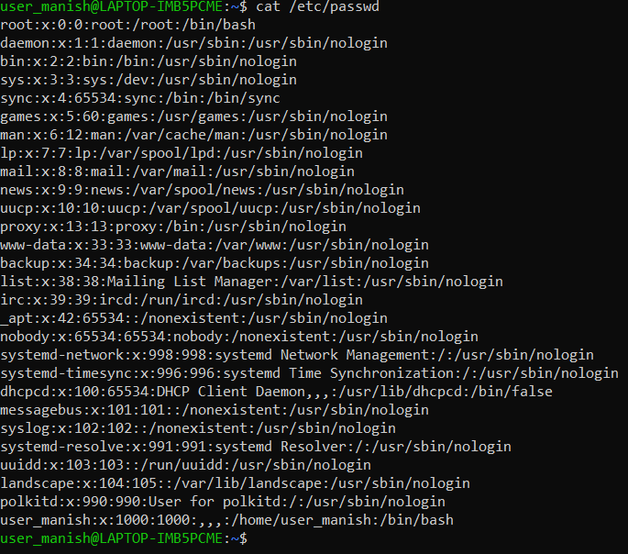
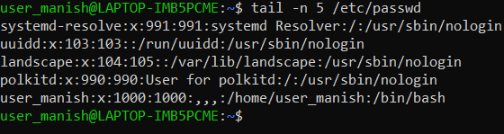
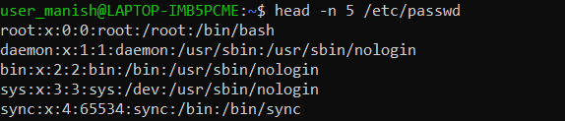

3. Searching for Patterns
grep root /etc/passwd
Explanation: Searches for lines containing the word 'root' in /etc/passwd.

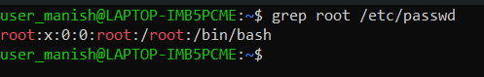

4. Zipping and Unzipping
zip -r test_dir.zip test_dir
Explanation: Compresses the test_dir directory into test_dir.zip.
unzip test_dir.zip -d unzipped_dir
Explanation: Extracts test_dir.zip into unzipped_dir.
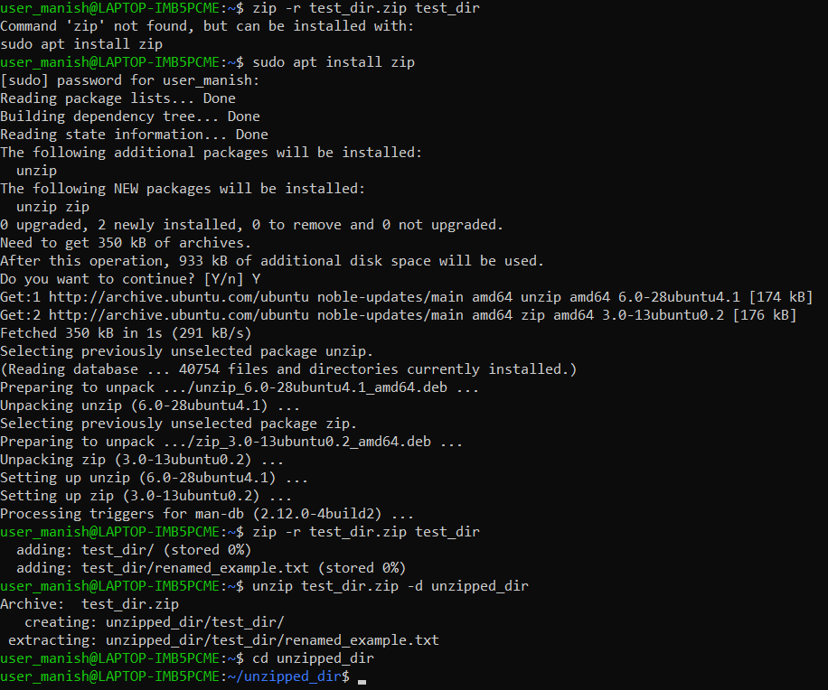
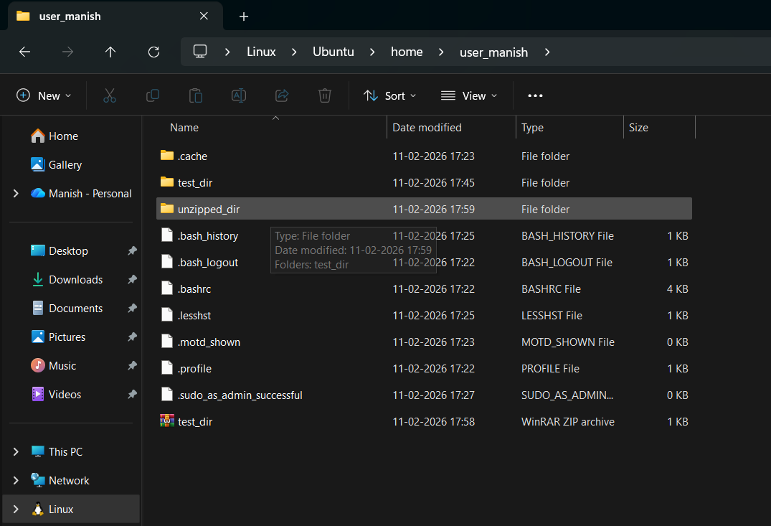

5. Downloading Files
wget https://example.com/sample.txt
Explanation: Attempted to download a file. Server returned 404 Not Found, The file does not exist at the URL.
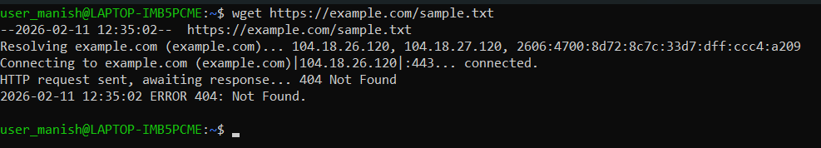

6. Changing Permissions
touch secure.txt
Explanation: Creates an empty file named secure.txt.
chmod 444 secure.txt
Explanation: Changes permissions to read-only for everyone.
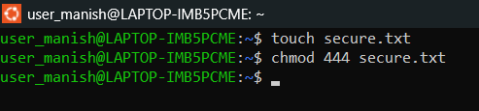

7. Working with Environment Variables
export MY_VAR="Hello, Linux!"
Explanation: Creates an environment variable MY_VAR.
echo $MY_VAR
Explanation: Displays the value of MY_VAR.
