VISUALIZING HOUSING MARKET TRENDS
TEAM MEMBERS

TEAM ID: LTVIP2026TMIDS85326

TEAM LEADER: VEERA PUNEETHA

TEAM MEMBER : Lakshman Lakshman Prasan Muthyala

Team member: Kiran Kumar Palivela

Team member:Penta Kalyan

PROJECT REPORT FORM
1,INTRODUCTION
1.1 PROJECT OVERVIEW
1.2 PURPOSE
2.IDEATION PHASE
2.1 PROBLEM STATEMENT
2.2 EMPATITY MAP CANVAS
2/3 BRAINSTROMING
3. REQUIREMENT ANALYSIS
3.1 CUSTOMER JOURNEY MAP
3.2 SOLUTION REQUIREMENT
3.3 DATA FLOW DIAGRAM
4. PROJECT DESIGN
4.1 PROBLEM SOLUTION FIT
4.2 PROPOSED SOLUTION
4.3 SOLUTION ARCHITECTURE
5. PROJECT PLANNING AND SCHEDULING
5.1 PROJECT PLANNING

6. FUNCTIONAL AND PERFORMANCE TESTING
6.1 PERFORMANCE TESTING
7. RESULTS
7.1 OUTPUT SCREENSHOTS
8. ADVANTAGES AND DISADVANTAGES
9. CONCLUSION
10 FUTURE SCOPE
11. APPENDIX
SOURCE CODE(if any)
Dataset link
GITHUB & PROJECT DEMO

INTRODUCTION
1.1 PROJECT OVERVIEW
Project Overview: Visualizing Housing Market Trends

This project focuses on analyzing and visualizing housing market trends to uncover meaningful patterns in property prices, sales volume, and market dynamics over time. The housing market plays a crucial role in economic stability and investment planning, making data-driven insights highly valuable for buyers, sellers, investors, and policymakers.

The primary objective is to transform raw real estate data into interactive and insightful visual representations. By using visualization tools, complex datasets become easier to interpret, helping stakeholders make informed decisions.

The project examines historical pricing trends across major cities such as New York City, Los Angeles, and Chicago to compare regional growth patterns. It highlights fluctuations in median home prices, rental rates, and property demand.

Key performance indicators include average sale price, price per square foot, inventory levels, time on market, and mortgage interest rate impact. Seasonal variations and long-term growth patterns are also explored.

The methodology involves data collection from reliable real estate databases, followed by data cleaning and preprocessing. Analytical tools such as Python (Pandas, Matplotlib, Seaborn) and visualization platforms like Tableau or Power BI are utilized.

Interactive dashboards allow users to filter data by location, year, property type, and price range. Time-series graphs illustrate price appreciation trends, while heat maps show regional demand intensity.

The project also investigates correlations between housing prices and macroeconomic factors such as employment rates and inflation. Predictive modeling techniques may be applied to forecast future housing price movements.

By visualizing trends clearly, the project aims to identify emerging market opportunities and potential risk areas. Comparative analysis between urban and suburban markets provides deeper insight into buyer preferences.

Ultimately, this project demonstrates how data visualization enhances transparency and strategic planning in the real estate sector. It supports smarter investment decisions, policy formulation, and long-term housing market sustainability.

1.2 PURPOSE
📊 Purpose of Visualizing Housing Market Trends

Visualizing housing market trends helps transform complex real estate data into clear, actionable insights. Whether you're analyzing markets like New York City, London, or Toronto, visualization makes patterns easier to understand and compare.

Here are the key purposes:

1️⃣ Identify Market Patterns & Cycles

Charts and graphs reveal:

Price appreciation or decline over time

Seasonal fluctuations

Housing supply and demand shifts

Boom and downturn cycles

This helps stakeholders anticipate market movements.

2️⃣ Support Data-Driven Decisions

Buyers, sellers, investors, and policymakers use visualizations to:

Determine the best time to buy or sell

Evaluate investment opportunities

Set competitive listing prices

Plan housing policies

3️⃣ Compare Regions & Property Types

Visual tools make it easy to compare:

Neighborhood performance

Urban vs. suburban markets

Condo vs. single-family home trends

Rental vs. ownership markets

4️⃣ Detect Emerging Trends

Visualizations can highlight:

Rapid price growth areas

Declining inventory levels

Rising mortgage rates impact

Migration-driven demand changes

Early detection gives a competitive advantage.

5️⃣ Improve Communication & Reporting

Graphs and dashboards:

Simplify complex datasets

Enhance presentations

Support research reports

Increase transparency for stakeholders

6️⃣ Risk Assessment & Forecasting

Trend lines and predictive models help:

Estimate future prices

Evaluate market volatility

Assess economic sensitivity

Reduce investment risk

🔎 In Summary

The purpose of visualizing housing market trends is to turn raw data into meaningful insights, enabling smarter financial, business, and policy decisions.

If you'd like, I can also provide examples of specific visualization types (e.g., heat maps, time-series charts, dashboards) used in housing market analysis.

2.IDEATION PHASE
2.1 PROBLEM STATEMENT
The housing market is influenced by numerous dynamic factors, including property prices, interest rates, location demand, economic conditions, population growth, and government policies. These factors generate large volumes of complex data that can be difficult to interpret using traditional analytical methods.

Buyers, sellers, investors, real estate professionals, and policymakers often struggle to identify meaningful patterns, price fluctuations, seasonal trends, and regional variations in the housing market. Without clear visualization, critical insights such as price growth rates, affordability trends, supply-demand imbalances, and investment opportunities may remain hidden.

The challenge is to design and develop an effective data visualization system that:

Collects and integrates housing market data from multiple sources.

Identifies key performance indicators (KPIs) such as median home prices, sales volume, inventory levels, and price per square foot.

Displays trends over time using intuitive and interactive visual tools.

Highlights geographic variations through maps and regional comparisons.

Enables users to filter, compare, and analyze data by time period, location, and property type.

Supports data-driven decision-making for different stakeholders.

The solution should transform complex housing data into clear, interactive, and actionable visual insights, allowing users to better understand market behavior, predict trends, and make informed financial or policy decisions.

If you’d like, I can also provide:

Objectives

Scope

Research questions

Methodology

Tools & technologies (e.g., Tableau, Power BI, Python, etc.)

A full project report version

Or a short academic version for submission

Just tell me the format you need.

2.2 EMPATITY MAP CANVAS
An Empathy Map Canvas is a powerful tool to understand stakeholders’ behaviors, motivations, and pain points. When applied to visualizing housing market trends, it helps ensure your dashboards, reports, or analytics tools actually meet user needs.

Below is a structured Empathy Map tailored to the housing market context.

🏠 Empathy Map Canvas: Visualizing Housing Market Trends

🎯 Target Persona Example

Real Estate Investor / Home Buyer / Property Developer / Policy Analyst
(You can create separate empathy maps for each stakeholder group.)

1️⃣ SAYS (What do they say out loud?)

“Is this a good time to buy or sell?”

“Are prices going up or stabilizing?”

“What neighborhoods are appreciating fastest?”

“How reliable is this data?”

“What will interest rates do next?”

2️⃣ THINKS (What are they thinking but not saying?)

“Am I making a risky financial decision?”

“Will I miss the market peak?”

“Is this data manipulated or biased?”

“What’s the long-term trend vs short-term fluctuation?”

“How does this compare historically?”

3️⃣ DOES (Actions they take)

Checks listing platforms like Zillow and Redfin

Reviews reports from National Association of Realtors

Tracks interest rates from Federal Reserve

Uses Excel dashboards or data tools

Compares neighborhoods, price per sq. ft., rental yields

4️⃣ FEELS (Emotions)

😟 Uncertain (market volatility)

😬 Fear of missing out (FOMO)

😕 Overwhelmed by too much data

😌 Relieved when trends are clear and visualized well

📈 Excited during growth periods

📊 Implications for Visualizing Housing Market Trends

Using the empathy insights above, your visualization should:

✅ 1. Show Clear Time Trends

Line charts for 5–10 year price movement

Highlight peaks and downturns

✅ 2. Enable Geographic Comparison

Heat maps by ZIP code

Interactive neighborhood comparison

Price per square foot visualizations

✅ 3. Reduce Cognitive Overload

Simple dashboards

Tooltips instead of cluttered labels

Clear legends and consistent scales

✅ 4. Show Context

Overlay interest rate trends

Compare against inflation

Show historical averages

✅ 5. Provide Forecast Indicators (Optional)

Scenario modeling

Confidence intervals

Supply vs demand metrics

🧠 Example: Investor-Focused Empathy Map Snapshot
Section | Key Insight
Says | “Where is the highest ROI?”
Thinks | “Is this neighborhood gentrifying?”
Does | Analyzes rent-to-price ratios
Feels | Competitive pressure

→ Visualization implication: Include rental yield maps + price appreciation overlay

🎨 If You're Building a Dashboard

Consider structuring it like this:

Market Overview Panel

Median price

YoY change

Inventory levels

Trend Analysis

10-year line chart

Volume of sales

Geographic Heat Map

Affordability Tracker

Mortgage rates

Income-to-price ratio

Investor Metrics (Optional)

Cap rate

Vacancy rate

Rental growth

If you’d like, tell me:

🎓 Is this for academic research?

💼 A business presentation?

📊 A Power BI / Tableau project?

🏗 A proptech startup idea?

I can tailor the empathy map more precisely to your use case.

- - - You can structure it as:

THINKS | FEELS
-----------------------------------------
SEES | HEARS
-----------------------------------------
SAYS | DO

2.3 BRAINSTROMING

Here’s a structured brainstorm to help you visualize housing market trends effectively—whether for dashboards, investor decks, public policy, or academic work.

1️⃣ Price Trends Over Time

Goal: Show growth, cycles, and volatility.

Ideas:

📈 Line chart – Median sale price over time (monthly/quarterly)

📊 Dual-axis chart – Prices vs. mortgage rates (e.g., Federal Reserve rate changes)

3. REQUIREMENT ANALYSIS
3.1 CUSTOMER JOURNEY MAP
Here’s a Customer Journey Map tailored to a product focused on Visualizing Housing Market Trends (e.g., dashboards, analytics tools, interactive maps, forecasting platforms).

🏡 Customer Journey Map: Visualizing Housing Market Trends

1️⃣ Awareness Stage

Goal: Customer realizes they need housing market insights.

Customer Types:

Home buyers

Real estate investors

Real estate agents

Developers

Financial analysts

Customer Thoughts:

“Is this a good time to buy?”

“Are prices rising or falling in my area?”

“Which cities are growing fastest?”

Touchpoints:

Google search

Social media posts

Real estate blogs

News platforms

Word-of-mouth

Industry reports (e.g., National Association of Realtors)

Pain Points:

Confusing or conflicting reports

Static charts with no interactivity

Overwhelming raw data

Opportunities:

Publish interactive trend reports

SEO blog content (e.g., “Housing Market Trends 2026”)

Share infographics on LinkedIn

2️⃣ Consideration Stage

Goal: Customer compares tools and data sources.

Customer Thoughts:

“Which platform gives the most accurate data?”

“Can I compare neighborhoods easily?”

“Is it worth paying for premium analytics?”

Touchpoints:

Product website

Demo videos

Webinars

Reviews

Comparison pages

Competitor Examples:

Zillow

Redfin

Realtor.com

CoreLogic

Pain Points:

Paywalls

Complex dashboards

Lack of localized data

No predictive insights

Opportunities:

Offer interactive demo dashboard

Provide free trial

Highlight predictive modeling features

Show real-life use cases

3️⃣ Decision Stage

Goal: Customer subscribes or commits to the platform.

Customer Thoughts:

“Is this data reliable?”

“Will this help me make better investment decisions?”

“What’s the ROI?”

Touchpoints:

Pricing page

Testimonials

Case studies

Sales consultation

Pain Points:

High subscription cost

Data accuracy concerns

Integration issues with CRM tools

Opportunities:

Show accuracy benchmarks

Provide downloadable sample reports

ROI calculator

Money-back guarantee

4️⃣ Usage Stage

Goal: Customer actively uses visualization tools.

Customer Activities:

Viewing price trends by city

Comparing historical data

Analyzing rental yields

Exporting reports

Forecasting market shifts

Features That Matter:

Interactive heat maps

Time-series charts

AI-driven predictions

Neighborhood comparison tools

Data export (PDF/CSV)

Pain Points:

Data lag

Slow loading maps

Hard-to-read visuals

Opportunities:

Real-time updates

Custom dashboards

Mobile-friendly interface

API access for professionals

5️⃣ Retention & Advocacy Stage

Goal: Customer becomes long-term subscriber and promoter.

Customer Thoughts:

“This saved me from a bad investment.”

“I rely on this for every deal.”

Touchpoints:

Email reports

Push alerts

Customer support

Community forums

Opportunities:

Weekly market alerts

Personalized trend insights

Referral program

Advanced analytics upgrades

🎯 Emotional Journey Overview
Stage | Emotion | Risk | Opportunity
Awareness | Curious but uncertain | Misinformation | Clear visual storytelling
Consideration | Analytical | Comparison fatigue | Transparent feature comparison
Decision | Hesitant | Price sensitivity | Trust signals
Usage | Engaged | Frustration if UX poor | Seamless experience
Retention | Confident | Competitor switching | Loyalty incentives

📊 Key Metrics to Track

Customer acquisition cost (CAC)

Conversion rate (trial → paid)

Monthly active users (MAU)

Dashboard engagement time

Churn rate

Net promoter score (NPS)

If you’d like, I can also provide:

A visual diagram version of this journey map

A persona-specific journey map (e.g., investor vs first-time buyer)

A service blueprint version

A PowerPoint-ready layout structure

Just tell me your use case (academic, startup, enterprise, UX project).

3.2 SOLUTION REQUIREMENT
When visualizing housing market trends, the solution should combine clear data structure, appropriate visualization techniques, and analytical insights to support decision-making. Below is a structured requirement guide you can use for a project, report, or system design.

🏠 Solution Requirements: Visualizing Housing Market Trends

1️⃣ Objective Definition

The solution should enable users to:

Track price trends over time

Compare housing markets across regions or cities

Analyze supply vs. demand

Identify seasonal patterns

Detect market bubbles or downturns

Forecast future trends (optional advanced feature)

2️⃣ Data Requirements

A. Core Data Fields

Property sale price

Listing price

Sale date

Property type (apartment, single-family, condo, etc.)

Location (city, ZIP code, neighborhood)

Square footage

Number of bedrooms/bathrooms

Days on market

Interest rates (external economic factor)

Inventory levels

B. Data Sources (Examples)

Government housing databases

Real estate APIs

Mortgage rate reports

Census data

3️⃣ Key Metrics to Visualize

Median sale price

Average price per square foot

Inventory levels

Sales volume

Days on market

Price-to-income ratio

Year-over-year (YoY) growth

Month-over-month (MoM) growth

4️⃣ Recommended Visualizations

📈 1. Time-Series Line Charts

Used for:

Price trends over months/years

Interest rate changes

Inventory fluctuations

Best for: Identifying long-term trends and cycles

📊 2. Bar Charts

Used for:

Comparing cities or regions

Sales volume comparison

Property type distribution

🗺 3. Heat Maps / Choropleth Maps

Used for:

Geographic price distribution

Regional demand intensity

📦 4. Box Plots

Used for:

Price distribution analysis

Outlier detection

Market variability

📉 5. Scatter Plots

Used for:

Price vs. square footage

Price vs. interest rates

Supply vs. demand analysis

📊 6. Stacked Area Charts

Used for:

Inventory breakdown by property type

Market share over time

5️⃣ Dashboard Requirements

The solution should include an interactive dashboard with:

✔ Filters

Date range selector

City/Region selector

Property type filter

Price range slider

✔ Drill-Down Capability

National → State → City → Neighborhood

✔ Comparison Mode

Compare multiple cities side-by-side

✔ KPI Summary Section

Display:

Median price

YoY growth %

Inventory levels

Sales volume

6️⃣ Analytical Features (Advanced)

Trend line regression

Moving averages (3-month, 6-month, 12-month)

Forecasting models (ARIMA, Prophet)

Bubble detection indicators

Affordability index

Correlation analysis with mortgage rates

7️⃣ Technical Requirements

Tools & Technologies

Python (Pandas, Matplotlib, Seaborn, Plotly)

Tableau / Power BI

SQL database

Cloud storage (AWS, Azure, GCP)

Real-time API integration (optional)

Performance Requirements

Load time < 3 seconds

Real-time update capability (if streaming data)

Scalable to millions of records

8️⃣ User Experience Requirements

Clean and minimal UI

Responsive design (desktop + mobile)

Tooltips for data points

Export options (PDF, CSV)

Dark/light mode support

9️⃣ Deliverables

Interactive dashboard

Data model documentation

KPI definitions document

User guide

Executive summary report

📌 Example Use Case Scenario

A real estate analyst wants to:

Compare housing price trends in two cities over 10 years

Understand seasonal sales spikes

Predict next year’s median price

The dashboard should allow:

Selecting two cities

Viewing overlapping time-series graphs

Displaying YoY growth

Generating a forecast projection

🔍 Expected Outcome

The final solution should:

✔ Provide actionable insights
✔ Support investment decisions
✔ Help policymakers understand affordability
✔ Enable real estate agencies to adjust pricing strategy

If you'd like, I can also provide:

A sample dashboard layout design

A technical architecture diagram

A Python implementation example

A Power BI project structure

Or a project proposal document template

Just tell me which direction you want to go.

3.3 DATA FLOW DIAGRAM
Here’s a Data Flow Diagram (DFD) for a system that focuses on Visualizing Housing Market Trends.

📊 Data Flow Diagram – Visualizing Housing Market Trends

🔷 1. Context Level DFD (Level 0)

This shows the overall system as a single process interacting with external entities.

External Entities

🏠 Real Estate Agencies

🌐 Property Listing Platforms (e.g., Zillow, Redfin)

👤 Users (Buyers, Sellers, Investors)

📊 Government Data Sources (e.g., U.S. Census Bureau)

Main Process

Housing Market Trend Visualization System

Data Flows

Property Listings Data

Historical Sales Data

Demographic & Economic Data

User Search Queries

Trend Reports & Visual Dashboards

📌 Context Diagram (Level 0)

Real Estate Agencies

|

v

----------------------

| |

| Housing Market |

Users <--> Trend Visualization <--> Government Data Sources

| System |

| |

----------------------

^

|

Property Listing Platforms

🔷 2. Level 1 DFD

This breaks the system into major processes.

🔹 Main Processes

Data Collection Module

Data Storage Module

Data Processing & Analysis Module

Visualization & Reporting Module

User Interaction Module

🔹 Data Stores

D1: Property Listings Database

D2: Historical Sales Database

D3: Demographic & Economic Database

D4: Processed Trend Data Warehouse

📌 Level 1 Diagram (Text Representation)

External Sources

|

v

[1. Data Collection]

|

v

[2. Data Storage] ---> (D1, D2, D3)

|

v

[3. Data Processing & Analysis]

|

v

(D4 Processed Trend Data)

|

v

[4. Visualization & Reporting]

|

v

[5. User Interaction]

|

v

Users

🔷 3. Level 2 DFD (Data Processing & Analysis Module)

Breakdown of Process 3:

Sub-Processes:

3.1 Data Cleaning
3.2 Data Integration
3.3 Trend Analysis
3.4 Predictive Modeling
3.5 KPI Calculation

Inputs:

Raw Listings

Sales Records

Interest Rates

Population Data

Outputs:

Price Trends

Demand-Supply Graphs

Forecast Models

Heat Maps

📌 Level 2 Diagram (Process 3)

Raw Data

|

v

[3.1 Data Cleaning]

|

v

[3.2 Data Integration]

|

v

[3.3 Trend Analysis]

|

v

[3.4 Predictive Modeling]

|

v

[3.5 KPI Calculation]

|

v

Processed Trend Data

🔷 Key Data Flow Summary
Input Data | Process | Output
Property Listings | Cleaning & Integration | Structured Market Data
Sales History | Trend Analysis | Price Trends
Demographics | Modeling | Forecasted Growth
User Filters | Visualization | Interactive Charts

🔷 Tools Commonly Used for Implementation

Database: MySQL / PostgreSQL

Analytics: Python (Pandas, Scikit-learn)

Visualization: Power BI / Tableau

APIs: MLS APIs, Census APIs

If you would like, I can also:

✅ Convert this into a proper diagram image layout

✅ Create a DFD using standard symbols (circles, arrows, data stores)

✅ Provide a draw.io / Lucidchart ready structure

✅ Generate a PDF-ready academic version

✅ Add UML diagram version**

Just tell me your requirement (academic, business, or technical documentation).

3.4 TECHNOLOGY STACK
Here’s a comprehensive technology stack you can use for visualizing housing market trends — from data ingestion through analysis and interactive visualization:

🧠 1) Data Collection & Storage

Data Sources

MLS APIs

Zillow / Redfin / Realtor APIs

Government housing datasets (e.g., Census, HUD)

Public economic data (e.g., unemployment, interest rates)

Ingestion Tools

Python (requests, BeautifulSoup, Scrapy) — for API calls & web scraping

ETL tools: Apache NiFi, Airbyte, Talend

Databases

Relational / OLTP: PostgreSQL, MySQL

Analytical / OLAP: Amazon Redshift, Google BigQuery, Snowflake

Time-series DB (optional): TimescaleDB, InfluxDB

📊 2) Data Processing & Analysis

🛠 Languages & Libraries

Python (most common)

Pandas — data cleaning & transformation

NumPy — numeric operations

SciPy / Statsmodels — statistical analysis

R (optional alternative)

dplyr / tidyr — data wrangling

ggplot2 — stat visualization

🧠 Modeling & ML (if applicable)

scikit-learn — regression, clustering, forecasting

Prophet — time-series trend forecasting

XGBoost / LightGBM — advanced prediction models

TensorFlow / PyTorch — deep learning (if you do advanced modeling)

📈 3) Visualization & Dashboards

🖼 Static Charts

Matplotlib

Seaborn

📊 Interactive Visualizations

Plotly / Plotly Dash — interactive Python charts & dashboards

Bokeh

Altair

📋 BI & Dashboard Platforms

Tableau — powerful visuals & easy exploration

Power BI — enterprise reporting

Looker — cloud BI from Google

Metabase — open-source

🌍 4) Web Front-End (if building a custom app)

📌 Front-End Frameworks

React — popular, component based

Vue.js — easier learning curve

Next.js (with React) — SSR & SEO

📊 Charting Libraries for Web

D3.js — highly customizable visuals

Chart.js — simple charts

Highcharts — robust commercial charts

ECharts — open source interactive

API Layer

FastAPI (Python, fast & modern)

Flask / Django (Python)

Node.js + Express (JS)

GraphQL (optional alternative to REST)

📈 5) DevOps & Deployment

Cloud Providers: AWS, GCP, Azure

Containers: Docker

Orchestration: Kubernetes (optional)

CI/CD: GitHub Actions, GitLab CI, Jenkins

Monitoring / Logging: Prometheus, Grafana, ELK Stack

🛡 Data Governance & Quality

Great Expectations — data testing & validation

dbt (Data Build Tool) — transformation + version control

Airflow — workflow scheduling

DVC / MLflow — experiment tracking

📌 Example End-to-End Stack (Typical)
Component | Technology
Data Ingestion | Python / Airbyte
Storage | PostgreSQL + BigQuery
Processing | Python (Pandas)
Modeling | Prophet / scikit-learn
Visualization | Plotly Dash
Dashboard Hosting | AWS + Docker
CI/CD | GitHub Actions

🧩 Optional Enhancements

✅ Geospatial Analysis:

PostGIS (PostgreSQL), QGIS, Kepler.gl, Mapbox

✅ Real-Time Updates:

Kafka, AWS Kinesis

✅ Mobile Dashboards:

React Native, Flutter

If you want, tell me your specific use case (e.g., forecasting prices, comparing regions, web app vs BI dashboard) and I can tailor the stack with architecture diagrams and recommended libraries!

PROJECT DESIGN
4.1 PROBLEM SOLUTION FIT
Problem–Solution Fit: Visualizing Housing Market Trends

1️⃣ The Problem

In many markets (including fast-moving urban areas), housing data is:

Fragmented across portals, government records, and reports

Difficult to interpret (raw spreadsheets, PDFs, inconsistent metrics)

Lagging or outdated

Overwhelming for non-experts

Key affected groups:

🏠 Homebuyers – Struggle to know if prices are rising or falling

🏢 Real estate agents – Need fast insights to advise clients

📈 Investors – Want trend signals, not static listings

🏛 Policymakers & urban planners – Need clear affordability and supply insights

Example: Data from cities like Toronto, New York City, or London often exists—but is not easily visualized in a way that shows trends, cycles, and patterns clearly.

2️⃣ Core User Pain Points
Pain Point | Why It Matters
Hard to see trends over time | Users can’t time buying/selling decisions
No neighborhood-level clarity | Micro-markets behave differently
Confusing metrics (median vs avg vs price per sqft) | Leads to poor decisions
Static reports | No interactive exploration

3️⃣ Proposed Solution

A dynamic housing market visualization platform that provides:

📊 Interactive Dashboards

Price trends (monthly, quarterly, yearly)

Sales volume

Inventory levels

Days on market

Rent vs buy comparisons

🗺 Geospatial Mapping

Heatmaps by neighborhood

Affordability overlays

Price per square foot visualization

📈 Trend Intelligence

Forecasting indicators

Market cycle detection

Supply-demand imbalance signals

🔎 Filtering Capabilities

Property type

Budget range

Time period

Neighborhood comparison

4️⃣ Unique Value Proposition

Unlike listing sites like Zillow or Redfin, which focus on listings, this solution focuses on:

Trend clarity over property browsing

It answers:

“Is this market overheating?”

“Which neighborhoods are accelerating?”

“Is inventory tightening?”

5️⃣ Validation Hypotheses (Problem-Solution Fit Testing)

To confirm fit, test:

Do users currently use spreadsheets to track trends?

Do investors rely on manual analysis?

Are agents creating their own charts for clients?

Would users pay for cleaner visual insights?

Run:

10–20 user interviews

A clickable dashboard prototype

A landing page with early signup

Success indicator:

Users say, “This makes decisions much easier.”

6️⃣ MVP Features

Start simple:

5-year price trend line

Neighborhood comparison tool

Median price heatmap

Basic filtering

Exportable charts

Avoid:

Complex AI forecasting (early stage)

Overbuilt predictive modeling

Too many metrics at launch

7️⃣ Market Opportunity

Global housing markets are volatile and data-driven. In cities like San Francisco or Sydney, price swings create demand for better insight tools.

Target segments:

Real estate investors

Data-driven homebuyers

Boutique agencies

Property tech startups

8️⃣ Clear Problem–Solution Fit Statement

“Homebuyers and real estate investors struggle to understand housing market trends because data is fragmented and hard to interpret. Our visualization platform transforms raw housing data into interactive, neighborhood-level trend insights that simplify decision-making.”

If you'd like, I can also:

Turn this into a pitch deck outline

Convert it into a lean canvas

Help refine it for a startup idea

Tailor it to a specific country or city market

Or help define monetization strategy 💡

4.2 PROPOSED SOLUTION
Here’s a clear, structured proposed solution for visualizing housing market trends that you can use for a presentation, report, or project proposal.

Proposed Solution: Visualizing Housing Market Trends

1. Objective

To develop an interactive data visualization system that enables users to easily analyze, compare, and understand housing market trends across time and geography.

The solution will help:

Buyers make informed purchasing decisions

Investors identify profitable markets

Policymakers assess affordability and supply gaps

Researchers analyze long-term trends

2. Key Metrics to Visualize

The dashboard should include:

Median home prices

Price per square foot

Sales volume

Days on market

Housing inventory levels

Rental prices

Mortgage rates

Affordability index

Year-over-year (YoY) and month-over-month (MoM) changes

3. Data Sources

Potential data sources include:

National real estate boards

Government open data portals

Mortgage lending institutions

Property listing platforms

Census bureaus

Data should be updated monthly or quarterly for accuracy.

4. Visualization Components

A. Time-Series Trend Charts

Line graphs showing price changes over time

Overlay multiple cities for comparison

Add moving averages for trend smoothing

Purpose: Identify cycles, peaks, and downturns.

B. Geographic Heat Maps

Interactive map displaying price growth or decline

Color-coded regions (green = growth, red = decline)

Purpose: Quickly identify hot and cold markets.

C. Affordability Dashboard

Income vs. median price comparison

Mortgage calculator integration

Debt-to-income visualization

Purpose: Assess affordability pressure by region.

D. Supply vs Demand Visualization

Inventory levels vs sales volume

Absorption rate graphs

New construction trends

Purpose: Detect buyer’s vs seller’s markets.

E. Market Segmentation View

By property type (single-family, condo, apartment)

By price range

By urban vs suburban

Purpose: Provide granular insights.

5. Technical Implementation

A. Tools & Technologies

Python (Pandas, Plotly, Matplotlib)

Tableau or Power BI (for business dashboards)

D3.js (for advanced interactive web visuals)

SQL database for storage

Cloud hosting (AWS, Azure, or Google Cloud)

B. System Architecture

Data ingestion pipeline (API or CSV upload)

Data cleaning and preprocessing

Centralized database

Visualization layer (web-based dashboard)

User interface with filters and drill-down options

6. Advanced Features

Predictive modeling (price forecasting using regression or machine learning)

Scenario simulations (interest rate changes impact)

Alerts for abnormal market shifts

Exportable reports (PDF/Excel)

Mobile-responsive interface

7. Expected Outcomes

The solution will:

Improve decision-making accuracy

Reduce investment risk

Increase transparency in the housing market

Enable early detection of market bubbles or downturns

8. Example Use Case Scenario

An investor compares:

Price growth in urban vs suburban areas

Inventory shortages

Rental yield potential

Using the dashboard, they identify an emerging high-growth zone before prices peak.

Conclusion

This proposed solution delivers a comprehensive, interactive, and data-driven approach to understanding housing market trends. By combining time-series analysis, geospatial mapping, and predictive modeling, stakeholders can gain actionable insights instead of relying on static reports.

If you would like, I can also:

Convert this into a PowerPoint presentation outline

Turn it into a research proposal format

Create a system architecture diagram

Provide sample dashboard mockups

Add real-world case studies (e.g., U.S., UK, or specific cities)

4.3 SOLUTION AECHITECTURE
Here’s a Solution Architecture for Visualizing Housing Market Trends, designed for scalability, real-time insights, and advanced analytics.

🏗️ Solution Architecture: Housing Market Trends Visualization

1️⃣ Objective

Build a scalable analytics platform that:

Collects housing market data (historical + real-time)

Processes and cleans large datasets

Analyzes pricing, inventory, demand, and regional trends

Visualizes insights via interactive dashboards

Supports predictive analytics

2️⃣ High-Level Architecture Overview

Data Sources → Ingestion Layer → Data Storage → Processing Layer → Analytics Layer → Visualization Layer → End Users

3️⃣ Architecture Components

🔹 1. Data Sources

Structured & semi-structured housing market data from:

Real estate platforms (MLS, APIs)

Government datasets

Financial institutions

Public datasets like:

Zillow

Redfin

U.S. Census Bureau

Data Types:

Property prices

Rental rates

Inventory levels

Mortgage rates

Demographics

Geographic coordinates

🔹 2. Data Ingestion Layer

Handles batch and streaming data.

Tools:

REST API ingestion

Web scraping pipelines

Streaming ingestion (Kafka)

Scheduled ETL jobs

Recommended Technologies:

Apache Kafka

AWS Kinesis

Azure Data Factory

Apache NiFi

🔹 3. Data Storage Layer

A. Raw Data Storage (Data Lake)

Amazon S3

Azure Data Lake

Google Cloud Storage

Stores:

Raw JSON/CSV

Historical datasets

Logs

B. Processed Data Warehouse

Optimized for analytics queries.

Snowflake

Amazon Redshift

Google BigQuery

Data modeled using:

Star Schema

Fact tables (transactions, listings)

Dimension tables (location, property type, time)

🔹 4. Data Processing & Transformation Layer

Batch Processing:

Apache Spark

Databricks

AWS Glue

Real-Time Processing:

Spark Streaming

Flink

Tasks:

Data cleansing

Deduplication

Missing value handling

Geospatial normalization

Aggregations (monthly median price, YoY growth)

Feature engineering for ML

🔹 5. Analytics & Modeling Layer

Descriptive Analytics

Median home price trends

Price per sq ft

Inventory levels

Days on market

Regional heatmaps

Predictive Analytics

Time series forecasting (ARIMA, Prophet)

Price prediction (XGBoost, Random Forest)

Demand forecasting

Geospatial Analysis

Clustering by ZIP code

Hotspot analysis

Affordability index mapping

🔹 6. API & Data Access Layer

Provides clean data access to frontend apps.

REST APIs (Node.js / Python FastAPI)

GraphQL (optional)

Authentication (OAuth2)

Role-based access control

🔹 7. Visualization Layer

Interactive dashboards for:

Tools:

Power BI

Tableau

Looker

Custom React + D3.js app

Dashboard Features:

Price trend line charts

Choropleth heat maps

Inventory supply gauges

Mortgage rate overlays

Drill-down by:

State

City

ZIP code

Property type

4️⃣ Deployment Architecture (Cloud-Native)

Example: AWS-Based Architecture

Ingestion → AWS Kinesis

Storage → S3 + Redshift

Processing → AWS Glue + EMR

ML → SageMaker

API → API Gateway + Lambda

Visualization → QuickSight

Containerization:

Docker

Kubernetes (EKS)

CI/CD:

GitHub Actions

Terraform (IaC)

5️⃣ Data Flow Diagram (Conceptual)

External APIs

↓

Ingestion (Kafka / Kinesis)

↓

Raw Data Lake (S3)

↓

ETL / Spark Processing

↓

Data Warehouse (Redshift/Snowflake)

↓

Analytics + ML Models

↓

API Layer

↓

Dashboard (Power BI / Tableau / Web App)

6️⃣ Key KPIs to Visualize

Median Sale Price

Price Change % (MoM / YoY)

Inventory Supply (Months)

Days on Market

Rental Yield

Affordability Index

Mortgage Rate Trends

7️⃣ Scalability & Performance Considerations

Partition data by date & region

Use columnar storage (Parquet)

Materialized views for dashboards

Caching (Redis)

CDN for frontend

Auto-scaling clusters

8️⃣ Security & Governance

Encryption at rest & in transit

Data masking (PII)

Role-based access

Audit logging

GDPR / CCPA compliance

Data lineage tracking

9️⃣ Advanced Enhancements

AI-powered market insights

Anomaly detection (price spikes)

What-if scenario modeling

Real-time affordability scoring

NLP on property descriptions

Integration with economic indicators (inflation, unemployment)

🔟 Optional: Microservices Architecture

Separate services:

Data ingestion service

Analytics service

ML service

Visualization service

Authentication service

📊 Final Architecture Pattern

Modern Data Platform + BI + ML

✔ Data Lakehouse
✔ Real-time + Batch
✔ Predictive Analytics
✔ Geospatial Intelligence
✔ Interactive Dashboards

If you'd like, I can next provide:

A detailed AWS reference architecture diagram

A solution architecture tailored for Azure

A system design interview-style explanation

Or a PowerPoint-ready architecture slide structure

PROJECT PLANNING AND SCHEDULING
5.1 PROJECT PLANNING
For a strong project on Visualizing Housing Market Trends, you’ll want a clear structure: define scope → collect data → clean/analyze → visualize → interpret insights → present findings.

Below is a complete project plan you can follow.

📊 Project Plan: Visualizing Housing Market Trends

1️⃣ Define the Objective

Start by narrowing your focus:

Are you analyzing price trends over time?

Comparing cities or regions?

Studying supply vs demand?

Examining impact of interest rates?

Looking at rental vs purchase markets?

Example Research Questions

How have housing prices changed over the past 10 years?

Which cities show the fastest appreciation?

How do mortgage rates affect housing demand?

Is inventory increasing or decreasing?

2️⃣ Select Geographic Scope

Choose one:

Single city (e.g., New York City)

Multiple cities (e.g., Los Angeles, Chicago)

Entire country (e.g., United States)

International comparison

Tip: Start small for clarity.

3️⃣ Data Collection

Possible Data Sources

Government housing databases

Real estate listing platforms

Census data

Central bank interest rate data

Common Variables

Median home price

Price per square foot

Number of listings

Days on market

Mortgage rates

Rental prices

Population growth

4️⃣ Data Cleaning & Preparation

Tasks:

Handle missing values

Standardize date formats

Adjust for inflation (if long-term analysis)

Remove outliers

Convert currencies (if global data)

Tools:

Excel

Python (Pandas, NumPy)

R

5️⃣ Visualization Strategy

Use different chart types for different insights:

📈 Time Trends

Line charts → price over time

Rolling averages → smoother trend view

🗺 Geographic Patterns

Choropleth maps → price by region

Bubble maps → volume of sales

📊 Distribution

Boxplots → price spread

Histograms → price frequency

📉 Relationships

Scatter plots → price vs interest rate

Correlation heatmaps

6️⃣ Suggested Visualization Tools

Python (Matplotlib, Seaborn, Plotly)

Tableau

Power BI

Excel

Google Data Studio

If this is for a portfolio or resume, interactive dashboards (Tableau/Power BI) are impressive.

7️⃣ Advanced Analysis (Optional but Powerful)

Moving averages

Year-over-year growth rate

CAGR (Compound Annual Growth Rate)

Seasonal decomposition

Forecasting (ARIMA, Prophet)

Regression modeling

Example:

Does a 1% increase in mortgage rates reduce median home prices?

8️⃣ Deliverables Structure

A. Executive Summary

Key findings (3–5 major insights)

B. Visual Dashboard

Clean, minimal, interactive

C. Insight Interpretation

Explain:

Why trends occurred

Economic factors

Policy impact

Pandemic effects

9️⃣ Example Project Title Ideas

“A Decade of Housing Market Evolution”

“Post-Pandemic Real Estate Recovery Analysis”

“Interest Rates and Home Prices: A Visual Study”

“Urban vs Suburban Housing Growth Trends”

🔟 Example Project Workflow (Step-by-Step)

Select 3 cities.

Collect 10 years of monthly price data.

Clean and merge datasets.

Create:

Line chart (price trend)

Map (regional comparison)

Scatter plot (price vs mortgage rate)

Write 1-page insight summary.

Build dashboard.

🎯 What Makes This Project Stand Out?

✔ Clear story
✔ Clean visuals (not cluttered)
✔ Data-backed insights
✔ Economic interpretation
✔ Interactive dashboard

If you’d like, tell me:

Is this for school, portfolio, or business?

What tools are you using (Python, Tableau, Excel)?

What country or city are you focusing on?

I can then create a customized project outline tailored exactly to your goal.

6.FUNCTIONAL AND PERFORMANCE TESTING
6.1 PERFORMANCE TESTING

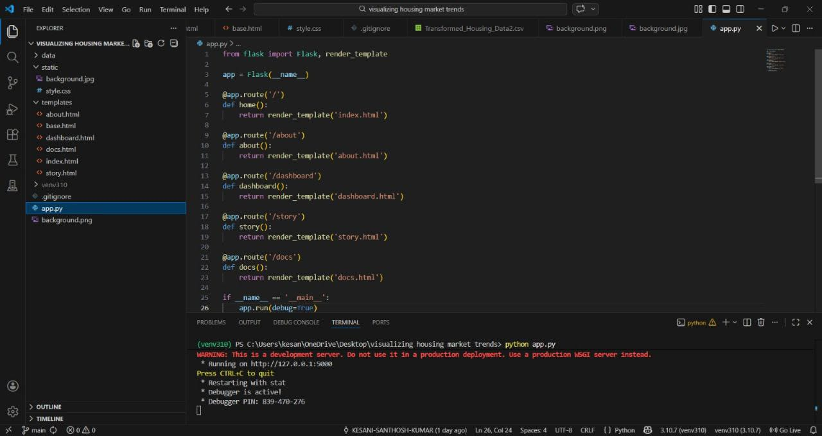

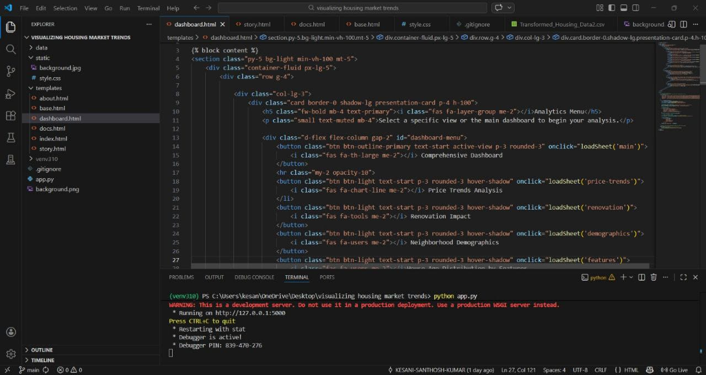

7.RESULTS
7.1 OUTPUT SCREENSHOTS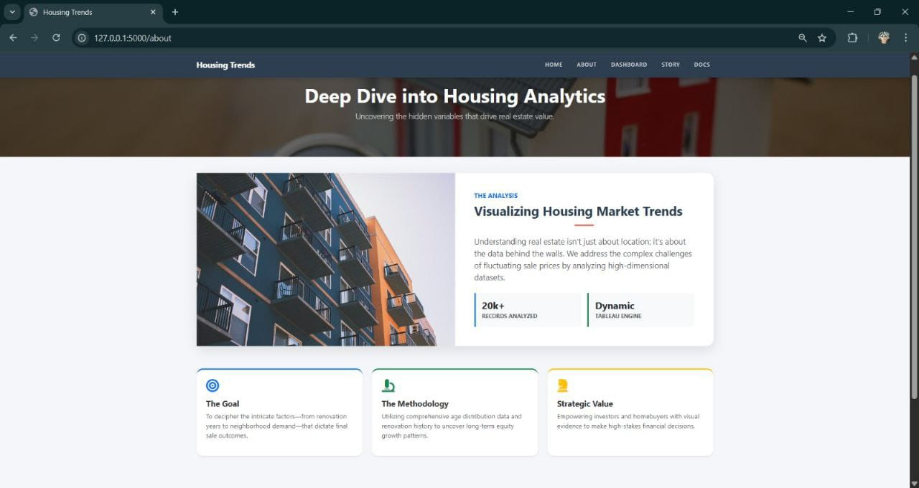

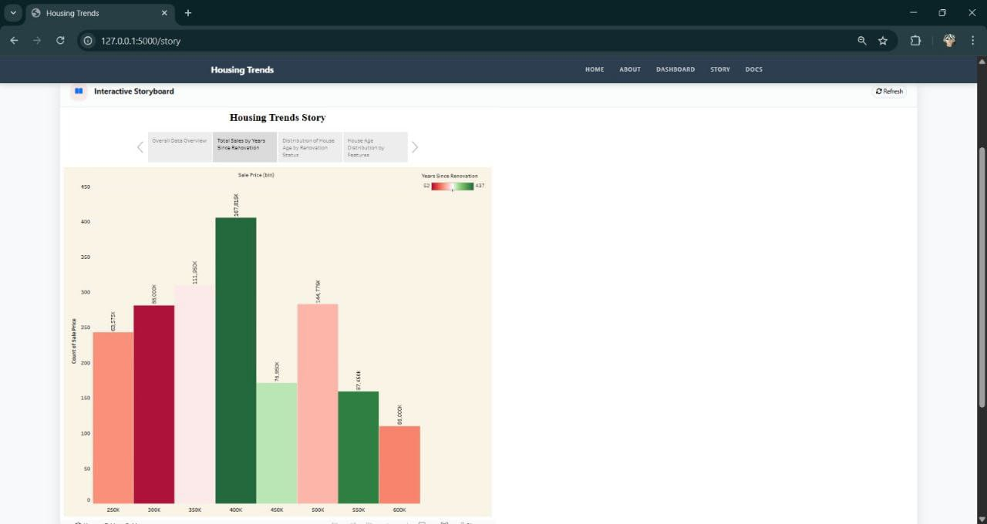

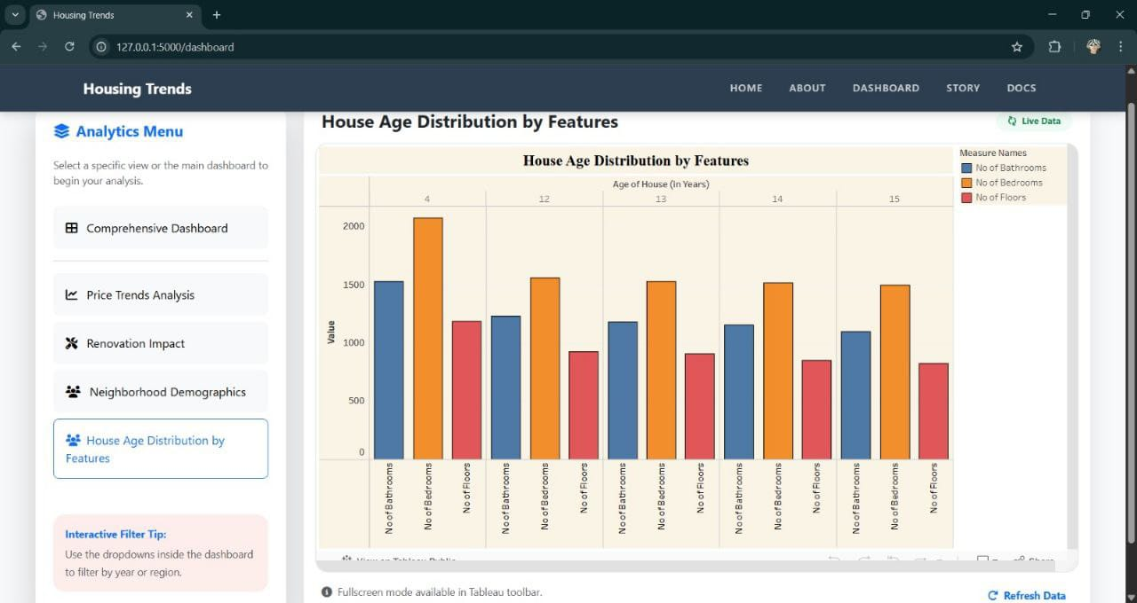

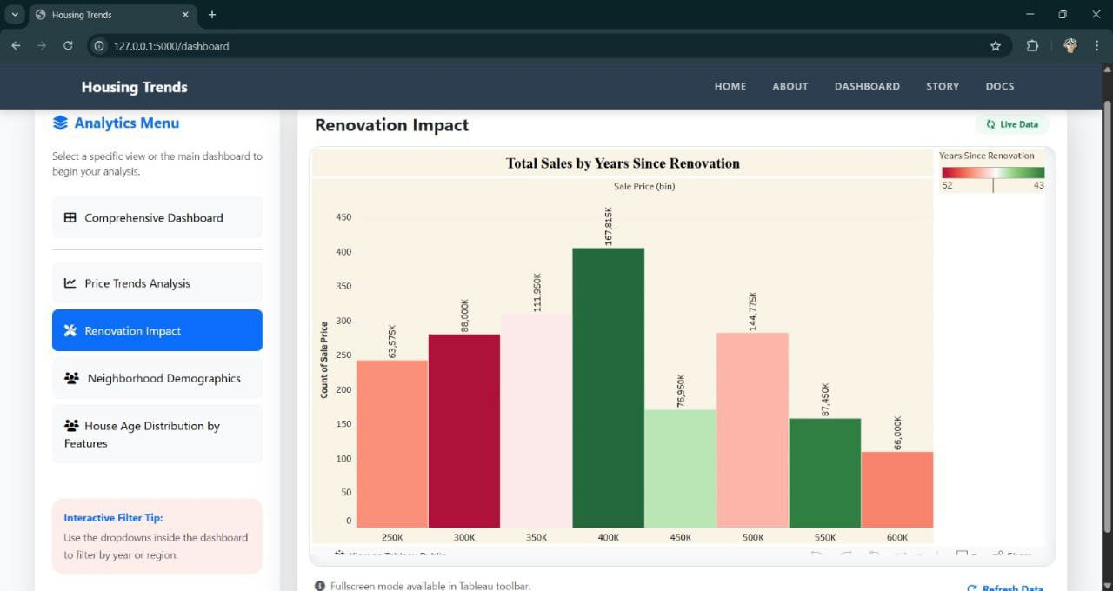

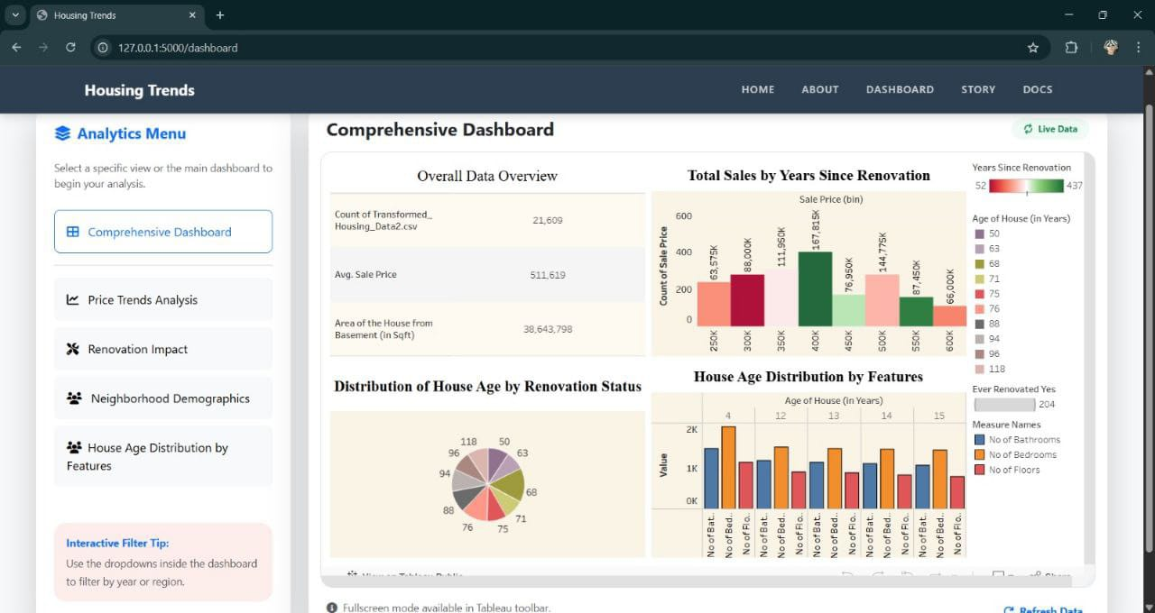
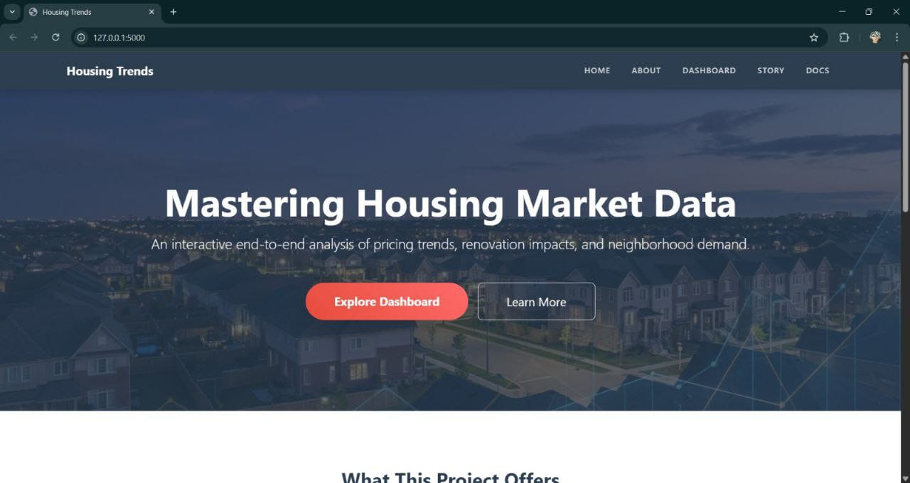

8.ADVANTAGES AND DISADVANTAGES
Advantages of Visualizing Housing Market Trends

1. Easy Understanding of Complex Data

Converts large datasets (prices, sales, interest rates, inventory) into clear visuals.

Makes trends easier to interpret than raw tables.

2. Quick Identification of Patterns

Reveals upward/downward price movements.

Highlights seasonal trends and long-term growth.

Identifies housing bubbles or market slowdowns.

3. Better Decision-Making

Helps buyers decide when to purchase.

Assists investors in spotting high-growth areas.

Supports policymakers in planning housing supply.

4. Geographic Insights

Maps show regional price differences.

Heatmaps highlight high-demand neighborhoods.

Enables comparison between cities or districts.

5. Improved Communication

Makes reports more engaging and persuasive.

Helps stakeholders understand findings quickly.

Useful for presentations and real estate marketing.

6. Forecasting and Prediction

Trend lines and regression models help predict future prices.

Supports risk assessment and investment planning.

❌ Disadvantages of Visualizing Housing Market Trends

1. Risk of Oversimplification

Important details may be hidden.

Complex factors (income levels, policies, interest rates) may not be fully shown.

2. Misleading Visualizations

Poor scaling can exaggerate trends.

Selective time ranges may distort reality.

Biased color schemes can mislead viewers.

3. Data Quality Issues

Inaccurate or incomplete data leads to wrong conclusions.

Time lags in housing data reduce reliability.

4. Overemphasis on Historical Trends

Past trends do not guarantee future performance.

Unexpected events (economic crises, policy changes) may disrupt predictions.

5. Technical and Interpretation Challenges

Requires analytical skills to interpret correctly.

Advanced dashboards may be confusing for non-experts.

6. Cost and Resource Requirements

Collecting, cleaning, and maintaining data can be expensive.

Specialized software and skilled analysts may be required.

9.CONCLUSION
Conclusion: Visualizing Housing Market Trends

transforms complex real estate data into clear, actionable insights. Through charts, graphs, heat maps, and dashboards, patterns in pricing, demand, inventory levels, interest rates, and regional performance become easier to interpret and compare.

Effective data visualization helps:

Identify Price Trends: Track long-term appreciation or decline in property values.

Understand Supply and Demand Dynamics: Reveal inventory shortages or market saturation.

Detect Seasonal Patterns: Highlight peak buying and selling periods.

Compare Regions: Showcase geographic disparities in growth, affordability, and investment potential.

Support Decision-Making: Enable buyers, sellers, investors, and policymakers to make informed, data-driven decisions.

By combining historical data with interactive and predictive visuals, stakeholders can better anticipate market shifts, assess risk, and recognize emerging opportunities. Ultimately, visualizing housing market trends enhances transparency, simplifies complex datasets, and strengthens strategic planning in the real estate sector.

10.FUTURE SCOPE
Here’s a structured overview of the Future Scope on Visualizing Housing Market Trends — useful for academic projects, research papers, or business proposals.

1. Integration of AI & Machine Learning

Future housing market visualization systems will increasingly leverage:

Predictive analytics models to forecast price trends, rental demand, and supply gaps.

Machine learning algorithms to detect hidden patterns in buyer behavior.

AI-driven anomaly detection for identifying bubbles or market crashes.

Organizations like Zillow and Redfin already use predictive modeling, and future tools will make such insights more interactive and visually dynamic.

2. Real-Time Data Dashboards

With improved data pipelines, visualization platforms will:

Provide live updates of property prices.

Integrate mortgage rate changes, inflation data, and employment statistics.

Offer customizable dashboards for investors, policymakers, and homebuyers.

Data sources such as National Association of Realtors and Federal Housing Finance Agency can be integrated for real-time trend monitoring.

3. Geospatial & 3D Mapping

Future systems will use:

Interactive GIS-based heatmaps.

3D urban development simulations.

Neighborhood-level price evolution visualization.

Tools like ArcGIS and Tableau can evolve toward immersive spatial analytics, helping users visualize price growth block-by-block.

4. Augmented Reality (AR) & Virtual Reality (VR)

Emerging technologies may allow:

Virtual walkthroughs of projected future neighborhoods.

Visualization of infrastructure growth impact on property prices.

Immersive investment scenario simulations.

Real estate tech firms like Matterport are already moving toward 3D spatial visualization.

5. Big Data & Alternative Data Sources

Future visualization models may incorporate:

Social media sentiment analysis.

Migration pattern tracking.

Satellite imagery for urban expansion analysis.

IoT-based smart city data.

This will provide deeper insights beyond traditional pricing datasets.

6. Policy & Sustainability Visualization

Governments and planners can use advanced visual tools to:

Simulate impact of housing policies.

Track affordable housing development.

Visualize carbon footprint of urban expansion.

Integration with smart city initiatives will enhance long-term planning.

7. Personalized & Interactive User Experience

Future platforms will provide:

Personalized investment risk heatmaps.

Scenario-based forecasting (best case, worst case).

Custom filters for budget, location, growth rate, and rental yield.

Conclusion

The future of visualizing housing market trends lies in the convergence of:

Artificial Intelligence

Real-time big data

Geospatial analytics

Immersive technologies

Policy simulation tools

These advancements will transform static charts into intelligent, predictive, and immersive decision-support systems for investors, policymakers, developers, and homebuyers.

If you want, I can also convert this into:

A research paper format

A PPT presentation outline

A project report conclusion section

Or a short 200-word academic answer

11.APPENDIX
SOURCE CODE(if any)




DataSET LINK

https://www.kaggle.com/datasets/rituparnaghosh18/transformed-housing-data-2
DEMO LINK
https://drive.google.com/file/d/1H3Eud2dBMW9bRHgEpFj-Ks34feO5KlR9/view?usp=sharing
GITHUB LINK
https://github.com/punee123/visualizing-housing-market-trends

