**SQL QUERIES FOR PRACTICE**

Hello SQL learner,

Below are a few solved SQL queries, which were shared by my manager for my practice or for fun while I was working as an intern at Symphony Retail Ai. Although we generally used to face simpler queries in our day-to-day tasks but he the other day shared the problems and asked to solve in free time. Hence in my free time I would pick them up and practice. These were really nice queries which took long to solve as I did not have much practice of SQL then.

Question 1.

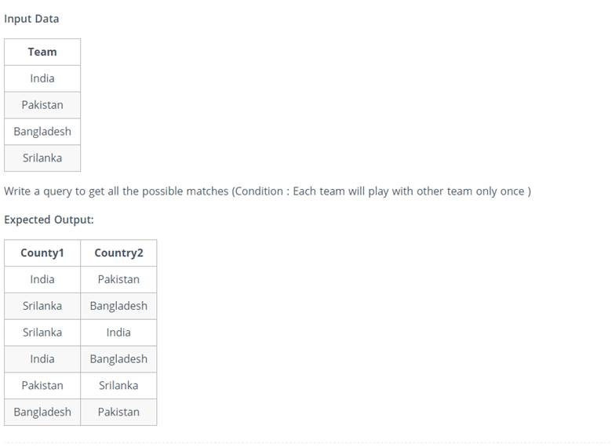

Question 2.

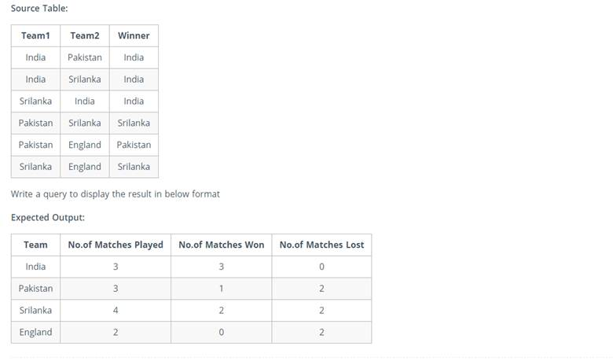

Question 3.

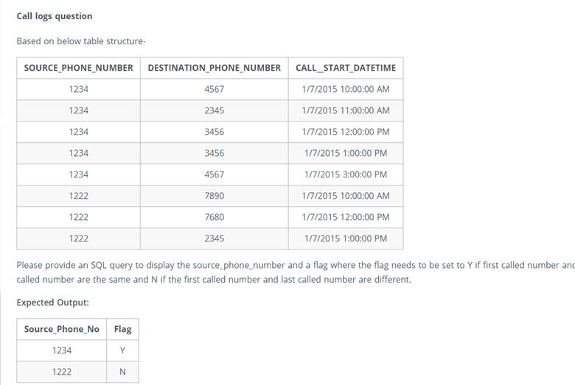

Question 4.

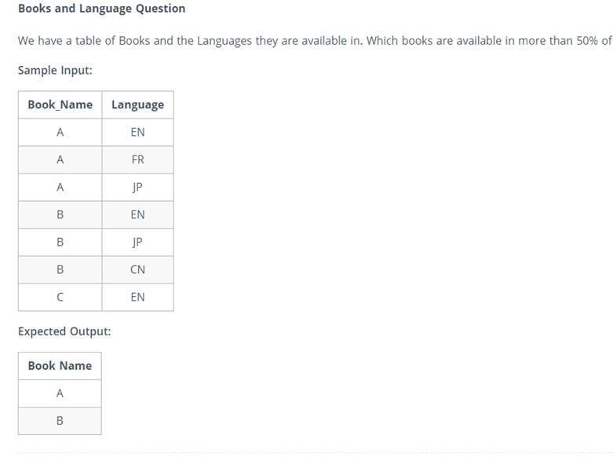

Question 5.

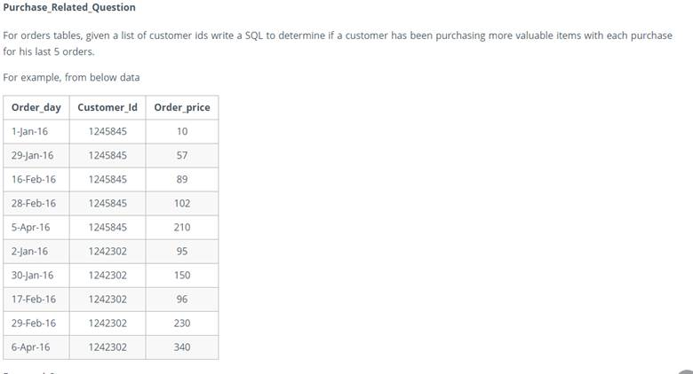

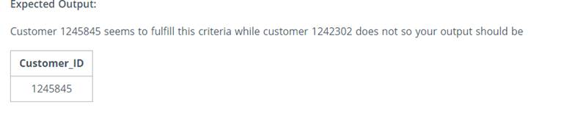

Question 6.

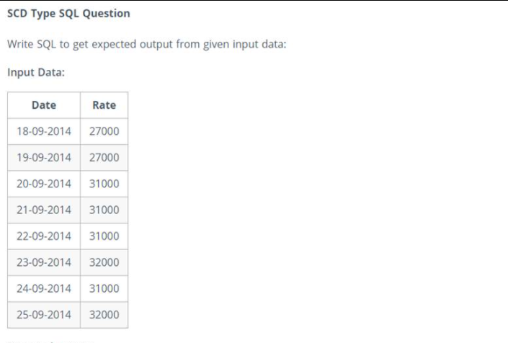

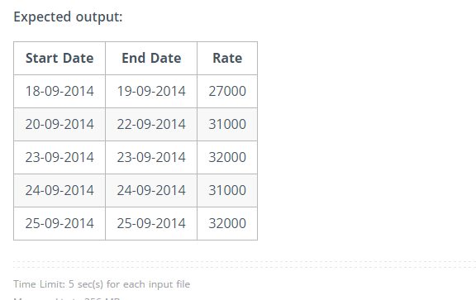

Question 7.

