Document of Understanding (DOU)
  - SAP SD Functional Support | EAEDI Special Processes and Sales Order Integration
Document status | Draft for functional validation
Audience | SAP SD Senior Functional Consultants / EAEDI Support
Knowledge-transfer presenters | Monika Roegele (Consignment & DON); Sven Hildebrand (Sales Orders)
Source material | Provided KT transcript excerpts and five presentation screenshots
Prepared on | 24 October 2026

1. Executive Understanding
The sessions explain Schaeffler-specific EAEDI processing beyond standard SAP SD: external consignment stock and its EDLNOT reconciliation, customer-specific delivery order number (DON/Kanban) handling, and inbound sales orders/order changes with outbound confirmations. Support must distinguish EDI mapping/IDoc failures from business data, stock, scheduling agreement, and delivery execution issues.

2. Process Landscape
Area | Main SAP object / message | Key business outcome
Consignment | Consignment scheduling agreement; EDLNOT 30/35/36 | Stock, withdrawal and billing reconciliation
DON / Kanban | Special scheduling agreement (ZV87 per slide); JIT / ZDELFOR1 | Preserve customer Kanban/pickup identifiers through delivery and ASN
Sales orders | ORDERS04; order and order-change messages | Correct partner determination, tolerance controls and confirmations

3. Consignment Process (EDL)

3.1 End-to-end business flow
- Customer transmits DELINS requirements to Schaeffler; goods are delivered to a customer-operated or third-party consignment warehouse near the customer.
- Ownership of the consignment inventory remains with Schaeffler until the relevant withdrawal/consumption event under the agreed model.
- Warehouse sends EDLNOT 30 (physical receipt), EDLNOT 35 (stock position; sometimes 35F free / 35S blocked), and EDLNOT 36 (goods issue/withdrawal).
- Schaeffer reconciles the received stock and withdrawal information with SAP stock and the scheduling agreement; withdrawal information supports customer invoicing or self-billing invoice (SBI) reconciliation.

3.2 Functional setup and transactions
- Consignment scheduling agreement has a special stock partner (consignment destination); the customer may also operate that location.
- Cumulative quantities include delivered, received, in-transit and withdrawn/issued quantities. A linked internal sales order can be generated for withdrawal processing.
- ZVEDLMON / ZV EDLMON (presentation spelling: ZVEDLMON): monitor EDLNOT inbound consignment messages.
- MB58: display customer consignment stock in SAP.
- /SGD/SD_EDLMON: business EDL cockpit with traffic-light reconciliation, in-transit quantities, stock and open postings.
- /SGD/SD_EDI_MINSTOCK: maintain minimum stock demand; special schedule line M may be generated (illustrated with 480 pieces).
- OVD0 / Z_VT664A and VA01 order type ZV89: internal sales-order-type definition/setup shown in presentation; normally onboarding activity, not routine incident handling.
- Cumulative reset and special cumulative values are relevant to consignment scheduling agreements; follow customer-specific process before modifying values.

3.3 Customer-specific switches
Customer switch configuration is accessed via SM30 and table/view name that appears as ZBK…SH in the transcript; the exact technical name must be verified in the system. Select sold-to party, sales organization and validity period. Under the External Service Provider (ESP) warehouse tab, options described include adding the order number, overriding the unloading point, overriding customer plant, aggregating same-date EDLNOT 35 records, and customer-specific VMI behavior. Do not change switches without approved impact analysis.

3.4 Consignment support approach
- Open the EDL cockpit for the sales responsible or scheduling agreement; review red/yellow/green status and stock differences.
- Compare MB58 stock, cockpit stock, customer-reported EDLNOT 35 stock, cumulative deliveries/withdrawals and in-transit quantity.
- Check last receipt date and completeness of EDLNOT 30/35/36 messages; some customers do not send 35 stock reports, so red status may reflect missing stock reporting rather than a posting failure.
- Review message-level processing and warnings in ZVEDLMON; reconcile movements chronologically using opening stock + receipts − withdrawals ± corrections.
- For failed goods issue or missing delivery, validate stock availability, linked sales document and IDoc processing; escalate business quantity or missing-customer-message issues with evidence.

4. Delivery Order Number (DON / Kanban)
DON is a customer-specific process in which schedule-line-level Kanban, run, pickup-sheet or receiving-point information must be preserved on labels, delivery documents and ASN. Schaeffler uses an established customized approach rather than SAP’s newer S/4HANA sequence-JIT process.

4.1 Schedule and message behavior
- The presentation identifies scheduling agreement ZV87 (and related ZV44 processing).
- Special information is usually received in JIT schedules, not forecast schedules; Kanban Detail displays identifiers for individual schedule lines.
- ZVDELMON displays forecast/JIT messages, including special DON fields; the slide identifies ZDELFOR1.
- Customer receiving point may differ by schedule line and must be retained for downstream delivery/ASN.

4.2 Kanban types and delivery creation
Type | Rule | Operational impact
01 | One Kanban identifier per handling unit | Multiple Kanban numbers may be represented within one delivery, subject to packaging and checks
03 | One Kanban identifier per delivery note | Do not combine different Kanban numbers into one delivery
02 | Described as no longer in use | Verify legacy customers before any change
Use the dedicated delivery creation transaction ZDON_VL10 / ZDON_VL10 (transcript appears as “set on VL10”; verify exact code), which validates compatible Kanban grouping. Creating delivery directly from the scheduling agreement may combine open quantities without required DON checks. The session also references ZV44 packaging/deviating order handling and ZV87 setup in the customer-specific switch table; validate exact document type codes before operational use.

4.3 Frequent DON incidents
- ASN fails or lacks DON number: compare delivery, schedule-line Kanban detail and customer requirement; a manually added line or over-delivery may have blank Kanban information.
- Missing Kanban Detail button: check customer-specific switch setup, agreement type and applicability.
- Delivery combination error: confirm whether Kanban type 01 or 03 applies; recreate delivery using validated transaction where necessary.
- Missing or inconsistent receiving-point / pickup-sheet data: check inbound JIT IDoc, schedule-line fields and delivery transfer.
Important control: do not invent or manually assign a missing Kanban number. Obtain the correct identifier from the sales responsible/customer and follow authorized correction and ASN reprocessing steps.

5. EAEDI Sales Orders and Order Changes

5.1 Inbound processing
- External customers send purchase orders and changes using ORDERS04 basic type, with customer-specific message processing.
- Inbound sales-order errors are reviewed in the EAEDI order monitor (transcript pronunciation “CV Ottman / CV Hartmann”; exact SAP transaction must be verified).
- Typical exceptions include duplicate orders already created manually, invalid customer material, and IDocs set to status 68 after business intervention.
- One ship-to address per sales order is preferred. Using a document-specific address instead of customer master ship-to can prevent expected delivery/shipment consolidation.

5.2 Partner determination and master data
- VOE4 / EDPA mapping determines internal sold-to, ship-to and potentially bill-to accounts from external EDI partner identifiers; the session also references VOE2 for sales organization determination.
- Inbound E1EDKA1 partner segments may include AG (sold-to), LF (vendor) and WE (ship-to). External IDs/branch codes map to SAP customer master accounts.
- EDPA and EDSDC are described as required foundational setup for customers using EAEDI sales-order creation and change processing.
- Customer master must contain valid ship-to, sales area, partner functions, unloading point where used, and order expert/contact.
- Order combination settings differ between scheduling agreements and sales orders; confirm customer delivery-consolidation requirements.

5.3 Order change, tolerance and confirmation
- Schaeffler-specific tolerance profile is copied to sales-order item at creation, then applied to incoming changes in quantity/date. Sales can adjust approved profile per business requirements.
- A strict example shown is profile 003 (90 days / 0%); alternative profile values are customer-specific and require system verification.
- Instead of physically deleting a sales-order item after customer cancellation, Schaeffler can set a reason for rejection through customer switch logic.
- Customer PO item reference must remain correct when copying or replacing order items; missing reference may block outbound confirmation.
- Order confirmation output is header-level; CVAB is referenced as a multipurpose output type. EAEDI, manual EAEDI and internal EAEDI SAP modes are described.
- For unconfirmed quantities, customer-specific dummy/future confirmation dates may be sent where EDI requires a date. Such settings are not universal and must be validated.
- Order confirmation switch settings can suppress rejected items, control required PO-item checks and customer-specific outbound behavior.

6. Functional Incident Triage Matrix
Symptom | Functional validation | Likely owner / action
Consignment red light | EDLNOT 35 timing; MB58; withdrawals; transit; cockpit | SD/EAEDI investigate; sales/customer confirm stock
EDLNOT posting failure | IDoc status; scheduling agreement; stock; customer switches | EAEDI/SD support; integration escalation if mapping
DON ASN missing number | JIT Kanban Detail; delivery; switch; grouping type | Sales confirms ID; SD/EAEDI authorized fix
Sales order wrong partner | E1EDKA1, EDPA/EDSDC, customer master | Master data / EAEDI setup owner
Order change rejected | Tolerance profile, order/delivery status | Sales decides accept/reject; SD supports
Order confirmation failure | CVAB output, PO item reference, partner and output switches | SD/EAEDI outbound owner subject to agreed scope

7. Support Scope and Handover Understanding
During KT, the internal EAEDI team retains primary intake and manually forwards suitable tickets to the external SAP SD support team. The longer-term target is direct intake by the external team with internal escalation for access-restricted or non-transferred topics. Inbound IDoc readiness is to be confirmed after KT/playback; outbound ASN/order-confirmation ownership was not fully finalized in the supplied discussion. Do not treat this draft as final RACI approval.

8. Open Points / Validation Checklist
- Confirm exact SAP transaction names: EDL monitor, order monitor, DON delivery creation, customer switch SM30 view and internal order types.
- Confirm actual technical IDoc/message types and variants for DON, EDLNOT and ORDERS/ORDCHG by customer/system.
- Obtain one anonymized end-to-end IDoc, scheduling agreement, delivery and ASN example for each process.
- Confirm whether all outbound ASN and order-confirmation tickets belong to the external team and when intake transition takes effect.
- Agree escalation matrix, change authorization, customer contact protocol, and evidence required in tickets.
- Validate consignment minimum-stock logic, cumulative reset procedure, and business sign-off ownership.

Appendix A. Presentation Evidence
Figure 1. Consignment Process (EDL)
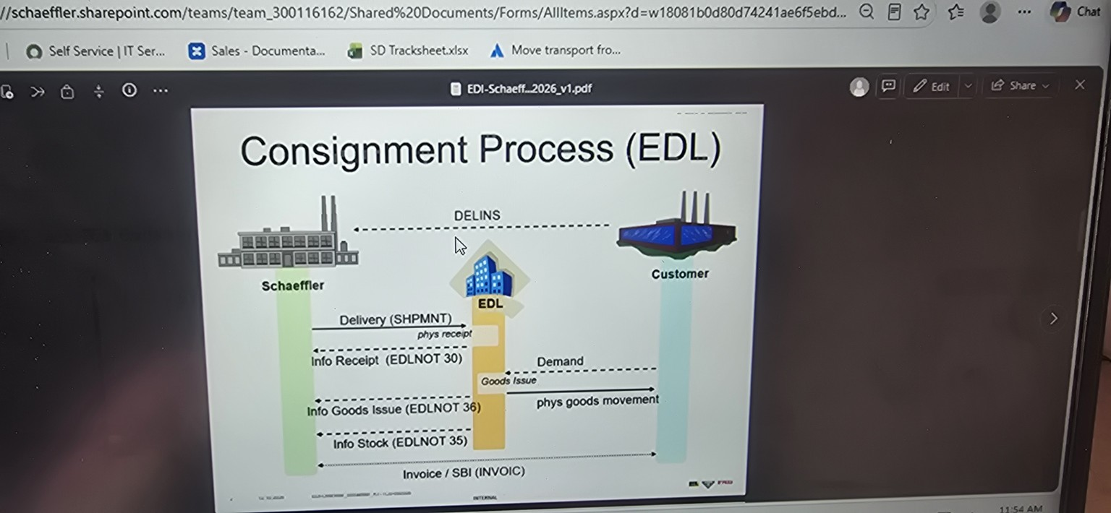
Figure 2. Consignment processing ZVEDLMON
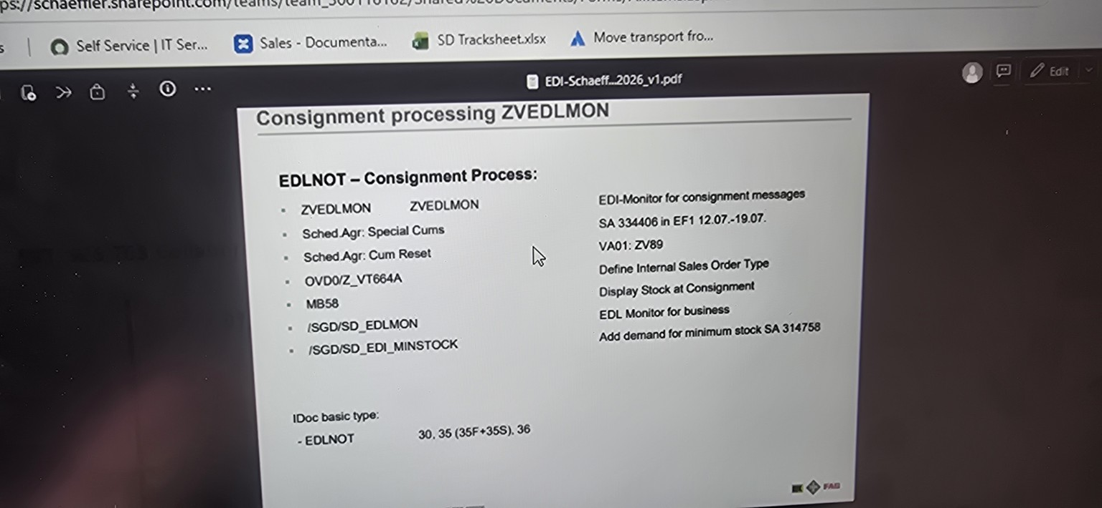
Figure 3. Consignment process: Cums
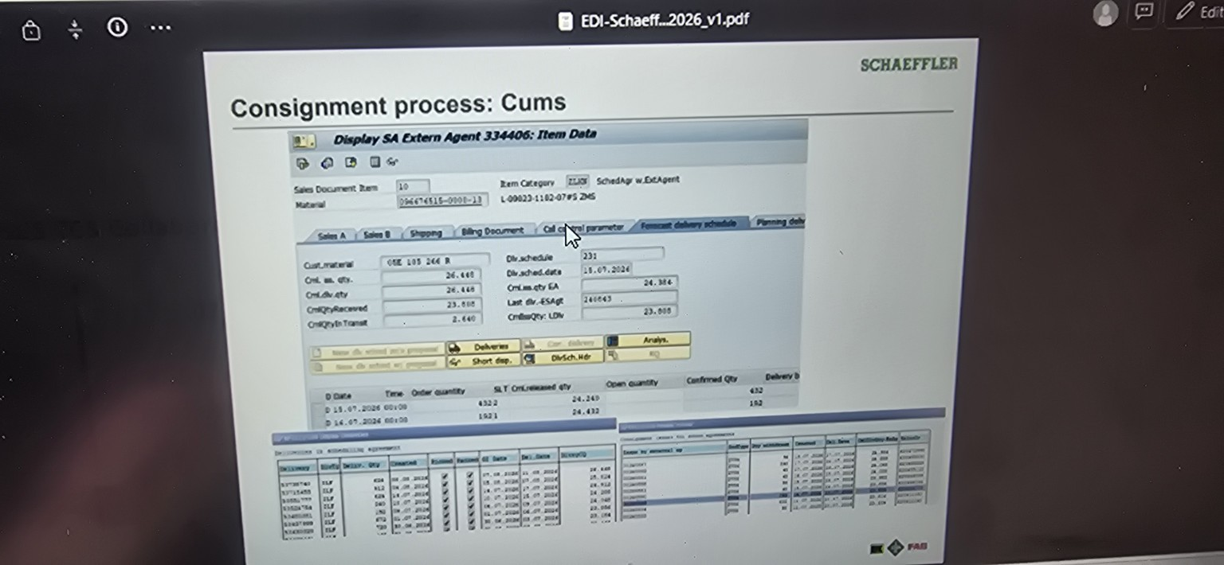
Figure 4. Customer switch framework for EDLNOT
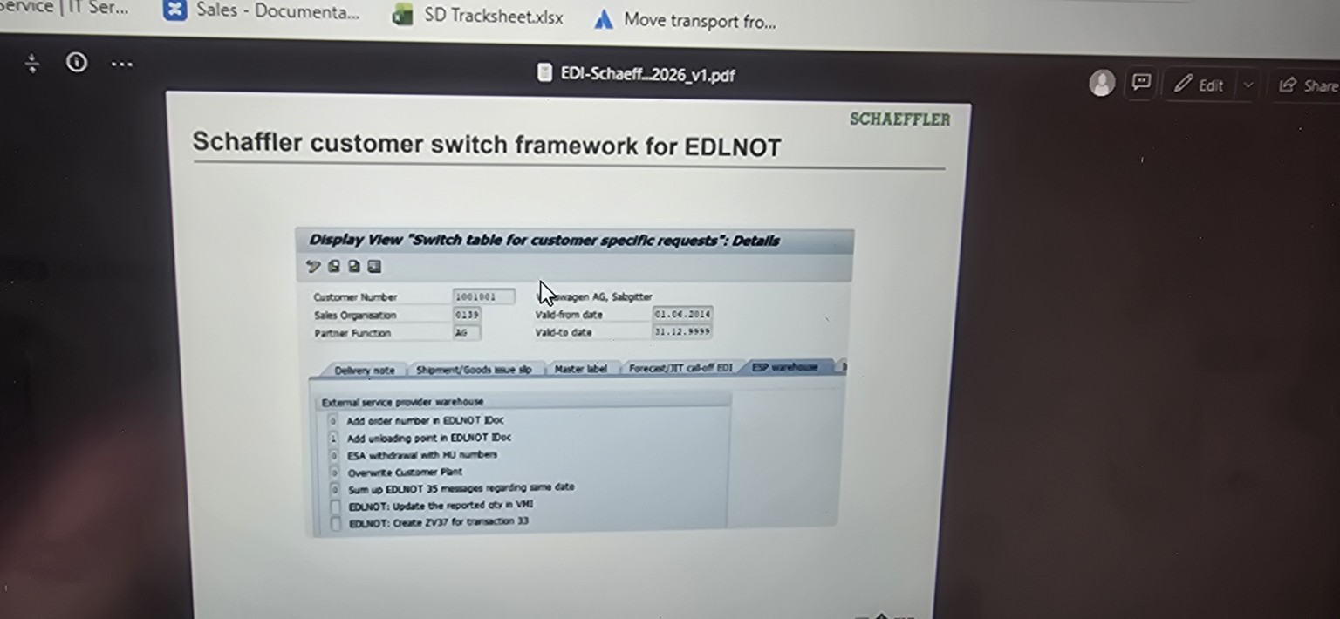
Figure 5. SA ZV87 + ZV44 – DON Process
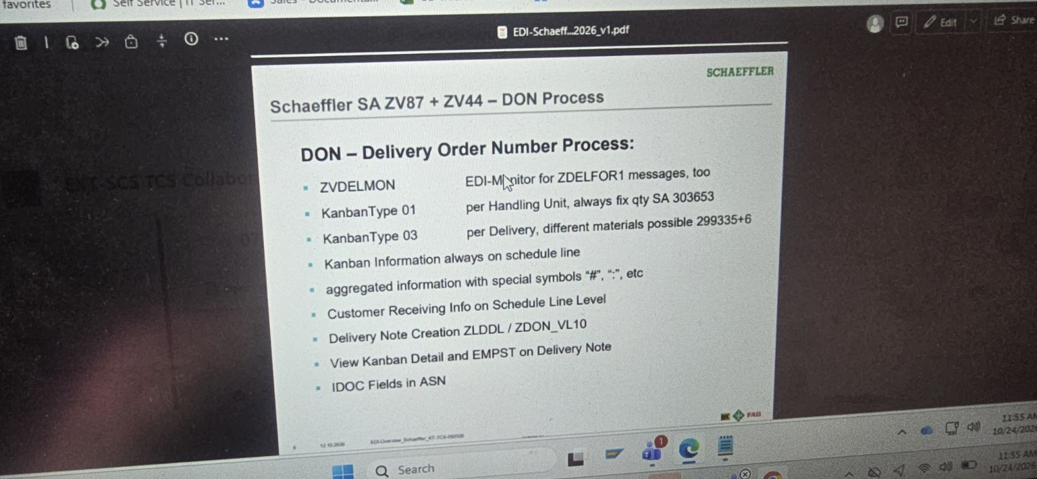
Source caveat: the transcript is AI-generated and includes fragmented or phonetically rendered SAP codes. Items marked for verification must be checked against the productive SAP configuration and official Schaeffler documentation before execution.

