GULFTAINER OPERATIONS PLATFORM
Project Documentation
Research, requirements, prototype design and the production architecture for Gulftainer’s container operations, inland logistics, warehousing and finance platform.

Version 1.0
Date 30 October 2026
Author Puneet Shukla
Organisation SSI Maya
Prepared for Gulftainer Company Limited, IT Infrastructure and Operations
Repository https://github.com/puneet2343/gulftainer-operations-platform
Live prototype Vercel deployment link to be added after deployment
Prototype login operations / gulftainer2026
Status Prototype complete; production design proposed

Contents
Contents
1. Executive summary
2. How the work was done
2.1 Sources
3. Gulftainer as the research found it
3.1 The business
3.2 Systems in use
3.3 How a container moves through the terminal today
4. The supplied SRS against Gulftainer’s reality
5. Scope of the prototype
5.1 Demonstration data
6. Domain model and business rules
6.1 Entities
6.2 Rules
6.3 Integrity mechanisms
7. Prototype architecture
8. Production architecture
8.1 Technology stack
8.2 Data placement
8.3 API design
8.4 Capacity and performance
9. Security, compliance and continuity
10. Delivery plan to production
10.1 Testing strategy
10.2 Risks and how the design treats them
11. Appendices
A. Repository layout
B. Running the prototype
C. Acceptance criteria of the SRS and where the prototype shows them

1. Executive summary
This document records the work I carried out between 1 and 30 October 2026 to design and build a working prototype of an operations platform for Gulftainer, and sets out how the same design would be built for production. The brief I received was a generic software requirements specification for an international cargo and inventory platform. Rather than build to that specification as written, I researched how Gulftainer actually operates: its terminals and inland network, its published tariff and customer advisories, its existing systems and the processes its customers follow every day. The prototype is shaped by that research.
The result is a browser-based prototype with twenty-four working screens across six modules (terminal, gate and e-tokens, inland logistics, warehousing, finance and control) plus a customer e-services portal. It enforces the business rules that matter in a terminal: a container is released only when customs, the delivery order and the charges are complete; export boxes are received only inside the vessel’s gate window; stock balances are never edited, only moved through an immutable ledger; retried requests cannot act twice; offline gate work replays through the same rules; inbound messages are de-duplicated. Every action is audited with who, where, what changed and why.
For production I propose a serverless architecture on AWS: the front end on CloudFront, the APIs on Lambda behind API Gateway with identity federated from Gulftainer’s Microsoft Entra ID, Aurora PostgreSQL as the system of record, DynamoDB for high-rate gate and e-token state, S3 for documents and MongoDB Atlas for histories and feeds. Section 8 describes it; section 9 covers security and continuity in the terms Gulftainer’s IT infrastructure team already uses (ISO 27001, Conditional Access, PAM, Intune, Veeam-style restore drills, Zabbix and Grafana).
Links and access
Source code: https://github.com/puneet2343/gulftainer-operations-platform
Live prototype: Vercel deployment link to be added after deployment
Login: operations / gulftainer2026 (prefilled on the sign-in screen)
User guide: Gulftainer-Operations-Platform-User-Guide.docx, delivered with this document

2. How the work was done
The month divided into four phases. Each produced something I could check against the previous one, so the final design does not rest on assumptions I made in week one.
Dates (2026) | Phase | Output
1 to 7 October | Research | Gulftainer’s network, services, systems and customer processes from its own publications; comparison with the supplied SRS; decision on scope.
8 to 14 October | Domain model and rules | Entity model, state machines, tariff engine, release conditions, ledger design; written as the service layer with a replayable seed to prove the rules reconcile.
15 to 24 October | Prototype build | Twenty-four admin screens, the customer portal, offline queue, integrations simulator, reports; design system kept identical to the SSI Events frontend.
25 to 30 October | Validation and documentation | Workflow testing in the browser, seed reconciliation checks, production architecture, security and continuity design, this document and the user guide.

2.1 Sources
Everything in the domain model traces back to one of these sources. Where a figure in the prototype is not published (for example the reefer monitoring rate), it is marked as a placeholder on the Tariff screen so it cannot be mistaken for a fact.
- gulftainer.com: About us, Solutions, Digital technologies, news releases 2025 and 2026, the Client Portal menu (customer registration, vessel schedule, container charges enquiry, container tracking, TOS portal, GT Lines portal, e-token portal).
- Khorfakkan Container Terminal brochure (June 2026): 5 million TEU capacity, 1,880 m quay, 16 m draft, 18 STS cranes, 28 RTGs, 63 terminal tractors, 50,000 TEU yard, 623 reefer plugs, 29 gross moves per hour, 24/7 operations, MACH TOS and SAP since 2017.
- Schedule of Charges effective 1 June 2026: stevedoring, port receiving, shifting, storage slabs by day and category, dangerous goods surcharge, pre-arrival document obligations (clause 8), overtime window (clause 21.1), misdeclaration (clause 26).
- Customer advisories GT/26/015, GT/26/016 and GT/26/019 (March and June 2026): clearing agents and forwarders to complete customs and delivery order formalities promptly; the Marshall Yard E-Token portal; e-token tariff (AED 25 import pick-up, AED 20 amendment).
- Customer registration advisory (6 March 2026): online payment is the only accepted mode for cargo collection; the Container Cash Collection screen with full, partial and zero payment per service line and the 22:00 to 06:00 overtime window.
- Marshall Yard E-Token Consignee User Manual: dashboard counters, container assignment to hauliers, token deletion only before marshalling yard entry.
- Momentum Logistics customer advisory (1 April 2026): containers not collected within three days of vessel completion are transferred to Sharjah Inland Container Depot or Saja’a Dry Port for the account of the cargo interests.
- momentumlogistics.com: inland container depot, logistics cities, contract logistics (receipt, put-away, storage, pick, pack, dispatch, inventory management), freight forwarding, container services.
- Trade press, July to October 2026: the USD 2 billion strategy and four platforms (GT Ports, GT Logistics, GT Parks, GT Maritime), Khorfakkan expansion to 5 and then 10 million TEU, Al Dhaid corridor, Sajaa bonded dry port, UAE to Umm Qasr feeder by GT Lines, EGA aluminium exports agreement.

3. Gulftainer as the research found it

3.1 The business
Gulftainer is a port and logistics operator founded in Sharjah in 1976. Its core is container terminal operation: Khorfakkan Container Terminal (the only fully operational UAE container terminal outside the Strait of Hormuz, and the group’s transhipment hub), Sharjah Container Terminal and Hamriyah in the UAE; Iraq Container Terminal at Umm Qasr; three terminals in Saudi Arabia through Gulf Stevedoring Contracting Company (Jeddah Northern Container Terminal, Jubail Commercial and Industrial Ports); and Canaveral Cargo Terminal and Wilmington in the United States. It also handles bulk, break-bulk, Ro-Ro and project cargo.
GT Logistics, largely through Momentum Logistics, operates the Sharjah Inland Container Depot, the Sajaa bonded dry port, the Umm Qasr Logistics Centre, the Jubail inland depot and empty yard, a truck fleet, contract-logistics warehouses, freight forwarding with in-house customs brokerage, and container repair and trading. In July 2026 the group announced a USD 2 billion strategy organised as four platforms and a plan to connect Khorfakkan to Etihad Rail through the Al Dhaid corridor. The 2026 Hormuz disruption pushed Khorfakkan’s local UAE cargo from about 6,000 to more than 150,000 TEU, which is why yard capacity and the three-day collection rule matter so much this year.

3.2 Systems in use
- MACH terminal operating system (customer portal at tos.gulftainer.com, being replaced by a new customer service portal from 1 November 2026) and TCS Dynaport.
- SAP S/4HANA for finance, asset management and logistics; CargoWise One for freight forwarding; a transport management system at Momentum.
- E-services platform: customer registration, container tracking, e-token generator, online payment through a secure gateway.
- IT infrastructure, as described publicly by the IT infrastructure lead: Microsoft 365 with Conditional Access and Defender, Intune device management, Aruba ClearPass network access control, privileged access management, Azure, OCI and AWS, Veeam backups with restore testing for ISO 27001, Zabbix and Grafana monitoring, managed service providers under SLA, 24/7 uptime.

3.3 How a container moves through the terminal today
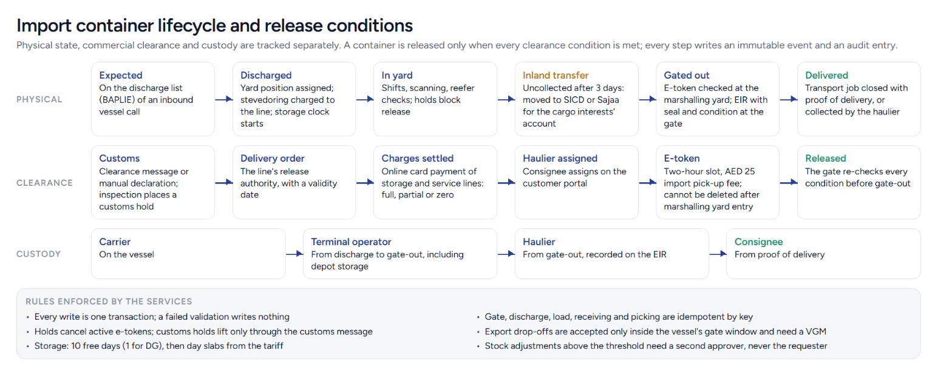
Figure 1. Import container lifecycle and release conditions as modelled.
- The carrier gives 72, 48 and 24 hour arrival notices and, 48 hours before arrival, the bay plan, discharge and load lists, dangerous cargo list and BAPLIE by EDI.
- The vessel berths and is worked around the clock; each discharge is a stevedoring charge to the line and starts the storage clock.
- The clearing agent or forwarder completes customs clearance and obtains the delivery order from the line; delays cost storage.
- The consignee pays storage and service lines online through the customer portal (full, partial or zero per line) and assigns a haulier.
- The haulier generates an e-token for a two-hour slot; the truck checks in at the marshalling yard, after which the token cannot be deleted; the gate releases the box with an equipment interchange receipt.
- A box not collected within three days of vessel completion is moved to SICD or Sajaa; transfer and storage are for the cargo interests’ account.
- Exports are received only inside the gate window (four days before ETB to one day before), need a verified gross mass and customs clearance, and are loaded; transhipment boxes move vessel to yard to vessel.

4. The supplied SRS against Gulftainer’s reality
The specification I received describes a generic warehouse and inventory platform: cargo items with SKUs and quantities, stock reservations, low-stock alerts, shipments between locations. That model fits Momentum’s contract-logistics warehouses well, but it does not fit a container terminal, where the unit of work is a container with an ISO number, a vessel call, a yard position, holds, customs status, a delivery order and tariff-driven storage. The table records what I kept, what I re-modelled and what I set aside.
SRS area | Decision | Reason
Cargo records with SKU, quantity, weight, barcode | Re-modelled as containers (ISO 6346, size and type, category, DG, OOG, reefer) for the terminal; kept as SKUs for Momentum warehouses | Terminal operations never count units of a commodity; they move boxes.
Inventory ledger, balances, reservations, adjustments with approval | Kept in full for warehouse stock; the same immutable-ledger idea applied to containers as an append-only event history | Section 4.3 of the SRS is the strongest part of the brief and matches contract-logistics practice.
Low-stock alerts | Kept for warehouse SKUs only | Meaningless for containers; useful for FMCG and spare-parts customers.
Shipments between locations | Re-modelled as vessel calls, inland transfers and transport jobs | Gulftainer’s movements are vessel programmes, depot transfers under the three-day rule, and truck jobs.
Loading and unloading operations | Re-modelled as discharge and load per vessel call, and gate-in and gate-out with EIR | These are the terminal’s actual operations and their charges come from the tariff.
Billing: freight, handling, storage charges, invoices, multiple currencies | Kept and made specific: the June 2026 tariff engine, storage slabs with free days, e-token fees, online collection screen, VAT | Billing is where the SRS was vaguest and where Gulftainer’s rules are most precise.
Documents with versions, checksums, retention, access | Kept; document types replaced with the terminal set (DO, BL, customs, EIR, bay plan, BAPLIE, DG, VGM, POD) | Matches the paperwork named in the advisories and tariff.
Notifications, audit, concurrency, idempotency, offline sync, integrations, reporting, roles | Kept and implemented | These are platform qualities that apply regardless of domain; the roles were renamed to the terminal and logistics jobs that exist.
Customer-facing surface | Added: vessel schedule, container enquiry with storage estimate, e-token portal, online payment | Not in the SRS at all, yet it is the part of Gulftainer’s digital estate customers touch every day.

5. Scope of the prototype
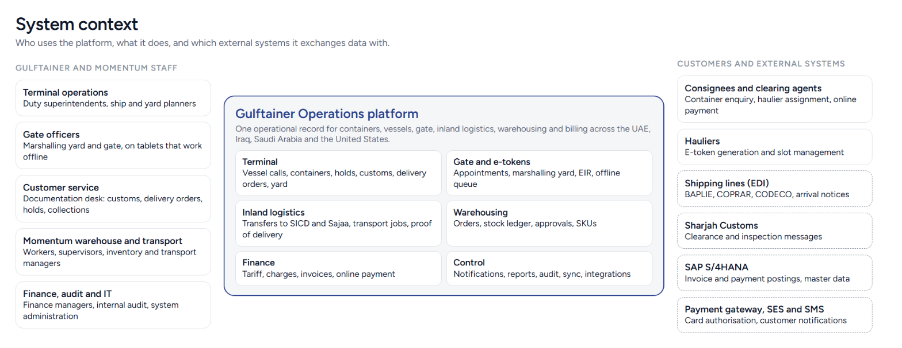
Figure 2. System context: users, modules and external systems.
Module | Screens | What it does
Dashboard | Overview | Attention list, vessel programme, yard utilisation, logistics position, recent activity.
Terminal | Vessel calls, vessel call record, containers, container record, register container | Pre-arrival documents, berth to departure, discharge and load worklists, clearance checklist, holds, customs, delivery orders, online collection, haulier and e-token, yard shifts, VGM, reefer checks, history.
Gate and e-tokens | Gate | Appointments by location, marshalling yard arrival, gate-in and gate-out with EIR, EIR register, all tokens, offline mode.
Inland logistics | Inland transfers, transport jobs | Uncollected containers, transfers to SICD and Sajaa, Momentum fleet dispatch with proof of delivery and delays.
Warehousing | Warehouse orders, inventory (balances, ledger, adjustments, SKUs), tasks | Inbound receipt with discrepancies, allocation, picking, stock transfers and holds, adjustments with second-person approval, reversals, shift tasks.
Customers and documents | Customers and parties, documents | Lines, consignees, agents, hauliers, contract customers; portal registration; versioned document register with SHA-256 checksums and role access.
Finance | Charges and invoices, invoice record, tariff | Automatic tariff charges, invoicing with VAT, online card and bank payments, overdue tracking, editable tariff with audit.
Control | Notifications, reports, audit log, sync and integrations | Role-addressed alerts, management reports with CSV, append-only audit with container trace, offline queue replay, event outbox, inbound message simulator with duplicate detection.
Administration | Network and locations, users and roles, design system | Entities and fourteen locations with capacity facts, eleven roles with a permission matrix, thresholds, demonstration data reset.
Customer e-services | Home, vessel schedule, container enquiry, e-token portal | Public vessel schedule with gate windows, enquiry with storage estimate, consignee dashboard and haulier token generation, online payment.

5.1 Demonstration data
The prototype seeds itself with a data set that replays real workflows through the same service functions a user would trigger: ten vessel calls across Khorfakkan, Sharjah, Umm Qasr, Jeddah and Canaveral; sixty-four containers in every state from expected to delivered; e-tokens, gate transactions and an inland transfer in progress; Momentum orders, stock and approvals; charges, invoices and payments; integration messages including a duplicate and a failure; two operations waiting in the offline queue. Because the seed runs through the services, every balance reconciles with its ledger and every container’s history is consistent with its state. I verify this with a script that rebuilds the seed under Node.js and checks the reconciliation on every change.

6. Domain model and business rules

6.1 Entities
Entity | Key attributes | Notes
Organisation, location | Platform (GT Ports, GT Logistics, GT Maritime), type (terminal, inland depot, logistics centre, warehouse), country, time zone, hours, bonded, berths, quay, draft, yard TEU, reefer plugs, warehouse area | Fourteen locations seeded from Gulftainer’s published network.
Employee, role | Eleven roles; location scope | System administrator, terminal operations, planner, gate officer, customer service, warehouse worker and supervisor, inventory manager, transport manager, finance manager, auditor.
Party | Shipping line, consignee, clearing agent, haulier, contract customer, shipper; portal registration; credit terms | Portal registration gates online payment and e-tokens.
Vessel call | Voyage, vessel, line, terminal, berth, ETA/ETB/ETD, gate window, planned and actual moves, pre-arrival documents, notices, status | Status: expected, berthed, working, completed, departed.
Container | ISO number, size and type, category, line, consignee, agent, weight and VGM, seal, DG, OOG, reefer, physical status, location and yard position, inbound and outbound calls, customs status, delivery order, holds, charges settled, haulier, token | Physical status: expected, in yard, on truck, on vessel, delivered. Release is derived, never stored.
Container event | Type, time, actor, location, from and to position, reference | Append-only; twenty event types.
E-token, gate transaction | Type, container, haulier, truck, driver, slot, status, fee; direction, seal check, remarks, overtime | Token status: generated, at marshalling yard, completed, cancelled, expired.
Inland transfer, transport job | Route, containers, reason, status, vehicle, proof of delivery | Transfers create a transport job automatically.
SKU, stock balance, stock movement, warehouse order, operation | Buckets available, allocated, damaged, held; movement effects; order lines with received, damaged and picked quantities | Balances are the sum of movement effects, checked on every seed.
Charge, invoice, payment, tariff | Service code (25 codes), party, quantity, unit amount; subtotal, VAT, total, paid, status, history; the June 2026 schedule | Invoice status: draft, issued, partially paid, paid, overdue, cancelled.
Document, notification, audit entry, approval | Versions with checksum and retention; audience roles; actor, entity, before and after, reason, request id; separation of duties | Audit entries are grouped by the request id of the transaction.
Outbox event, queued operation, integration event, idempotency record | Reliability plumbing | See section 6.3.

6.2 Rules
The rules below are enforced in the service layer, not in the screens, so they hold for every caller including the offline replay and the integration workers.
- Operations may only start on a call once the bay plan, discharge and load lists and, where dangerous goods are on board, the dangerous cargo list are on file; operations may only complete once every listed box is off the vessel.
- An import container is released only when it is in the yard, customs is cleared, no hold is active, a valid delivery order is on file and the consignee’s charges are settled. The gate re-checks these at gate-out.
- Export containers are received only inside the gate window, with the seal checked, and dangerous goods only with the declaration filed; they are loaded only with a verified gross mass and customs clearance.
- Holds cancel any active e-token. Customs holds are lifted only by the customs status; DG holds only by filing the declaration.
- E-tokens are generated by registered hauliers for two-hour slots; import pick-ups carry the AED 25 fee and amendments AED 20; a token cannot be deleted after the truck enters the marshalling yard; an unused token expires after its slot.
- Storage for import full boxes is free for 10 days (1 for DG) from discharge and then charged per day on the published slabs; collection settles storage to the expected exit, and the gate charges any further days. Deliveries between 22:00 and 06:00 carry the overtime charge.
- Containers not collected within three days of vessel completion are listed for inland transfer; transfer and depot storage are charged to the consignee.
- Stock balances change only through ledger movements whose effects can never take a bucket negative; corrections are compensating reversals; adjustments at or above the threshold, and any request by a supervisor or worker, need a second approver who is not the requester.
- Outbound orders are allocated as a whole or not at all; short picks release the balance and are recorded as exceptions.
- Invoices follow draft, issued, partially paid, paid, overdue, cancelled; payments cannot exceed the balance or reuse a reference; full payment settles the containers on the invoice.
- Every location-bound operation requires the location in the user’s scope; auditors are read-only everywhere.

6.3 Integrity mechanisms
Requirement (SRS) | Mechanism in the prototype | In production
Transactions for related updates | Every service runs inside one commit on a cloned document; a thrown rule leaves the database untouched. | PostgreSQL transactions with row-level locks on the container, balance and invoice rows.
Idempotency for critical operations | Discharge, load, gate-in, gate-out, shifts, receiving, picking and transfers take a client key; a repeat returns the first result. | DynamoDB conditional put on the key with a 24-hour TTL before the transaction.
Optimistic concurrency | Version numbers on calls, containers, jobs, orders and invoices; an edit with a stale version is refused with a clear message. | Same versions as a column; conflict returns HTTP 409.
Transactional outbox | Notifications and domain events are appended in the same commit; a worker publishes them after the commit. | Outbox table in PostgreSQL drained to EventBridge by a Lambda on a schedule and on commit.
Offline operations | Gate and warehouse screens queue operations with client-generated references; sync replays each through the normal service; rejections wait for reconciliation. | Same client model; replay via the idempotent APIs; queue state in DynamoDB.
Duplicate-event detection | Inbound messages are keyed by provider and event id; duplicates are recorded and ignored; failures are recorded without touching committed data. | Unique index on (provider, event id) in PostgreSQL plus the MongoDB message archive.
Audit | Append-only entries with actor, entity, before and after, reason, request id. | Append-only table with hash chaining; copies to immutable S3 Object Lock storage nightly.

7. Prototype architecture
The prototype is a Next.js 16 application (React 19, TypeScript, Tailwind CSS v4, framer-motion, recharts) with no backend. The operations database is one document persisted to the browser’s local storage and seeded on first use. This was a deliberate choice: it let me put the whole business model in front of users in one month, and it isolates the part that will change in production (persistence and transport) from the part that will not (the domain model, rules and screens).
Layer | Location | Responsibility
Domain model | lib/ops/types.ts | Every entity, enumeration and label.
Persistence | lib/ops/store.ts | Load and save the document, atomic commits on a clone, cross-tab synchronisation through the storage event, the React hook pages use.
Core | lib/ops/core.ts | Transaction context, errors, lookups, authorisation guards, references, audit, notifications, outbox, idempotency, charge creation.
Services | lib/ops/services/terminal.ts, logistics.ts, warehouse.ts, finance.ts, shared.ts | All business rules, written against the context so the seed and the UI call the same code.
Facade | lib/ops/ops.ts | Every service wrapped in a commit; the only API pages call.
Tariff and validation | lib/ops/tariff.ts, iso6346.ts | Schedule of charges, storage calculator, ISO 6346 check digit.
Seed | lib/ops/seed.ts | Demonstration data built by replaying the services with a moving clock.
Design system | app/globals.css, components/ui | Tokens and primitives ported one-to-one from the SSI Events frontend; new primitives (tabs, facts grid, timeline, form dialog, toast, table shell) documented on the live style guide.
Screens | app/admin, app/(site) | Twenty-four admin screens and the customer portal; every page renders a skeleton until the database is available on the client.
Quality gates: strict TypeScript, ESLint with the React Compiler rules (no impure calls in render), a production build of thirty routes, and the seed reconciliation script. Lint and build are clean at the time of writing.

8. Production architecture
The production design keeps the domain model and the service layer and replaces the browser document with managed AWS services. It is serverless by default because terminal load is spiky (vessel arrivals, gate peaks, month-end billing) and because Gulftainer’s IT team already runs multi-cloud estates and managed providers under SLA; a serverless estate has the smallest surface to patch and operate.

8.1 Technology stack
Concern | Choice | Why
Front end | Next.js 16 and React 19, built as a static and server-rendered application, delivered through Amazon CloudFront with AWS WAF | Same code as the prototype; CloudFront gives UAE edge delivery, caching and WAF protection; the customer portal and operations app are two builds of one repository.
API | Amazon API Gateway (HTTP API) in front of AWS Lambda functions, Node.js 22, TypeScript | The service modules become Lambda handlers; API Gateway gives throttling, usage plans for partner integrations and a JWT authoriser.
Identity | Amazon Cognito federated to Microsoft Entra ID (OIDC); roles and location scope as claims | Gulftainer’s MFA and Conditional Access policies apply unchanged; privileged roles can be gated by just-in-time group membership.
System of record | Amazon Aurora PostgreSQL Serverless v2, Multi-AZ, point-in-time recovery, read replica | Transactions, constraints and row locks for containers, ledger, invoices and audit; the SRS names PostgreSQL as the authoritative store.
Operational key-value | Amazon DynamoDB with TTL and on-demand capacity | Idempotency keys, e-token slot counters, gate device sessions, offline queue acknowledgements, throttle counters: single-digit millisecond reads at gate peaks without touching PostgreSQL.
Documents | Amazon S3 with SSE-KMS, versioning, Object Lock (compliance mode) for legal documents, lifecycle rules per retention policy | Delivery orders, EIRs, DG declarations and PODs must be kept unaltered for years; S3 does this natively.
Histories and feeds | MongoDB Atlas on AWS, me-central-1, with time-series collections | Container event history, notification feeds, integration message archive, reefer readings and report snapshots are append-heavy, read-mostly documents that do not need relational joins.
Messaging | Amazon EventBridge and SQS with dead-letter queues | Outbox events fan out to history, notifications, SAP posting and partner webhooks with retries and isolation.
Cache | Amazon ElastiCache for Redis | Vessel schedule, tariff and portal throttles.
Notifications | Amazon SES and SNS, SMS through a UAE-approved provider | Container ready, token confirmation, invoice issued.
Integration | Lambda workers on SQS; EDI parsing (BAPLIE, COPRAR, CODECO); SAP S/4HANA through its REST or IDoc interfaces; customs through the Sharjah Customs interface | Every inbound message carries a provider and event id for de-duplication.
Infrastructure as code and delivery | AWS CDK (TypeScript), GitHub Actions, four accounts (development, test, staging, production), canary releases | Reviewable, repeatable environments; rollback is a redeploy of the previous artefact.
Observability | CloudWatch, X-Ray, OpenTelemetry to Grafana; Zabbix for on-site gate hardware; PagerDuty-style alerting | Fits the monitoring stack Gulftainer IT already operates.
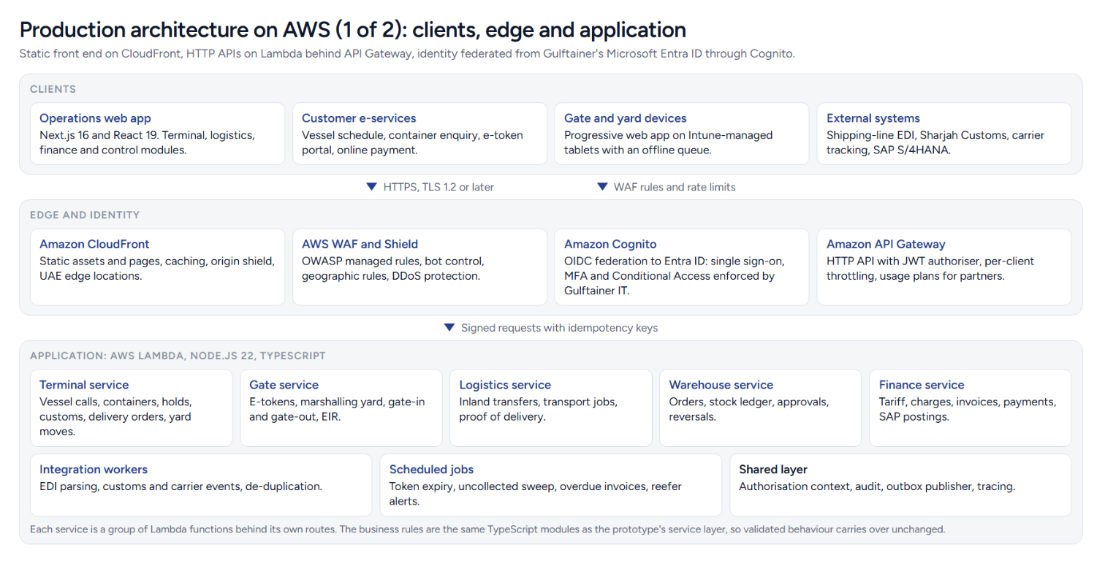
Figure 3. Production architecture: clients, edge, identity and application.
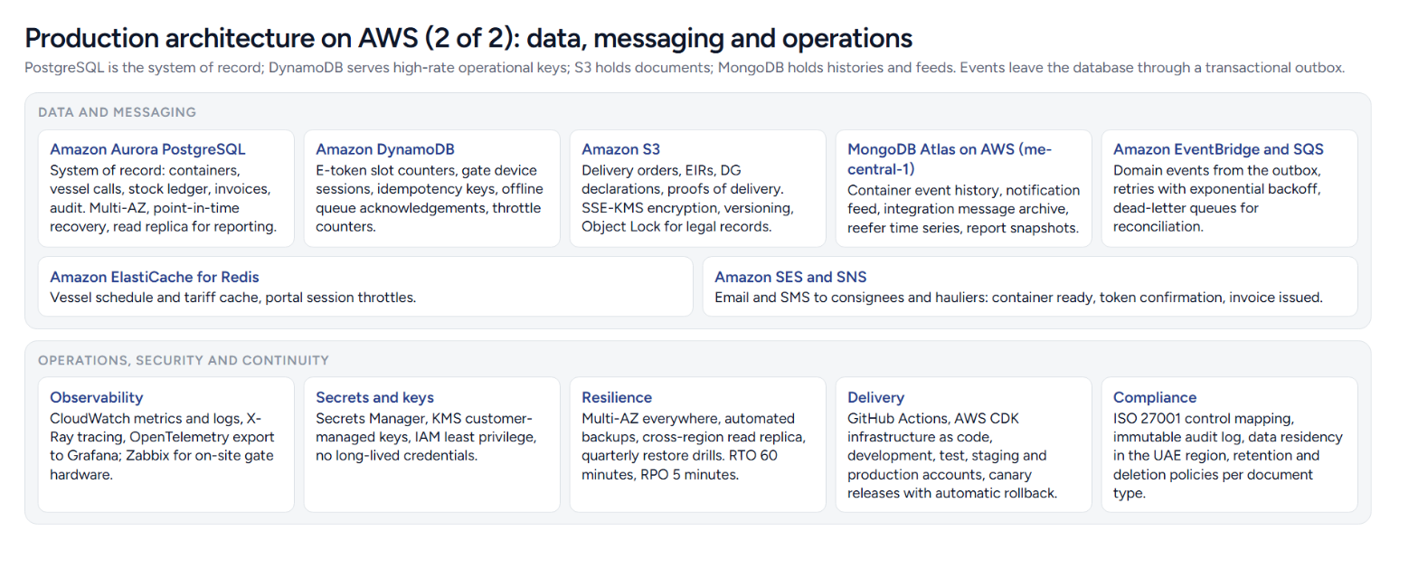
Figure 4. Production architecture: data, messaging, operations and continuity.

8.2 Data placement
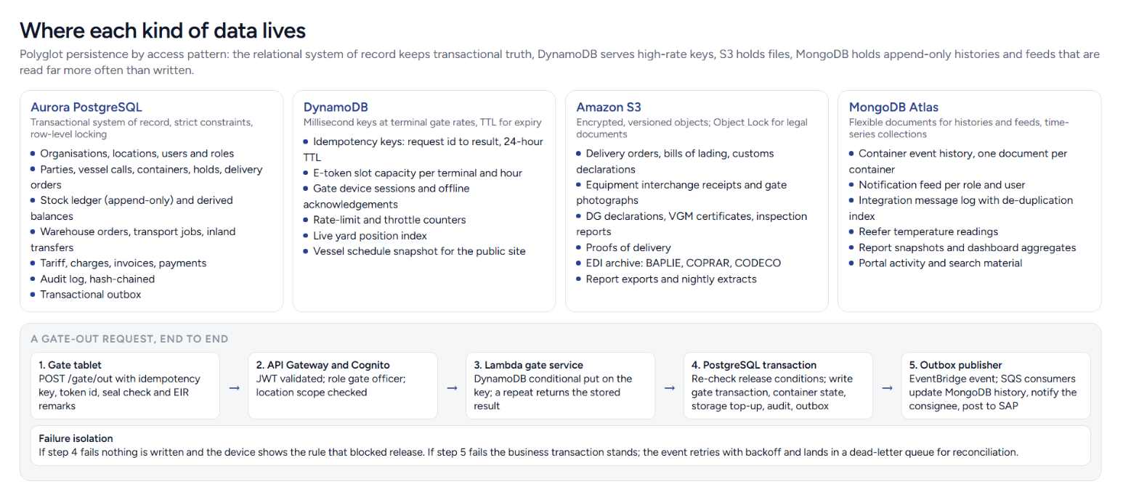
Figure 5. Where each kind of data lives, and a gate-out request end to end.
PostgreSQL holds everything that must be transactionally consistent: organisations, parties, vessel calls, containers, holds, the stock ledger and balances, orders, jobs, charges, invoices, payments, the audit log and the outbox. DynamoDB holds short-lived or very hot keys: idempotency records, e-token slot capacity per terminal and hour, gate device sessions and offline acknowledgements, throttle counters and the live yard index. S3 holds every document and the EDI archive. MongoDB holds the container event history (one document per container, appended on every event), notification feeds, the integration message log, reefer readings and report snapshots. Reporting reads from the Aurora read replica and from MongoDB snapshots, never from the primary.

8.3 API design
REST over HTTPS with JSON. Resources follow the modules: vessel calls, containers, tokens, gate transactions, transfers, transport jobs, SKUs, orders, movements, approvals, charges, invoices, documents, notifications, audit, integrations. Every mutating request carries an Idempotency-Key header and, for edits, the entity version; the API returns 409 on a stale version and 422 with the rule text when a business rule refuses the change. Webhooks for partners (lines, hauliers, SAP) are signed and retried. OpenAPI documents are generated from the TypeScript types so the prototype’s contracts carry over.

8.4 Capacity and performance
Assumption (SRS) | Design response
5,000 registered users, 500 concurrent at peak, 100 concurrent warehouse operations, about 720 requests per second | API Gateway and Lambda scale horizontally; Aurora Serverless v2 scales compute; DynamoDB on-demand absorbs gate bursts; CloudFront serves the static shell. Targets: p95 under 300 ms for reads, under 800 ms for transactional writes, error rate under 0.1 percent, outbox age under 30 seconds.
24/7 operation, 99.95 percent availability | Multi-AZ for every stateful service, no single-instance components, blue-green deployments, health checks and automatic rollback.
Growth to a geographically distributed enterprise platform | One AWS region (me-central-1) with a cross-region replica for disaster recovery; per-country data views by location scope; the same stack can be stamped out per region if data residency requires it.

9. Security, compliance and continuity
This section is written for Gulftainer’s IT infrastructure team and maps to the controls they already run.
Control area | Design
Identity and access | Single sign-on through Entra ID with MFA and Conditional Access; role-based access with location scope on every request; privileged roles (system administrator, finance manager) behind just-in-time group membership and PAM; customer portal accounts in Cognito with email verification; service accounts replaced by IAM roles.
Network and endpoints | Gate and yard tablets enrolled in Intune with compliance policies; network access through Aruba ClearPass 802.1x on terminal LANs; the application reachable only over HTTPS through CloudFront and WAF; private subnets for databases; no public database endpoints.
Data protection | TLS 1.2 or later in transit; KMS customer-managed keys at rest for Aurora, DynamoDB, S3 and backups; field-level masking of card references; secrets in Secrets Manager with rotation; S3 Object Lock for legally significant documents.
Application security | OWASP managed rules in WAF; input validation in the service layer; idempotency and version checks against replay and lost updates; dependency scanning and secret scanning in GitHub; penetration test before go-live.
Audit and separation of duties | Append-only, hash-chained audit log; approvals require a second person; tariff and user changes audited; auditors read-only; audit copies to immutable storage nightly.
Monitoring and response | CloudWatch and X-Ray with OpenTelemetry export to Grafana; Zabbix for on-site hardware; alerts on error rate, latency, outbox age, dead-letter depth, replication lag and backup health; integration with the 24/7 SIEM and MDR service.
Backup and disaster recovery | Aurora automated backups with point-in-time recovery and a cross-region replica; DynamoDB point-in-time recovery; S3 cross-region replication; MongoDB Atlas continuous backup. Targets RTO 60 minutes and RPO 5 minutes, validated by quarterly restore and failover drills in the manner of the existing Veeam programme.
Compliance | ISO 27001 control mapping maintained in the delivery repository; data residency in the UAE region; retention and deletion per document type; configurable regulatory controls per country for Iraq, Saudi Arabia and the United States.

10. Delivery plan to production
Phase | Duration | Scope | Exit criteria
0. Mobilise | 3 weeks | Workshops with terminal operations, customer service, Momentum and finance; confirm the tariff and placeholder rates; confirm integration contracts with MACH or Dynaport, SAP and customs; AWS landing zone. | Signed scope, environments live, integration specifications agreed.
1. Core terminal and gate | 10 weeks | Vessel calls, containers, holds, customs, delivery orders, e-tokens, gate, EIR, tariff and collection; migration of open containers. | Parallel run at one terminal; acceptance criteria 1 to 6, 13 and 14 of the SRS.
2. Customer portal and finance | 8 weeks | Public schedule, enquiry, e-token portal, payment gateway, invoicing, SAP postings. | Portal live for registered customers; invoices reconciled with SAP.
3. Inland logistics and warehousing | 8 weeks | Transfers, transport jobs, warehouse orders, stock ledger, approvals, offline devices. | Acceptance criteria 7 and 10; Momentum stock reconciled to ledger.
4. Reporting, hardening and rollout | 6 weeks | Reports on the read replica, load and failure testing, DR drill, penetration test, rollout to remaining terminals and countries. | Acceptance criteria 11, 12 and 15; 99.95 percent availability demonstrated over 30 days.

10.1 Testing strategy
- Unit tests on the service layer, generated from the rules in section 6.2 (the prototype already proves each rule through the seed replay).
- Contract tests on the APIs from the OpenAPI document; integration tests with recorded EDI, customs and SAP messages including duplicates and out-of-order delivery.
- Concurrency tests: two gate devices releasing the same container, two users allocating the same stock, replayed offline queues.
- Load tests to 2x the SRS peak with p95 and p99 targets; chaos tests on Lambda throttling, Aurora failover and queue backlog.
- Disaster recovery drill from backups into a clean account; security testing by an external party before go-live.

10.2 Risks and how the design treats them
Risk | Treatment
Integration contracts with MACH or Dynaport and SAP arrive late | The platform owns its own container and finance records; integrations are adapters behind queues; the message simulator in the prototype becomes the contract test harness.
Tariff values and rules change | The tariff is data with an audit trail; rates and free days are edited by finance, not deployed.
Gate connectivity at Khorfakkan and the depots | Offline-first gate client with idempotent replay; DynamoDB queue state; Zabbix on the gate network.
Customer adoption of the portal | The portal mirrors the processes customers already follow on Gulftainer’s e-services (registration, e-token, online payment), so the change is in presentation, not procedure.
Data migration from the current TOS | Open containers and calls migrated through the same registration services, so the rules validate the migrated data.

11. Appendices

A. Repository layout
Path | Contents
app/admin/* | Operations modules; one folder per screen; dynamic records under [id].
app/(site)/* | Customer e-services portal.
components/ui/* | Design-system primitives (ported from SSI Events plus the additions listed in DESIGN.md).
components/admin/* | Sidebar, shared badges and links, container dialogs, document upload, background workers.
lib/ops/* | Domain model, store, core, services, facade, tariff, ISO 6346, seed, hooks.
lib/admin-session.ts | Session, roles, permission matrix, prototype login.
docs/* | This document, the user guide and the screenshots they use.
DESIGN.md, README.md | Design system and run instructions.
docs/diagrams/* | Source pages for the architecture diagrams used in this document.

B. Running the prototype
- Install Node.js 20 or later. Clone the repository and run npm install.
- Run npm run dev and open http://localhost:3000. The operations platform is at /admin/login; the customer portal is at the root.
- Run npm run lint and npm run build before deploying. For Vercel, import the repository; no environment variables are required.
- To reset the demonstration data open Administration, Network and locations and press Reset demonstration data.

C. Acceptance criteria of the SRS and where the prototype shows them
Criterion | Where to see it
1. Concurrent operations without violating consistency | Open two browser tabs; every commit in one appears in the other; stale-version edits are refused.
2. Duplicate requests cannot create duplicate movements | Submit a pick, receipt or gate-out twice; the second returns the first result. Sync and integrations shows replayed queue items.
3. Every cargo movement traceable | Audit log, Trace a container; History tab on any container.
4. Loading and unloading update inventory and custody | Vessel call record: discharge and load; container record: custody line.
5. Inventory cannot be reserved beyond available | Warehouse orders: allocate an outbound order larger than stock.
6. Historical changes cannot be silently overwritten | Inventory, Movement ledger: reversals; Documents: versions.
7. Offline operations synchronise with validation | Gate, Work offline; Sync and integrations, Synchronise queue.
8. Documents stored, versioned and linked | Documents register; Upload on a container or call.
9. Integrations handle duplicate, delayed and failed events | Sync and integrations, message simulator.
13. Permissions prevent cross-location operations | Users and roles matrix; any operation outside a user’s locations is refused.
14. Dashboards accurate and fresh | Dashboard and Reports compute from the live record on every change.

