GULFTAINER OPERATIONS PLATFORM
User Guide
How to operate the Gulftainer Operations platform prototype: terminal, gate, inland logistics, warehousing, finance and the customer e-services portal.

Version 1.0
Date 30 October 2026
Prepared by Puneet Shukla, SSI Maya
Prepared for Gulftainer Company Limited, IT and Operations
Repository https://github.com/puneet2343/gulftainer-operations-platform
Live prototype Vercel deployment link to be added after deployment
Login ID operations
Password gulftainer2026

Contents
Contents
1. Getting started
1.1 Signing in
1.2 Finding your way around
1.3 The dashboard
2. Terminal
2.1 Vessel calls
2.2 Containers
2.3 Gate and e-tokens
2.4 Inland transfers
3. Logistics
3.1 Transport jobs
3.2 Warehouse orders
3.3 Inventory
3.4 Tasks
4. Customers and documents
4.1 Customers and parties
4.2 Documents
5. Finance
5.1 Charges
5.2 Invoices and payments
5.3 Tariff
5.4 Container cash collection (online payment)
6. Control
6.1 Notifications
6.2 Reports
6.3 Audit log
6.4 Sync and integrations
7. Administration
7.1 Network and locations
7.2 Users and roles
8. Customer e-services portal
8.1 Vessel schedule
8.2 Container enquiry
8.3 E-token portal
9. Everyday actions
Glossary

1. Getting started
The prototype runs entirely in the browser. It carries a realistic data set for Gulftainer’s network (Khorfakkan, Sharjah, Hamriyah, Umm Qasr, Jeddah, Jubail, Canaveral, the Sharjah Inland Container Depot, Sajaa Bonded Dry Port, Umm Qasr Logistics Centre and the Momentum warehouses) and every screen writes to the same operational record, so a change made on one screen appears everywhere else immediately.

1.1 Signing in

- The login ID and password are prefilled. Press Login.
- You land on the dashboard as the Operations Administrator, who can open every module.
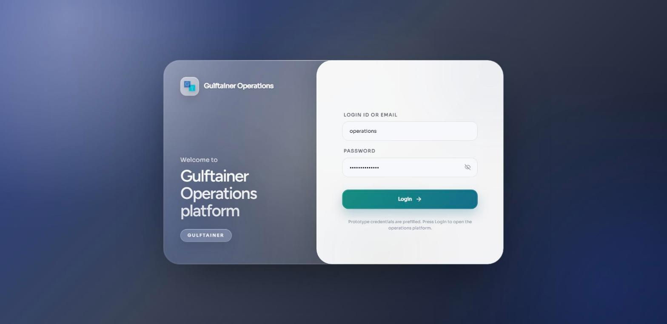
Figure 1. Sign-in screen with the prefilled prototype account.
Credentials
Login ID: operations
Password: gulftainer2026
The other people listed under Administration, Users and roles are the employees who appear on tasks, events and approvals; they do not sign in separately in the prototype.

1.2 Finding your way around
The left sidebar groups the modules the way the business works: Terminal, Logistics, Customers, Finance, Control and Administration. On phones and tablets the sidebar becomes a drawer behind the menu button. Every list page has the same parts: a row of figures at the top, a search box with a filter toggle, the table (which becomes cards on a phone) and page controls at the bottom. Actions that change data open a dialog that explains the rule being applied and shows the exact reason if the platform refuses the change.
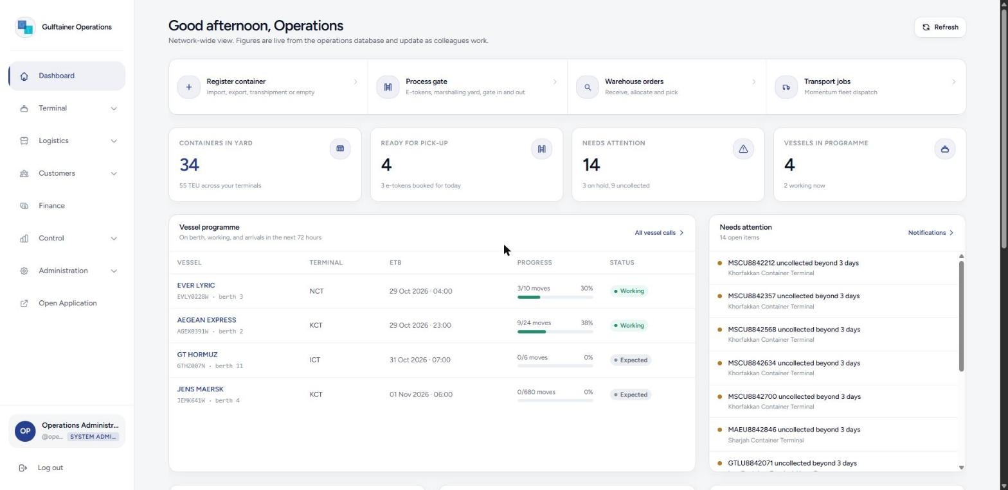
Figure 2. Dashboard: quick actions, key figures, vessel programme, attention list, yard utilisation, logistics position and recent activity.

1.3 The dashboard
- Needs attention lists uncollected containers, holds, reefer alerts, stock adjustments waiting for approval, rejected offline operations and overdue invoices. Each item opens the record it is about.
- Vessel programme shows vessels on berth, working and expected in the next 72 hours with progress against planned moves.
- Yard utilisation compares TEU in yard with the design capacity of each terminal and shows reefer plug use.
- Refresh re-runs the housekeeping checks (token expiry, uncollected containers, overdue invoices, unplugged reefers).

2. Terminal

2.1 Vessel calls
A vessel call is one voyage at one terminal. It carries the ETA, ETB and ETD, the berth, planned discharge and load moves, the carrier’s pre-arrival documents and the export gate window, which opens four days before the ETB and closes one day before, exactly as published on the Gulftainer vessel schedule.
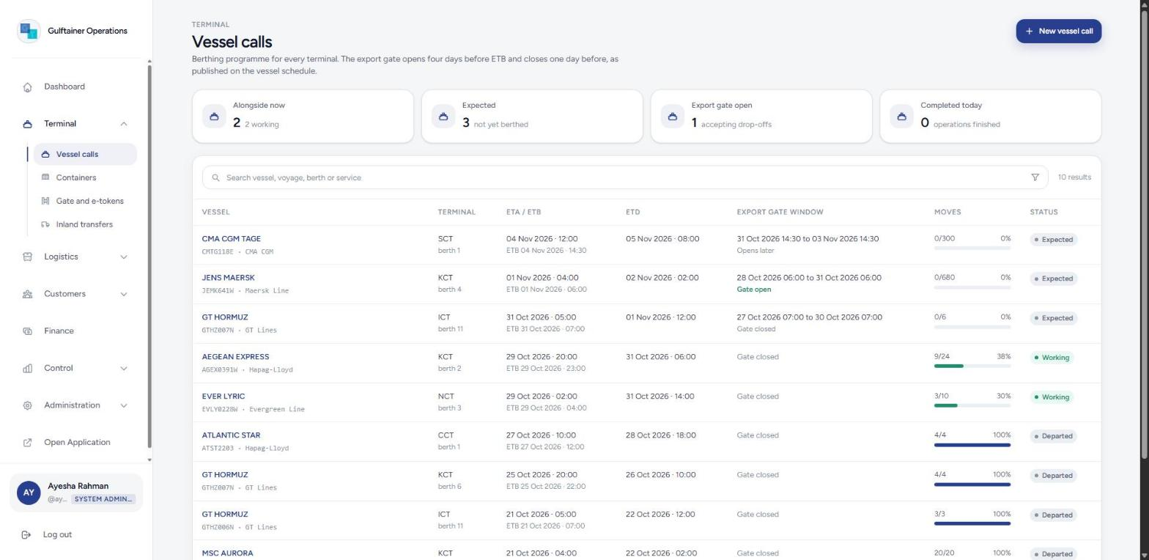
Figure 3. Vessel calls with the export gate window and progress per call.

Create a vessel call
- Open Terminal, Vessel calls and press New vessel call.
- Enter the vessel, voyage (as on the schedule, for example JEMK641W), shipping line, terminal, berth and service.
- Enter ETA, ETB and ETD in UTC, the cranes allocated and the planned discharge and load moves.
- Press Create call. The gate window is derived from the ETB and the call opens as Expected.

Work a call from arrival to departure
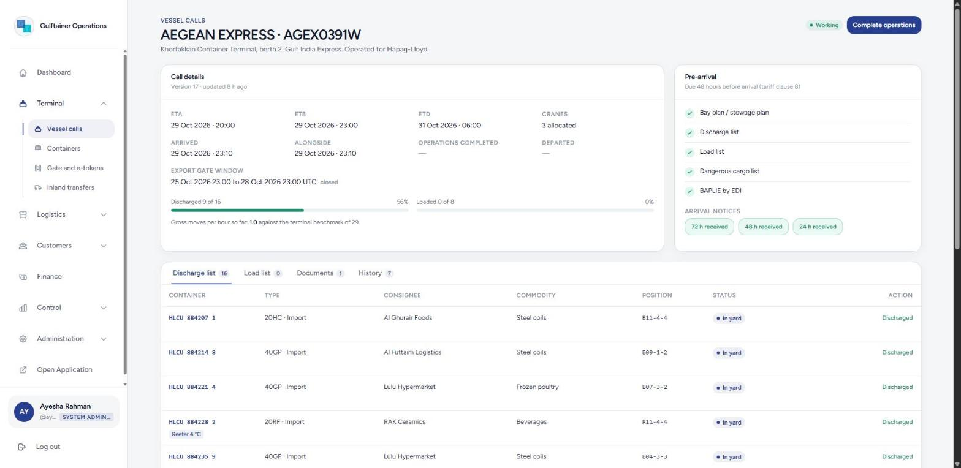
Figure 4. A working call: details, pre-arrival checklist, arrival notices, discharge and load worklists.

Record on berth when the vessel is alongside. The export gate closes for this voyage.
Start operations. The platform refuses until the bay plan, discharge list, load list and, if any dangerous goods are on board, the dangerous cargo list are on file. Discharge and load tasks are created for the shift.
Discharge for each container and enter its yard position (block, row, tier, for example C04-07-2). Stevedoring is charged to the line and the storage clock starts.
Load for export and transhipment containers. An export box needs a verified gross mass and customs clearance and must not be on hold.
Complete operations once every container on the discharge list is off the vessel, then Record departure.

2.2 Containers
The container register lists every box the network knows about with its physical status, location and yard position, line, consignee, voyage and the clearance position of import boxes: customs, delivery order and payment. Use the filters to find containers ready for pick-up, on hold, with customs pending, with charges unpaid, or by special category (dangerous goods, reefer, out of gauge).
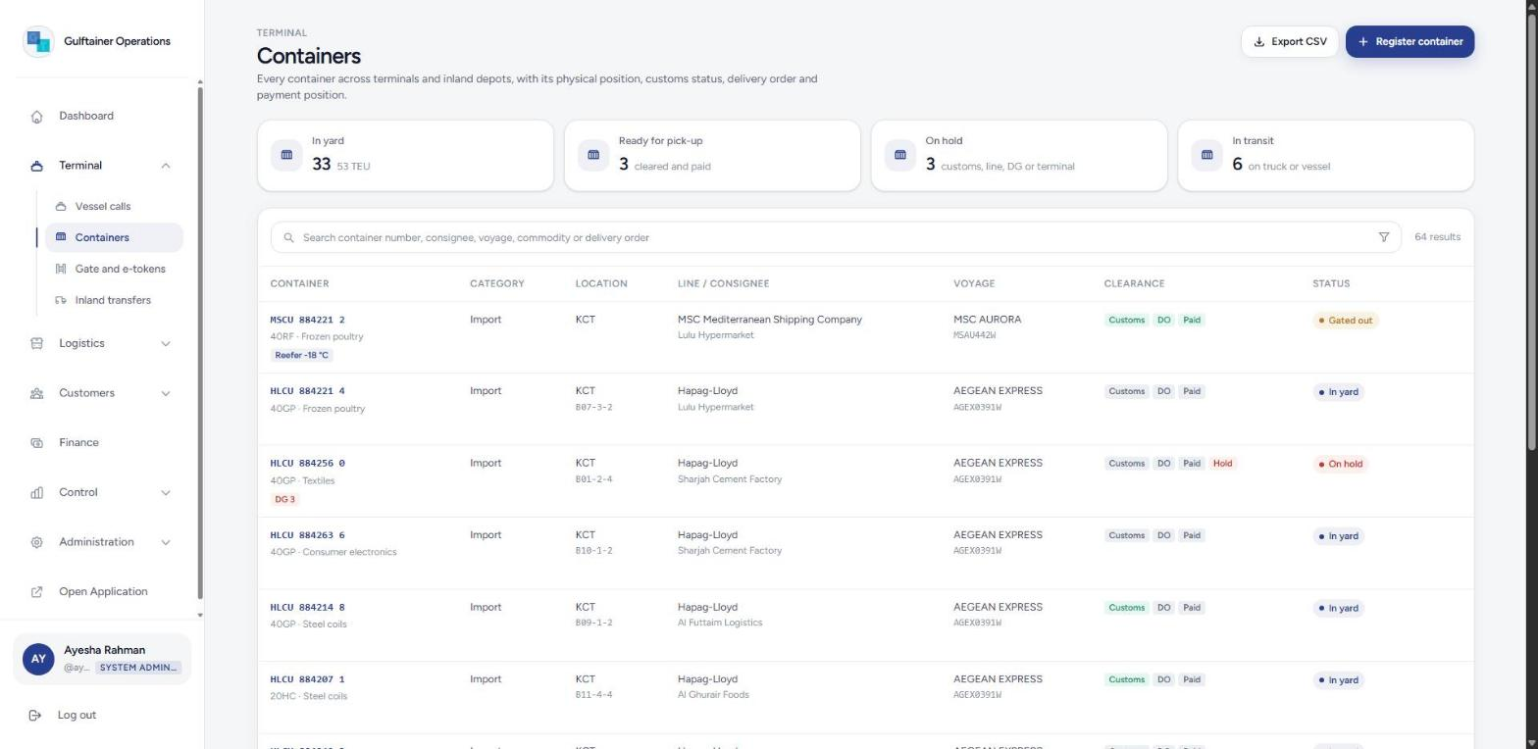
Figure 5. Container register with clearance chips and physical status.

Register a container
- Open Terminal, Containers and press Register container.
- Type the container number. The ISO 6346 check digit is validated as you type and a wrong digit is reported with the correct one.
- Choose the category: import and transhipment boxes go on an inbound vessel call; export bookings go on the booked outbound call; empties may have an outbound call or none.
- Enter size, type, line, seal, weight and commodity. Tick dangerous goods (IMO class and UN number) or out of gauge where relevant; reefers need a setpoint.
- Press Register container. A dangerous goods box receives a DG hold until the declaration is filed.

The container record
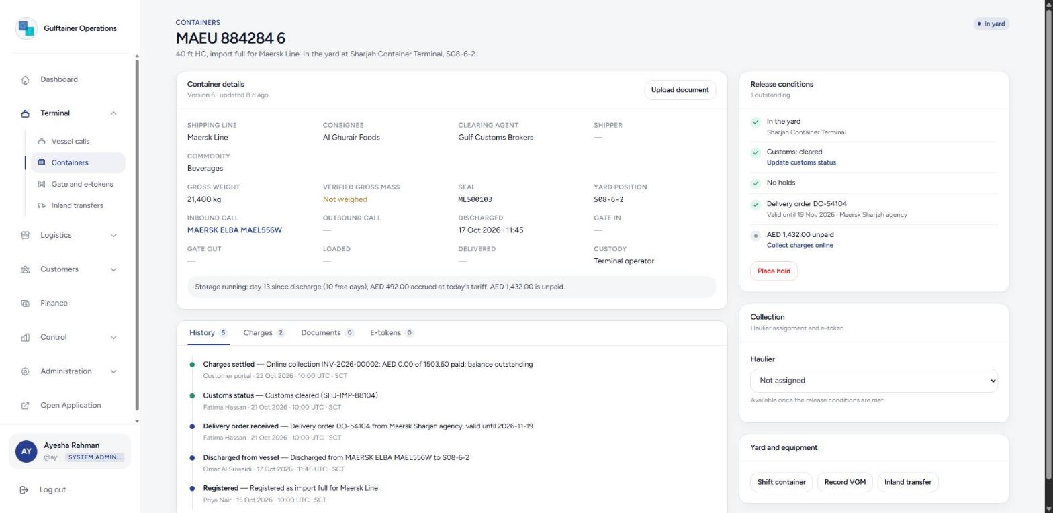
Figure 6. A container record: facts, storage running, history, and the release conditions with their actions.
The record is the clearance desk for an import box. The right-hand panel lists the release conditions in order and offers the action for each one that is still outstanding:
- Customs: normally updated by the customs clearance message (see Sync and integrations). Press Update customs status for a manual declaration; selecting Inspection places a customs hold and cancels any e-token.
- Holds: press Place hold for a terminal, shipping-line or documentation hold with a reason. Release lifts it. Customs holds are lifted only by clearance; DG holds are lifted by filing the dangerous goods declaration under Upload document.
- Delivery order: press Record delivery order and enter the number, validity date, issuer and consignee. An expired delivery order blocks release again.
- Charges: press Collect charges online to open the Container cash collection screen (section 5.4).
Once every condition is met, the Collection panel lets customer service assign a haulier and generate the e-token, or amend and cancel it while the truck has not reached the marshalling yard. Yard and equipment actions cover yard shifts (housekeeping, scanning, inspection or to CFS), recording the verified gross mass from the weighbridge, reefer checks and a link to inland transfers. The History tab is the complete immutable event trail; Charges, Documents and E-tokens show everything linked to the box.

2.3 Gate and e-tokens
The gate screen is written for the gate officer. Choose the terminal or depot at the top. Open appointments shows every e-token with its slot, the haulier and truck, and whether the container is cleared for release. The search box accepts an e-token number, a container number or a truck plate, so a scanned barcode finds the appointment immediately.
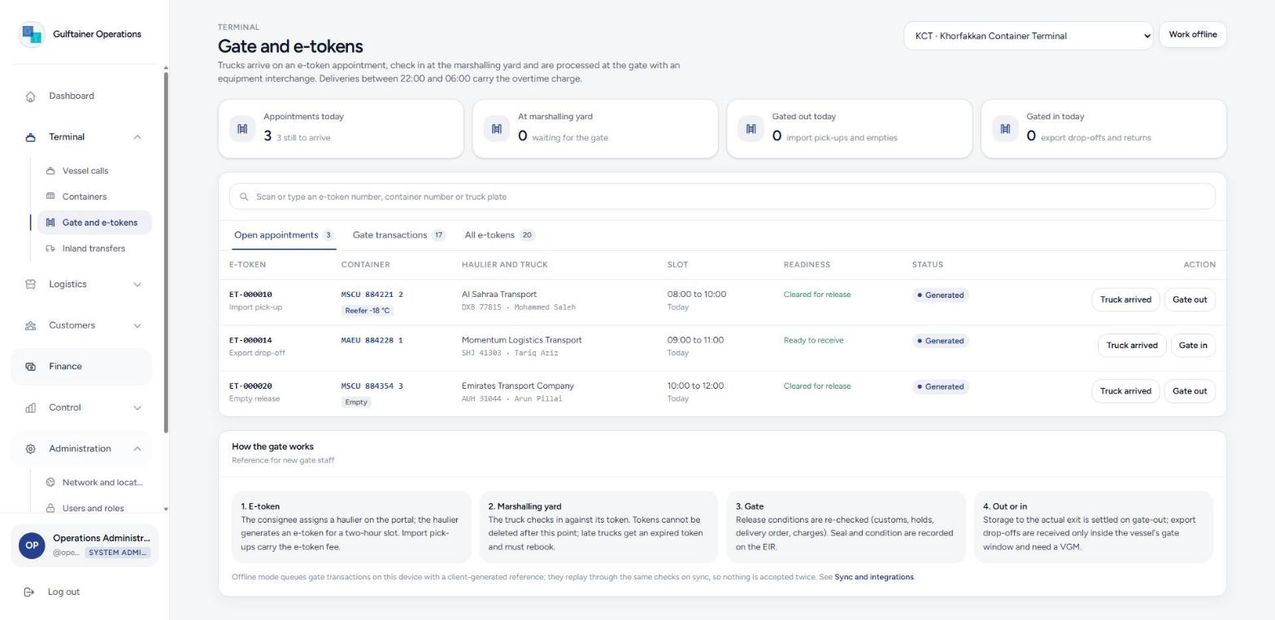
Figure 7. Gate screen: open appointments with readiness, status and the next action.

Process an import pick-up
Truck arrived. The token can no longer be deleted by the consignee; a truck arriving after its slot receives an expired token and must rebook.
Gate out. The dialog re-checks the release conditions and shows any blocker.
- Confirm the truck plate, tick the seal check (required for a full container) and record condition remarks for the equipment interchange receipt.
Confirm gate out. Storage to the actual exit is settled, an overtime charge applies between 22:00 and 06:00, custody passes to the haulier and the EIR appears under Gate transactions.

Process an export drop-off or empty return
Gate in on the export or empty-return token. Export boxes are accepted only inside the vessel’s gate window and, for dangerous goods, only with the DG declaration on file.
- Enter the yard position, tick the seal check, and enter the weighbridge mass if the box is weighed at the gate.
- Press Confirm gate in. The port receiving charge is raised to the line and the container shows In yard on the outbound call’s load list.
Working offline
Press Work offline when the gate loses connectivity. Gate-in, gate-out and yard shifts are then queued on the device with a client-generated reference. Press Reconnect and synchronise the queue from Control, Sync and integrations; each operation replays through the same checks, so nothing is accepted twice and anything the rules now refuse is listed for reconciliation.

2.4 Inland transfers
Import containers not collected within three days of vessel completion are transferred to the Sharjah Inland Container Depot or Sajaa Bonded Dry Port for the account of the cargo interests, as in the April 2026 advisory. The screen lists the candidates with days in yard and their clearance position.
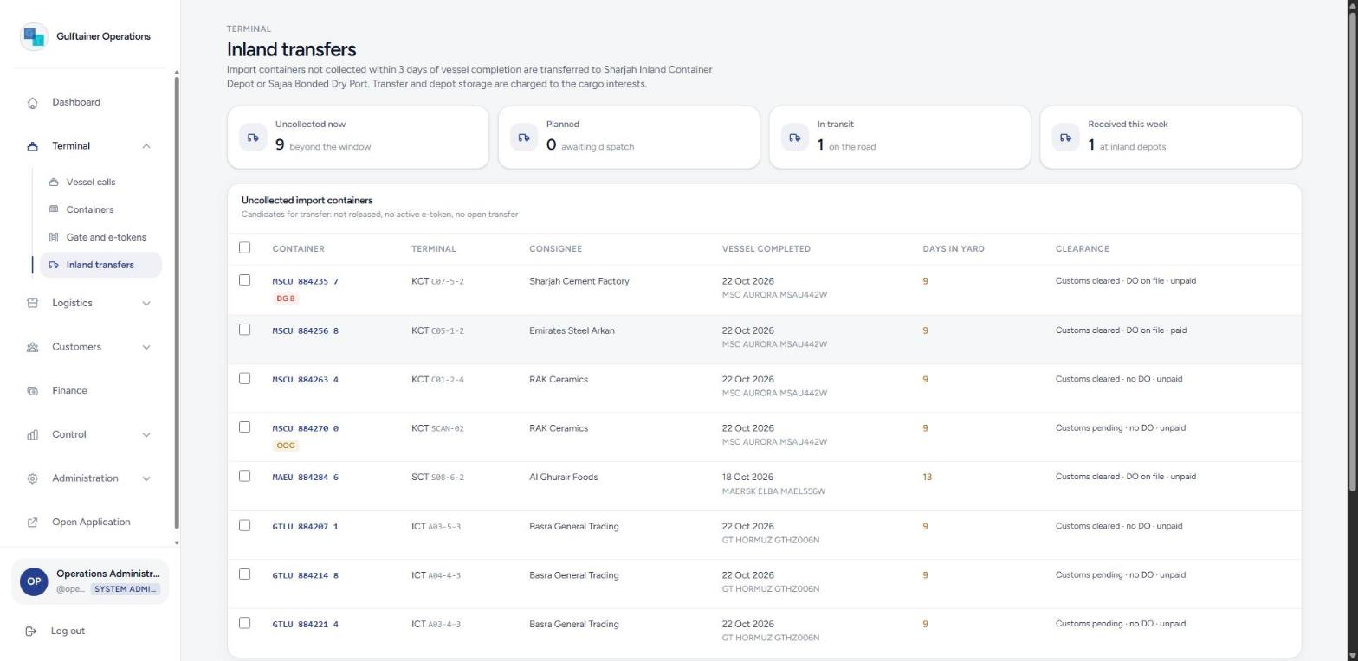
Figure 8. Uncollected import containers and the transfer list.
- Tick the containers to move (one terminal at a time) and press Plan transfer.
- Choose the destination depot and reason, and optionally the tractor, trailer and driver. A Momentum transport job is created.
- Press Dispatch when the truck leaves. The containers show Gated out on transfer.
- At the depot press Receive, enter each container’s yard position and confirm. The inland transfer charge is raised to the consignee and the container continues its clearance from the depot.

3. Logistics

3.1 Transport jobs
Transport jobs are the Momentum fleet’s work: import deliveries from the terminal to the consignee, export collections, empty repositioning and distribution of picked warehouse orders. A job carries the route, the load (containers or an order), the tractor, trailer and driver, and ends with a proof of delivery.
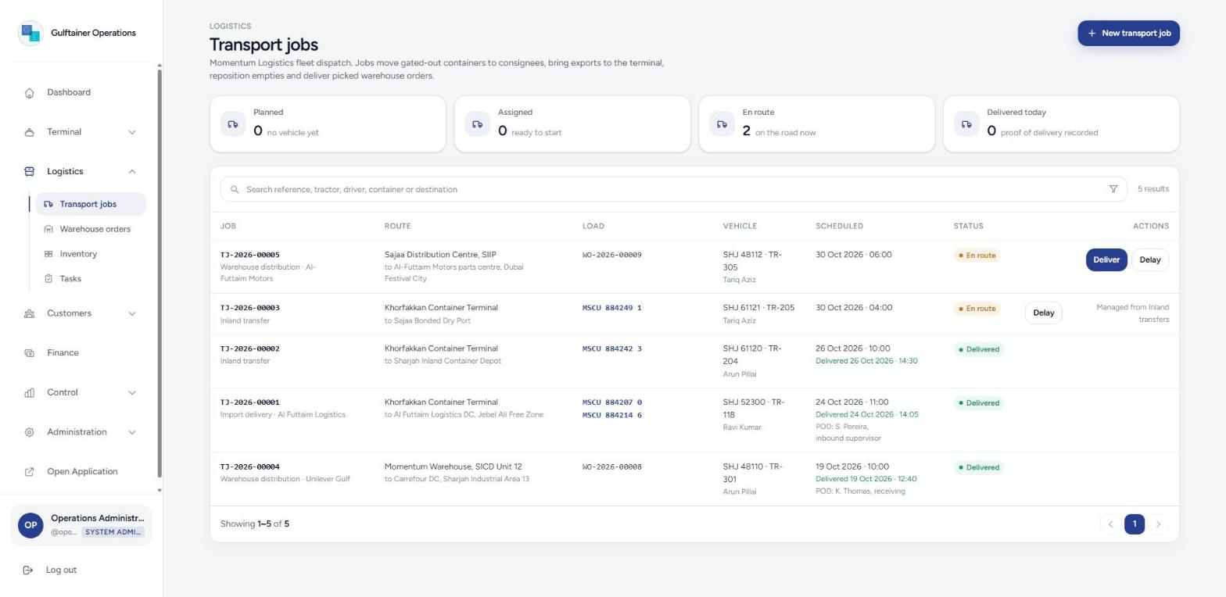
Figure 9. Transport jobs with status and actions.
- Press New transport job, choose the type, the customer to be charged, the origin and the destination (a Gulftainer location or a customer address).
- Pick the containers (only boxes eligible for that job type are offered) or the picked outbound order, enter the vehicle and schedule, and press Create job.
- Press Assign to set or change the vehicle; a tractor cannot be assigned while it is en route on another job.
- Press Start when the truck leaves and Deliver on arrival, entering who received the goods. Import containers close as Delivered; a picked order becomes Dispatched. Delay records a reason and notifies customer service.

3.2 Warehouse orders
Contract-logistics orders for Momentum customers. Inbound orders are advance notices of stock to receive; outbound orders are allocated from available stock and then picked.
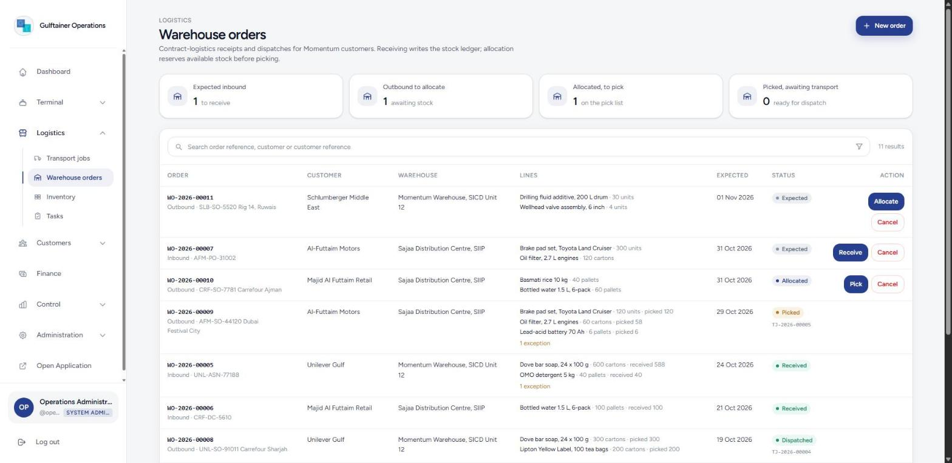
Figure 10. Warehouse orders with lines, exceptions and the next action per order.
- Press New order, choose inbound or outbound, the customer, the warehouse, the expected date and the lines (only that customer’s SKUs are offered).
Receive and count each line, recording any damaged units. Differences from the advised quantity and damage are recorded as exceptions and notified.
Allocate. Every line is reserved from available stock; the order fails as a whole if any line is short.
Pick and confirm the picked quantity per line. Short picks release the balance and are recorded as exceptions. The order is then ready for a transport job.

3.3 Inventory
Inventory shows stock per SKU and warehouse in four buckets: available, allocated, damaged and held. Every balance equals the sum of its ledger entries; corrections are posted as new movements, never by editing history.
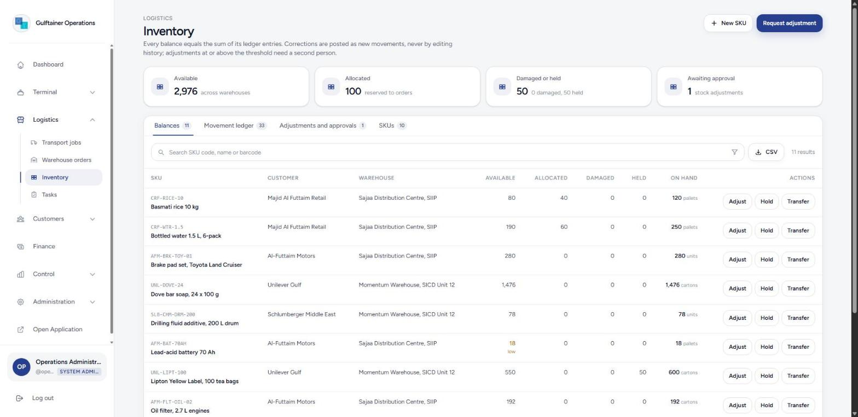
Figure 11. Stock balances with low-stock marking and per-row actions.
- Adjust requests a quantity change with a reason. Changes at or above the threshold, and any request from a supervisor or worker, wait for a second person; smaller requests from an inventory manager post immediately.
- Hold moves stock between available and held, for example a quality hold pending customer release.
- Transfer moves available stock to another warehouse in one movement with effects at both ends.
- Movement ledger lists every entry with its effects; an inventory manager can post a reversal, which creates a compensating entry and leaves the original in place.
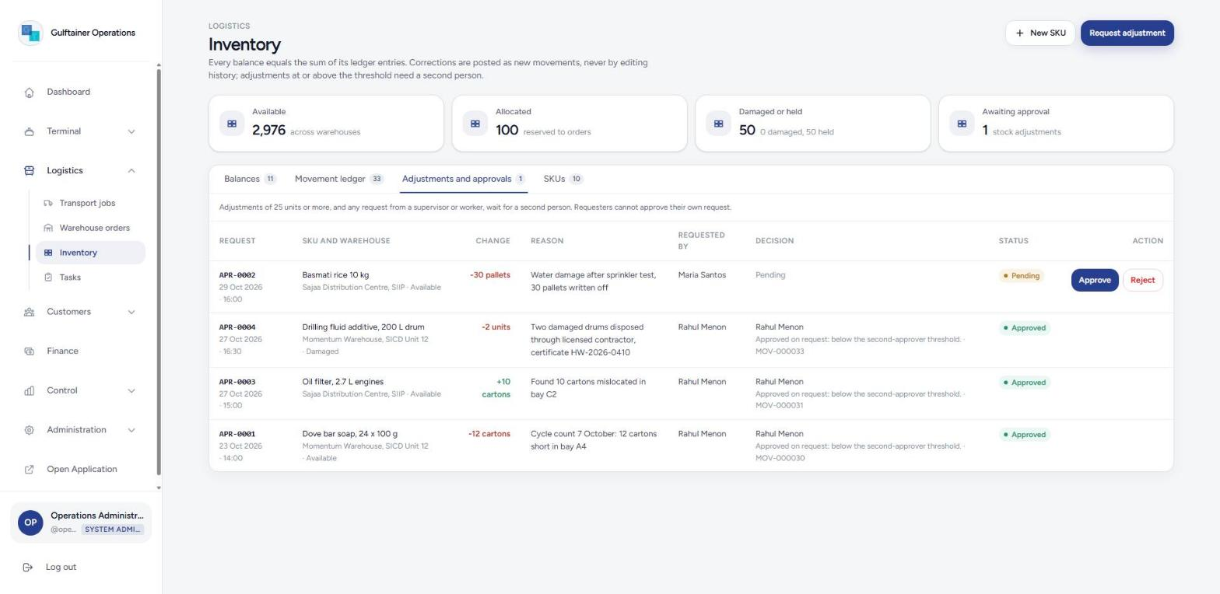
Figure 12. Adjustments and approvals: the requester can never approve their own request.

3.4 Tasks
Shift work across terminals and warehouses. Vessel, order and transfer tasks are created automatically by the platform; supervisors add others and assign them. Workers start and complete the tasks assigned to them.
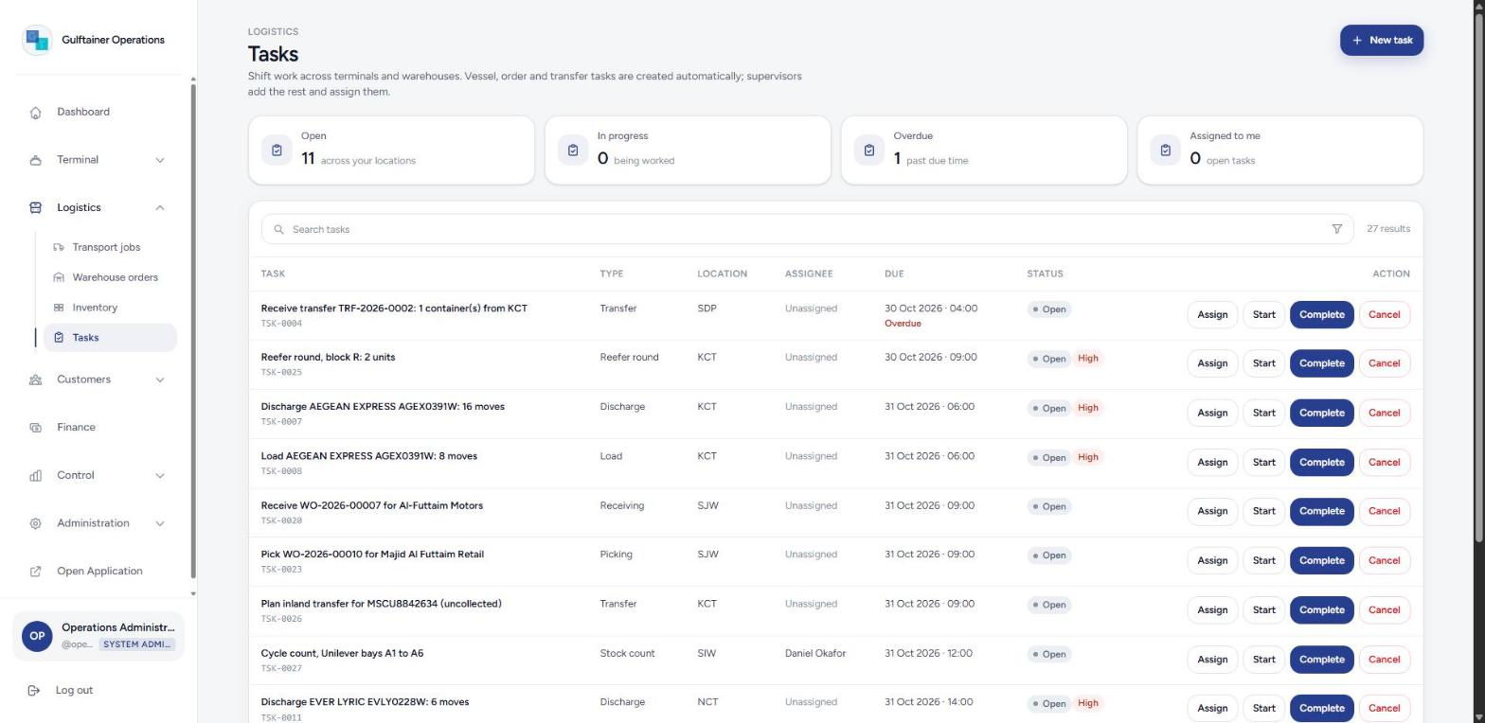
Figure 13. Task list with overdue marking and actions.

4. Customers and documents

4.1 Customers and parties
Every organisation that appears on a container, order or invoice: shipping lines, consignees, clearing agents, hauliers, contract-logistics customers and shippers. Consignees and hauliers must be registered on the customer portal before they can pay online or generate e-tokens; press Register in the Portal column to register one.
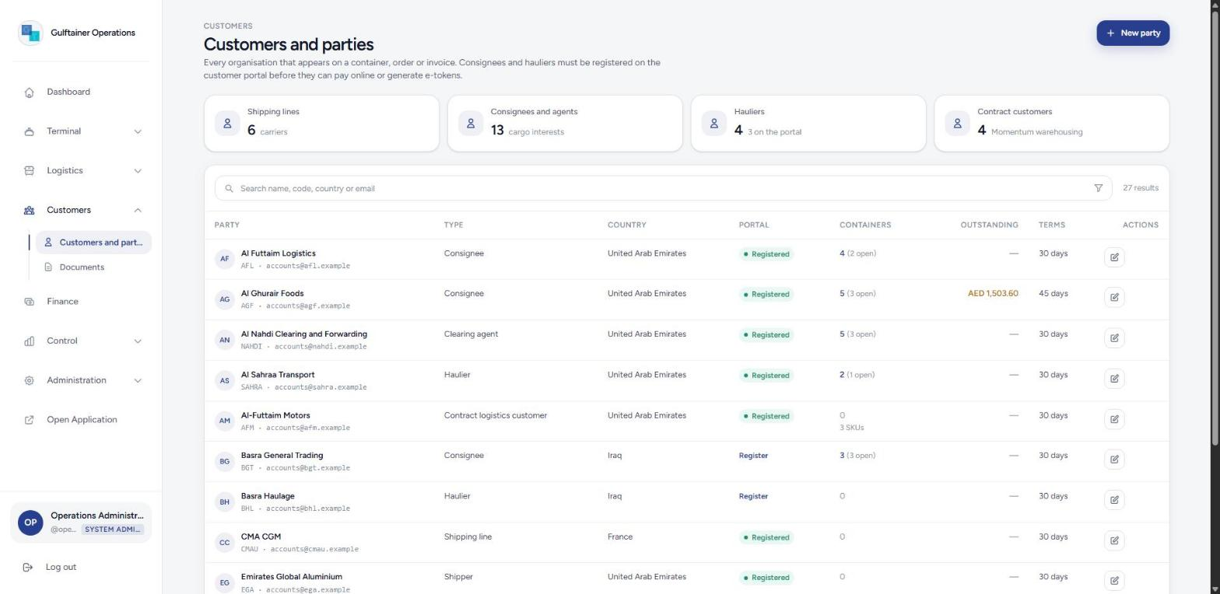
Figure 14. Customers and parties with portal registration and outstanding balances.

4.2 Documents
The document register holds delivery orders, bills of lading, customs declarations, equipment interchange receipts, bay plans, BAPLIE files, dangerous goods declarations, VGM certificates, proofs of delivery and inspection reports, each linked to the container, vessel call, order or transport job it belongs to. Files are hashed (SHA-256) on upload; legally significant types keep every version and are never overwritten. Access can be limited to roles.
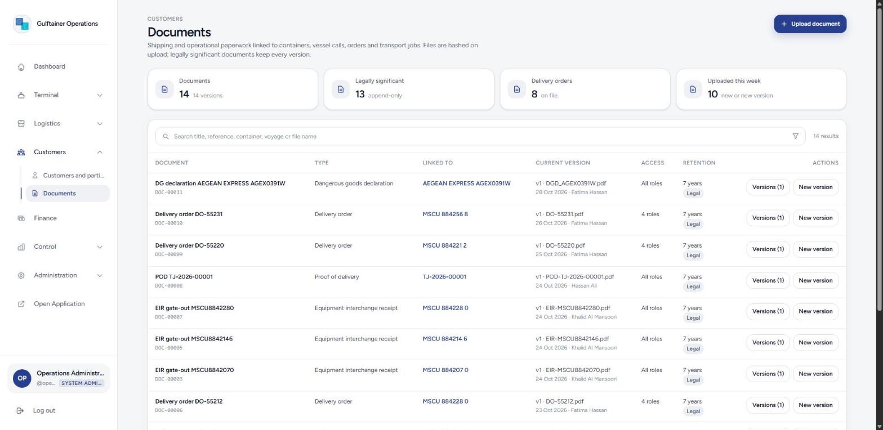
Figure 15. Document register with versions, access and retention.
- Press Upload document (or Upload document on a container or vessel call to link it automatically).
- Choose the type, title, retention and the roles allowed to open it, select the file and add a note.
- Press Upload. Filing a DG declaration against a container releases its DG hold; filing a bay plan or BAPLIE against a vessel call ticks the pre-arrival checklist.
- Press New version on an existing document to add a revision; identical files are rejected.

5. Finance

5.1 Charges
Operations raise charges automatically at the tariff rate: stevedoring on discharge and load, port receiving on gate-in, storage on collection and gate-out, shifting, VGM, e-token fees, overtime, inland transfer, warehouse handling and transport. Finance can add a manual charge for anything else. The Charges tab lists uninvoiced lines; tick the lines for one party and press Create and issue to raise an invoice with VAT.
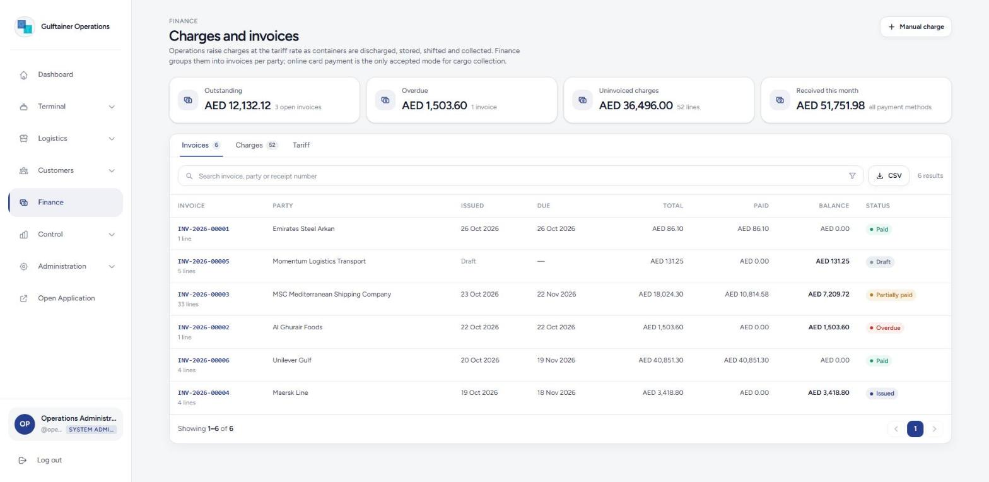
Figure 16. Invoices with totals, payments and balances.

5.2 Invoices and payments
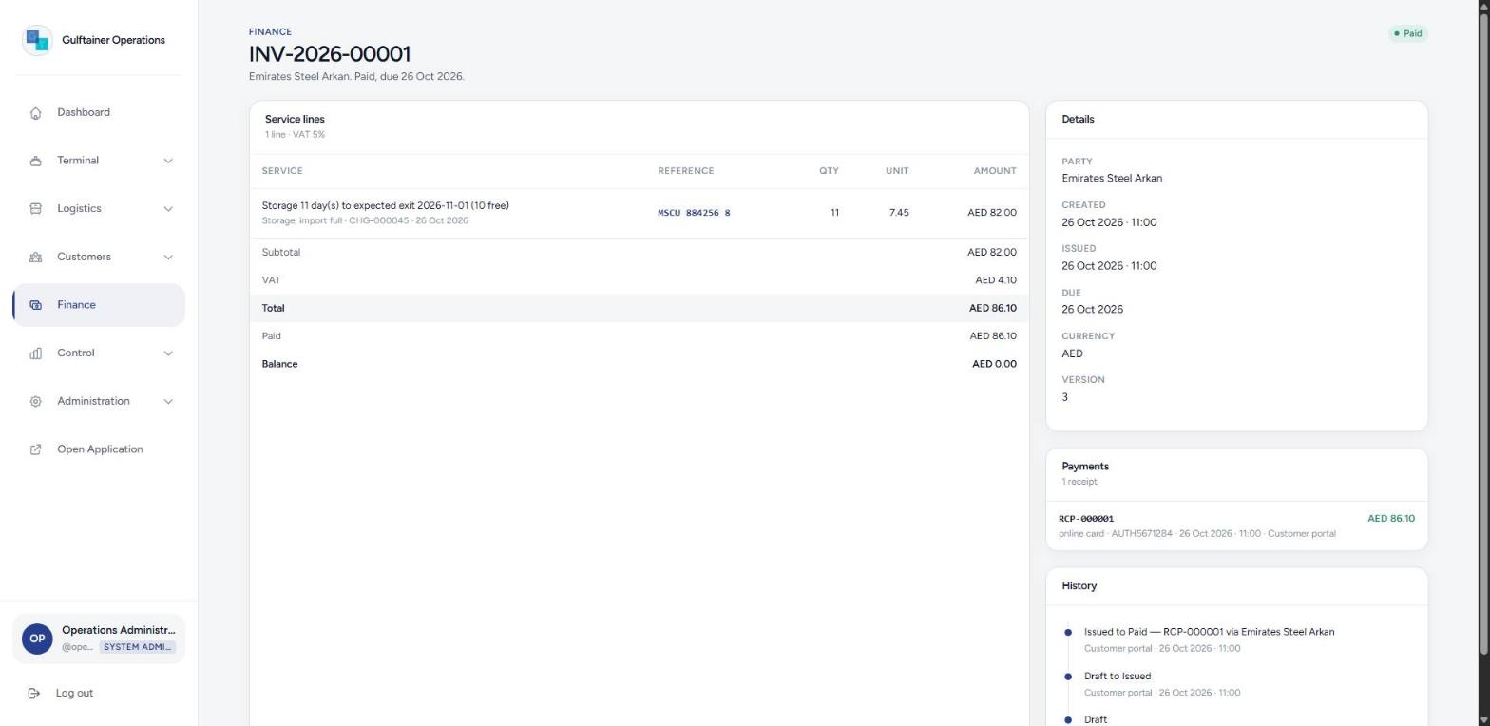
Figure 17. An invoice: service lines, VAT, payments and history.
- Open an invoice from the list. A draft can be issued with credit terms; issuing posts it to SAP S/4HANA through the outbox.
- Press Record payment and enter the amount, method (online card, bank transfer or credit note) and reference. Partial payments are allowed; a duplicate reference is refused.
- When an invoice for a consignee is paid in full, every import container on it is marked charges settled, which is one of the release conditions.
- Cancel returns the charges to the uninvoiced pool; an invoice with payments cannot be cancelled.

5.3 Tariff
The Tariff tab holds the Khorfakkan Container Terminal Schedule of Charges effective 1 June 2026: stevedoring, port receiving, shifting, storage slabs for import, export, empty and transhipment containers, the dangerous goods surcharge and the e-token fees. Free storage is 10 days for non-DG and 1 day for DG import boxes, counted from discharge. Rates the public schedule does not publish are marked as placeholders and can be edited by a finance manager; every change is audited.
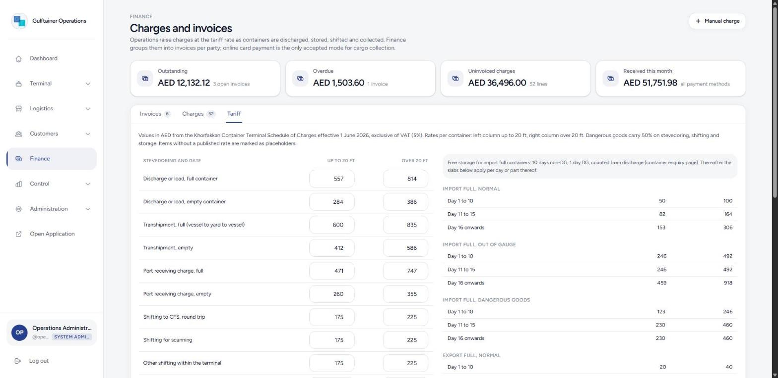
Figure 18. The tariff screen.

5.4 Container cash collection (online payment)
Online payment is the only accepted mode for cargo collection. From a container record press Collect charges online, or on the customer portal press Pay charges online. The screen quotes storage to the expected exit date (with the free days shown), lists the open service lines, adds VAT and offers full, partial or zero payment as on the terminal portal. Full payment settles the container; a later exit is charged the additional days at the gate.

6. Control

6.1 Notifications
Alerts addressed to roles: vessel berthed and completed, container ready for pick-up, holds, e-tokens, gate-outs, discrepancies, approvals, integration failures, overdue invoices, reefer alerts and uncollected containers. Each one opens the record it is about. Unread counts appear on the sidebar.
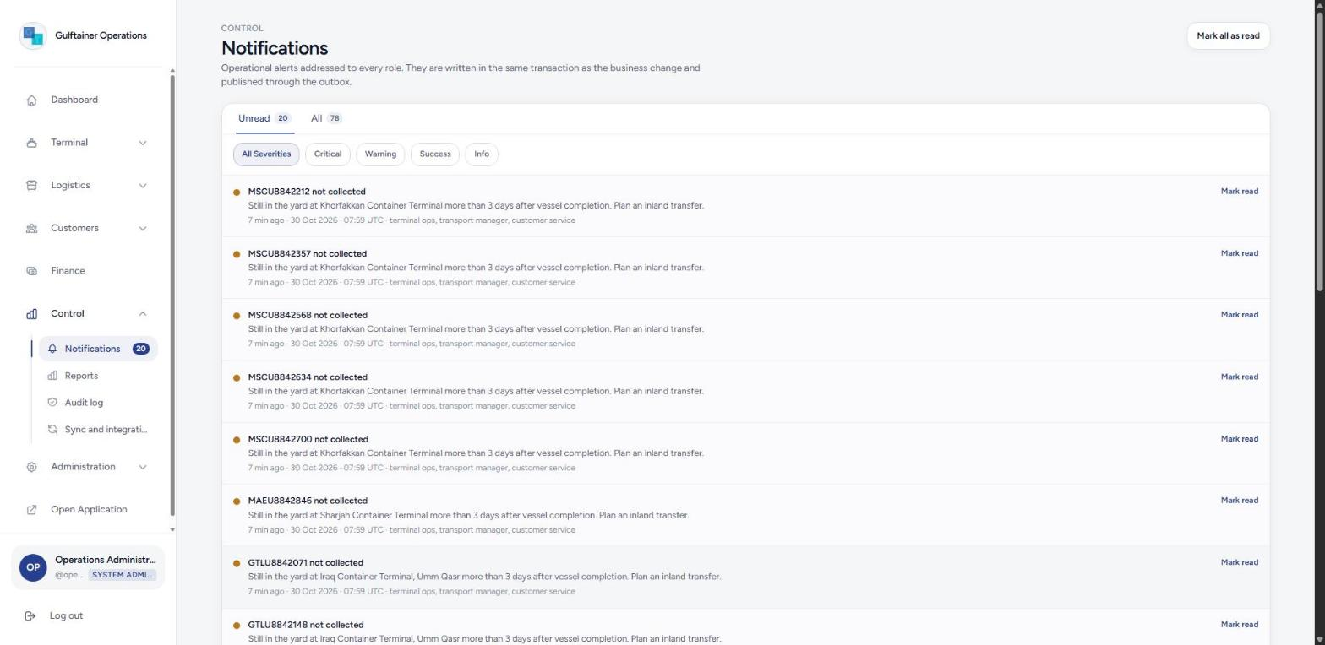
Figure 19. Notifications filtered by severity.

6.2 Reports
Management views for 7, 14 or 30 days: yard utilisation per terminal, vessel productivity (gross moves per hour against the 29 benchmark), import dwell time, gate transactions per day, e-token performance, charges by service group, outstanding by party, stock by warehouse, and operations and transport figures. Every table has a CSV export.
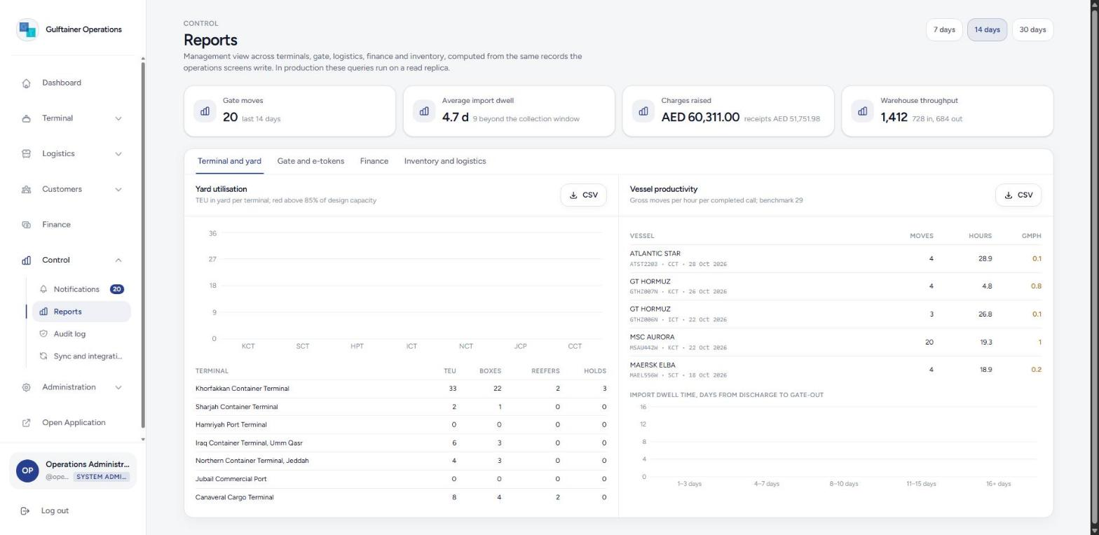
Figure 20. Reports, terminal and yard tab.

6.3 Audit log
An append-only record of every business action with the user, entity, location, before and after values, reason and the request id that groups the records written in one transaction. The Trace a container box returns the full history of a box from registration to delivery. The whole log exports to CSV.
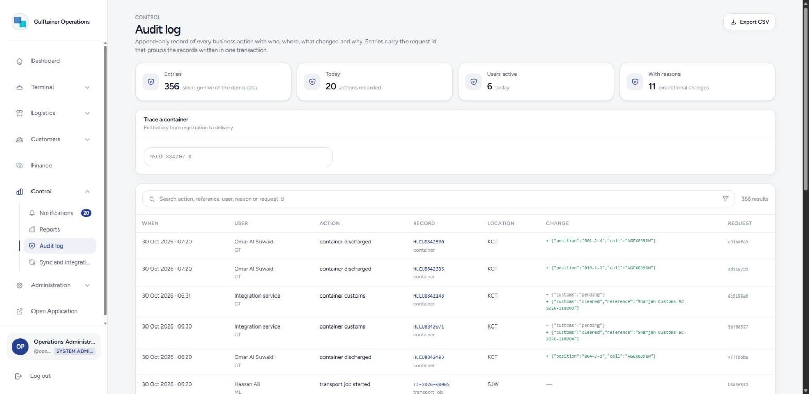
Figure 21. Audit log with container trace.

6.4 Sync and integrations
Three tabs: the offline queue from gate and warehouse devices (sync, retry, discard), the event outbox (every business event written in the same transaction as its change and published by the worker), and inbound messages from shipping lines (BAPLIE, COPRAR), Sharjah Customs, carrier tracking and SAP. The message simulator sends a message as the external system would; send the same event id twice to see duplicate detection, or an unknown container to see a failure recorded without touching committed data.
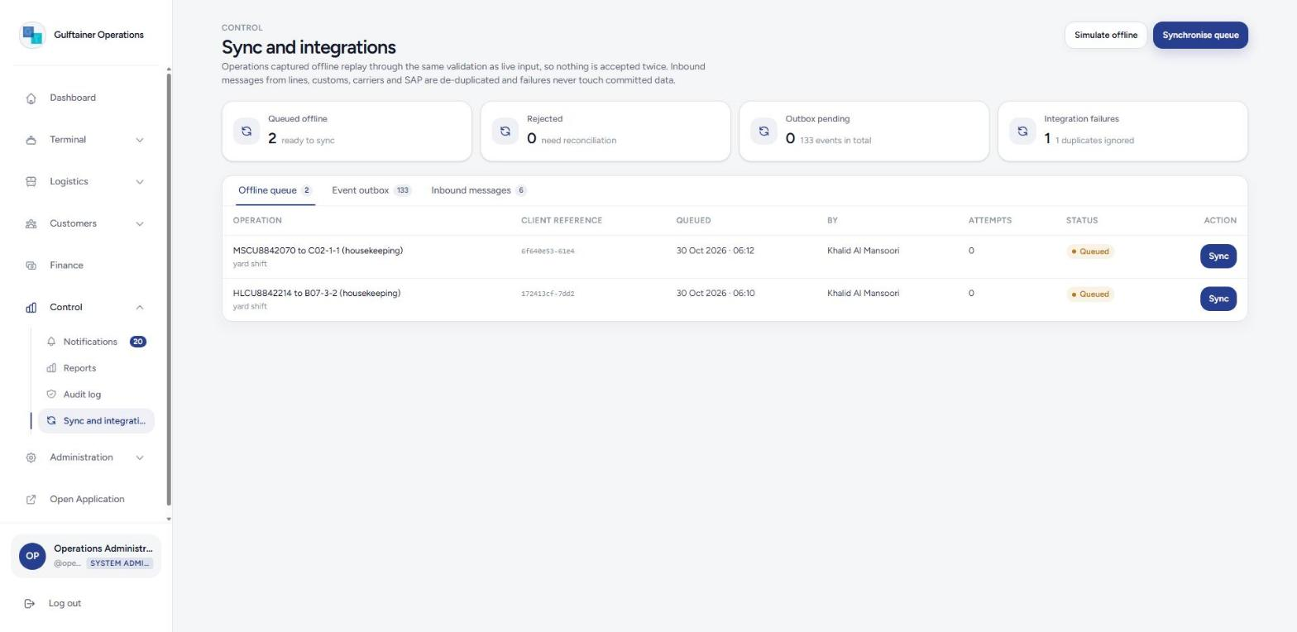
Figure 22. Sync and integrations.

7. Administration

7.1 Network and locations
Gulftainer’s operating entities and every terminal, inland depot, logistics centre and warehouse with its country, time zone, operating hours and capacity facts (berths, quay, draft, yard TEU, reefer plugs, warehouse area). System administrators add and edit locations, set the approval and low-stock thresholds, and can reset the demonstration data.
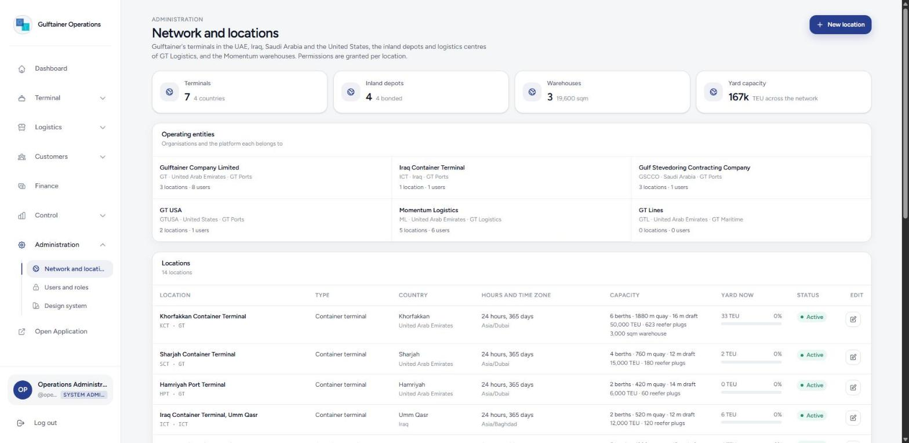
Figure 23. Network and locations.

7.2 Users and roles
Each account has a role and the locations it may operate in. The Roles and permissions tab shows the module matrix for the eleven roles and the action-level rules the services enforce regardless of the matrix.
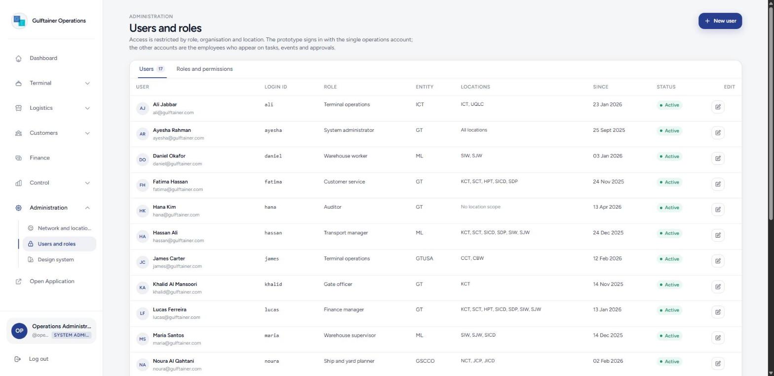
Figure 24. Users and roles.

8. Customer e-services portal
The public site at the root of the prototype is the customer-facing portal, modelled on Gulftainer’s e-services: vessel schedule, container enquiry with storage estimate, and the e-token portal for consignees and hauliers.
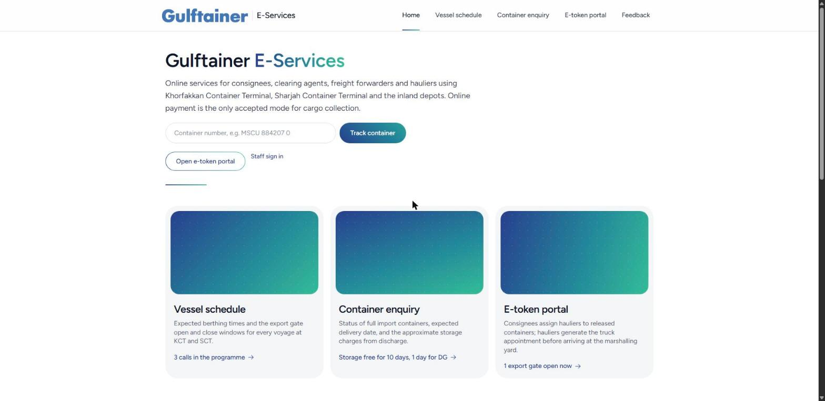
Figure 25. E-services home with direct container tracking.

8.1 Vessel schedule
Terminal, voyage, vessel and ETB, with the export gate open and close times and whether the gate is open now. Filter by terminal.
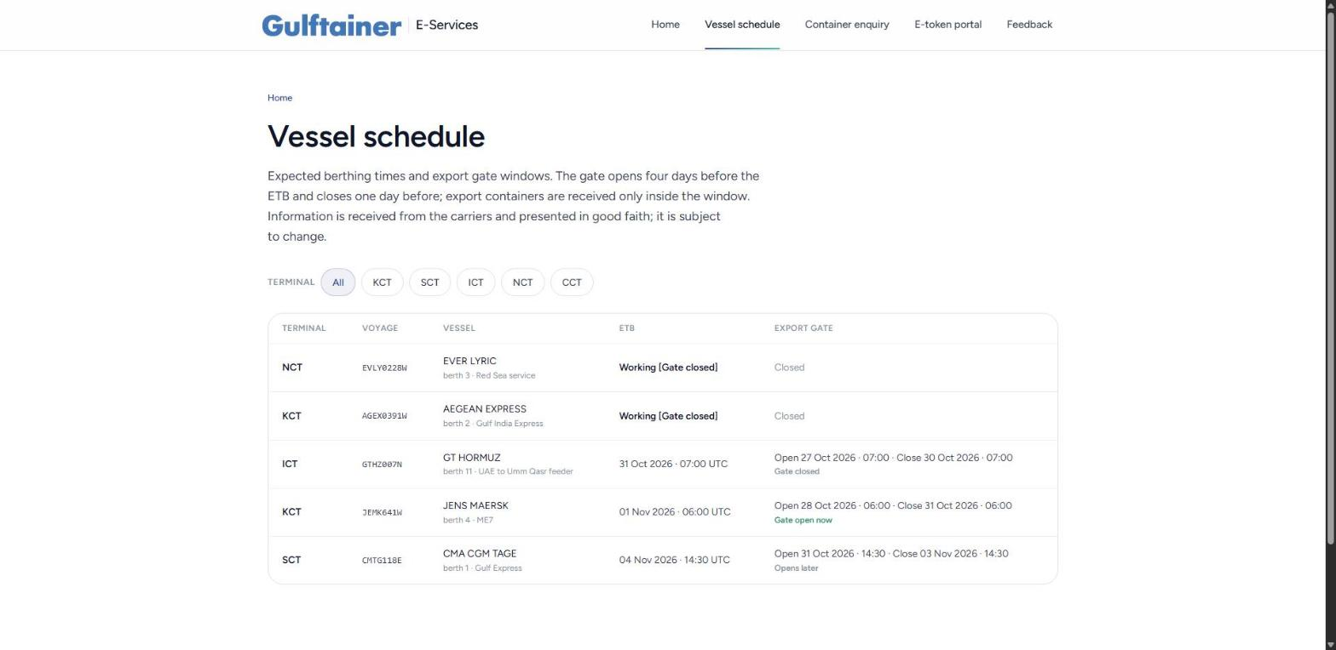
Figure 26. Public vessel schedule.

8.2 Container enquiry
Enter a container number and the expected delivery date. The result shows the status, location, vessel, customs, delivery order and payment position, and the approximate storage charges from discharge to the chosen date per the tariff, with the free days shown.
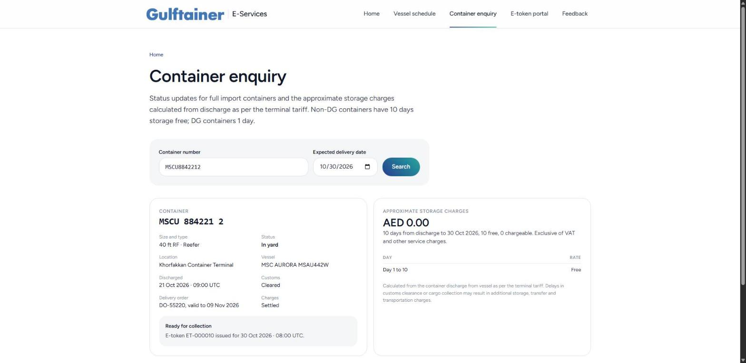
Figure 27. Container enquiry with storage estimate.

8.3 E-token portal
Choose the organisation you act for. A consignee sees the dashboard from the Marshall Yard E-Token manual (total, assigned, unassigned, tokens generated, pending, hazardous, reefer, out of gauge, on hold), assigns hauliers to released containers, deletes tokens that have not reached the marshalling yard, and pays charges online. A haulier sees the import pick-ups assigned to it and the export bookings awaiting drop-off, and generates the e-token for a two-hour slot.
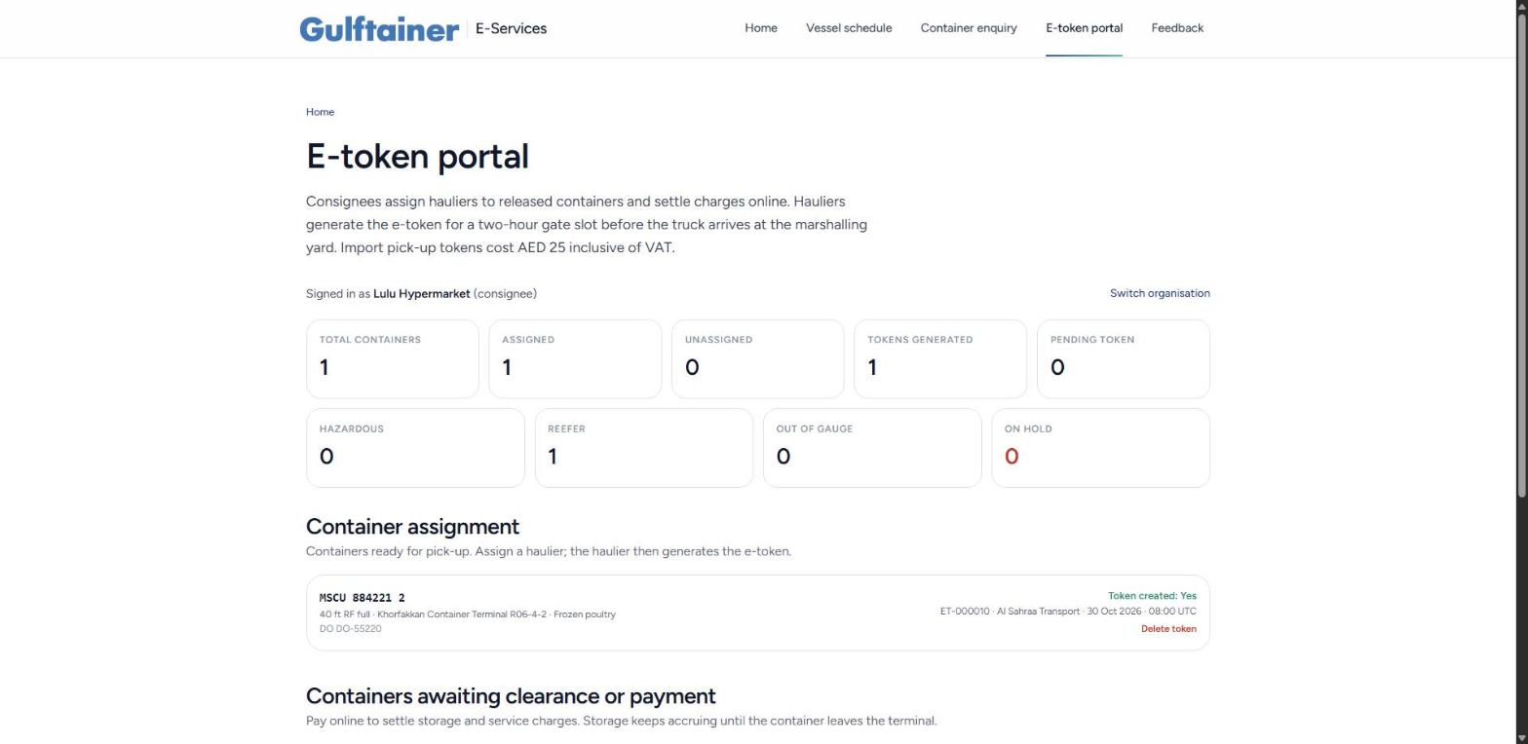
Figure 28. E-token portal, consignee view.
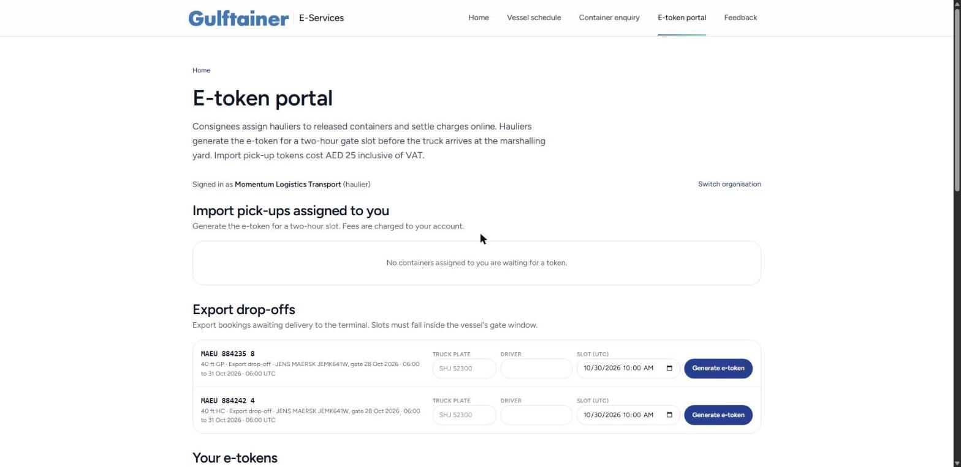
Figure 29. E-token portal, haulier view.

9. Everyday actions
Action | Where | How
Search a list | Any list page | Type in the search box; the funnel button opens the filter chips. Active filters appear as tags with Clear all.
Export data | Containers, inventory, invoices, charges, reports, audit | Press Export CSV or CSV; the file downloads with the current filter applied.
Undo a mistake | Inventory, Finance | Stock: post a reversal on the ledger entry. Finance: cancel the invoice before payment. Terminal records are corrected by new events, never by editing.
See why something is refused | Any dialog | The exact rule is shown in red in the dialog footer, for example a missing delivery order or an export gate that is closed.
Work offline | Gate, warehouse | Press Work offline; queued operations synchronise from Control, Sync and integrations.
Reset the demonstration data | Administration, Network and locations | Press Reset demonstration data. Every browser tab reloads the seeded data set.

Glossary
Term | Meaning
ETA, ETB, ETD | Estimated time of arrival, berthing and departure of a vessel.
BAPLIE, COPRAR | EDI messages from the shipping line: the bay plan with the discharge list, and the load list.
Delivery order (DO) | The shipping line’s authority to release an import container to the consignee, with a validity date.
E-token | The truck appointment generated by the haulier for a two-hour gate slot; required before entering the marshalling yard.
EIR | Equipment interchange receipt: the gate record of seal, condition and custody transfer.
VGM | Verified gross mass, required before an export container is loaded.
DG, OOG, TEU | Dangerous goods, out of gauge, twenty-foot equivalent unit.
GMPH | Gross moves per hour, the terminal productivity measure; Khorfakkan’s benchmark is 29.
SICD, SDP, UQLC | Sharjah Inland Container Depot, Sajaa Bonded Dry Port, Umm Qasr Logistics Centre.
SKU | Stock-keeping unit in the Momentum contract-logistics warehouses.

