**Information Gathering Tool Report**

**Problem statement**

In the rapidly evolving landscape of cybersecurity, effective information gathering is paramount for threat assessment, vulnerability identification, and strategic decision-making. Traditional methods of data collection can be time-consuming and prone to errors, making it challenging for cybersecurity professionals to obtain accurate and comprehensive insights about a target domain.

**Objectives**

This report presents the Information Gathering Tool, developed to automate the process of gathering critical information about domains. The tool aims to:

* Provide an efficient method to obtain WHOIS information, DNS records, geolocation data, and open ports using Nmap.
* Enhance the speed and accuracy of information collection in cybersecurity assessments.
* Offer a user-friendly interface that displays the results in a clear and organized manner.

**Key features**

* **WHOIS Lookup**: Retrieves domain registration information.
* **DNS Record Collection**: Fetches various DNS records, including A, MX, and CNAME.
* **IP Geolocation**: Uses external APIs to obtain geographical data related to the domain's IP address.
* **Nmap Integration**: Performs network scanning to identify open ports and their statuses.
* **User-Friendly Interface**: Displays results in a structured format with clear categorization.

**Architecture Overview**

The Information Gathering Tool follows a modular design, where each component is responsible for a specific functionality. This separation of concerns enhances maintainability, scalability, and readability of the code. The architecture can be visualized as follows:

* **User Input Module**: Accepts domain names for analysis.
* **Information Gathering Module**:
  + WHOIS Retrieval: Fetches registration details.
  + DNS Lookup: Resolves domain to IP and retrieves DNS records.
  + Geolocation Module: Utilizes an API to fetch geographical information based on IP address.
  + Network Scanning Module: Integrates Nmap for port scanning.
* **Output Module**: Displays results in a user-friendly format.

**Implementation Details**

1. **Development Environment**

The Information Gathering Tool was developed using the following technologies and libraries:

Programming Language: **Python 3.x**

Libraries:

* socket: For resolving domain names to IP addresses.
* whois: To fetch WHOIS information about the domain.
* dns.resolver: For DNS record lookups.
* requests: For making HTTP requests to retrieve geolocation data from external APIs.
* pyfiglet: To create ASCII art for the tool's title.
* rich: For enhanced console output, including formatted tables.
* nmap: For performing network scans.

1. **Code Structure**

The code is organized into classes and functions, promoting clarity and reusability. Below is a breakdown of the primary components:

Class: **InfoGatheringTool**

* **__init__(self, domain)**: Initializes the instance with the domain and resolves the IP address.

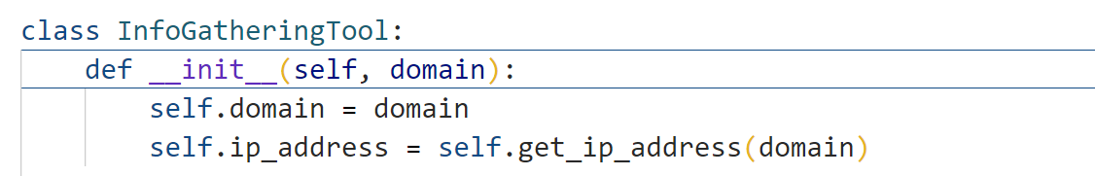

* **get_ip_address(self, domain)**: Resolves the domain name to an IP address.

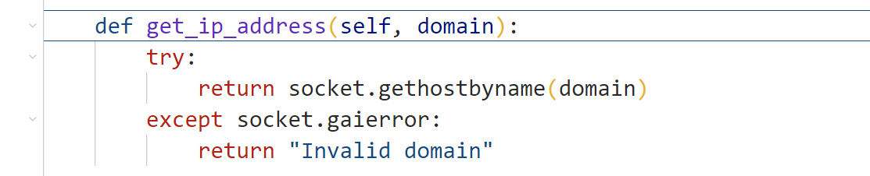

* **get_whois_info(self)**: Retrieves WHOIS information for the specified domain.

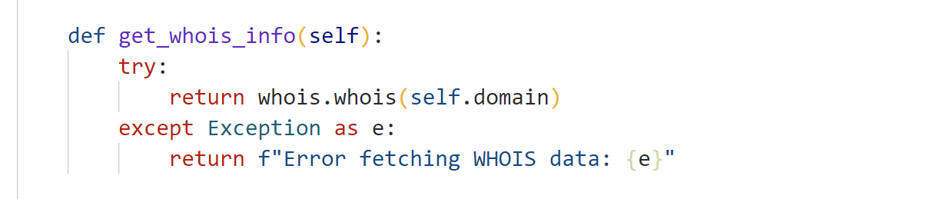

* **get_dns_records(self)**: Fetches various DNS records (A, MX, CNAME) for the domain.

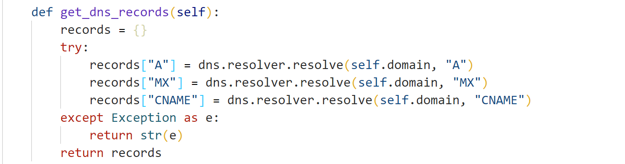

* **get_ip_geolocation(self)**: Queries the geolocation API using the resolved IP address.

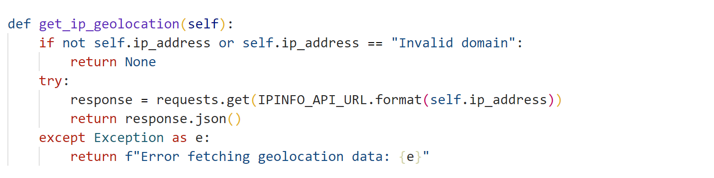

* **perform_nmap_scan(self)**: Executes a basic Nmap scan on the resolved IP address.

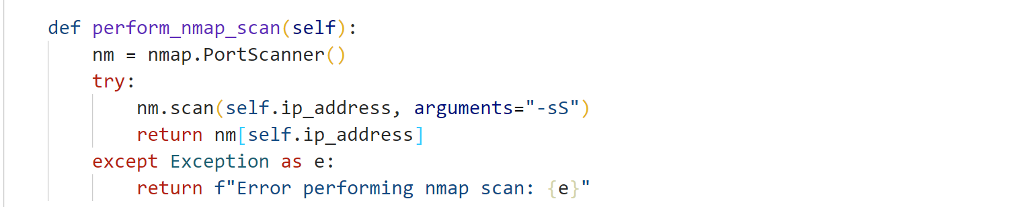

* **display_geolocation(self, geolocation)**: Formats and displays geolocation data.

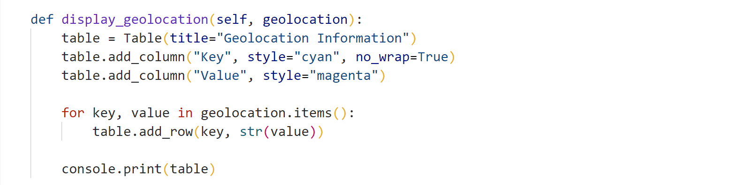

* **display_whois_info(self, whois_info)**: Formats and displays WHOIS information.

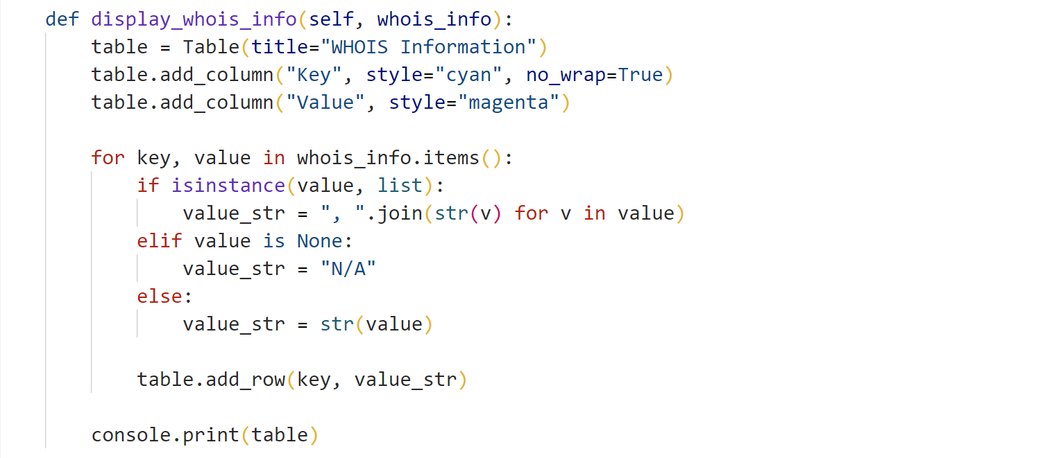

* **display_dns_records(self, dns_records)**: Formats and displays DNS records.

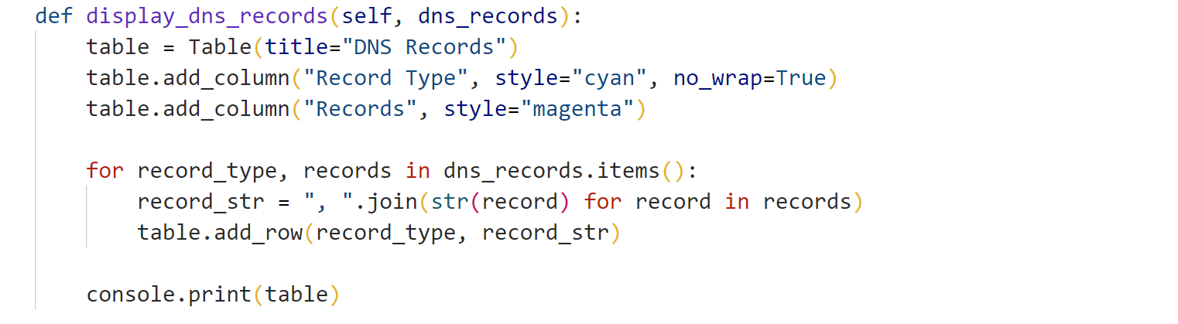

* **gather_info(self)**: Orchestrates the information-gathering process and displays the results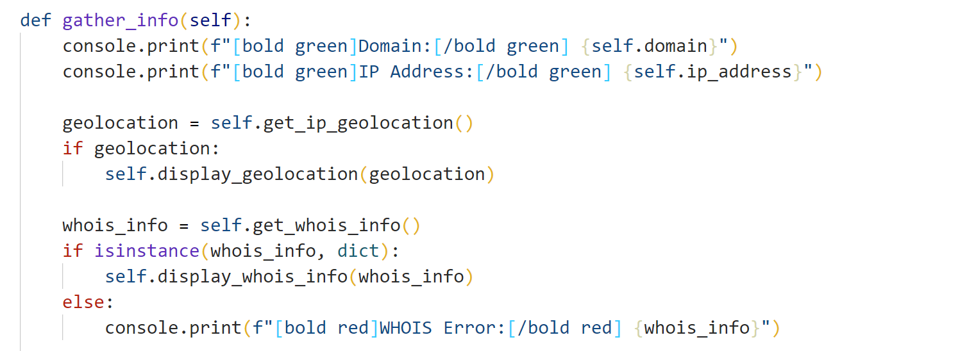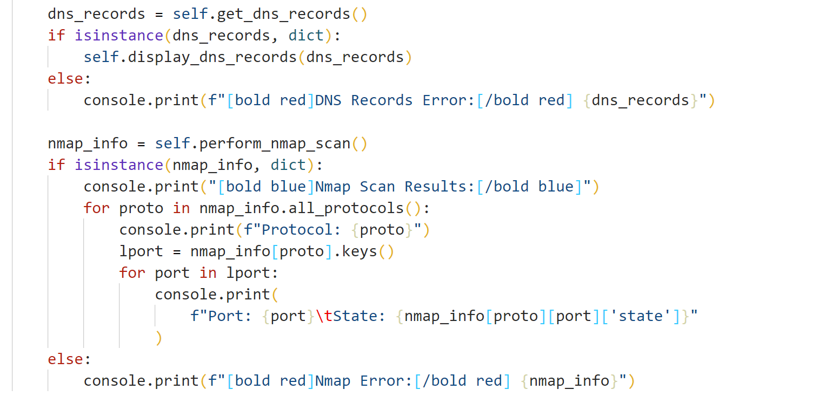

1. **Key Functions**

The implementation uses several key functions that interact with the libraries:

* **socket.gethostbyname(domain)**: Resolves the domain name to an IP address.
* **whois.whois(domain)**: Fetches WHOIS data for the given domain.
* **dns.resolver.resolve(domain, record_type)**: Retrieves DNS records based on the specified record type.
* **requests.get(url)**: Sends an HTTP GET request to the specified URL for fetching geolocation data.
* **nmap.PortScanner()**: Initializes the Nmap scanner to perform network scanning.

1. **Error Handling**

The tool incorporates robust error handling to ensure that any issues encountered during execution are reported gracefully. For instance, if the domain name is invalid or if there is an issue fetching data from the APIs, the program provides meaningful error messages rather than crashing.

This is achieved through try-except blocks around critical operations such as DNS resolution, WHOIS lookups, and API requests.

1. **User Interface**

The user interface (UI) of the Information Gathering Tool is designed to be simple and intuitive. It primarily interacts with the user through the console, providing a text-based interface that displays information clearly. The use of the rich library enhances the output with colored text and formatted tables, making it visually appealing and easier to read.

* 1. **Console Output**

Upon execution, the tool clears the console screen and displays a title using ASCII art generated by pyfiglet. The user is prompted to enter a domain, and the tool proceeds to gather and display relevant information in a structured format.

* 1. **Data Presentation**

The gathered information is presented in tables using the rich library, which provides a clean and organized output. Each section of the report is clearly labeled, and relevant data is displayed in columns for easy interpretation.

**Screenshots:**

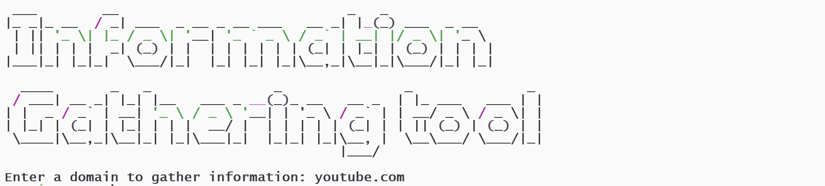

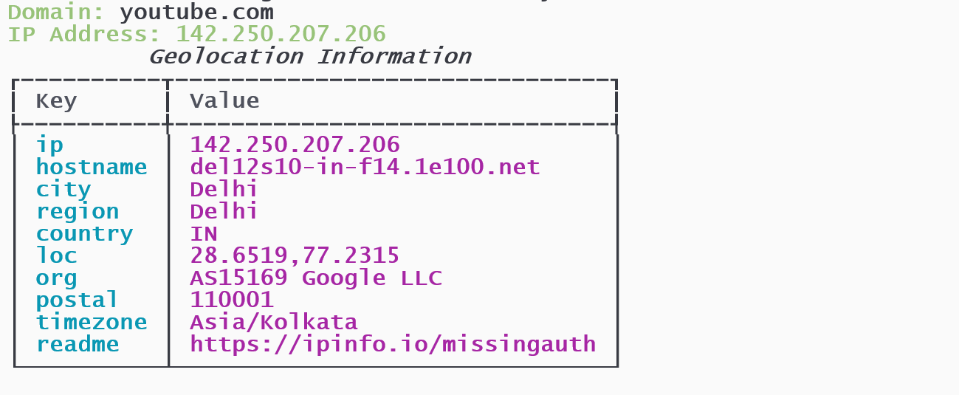

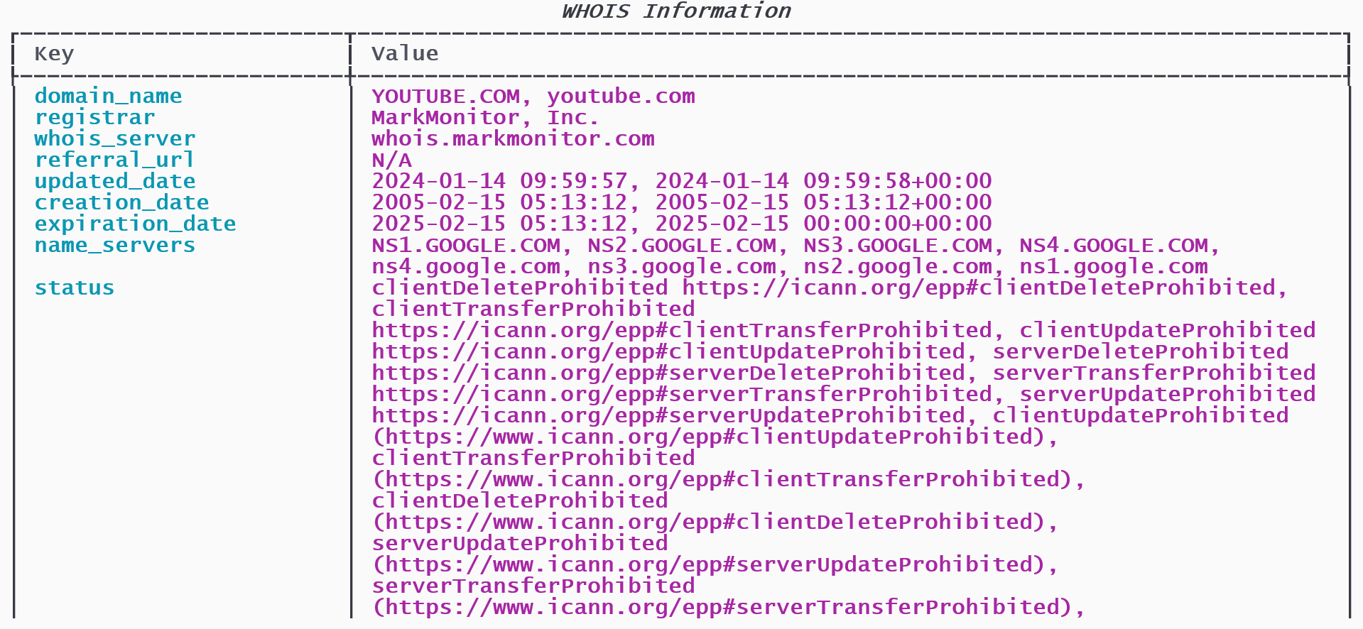

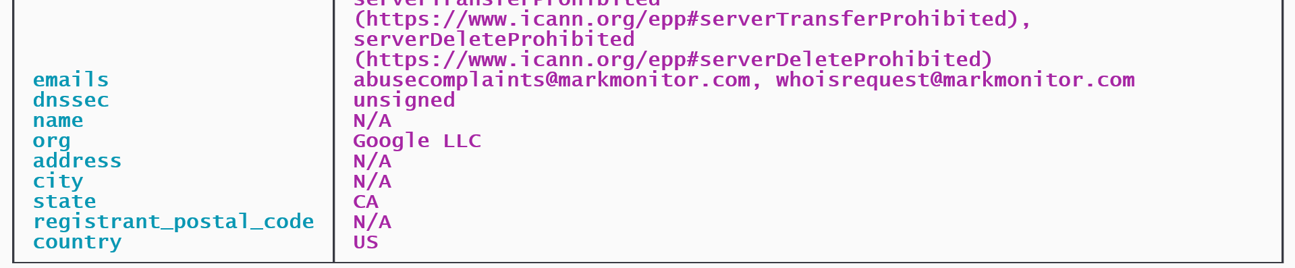

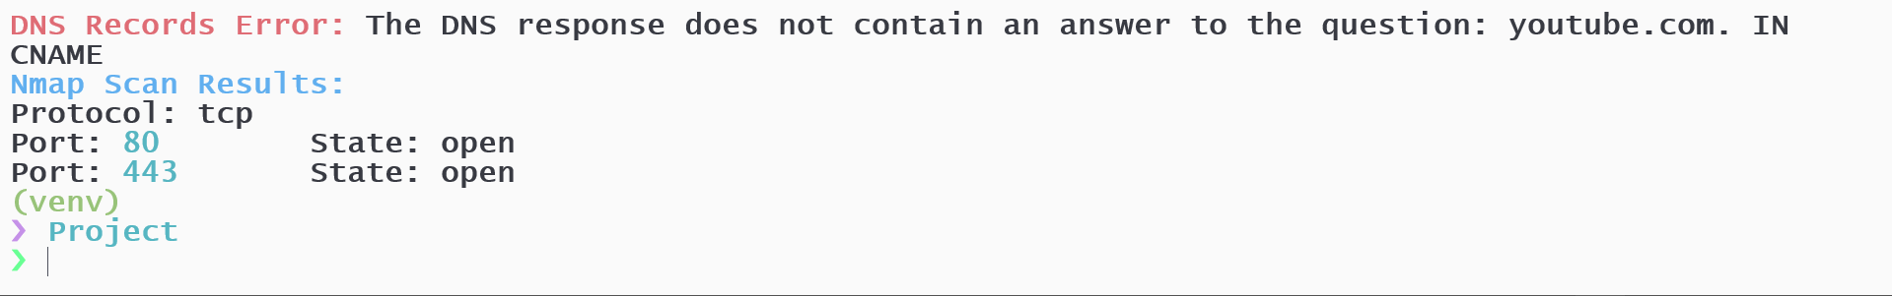

**Conclusion**

The Information Gathering Tool provides a streamlined solution for collecting domain-related data, integrating key functionalities such as WHOIS information retrieval, DNS resolution, IP geolocation, and port scanning using Nmap. By leveraging libraries such as socket, whois, dns.resolver, requests, and nmap, this tool automates tasks that are often essential in cybersecurity, system administration, and network troubleshooting.

The design of the tool ensures modularity, with each function handling a distinct responsibility, making it both efficient and easy to maintain or extend. It demonstrates a good balance between performance and functionality, albeit with potential optimizations required for Nmap scan times, especially when targeting remote or slow networks.

**Future Enhancements**

* **Parallel Execution**: To reduce the waiting time for slower operations like WHOIS lookups and Nmap scans, parallelizing the operations could significantly boost performance.
* **Enhanced Error** **Handling**: Implementing more granular error messages can help users diagnose issues more effectively, especially when network errors occur.
* **Support for More DNS Record Types**: Extending the tool to resolve additional DNS record types like TXT, NS, and SOA would enhance its utility.
* **Graphical User Interface (GUI)**: For better user experience, a GUI version of this tool could be developed, making it more accessible to non-technical users.
* **Advanced Nmap Features**: Implementing more advanced Nmap scanning techniques (e.g., OS detection, version scanning) would make this tool even more comprehensive for network security analysis.