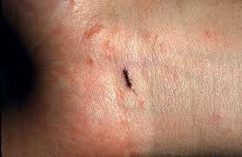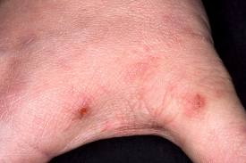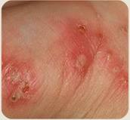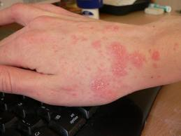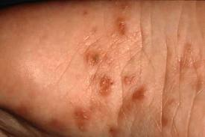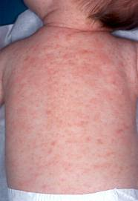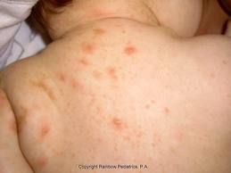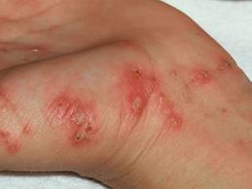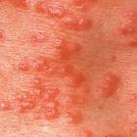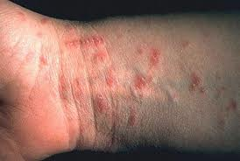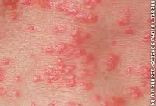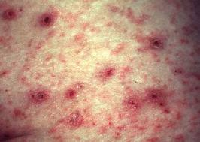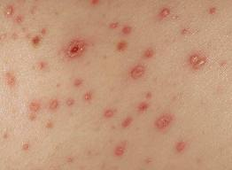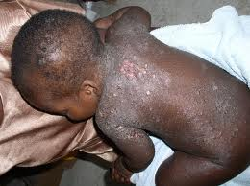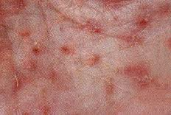

**Scabies**

**What is scabies?**

Scabies is a common and very itchy skin condition caused by human scabies mites. It can affect people of any age but is most common in the young and the elderly.

**What causes scabies?**

The mites that cause scabies are tiny parasites, smaller than a pinhead.  They are usually picked up by direct skin-to-skin contact with someone who already has scabies, and only very rarely from objects such as clothing or bedding.  Pets do not spread them. People with scabies have an average of about a dozen adult mites on their skin; a few carry many more. Being dirty does not cause scabies. Rarely, a variant of scabies called crusted scabies can occur in patients who are immunosuppressed or who are elderly and unwell. There are thousands of scabies mites on the skin in this variant and it is highly contagious.

**Is scabies hereditary?**

No, but it is common for several members of a family to have it at the same time.

**What are the symptoms of scabies?**

Itching is the main symptom of scabies, usually starting about a month after the mites were picked up.  The itching affects the body and limbs but usually spares the head and neck, except in infants.  The itch often gets worse in bed at night. It is common for several people in the same family, and their friends, to become itchy at roughly the same time.

**What does scabies look like?**

The rash of scabies is a mixture of scratch marks and red scaly areas; later it can become infected and develop small pus spots. A widespread rash similar to eczema (dermatitis) is very common. This itchy rash covers much of the skin but the mites are found mainly in the web spaces of the fingers and on the palms of the hands, the wrists, ankles and soles of the feet. The scabies mites burrow into the skin in these areas to lay their eggs. Burrows appear as small greyish lines on the skin. Adult mites are tiny, only about 0.4 mm long, appearing through a lens as a tiny dark dot lying at the end of a burrow. In crusted scabies the rash may mimic psoriasis and may not cause intense itching.

**How is the diagnosis of scabies made?**

Your doctor will usually be able to diagnose scabies on the basis of the story and on examination of the rash. Scrapings from a burrow can be looked at under the microscope for mites and their eggs.

**Can scabies be cured?**

If it is not treated, scabies lasts for months or even years; but with the right treatment, it clears up quickly and completely. Even after the mites have been killed by treatment the itching usually persists for a few weeks.

For information about available treatments please visit [this page](http://www.bad.org.uk/site/871/Default.aspx)on the website of the British Association of Dermatologists