**Aim:**

Build a docker image using Dockerfile containing some web application (apart from nginx) and push it to docker hub.

Using Jenkins, take that image from docker hub and run it to access at web browser.

**Answer:**

1. Building a docker image using Dockerfile.

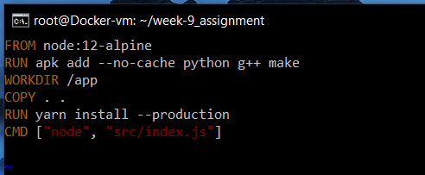

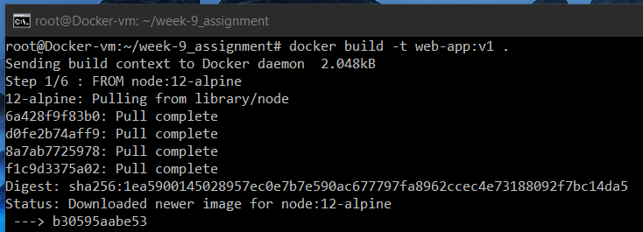

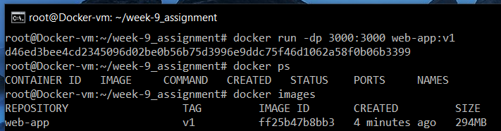

1. Testing the web application at 192.168.56.101:3000

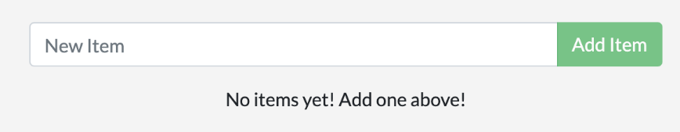

1. 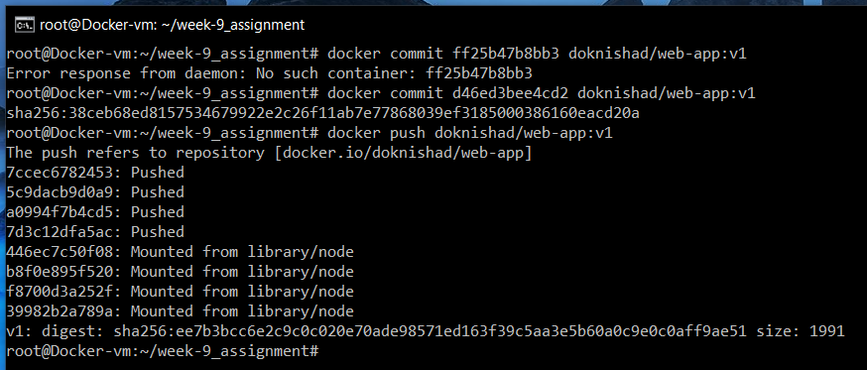Pushing the web-application to DockerHub.

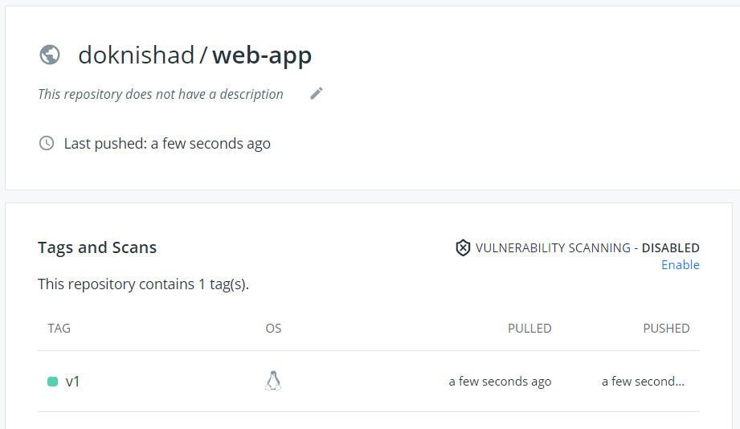

Remark* App entry at Hub.docker.com

1. 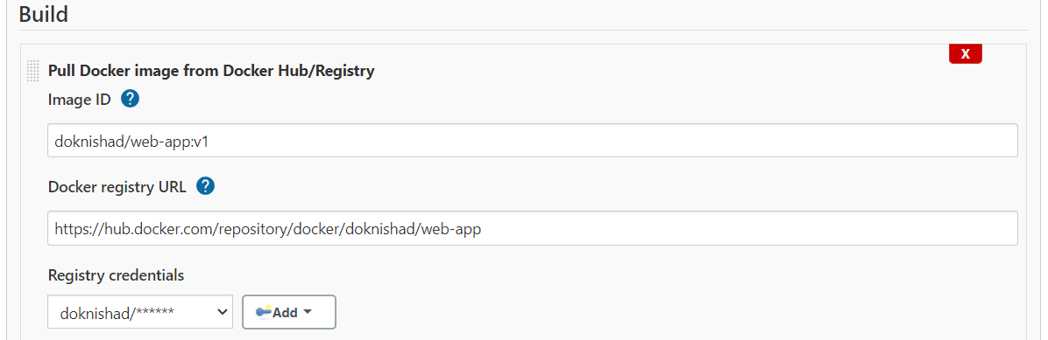Building this image from docker hub using Jenkins.

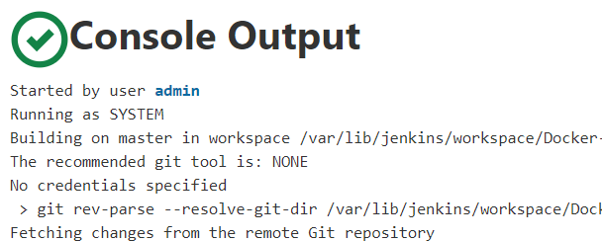

1. Checking the web-application at 192.168.56.101:3000



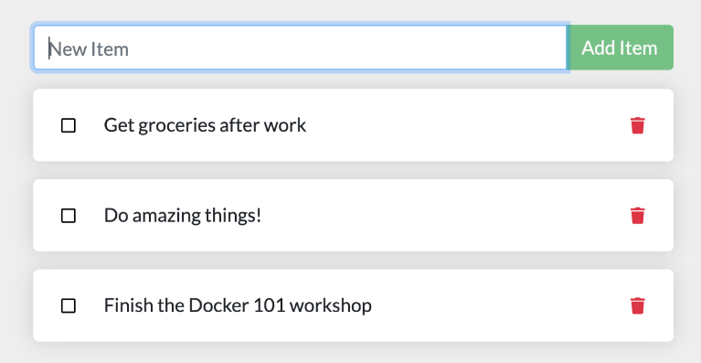

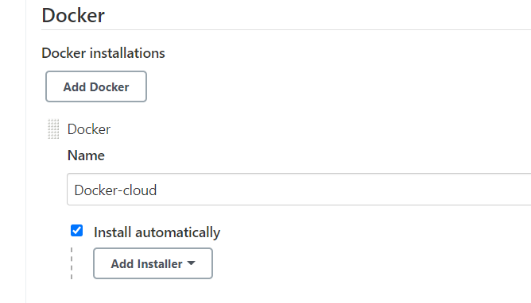6. Jenkins Global tool configuration- Docker details-

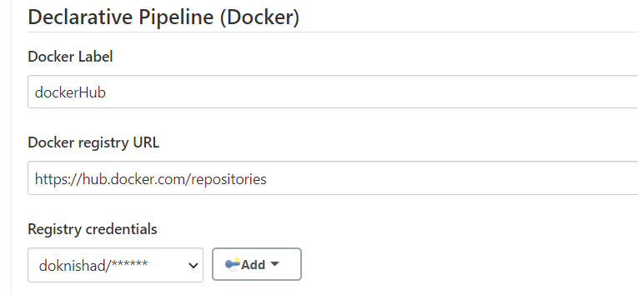7. Docker declarative pipeline option in Configure system (optional)-

8. Docker cloud setup-

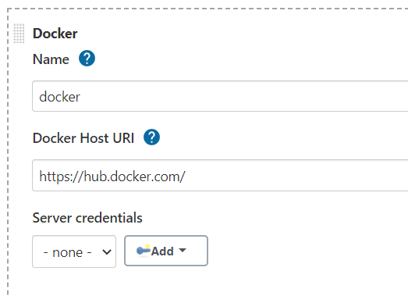

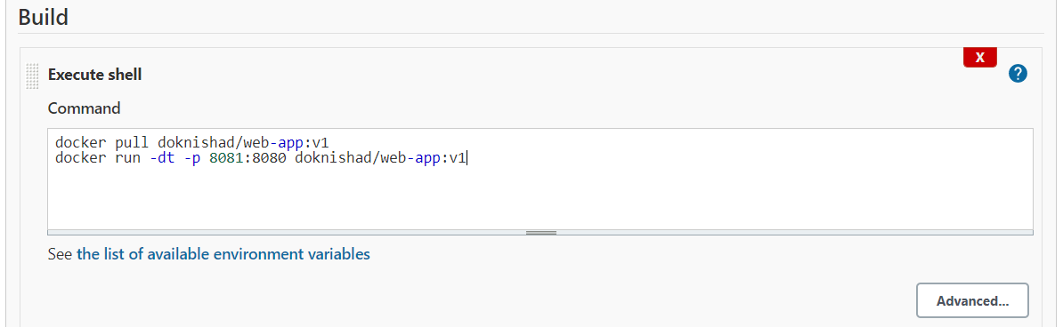1. Jenkins job configuration details-

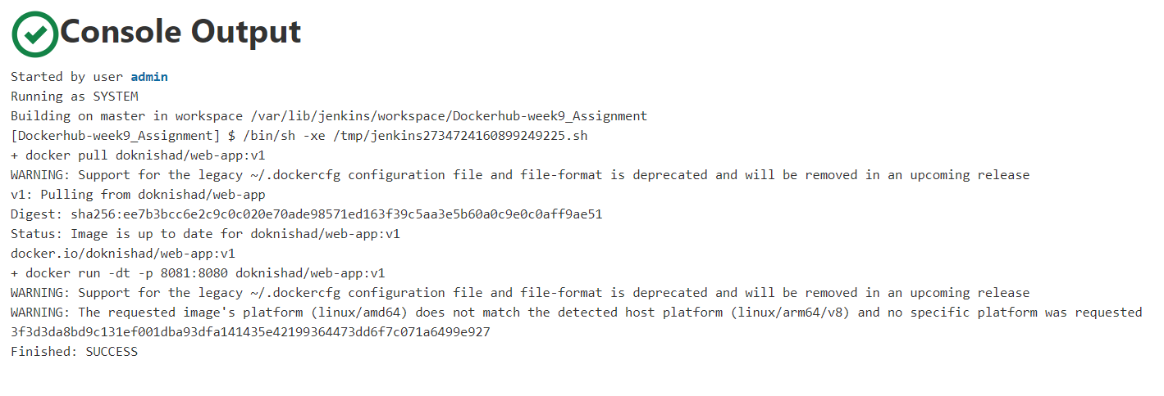2. Console output-

Submitted by- **Nishad Gotmare** (nishadgotmare@outlook.com)

(PROG_JAS21_DEVOPS_1)

HCLNGP0621005

NGP0721002