Providers in AWS
A provider is responsible for understanding API interactions and exposing resources.
When we run terraform init, plugins required for the provider are automatically downloaded and saved locally to a .terraform directory.
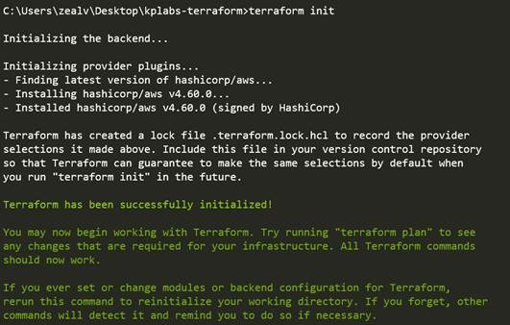

Interesting Question
Is provider block {..} mandatory to be added as part of your Terraform configuration? Yes/No
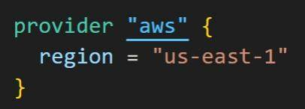
Two Pointers from Documentation
All Terraform configurations must declare which providers they require so that Terraform can install and use them.
A provider block may be omitted if its contents would otherwise be empty.
Concluding this Question
If you plan to explicitly add some contents to provider {} like region, credentials,
then defining this block is required.
Otherwise, even if you skip, the terraform apply will work fine.
Alias in Providers
alias can be used for using the same provider with different configurations for different resources
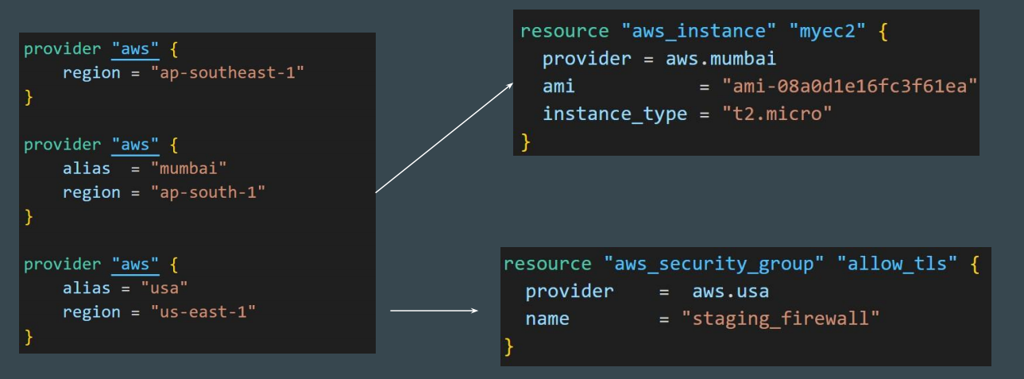
Point to Note - Providers
It is a good practice to store the credentials outside of Terraform configuration, such as in Environment Variables. Terraform Settings
Terraform Settings are used to configure project-specific Terraform behaviours, such as requiring a minimum Terraform version to apply to your configuration.
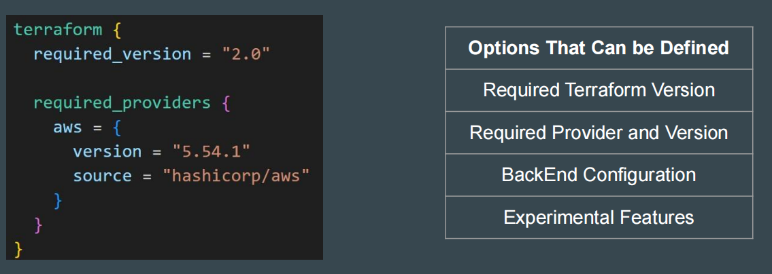
Point to Note
You cannot define configuration related to regions, Access/Secret keys inside required_provider block.
For these, you have to use a provider {} block.

Versioning Constraint
Version Constraint allows you to specify mix of multiple operators to select a suitable version of Terraform and Provider Plugins.
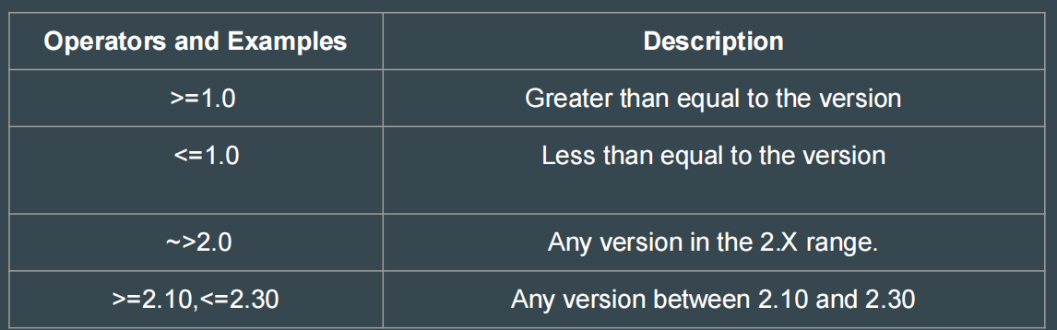

Provider Tiers
There are 3 primary type of provider tiers in Terraform.
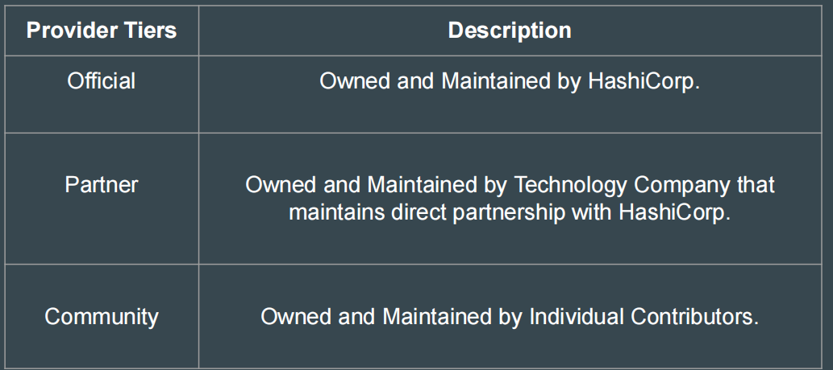

Terraform Init
The terraform init command initializes a working directory. Initialization includes Installing Provider Plugins, Backend initialization, Copy Source Module, etc.
This is the first command that should be run after writing a new Terraform configuration. It is safe to run multiple times.
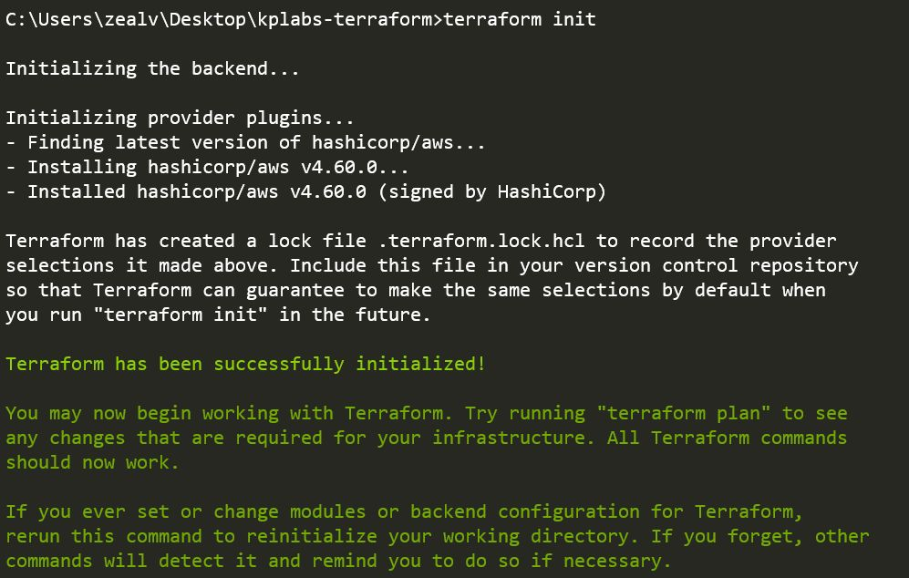

Terraform Init Upgrade
The terraform init -upgrade installs the latest module and provider versions allowed within configured constraints.
If you have latest provider plugins installed and if you define new version constraints that matches different version, you will have to run the init -upgrade
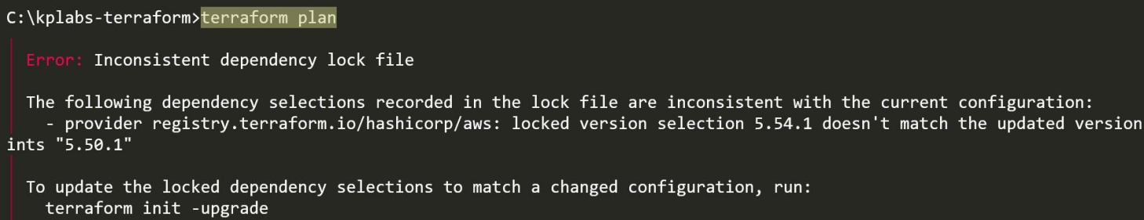

Terraform Plan
The terraform plan command is used to create an execution plan.
The infrastructure is not modified as part of this plan.
The state file is not modified even when it detects drift in real-world and current infrastructure.
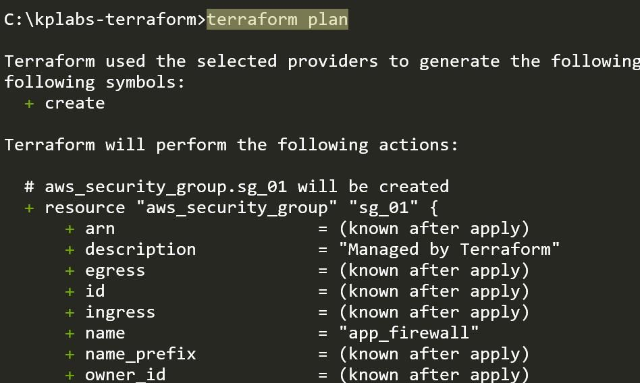

Saving Plan to File
You can use the optional -out=FILE option to save the generated plan to a file on disk, which you can later execute by passing the file to terraform apply as an extra argument.
This ensures consistent infrastructure as defined in the plan.
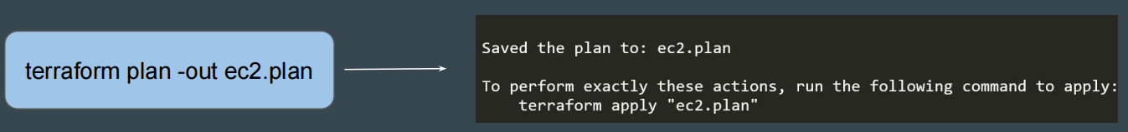

Terraform Apply
terraform apply command is used to apply the changes required to reach the desired state of the configuration.
The state file gets modified in this command.
Name of state file = terraform.tfstate
Terraform Apply can change, destroy and provision resources but cannot import any resource.

Terraform Destroy
terraform destroy command is used to destroy the Terraform-managed infrastructure.
terraform destroy command is not the only command through which infrastructure can be destroyed.
Terraform Format
terraform fmt command is used to rewrite Terraform configuration files to a canonical format and style. It will directly perform “write” operation and not “read’
For use-case, where the all configuration written by team members needs to have a proper style of code, terraform fmt can be used.

terraform fmt options
You have to keep a note of two important flags for terraform fmt command
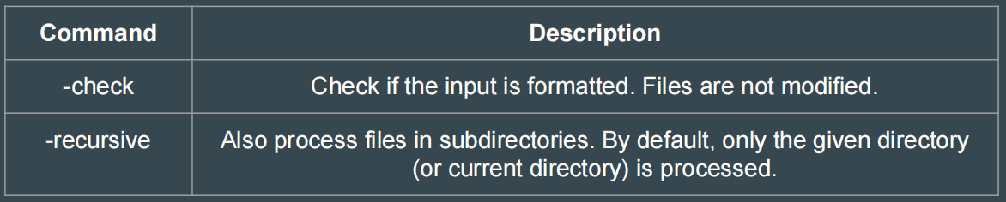

Terraform Validate
terraform validate command validates the configuration files in a directory.
Requires an initialized working directory with any referenced plugins and modules installed.
terraform plan uses implied validation check.
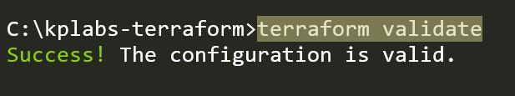
Terraform Refresh
terraform refresh command reads the current settings from all managed remote objects and updates the Terraform state to match.
This won't modify your real remote objects, but it will modify the Terraform state.
This command is deprecated, because its default behavior is unsafe.
Resource Blocks
A resource block declares a resource of a given type ("aws_instance") with a given local name ("web").
Resource type and Name together serve as an identifier for a given resource and so must be unique.
Address of the following resource is: aws_instance.web
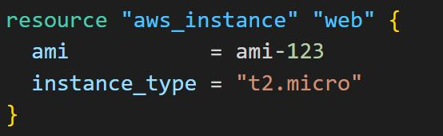
Important Terminology
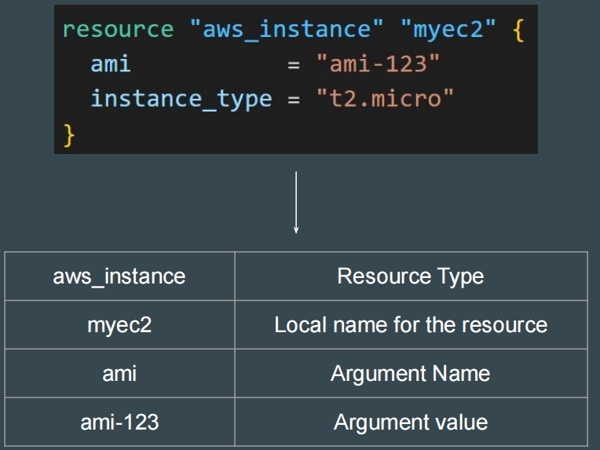
Data Types in Terraform
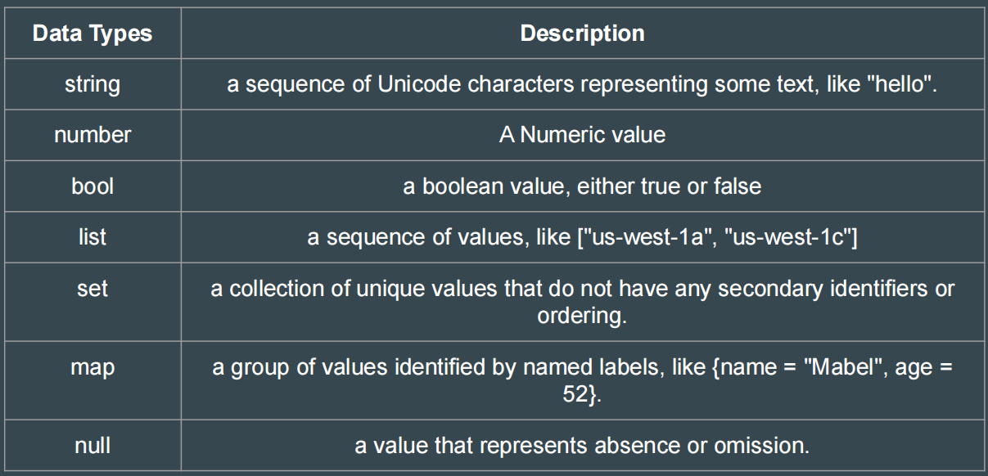
Point to Note - Data Types
Array data types are not supported in Terraform

State Management
The terraform state command is used for advanced state management
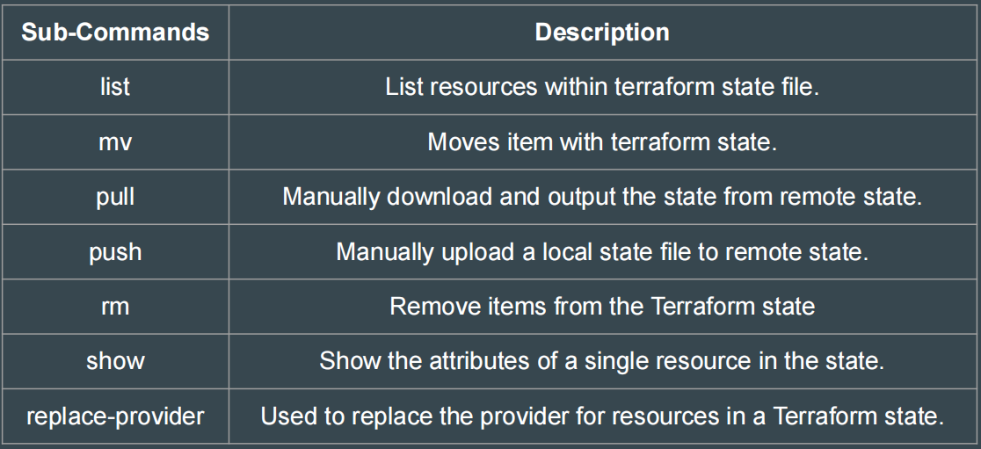

Use-Case - Removing Item from State
There are 5 EC2 instances created through Terraform using count =5
The Team wants to destroy all the EC2 instances except the second instance with the resource address of aws_instance.web[1].
1. This is not possible since the instance created through Count.
2. Apply taint on the EC2 instance.
3. Use terraform state rm aws_instance.web[1]
4. Use terraform state mv aws_instance.web[1]
5. None of the Above

Debugging in Terraform
Terraform has detailed logs that can be enabled by setting the TF_LOG environment variable to any value.
You can set TF_LOG to one of the log levels TRACE, DEBUG, INFO, WARN or ERROR to change the verbosity of the logs.
To persist logged output, you can set TF_LOG_PATH
Terraform Import
Allows importing existing infrastructure to Terraform.
Automatic code generation for imported resources is supported.
You can use import blocks to import more than one resource at a time.
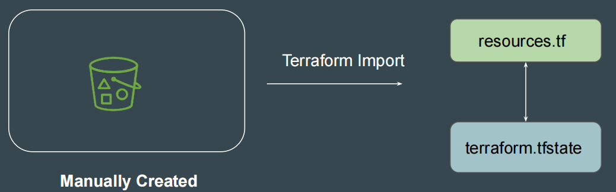

Import Workflow Steps
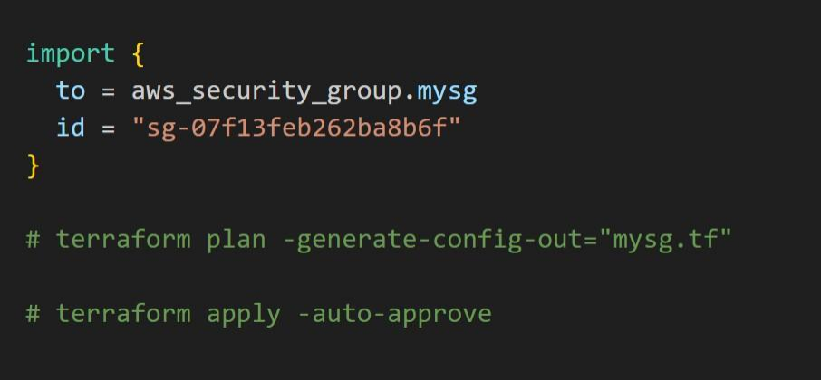
Local Values
Locals are used when you want to avoid repeating the same expression multiple times.
Local values are created by a locals block (plural), but you reference them as attributes on an object named local (singular)
Local value can reference values from other variables, locals etc.
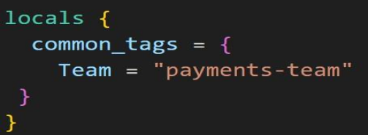
Terraform Workspace
Terraform workspaces enable us to manage multiple sets of deployments from the same sets of configuration files.
State File Directory = terraform.tfstate.d
Not suitable for isolation for strong separation between workspace (stage/prod)
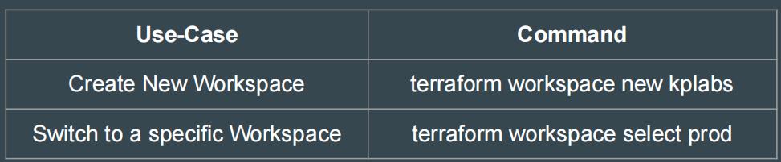
Terraform Modules
Terraform Modules allow us to centralize the resource configuration, and it makes it easier for multiple projects to re-use the Terraform code.
Instead of writing code from scratch, we can use multiple ready-made modules available.
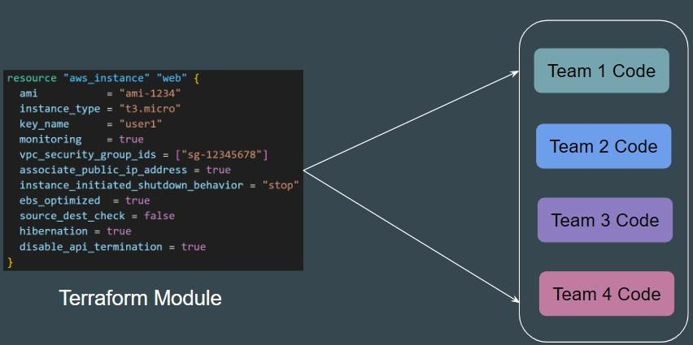

Calling a Module
Module source code can be present in a wide variety of locations including:
GitHub, Local Paths, Terraform Registry, S3 Buckets, HTTP URLs
To reference a module, you need to make use of module block and source
Terraform uses this during the module installation step of terraform init to download the source code to a directory on local disk so that other Terraform commands can use it.
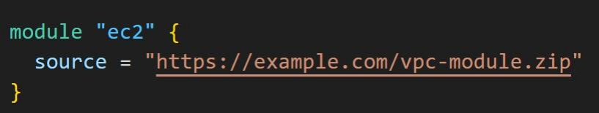
Example 1 - Local Paths
Local paths are used to reference to a module that is available in local filesystem.
A local path must begin with either ./ or ../ to indicate that a local path.
Modules sourced from local paths do NOT support versions.
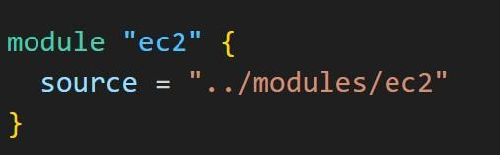
Example 2 - Generic Git Repository
Arbitrary Git repositories can be used by prefixing the address with the special git:: prefix.
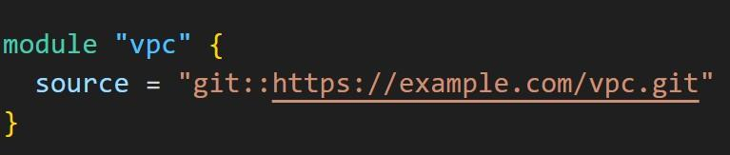

Root vs Child Modules
Root Module resides in the main working directory of your Terraform configuration. This is the entry point for your infrastructure definition
A module that has been called by another module is often referred to as a child module.
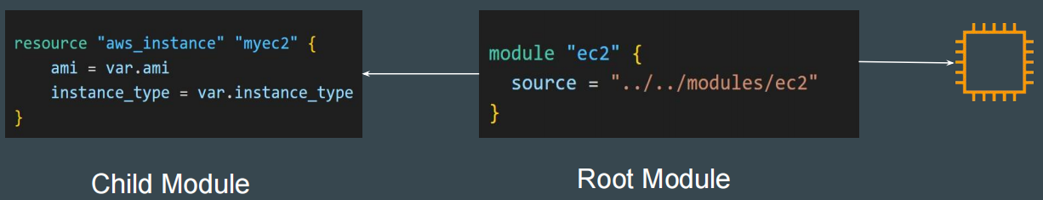

Module Outputs
A child module can use outputs to expose a subset of its resource attributes to a parent module.
Format: <MODULE NAME>.<OUTPUT NAME>
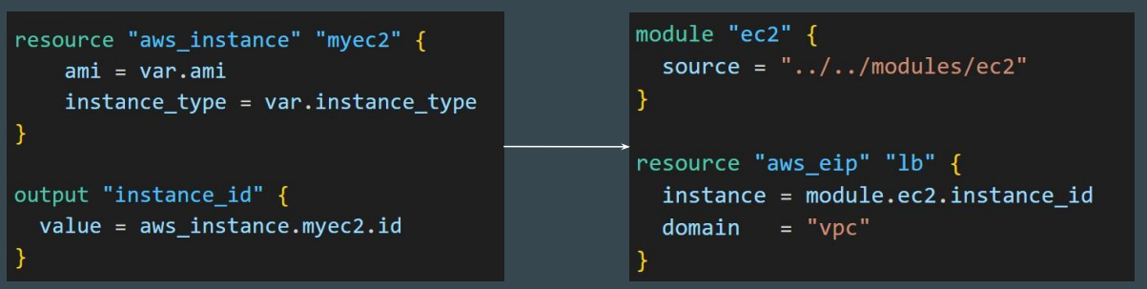

Module Versioning
When using modules installed from a module registry, HashiCorp recommends explicitly constraining the acceptable version numbers to avoid unexpected or unwanted changes.
It is not mandatory to specify a version argument.
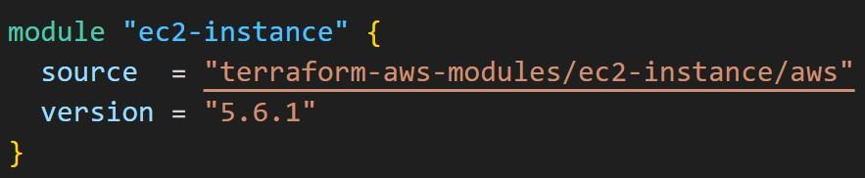

Terraform Registry
● Hosts a broad collection of publicly available Terraform modules.
● Each Terraform module has an associated address.
● A module address has the syntax hostname/namespace/name/system
The hostname/ portion of a module is optional, and if omitted, it defaults to registry.terraform.io/.
Functions in Terraform
The Terraform language includes a number of built-in functions that you can use to transform and combine values.
NO SUPPORT for User-Defined Functions.
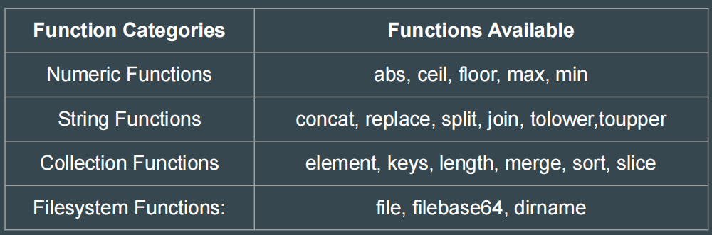

Lookup function
lookup retrieves the value of a single element from a map, given its key. If the given key does not exist, the given default value is returned instead.
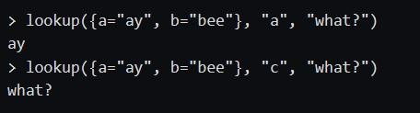
Zipmap function
zipmap constructs a map from a list of keys and a corresponding list of values.
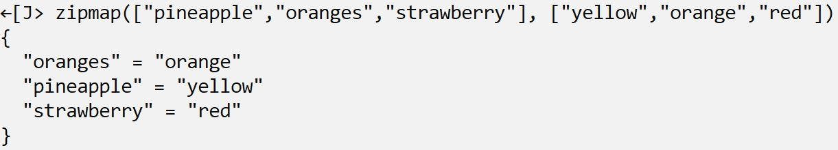
Index function
index finds the element index for a given value in a list.
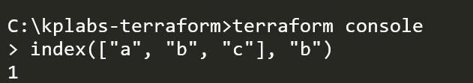
Element Function
element retrieves a single element from a list.
Format: element(list, index)
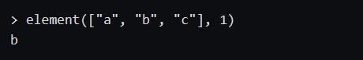
Testing Element Function
Code: Name = element(var.tags,count.index)
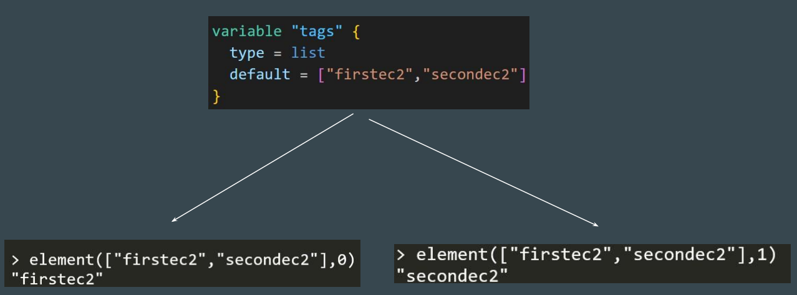

toset Function
toset function will convert the list of values to SET
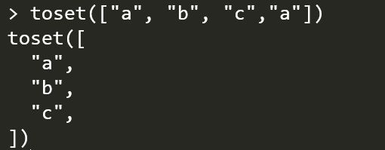
TimeStamp Function
timestamp returns a UTC timestamp string in RFC 3339 format.
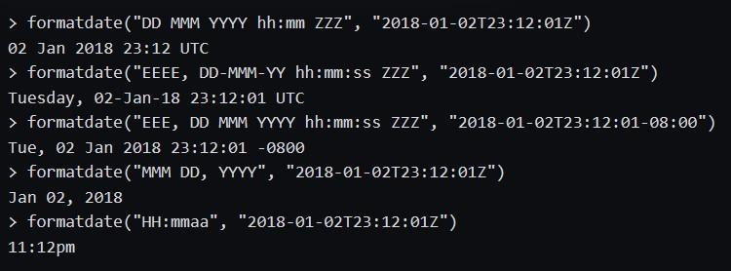
File Function
File function can reduce the overall Terraform code size by loading contents from external sources during terraform operations.
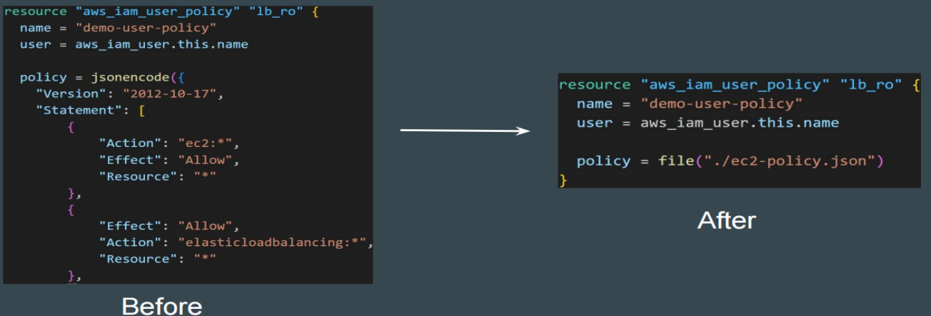

Meta Arguments in Terraform
Terraform allows us to include meta-arguments within the resource block, which allows some details of this standard resource behaviour to be customized on a per-resource basis.
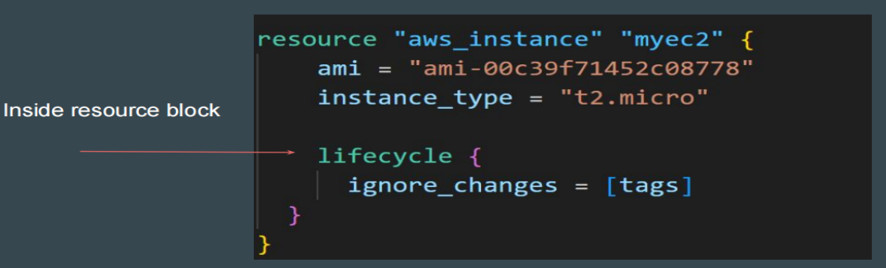
Different Meta-Arguments
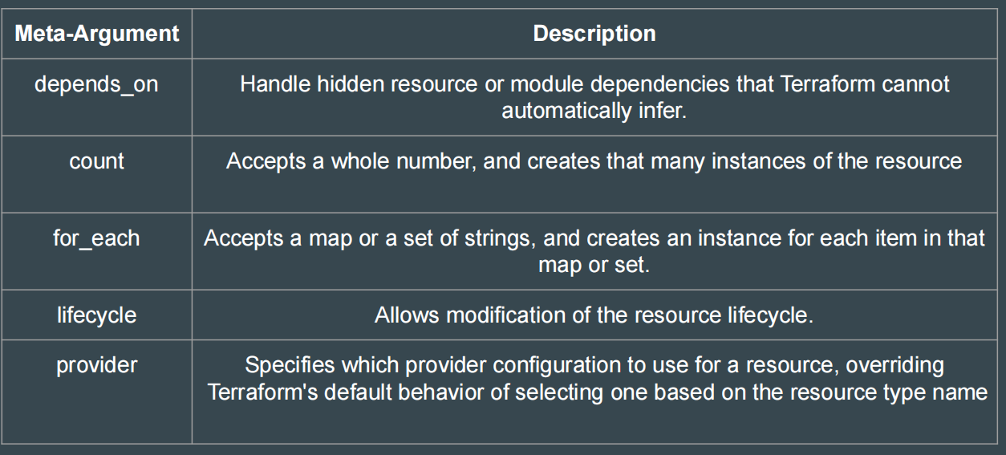

Lifecycle Meta-Argument
Some details of the default resource behaviour can be customized using the special nested lifecycle block within a resource block body:
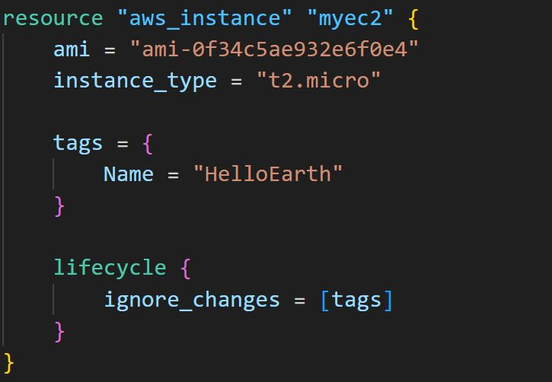

Arguments Available for LifeCycle Block
There are four argument available within lifecycle block.
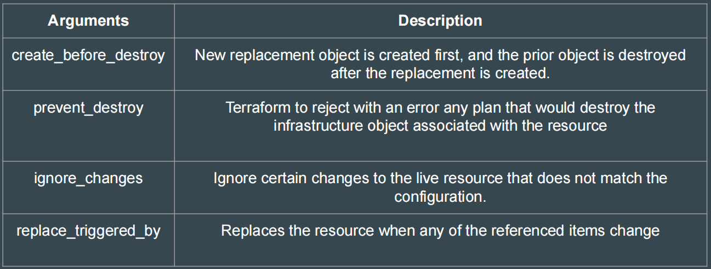
Count and Count Index
The count argument accepts a whole number, and creates that many instances of the resource.
count.index — The distinct index number (starting with 0) corresponding to this instance.
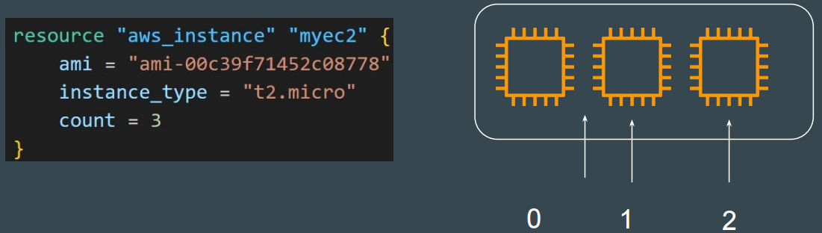

Find the Issue - Use-Cases
You can expect a use case in exam with a sample Terraform code, and you must find what should be removed as part of Terraform best practice.
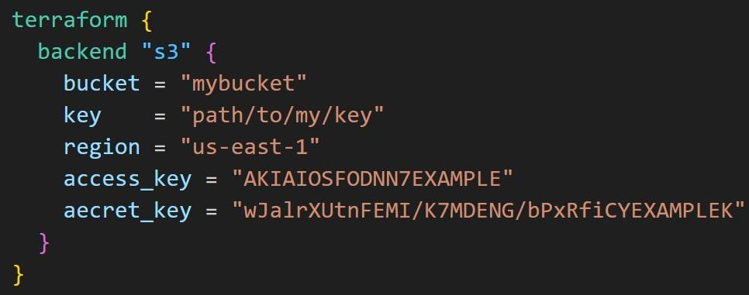

Sentinel
Sentinel is an embedded policy-as-code framework integrated with the HashiCorp Enterprise products. Sentinel is a proactive service.
Can be used for various use-cases like:
● Verify if EC2 instance has tags.
● Verify if the S3 bucket has encryption enabled.
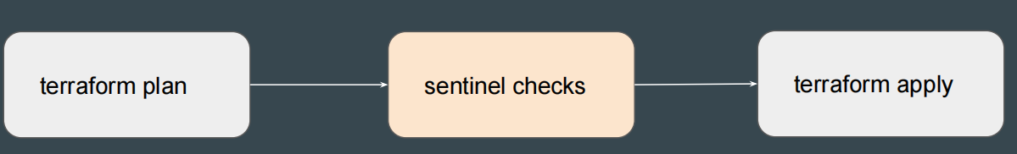

Terraform Graph
Terraform graph refers to a visual representation of the dependency relationships between resources defined in your Terraform configuration.
The output of terraform graph is in the DOT format, which can easily be converted to an image.
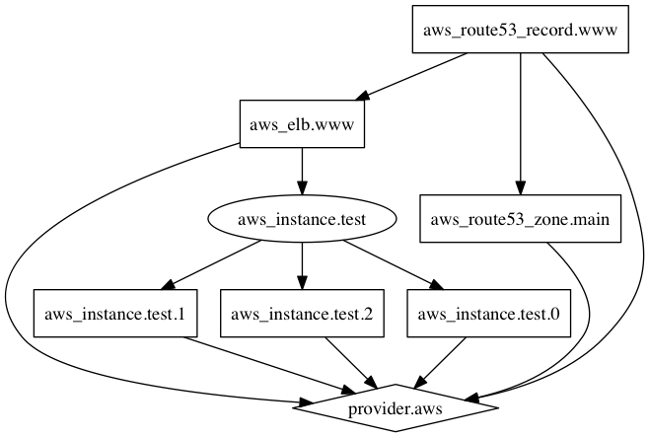

Input Variables
Terraform input variables are used to pass certain values from outside of the configuration
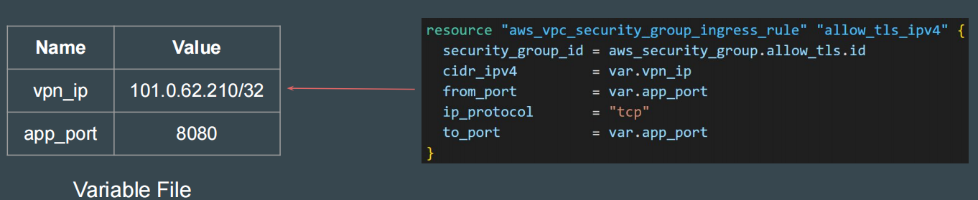
Terraform TFVARS
terraform.tfvars file can be used to define value to all the variables.
This approach leads to easier setup for multi-project deployments.
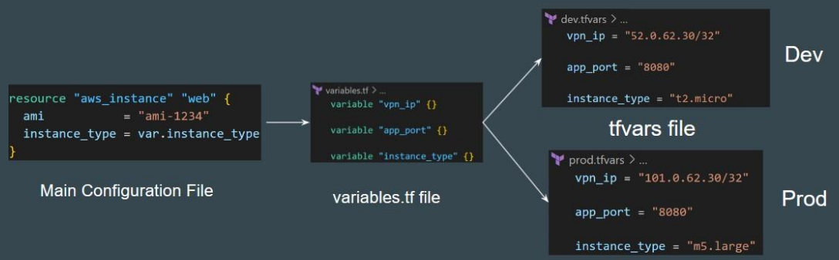
Selecting tfvars File
If you have multiple variable definitions file (*.tfvars) file, you can manually define the file to use during the command line.
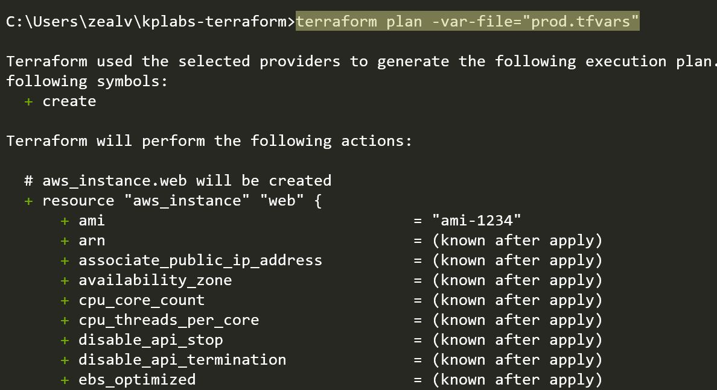

Declaring Variable Values
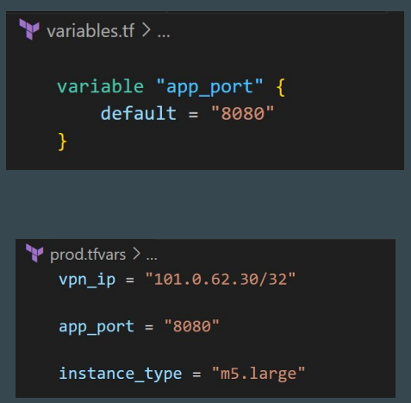
When variables are declared in your configuration, they can be set in a number of ways:
1. Variable Defaults.
2. Variable Definition File (*.tfvars)
3. Environment Variables
4. Setting Variables in the Command Line.

Setting Variable in Command Line
To specify individual variables on the command line, use the -var option when running the terraform plan and terraform apply commands:
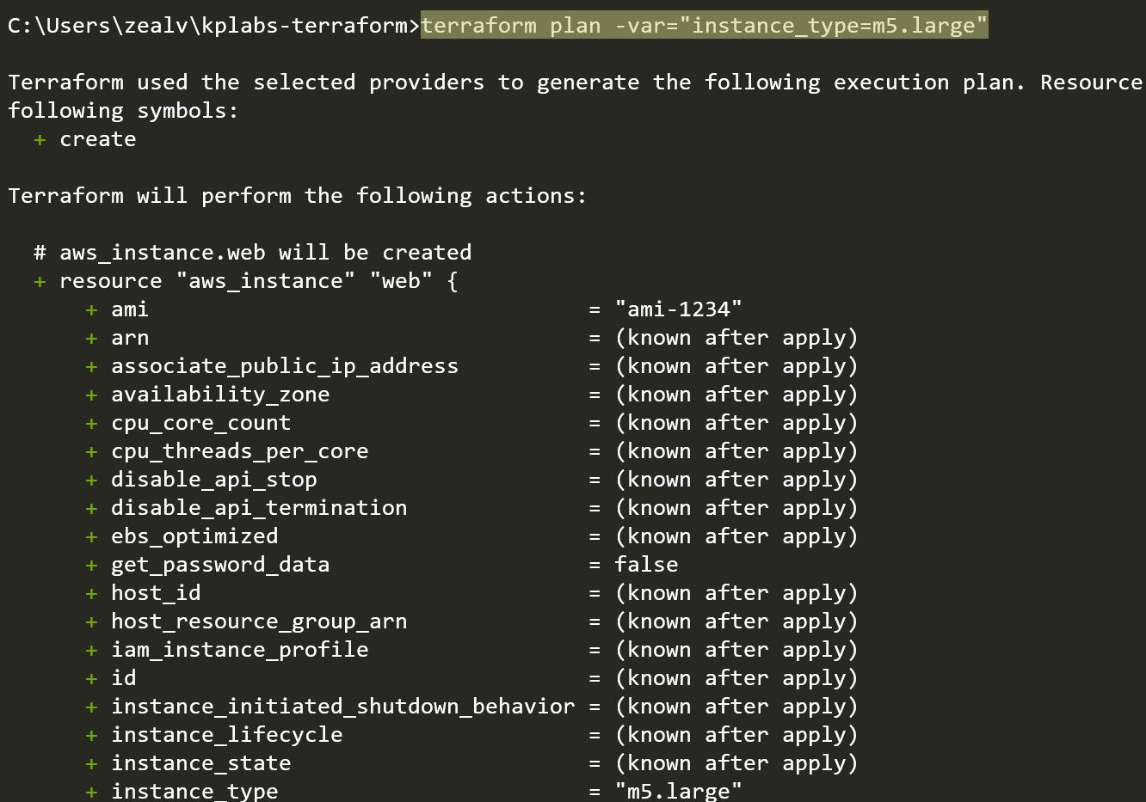
Setting Variable through Environment Variables
Terraform searches the environment of its own process for environment variables named TF_VAR_ followed by the name of a declared variable.
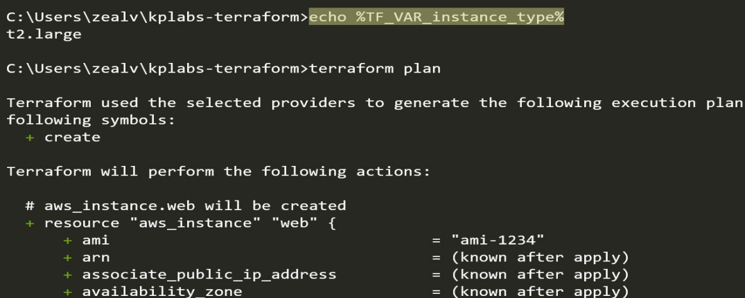
Variable Definition Precedence
Terraform loads variables in the following order, with later sources taking precedence over earlier ones:
1. Environment variables
2. The terraform.tfvars file, if present.
3. The terraform.tfvars.json file, if present.
4. Any *.auto.tfvars or *.auto.tfvars.json files, processed in lexical order of their filenames.
5. Any -var and -var-file options on the command line

Variables with undefined values
If you have variables with undefined values, it will NOT directly result in an error.
Terraform will ask you to supply the value associated with them.
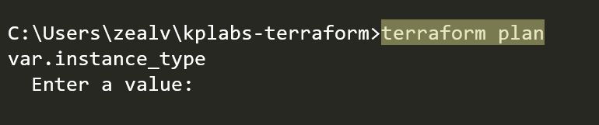
Not Allowed Variable Names
We cannot use all words within variable names.
Terraform reserves some additional names that can no longer be used as input variable names for modules. These reserved names are:
● count
● depends_on
● for_each
● lifecycle
● providers
● source

Points to Note - State File
Terraform state file generally stores details about the resources that it manages.
Various aspects like “Input Variables” are not stored.
Output value will be stored in state file but not the description
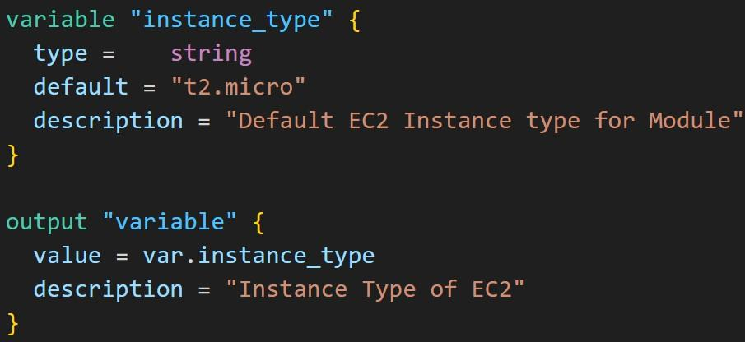
Terraform Console
Terraform Console provides an interactive environment specifically designed to test functions and experiment with expressions before integrating them into your main code.
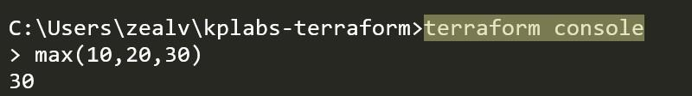
Dependency Lock File
Terraform dependency lock file allows us to lock to a specific version of the provider. Name is terraform.lock.hcl. For tracking provider dependencies.
If a particular provider already has a selection recorded in the lock file, Terraform will always re-select that version for installation, even if a newer version has become available.
You can override that behavior by running terraform init -upgrade

Dependencies - Implicit
With implicit dependency, Terraform can automatically find references of the object, and create an implicit ordering requirement between the two resources.
In the following screenshot, Terraform will create EC2 first before EIP.
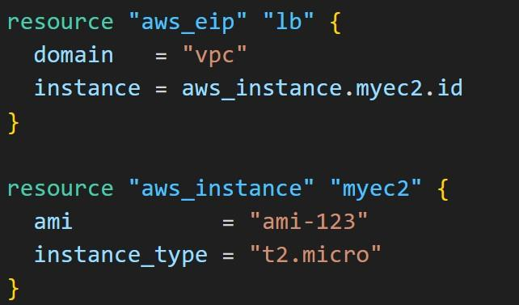
Dependencies - Explicit
Explicitly specifying a dependency is only necessary when a resource relies on some other resource's behavior but doesn't access any of that resource's data in its arguments.
Uses the depends_on meta-argument
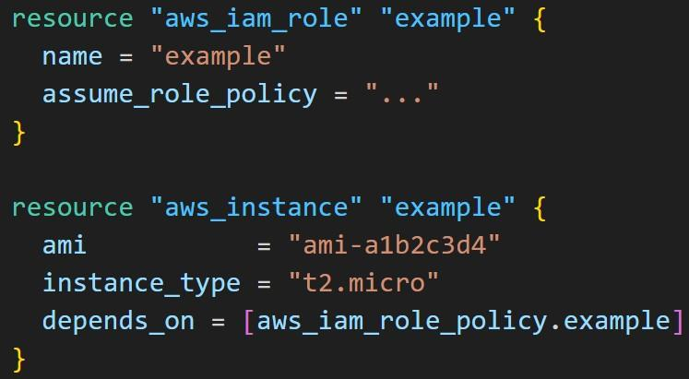

Data Sources
Data sources allow Terraform to use / fetch information defined outside of Terraform
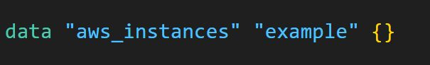
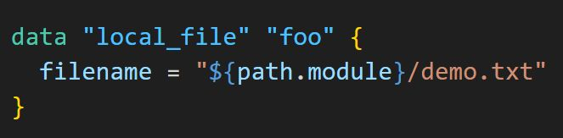

Terraform Enterprise
Terraform Enterprise provides several added advantages compared to Terraform Cloud.
Some of these include:
● Single Sign-On
● Auditing
● Private Data Center Networking
● Clustering
Team & Governance features are not available for Terraform Cloud Free (Paid)

Remote Backend
The remote backend stores Terraform state and may be used to run operations in Terraform Cloud.
When using full remote operations, operations like terraform plan or terraform apply can be executed in Terraform Cloud's run environment, with log output streaming to the local terminal.
The remote backend was the primary implementation of HCP Terraform's CLI-driven run workflow for Terraform versions 0.11.13 through 1.0.x. We recommend using the native cloud integration for Terraform versions 1.1 or later, as it provides an improved user experience and various enhancements.
Points to Note
HCP = HashiCorp Cloud Platform
Secure Variable Storage is available in Terraform Enterprise and Cloud but not in the normal version of Terraform.
Terraform Cloud / Enterprise comes with a Private Module registry which allows organizations to restrict access based on requirements.
Terraform Cloud provides the feature of Remote State storage.
Encryption of state file is available
In a HCP workspace linked to a VCS repository, runs start automatically when you merge or commit changes to version control.
A workspace is linked to one branch of a VCS repository and ignores changes to other branches.
To protect secret values in HCP, you can mark any Terraform or environment variable as sensitive data by clicking its Sensitive checkbox that is visible during editing. Marking a variable as sensitive makes it write-only and prevents all users (including you) from viewing its value
Sensitive Values in HCP
To protect secret values in HCP, you can mark any Terraform or environment variable as sensitive data by clicking its Sensitive checkbox that is visible during editing.
Marking a variable as sensitive makes it write-only and prevents all users (including you) from viewing its value
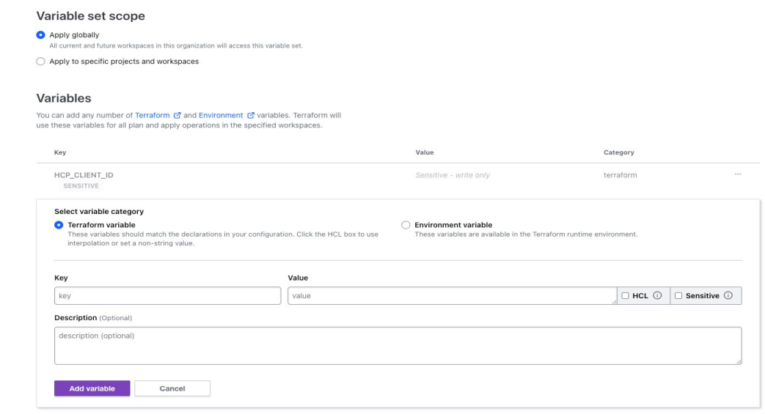
Recreating the Resource
The -replace option with terraform apply to force Terraform to replace an object even though there are no configuration changes that would require it.
terraform apply -replace="aws_instance.web"
A similar kind of functionality was achieved using the terraform taint command in older versions of Terraform. Not recommended now.
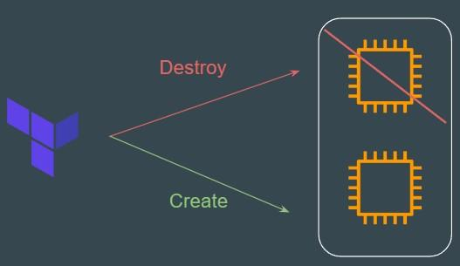

Benefits of IAC Tool
There are three primary benefits of Infrastructure as Code tools:
Automation, Versioning, and Reusability.
Various IAC Tools Available in the market:
● Terraform
● CloudFormation
● Azure Resource Manager
● Google Cloud Deployment Manager

terraform output
The terraform output command is used to extract the value of an output variable from the state file.
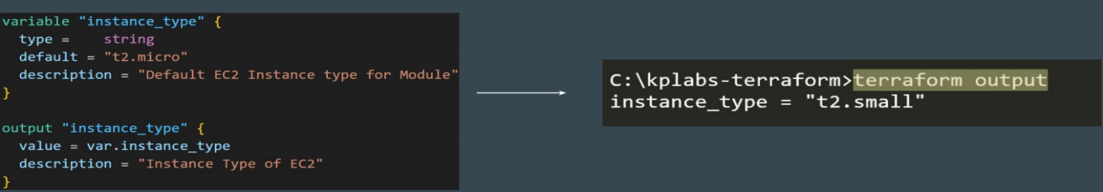

Module Source and Git Branches
By default, Terraform will clone and use the default branch (referenced by HEAD) in the selected repository.
You can override this using the ref argument.
Format: ?ref=<version-number>
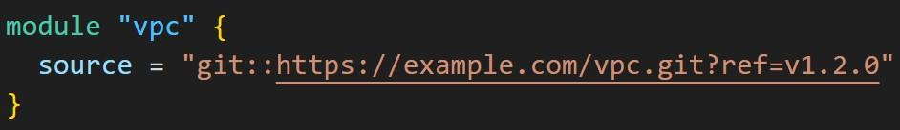

Splat Expressions
Splat Expression allows us to get a list of all the attributes.
Resources that use the for_each argument will appear in expressions as a map of objects, so you can't use splat expressions with those resources.
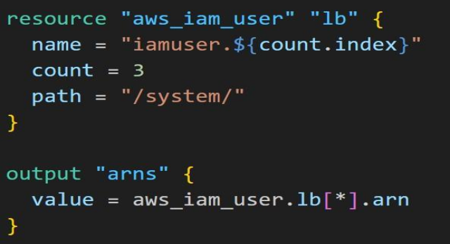
Important Documentation Reference - Splat
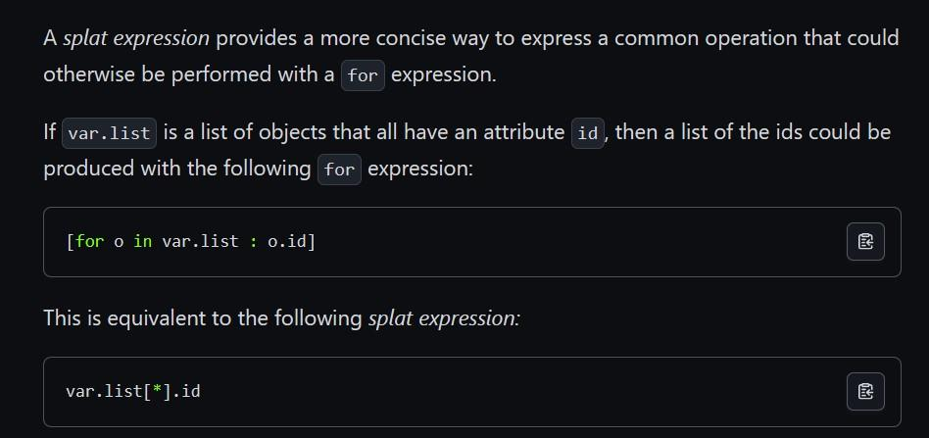
Point to Note
Will this code block display the names of all the IAM usernames created?
Answer = NO
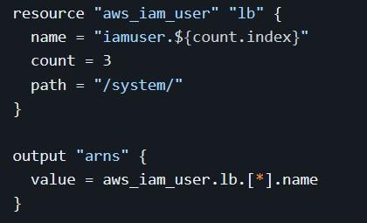

Legacy Splat Expression
Earlier versions of the Terraform language had a slightly different version of splat expressions, which Terraform continues to support for backward compatibility.
The legacy "attribute-only" splat expressions use the sequence .*, instead of [*]:
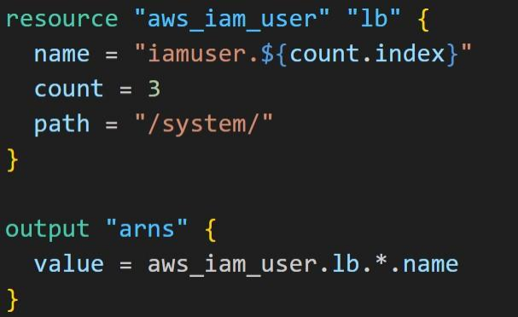

Fetching Values from List
To fetch the instance_type value of m5.xlarge from the list, you can reference to the key of 1
var.size[1]
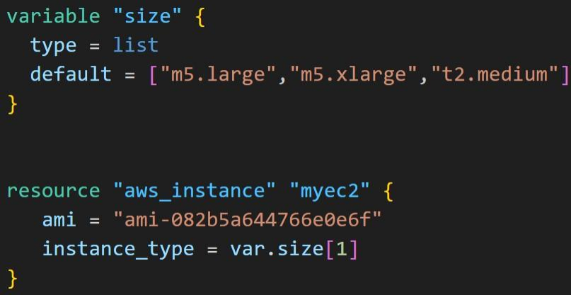
Fetching Values from Map
To reference the “t2.small” instance type from the below map, the following approaches need to be used:
var.types[“ap-south-1”]
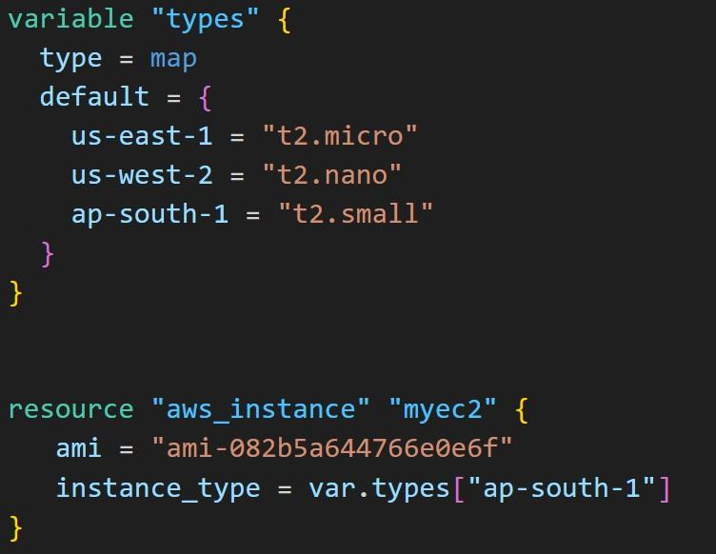
Dealing with Larger Infrastructure
Cloud Providers have set a certain rate limit, so Terraform can only request a certain number of resources over a period of time.
It is important to break larger configurations into multiple smaller configurations that can be independently applied.
Alternatively, you can make use of -refresh=false and target flag for a workaround (not recommended)

BackEnds
Backends primarily determine where Terraform stores its state.
By default, Terraform implicitly uses a backend called local to store state as a local file on disk.
If required, you can store state file in other backend as well.
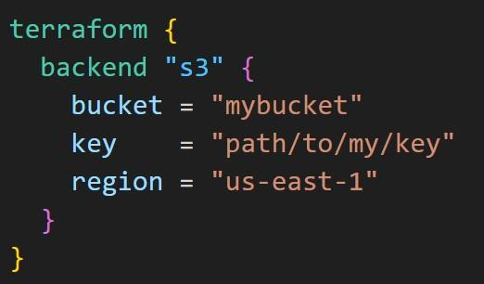
Points to Note - Initializing Backend
When configuring a backend for the first time (moving from no defined backend to explicitly configuring one), Terraform will give you the option to migrate your state to the new backend.
This lets you adopt new backends without losing any existing state.
Local Backend
The local backend stores the state on the local filesystem, locks that state using system APIs, and performs operations locally.
By default, Terraform uses the "local" backend, which is the normal behavior of Terraform you're used to
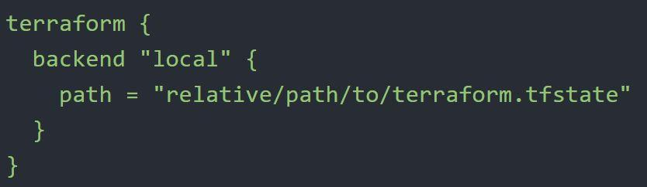

Air Gapped Environments
An air gap is a network security measure employed to ensure that a secure computer network is physically isolated from unsecured networks, such as the public Internet.
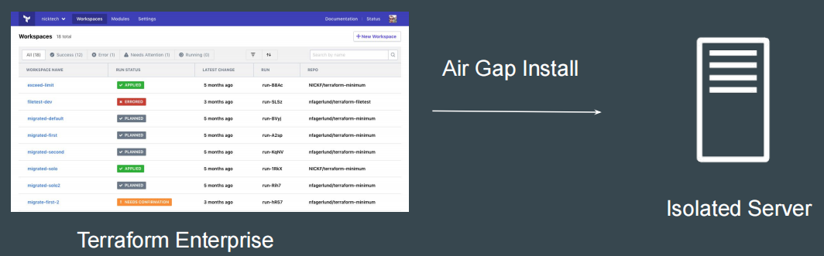

Requirements for Publishing Module in Registry
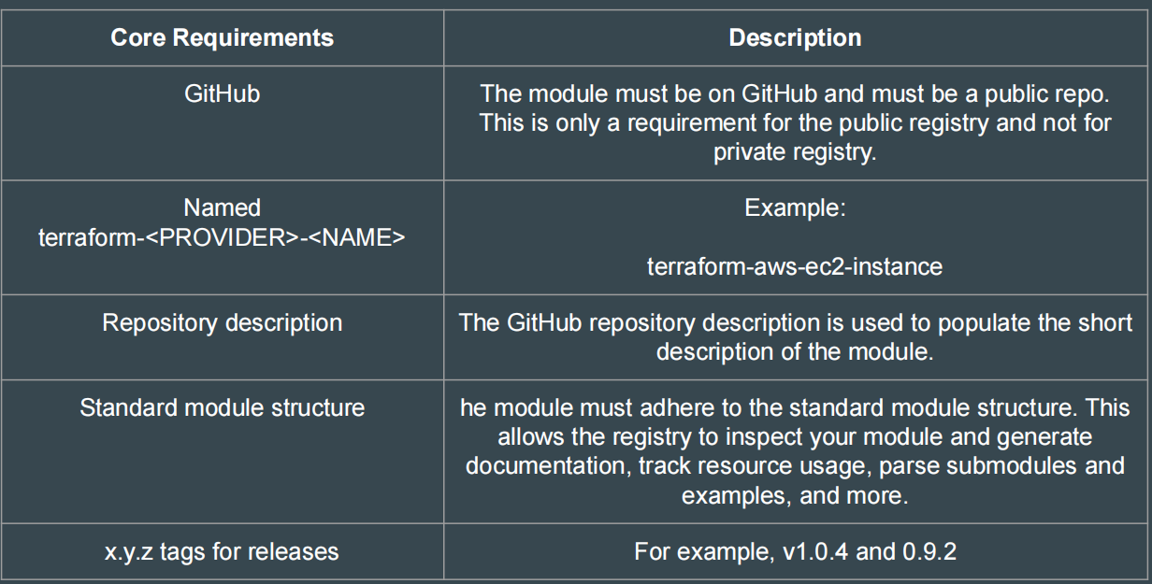

Comments in Terraform
A comment is a text note added to the source code to provide explanatory information, usually about the function of the code.
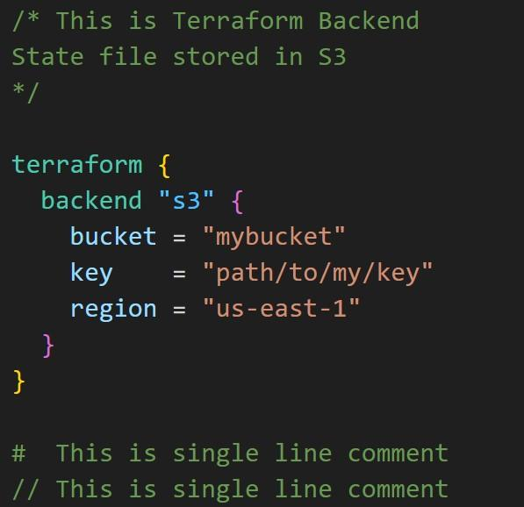

Dynamic Blocks
Dynamic Block allows us to dynamically construct repeatable nested blocks, which are supported inside resource, data, provider, and provisioner blocks.
Overuse of Dynamic blocks can make configuration hard to read and maintain.
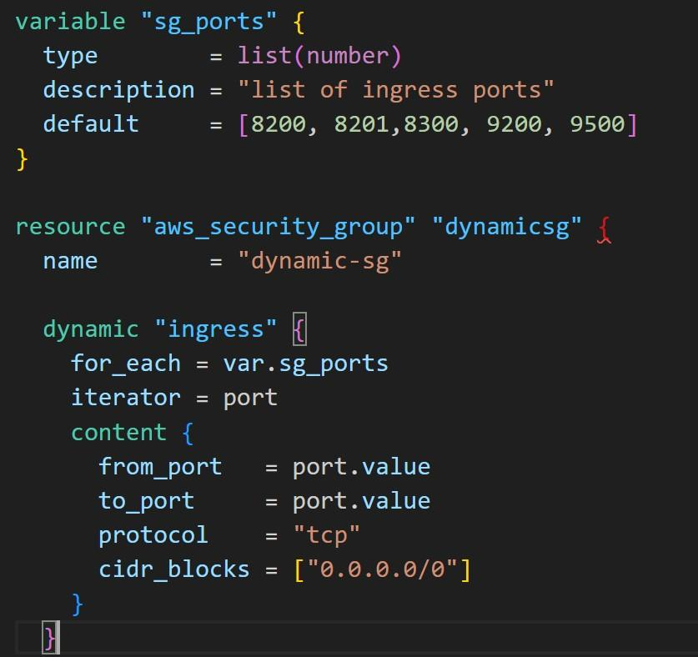

Miscellaneous Pointers
GitHub is not the supported backend type in Terraform.
API and CLI access for Terraform Cloud can be managed through API tokens that can be generated from Terraform Cloud UI.
Terraform uses Parallelism to reduce the time it takes to create the resource. By default, this value is set to 10
Code Formatting Recommended Practices
Indent two spaces for each nesting level
When multiple arguments with single-line values appear on consecutive lines at the same nesting level, align their equals signs:
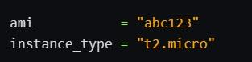

Terraform does not require go as a prerequisite.
Terraform providers are NOT always installed through the internet. There is a different offline approach for air-gapped systems.
Terraform and Terraform Provider NEED NOT have the same major version for compatibility.

Sensitive Parameter
Adding sensitive parameter ensures that you do not accidentally expose this data in CLI output, log output.
The sensitive value will be present as part of the state file.
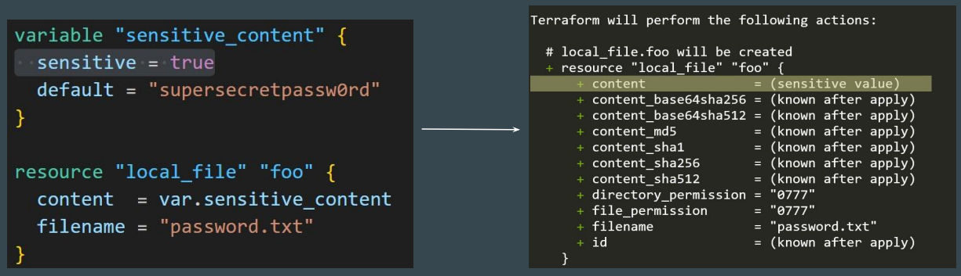

Actions Forbidden When State File is Locked
When the state file is locked, the following actions are forbidden:
Running terraform apply or any other command that modifies the state file (e.g. terraform plan, terraform destroy, etc.)
Running terraform refresh, which updates the state file to reflect the current state of the infrastructure
terraform state [push, rm, mv]
1. terraform.tfstate will NOT always match the current state infrastructure.
If you are making use of the GIT repository for commiting terraform code, the .gitignore should be configured to ignore certain terraform files that might contain sensitive data.
Some of these can include:
terraform.tfstate file (this can include sensitive information)
*.tfvars (may contain sensitive data like passwords)
Points to Note - State
1. If supported by your backend, Terraform will lock your state for all operations that could write state.
2. Not all backends support locking functionality.
3. Terraform has a force-unlock command to manually unlock the state if unlocking failed. terraform force-unlock LOCK_ID [DIR]

