This is a project for hackAIACTR

made by:

PUNEET DHIMAN & SHREYA CHAUHAN.

Hope you all are safe and making a good use of these quarantine.

**Purpose:**

As the name suggests venom protégé where “venom” stands for “virus” and “protégé” stands for “protector” in latin. This app is based on an old saying “PRECAUTION IS BETTER THAN CURE”, and this statement is 110% valid and the best way to be safe from corona virus. As corona virus or COVID-19 is a disease that is 10 times more easily catchable compared to a normal virus and we all know the effects and harm that it can cause to us but also to our loved ones without even giving a single hint. So just stay home and go outside only in an emergency and wear all the protective equipment and don’t forget to check out web-app just to make sure that you are not entering a red zone.

**History:**

So it all started when we were both worrying that in our society there are so many cases coming daily but the pizza delivery or zomato guy etc , where going into that building without knowing or some people visit their relatives or friends in the same building without knowing that a corona positive person was /is to live there. So those people are a great risk without knowing about such information. So here is part we are playing in such people’s lives.

By using this web application you can know the exact location of that person or group of people who were found to be corona positive, so that you can take precautions before it is too late.

**How did we created it**

1. we use a custom google map that we created and added layers and marked the exact locations of the houses. On the map using satellite mode.

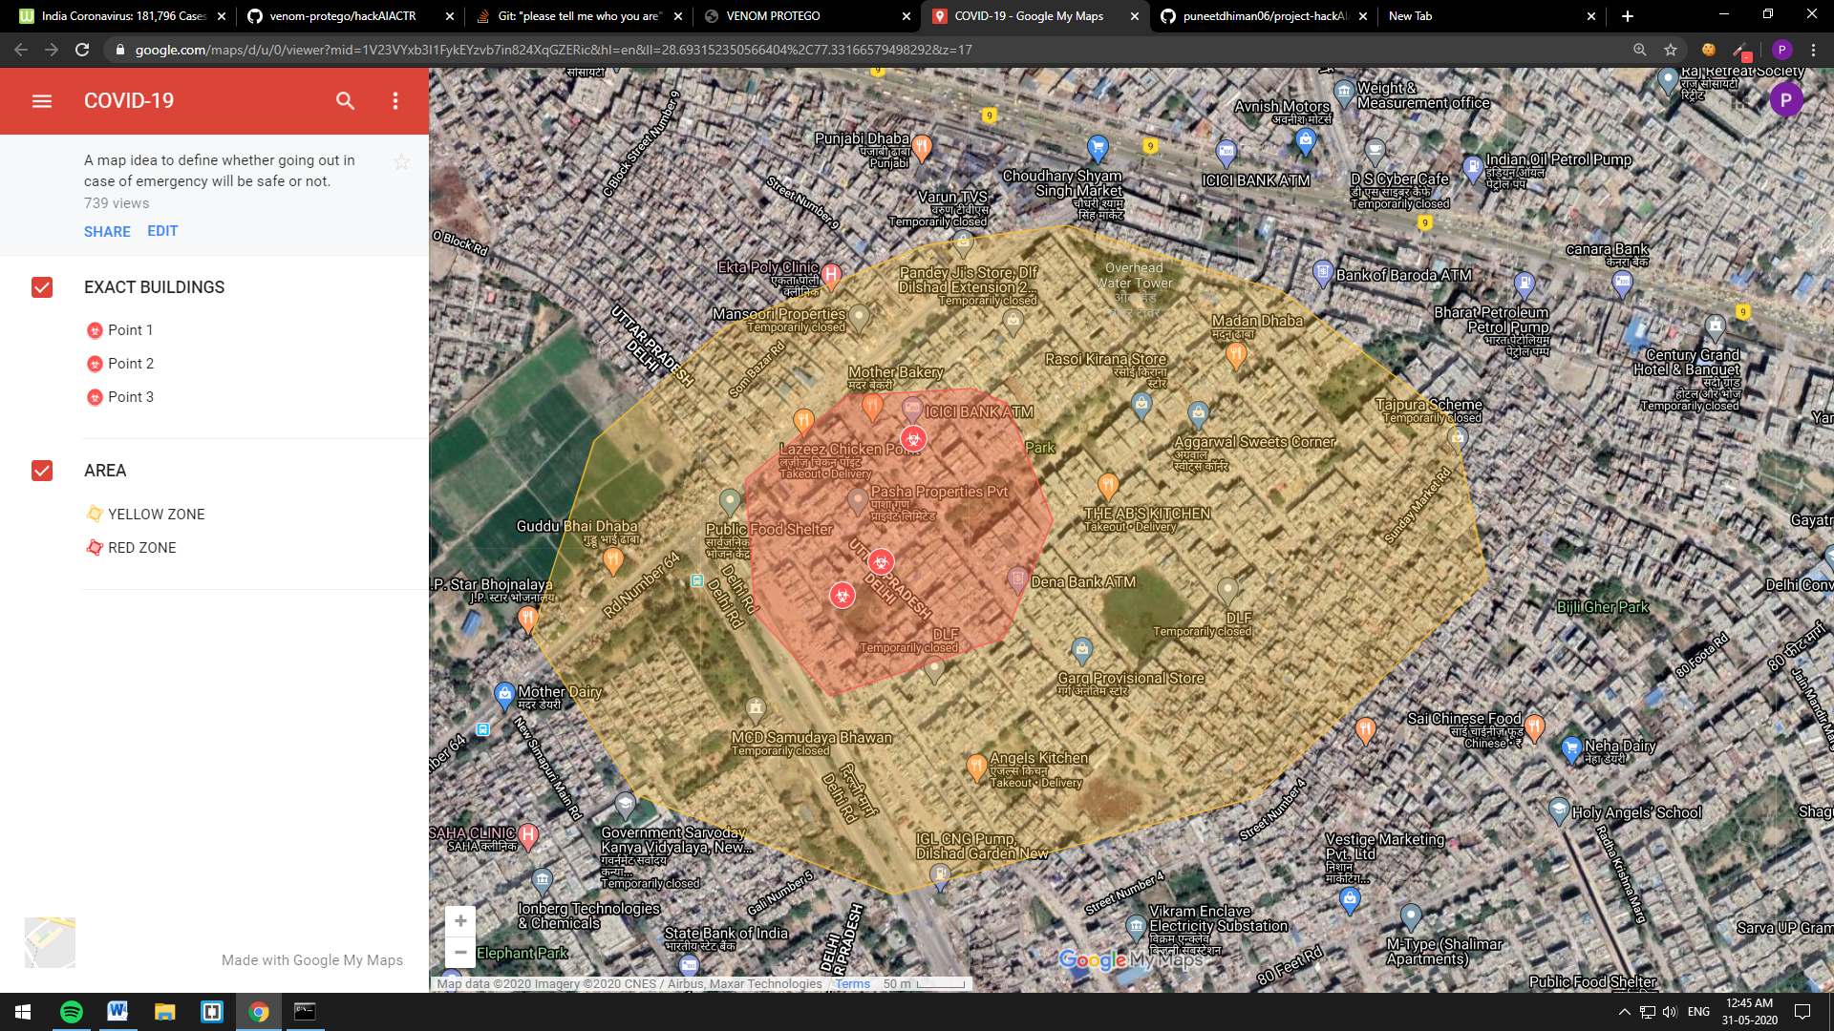

1. Then we iframed it into our web-page.

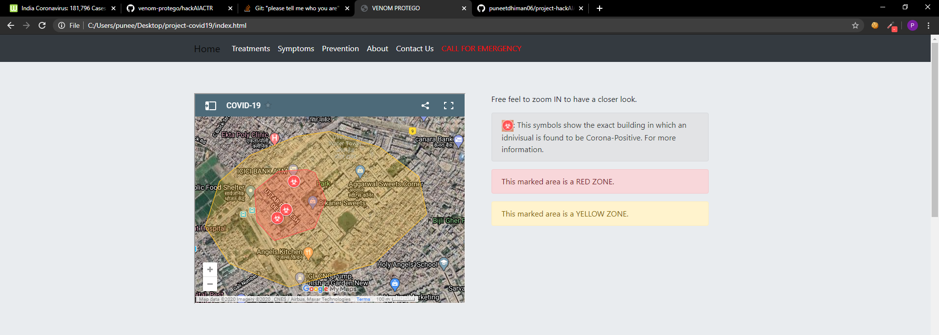

1. We also mentioned the name of the people who are infected and their address.

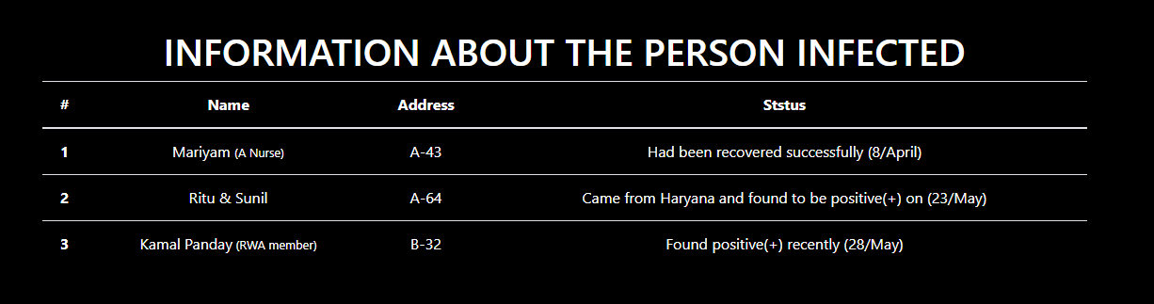

1. Then we added case meter representing current status of India

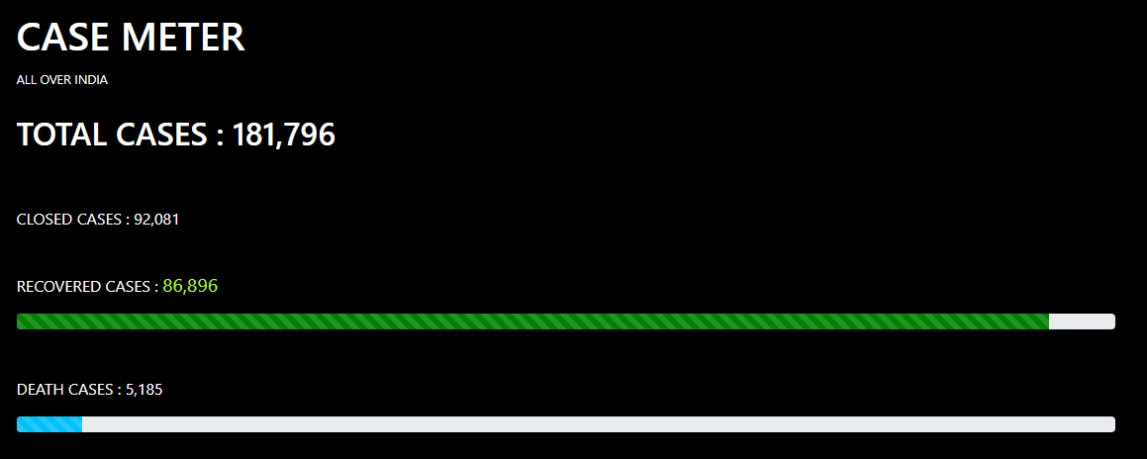

1. We also added a editing tool if someone with new and updated information can edit (condition is information should be correct as it can cause serious risk to a person).

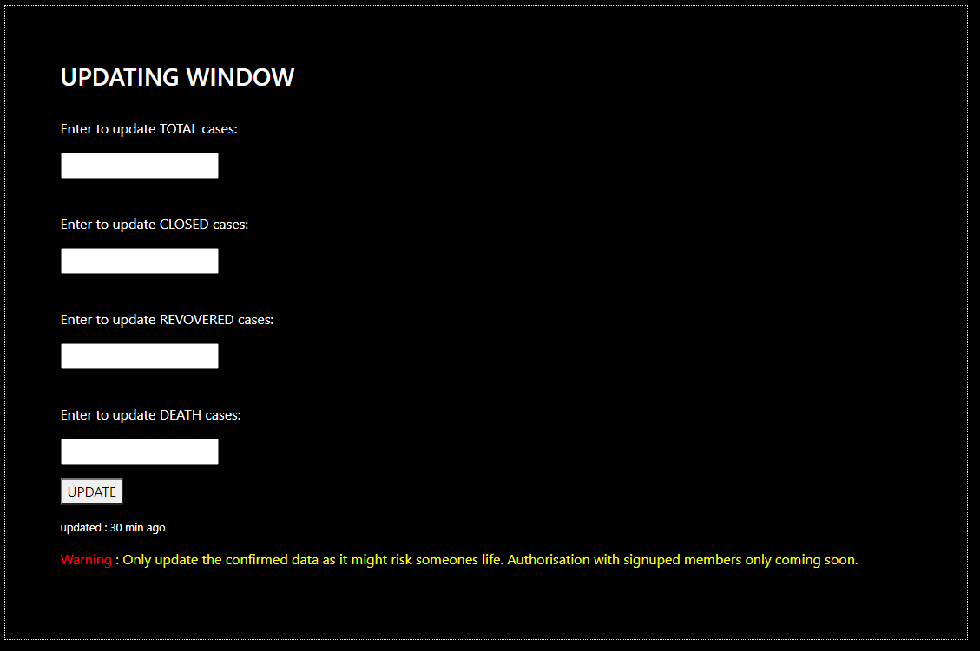

1. We used javaScript and jQuery to manage that the data would not be wrong.

